PANASA

Software Requirements Specification
  - FieldPulse
Project | FieldPulse
Project code | FIELDPULSE
Client | Acme Logistics
Document type | Software Requirements Specification (SRS)
Version | 0.2
Status | In review
Date | 27 Oct 2026
Prepared by | Vishnu Ravi
Reviewed by | TBD
Approved by | TBD
Classification | Confidential

Confidential. Prepared by Panasa for Acme Logistics. Do not share outside the project team without approval.
Revision history
Version | Date | Author | Changes
0.1 | 20 Oct 2026 | Vishnu Ravi | First draft
0.2 | 27 Oct 2026 | Vishnu Ravi | Added offline requirements and NFRs after workshop 2

Contents
1. Introduction
1.1 Purpose
1.2 Scope
1.3 Definitions and abbreviations
1.4 References
2. Overall description
2.1 Product context
2.2 User roles
2.3 Assumptions
2.4 Constraints
2.5 Dependencies
3. Functional requirements
3.1 Routes
3.2 Proof of delivery
4. Non-functional requirements
5. External interfaces
5.1 User interfaces
5.2 APIs
5.3 Third-party integrations
6. Data requirements
7. Out of scope
8. Open questions
9. Sign-off

1. Introduction

1.1 Purpose
This document specifies the requirements for FieldPulse for Acme Logistics.

1.2 Scope
FieldPulse is an Android app that Acme's delivery drivers use to follow their route, capture proof of delivery and report failed deliveries. A web dashboard lets dispatchers follow deliveries as they happen. The first release covers Android phones and the dispatcher dashboard.

1.3 Definitions and abbreviations
Term | Meaning
POD | Proof of delivery: a photo and the recipient's signature, captured at the door
Dispatcher | Acme staff member who assigns routes to drivers
ERP | Enterprise resource planning: Acme's system that holds orders

1.4 References
Document | Version | Location
Project Overview | 1.0 | FIELDPULSE_OVR_v1.0.docx
Workshop 2 notes | 24 Oct 2026 | Shared drive

2. Overall description

2.1 Product context
FieldPulse replaces the paper delivery sheets drivers use today. It reads each day's orders from Acme's ERP and sends delivery results back to it.
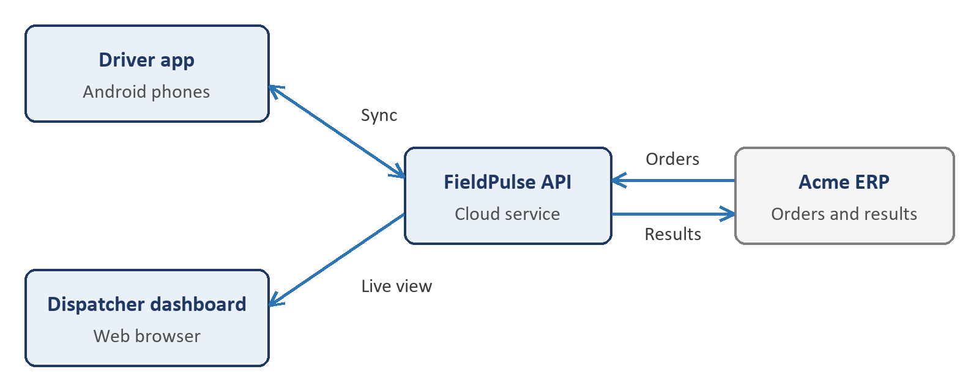
Figure 1: FieldPulse and the systems it connects to

2.2 User roles
Role | Description | What they can do
Driver | Delivers parcels | See their own route, capture POD, report a failed delivery
Dispatcher | Plans routes | Assign routes, follow drivers live, reassign stops
Administrator | Acme IT staff | Manage users and depots

2.3 Assumptions
- Every driver has an Acme-issued Android phone running Android 10 or later.
- Acme's ERP offers an order API that FieldPulse can call.

2.4 Constraints
- Go-live date: TBD (owner: Acme operations head).
- Signatures must be kept for 7 years, as Acme's customer contracts require.

2.5 Dependencies
- ERP order API documentation from Acme IT.

3. Functional requirements

3.1 Routes

FR-001: Show today's route
- Priority: Must
- Description: The system shall show drivers the stops assigned to them for the current day, in delivery order.
- Acceptance criteria:
1. Given a driver with 12 assigned stops, when they open the app, then all 12 stops appear in the planned order.
2. Given a stop reassigned by a dispatcher, when the driver's app next syncs, then the stop disappears from their route.
- Source: Workshop 1, 13 Oct 2026

FR-002: Work offline
- Priority: Must
- Description: The system shall let drivers complete deliveries without a network connection and upload them when the connection returns.
- Acceptance criteria:
1. Given the phone is offline, when the driver captures POD, then the POD is saved on the phone.
2. Given saved PODs, when the connection returns, then they upload within 2 minutes without any action from the driver.
- Source: Workshop 2, 24 Oct 2026

3.2 Proof of delivery

FR-003: Capture proof of delivery
- Priority: Must
- Description: The system shall capture a photo and the recipient's signature for each delivered parcel.
- Acceptance criteria:
1. Given a stop, when the driver marks it delivered, then the app requires a photo and a signature before saving.
- Source: Workshop 1, 13 Oct 2026
Note: Acme asked whether a one-time code sent to the customer could replace the signature. This is open question OQ-001.

4. Non-functional requirements
ID | Category | Requirement | Target or measure | Source
NFR-001 | Performance | The app shall show the route screen within the target time after the driver opens it. | Under 2 seconds on a 4G connection for 95% of opens, on Acme's standard driver phone | Workshop 2, 24 Oct 2026
NFR-002 | Availability | The dispatcher dashboard shall be available during delivery hours. | 99.5% between 06:00 and 22:00 IST, measured monthly | Workshop 2, 24 Oct 2026
NFR-003 | Security | The system shall encrypt delivery data in transit and at rest. | TLS 1.2 or later in transit; AES-256 at rest | Acme IT security policy v3

5. External interfaces

5.1 User interfaces
Android phones with 5 to 7 inch screens, in English and Hindi. Designs: TBD (owner: Panasa design lead).

5.2 APIs
API | Direction | Purpose | Format and authentication
ERP order API | Outbound | Read the day's orders | REST and JSON, OAuth 2.0 client credentials
Delivery results API | Outbound | Send delivery results to the ERP | REST and JSON, OAuth 2.0 client credentials

A delivery result sent to the ERP looks like this:
{
"orderId": "ACM-104233",
"status": "DELIVERED",
"deliveredAt": "2026-10-27T10:42:00+05:30"
}

5.3 Third-party integrations
System | Purpose | Owned by | Notes
Google Maps Platform | Maps and turn-by-turn directions | Acme Logistics | Billing and keys sit in Acme's Google Cloud project

6. Data requirements
Data | Description | Personal data | Retention
Delivery record | Stop address, time, status and driver | Yes (driver and delivery address) | 7 years
Proof of delivery | Photo and signature | Yes | 7 years
Driver location | GPS position during shifts | Yes | 90 days

7. Out of scope
- iOS app
- A tracking page for Acme's customers

8. Open questions
ID | Question | Raised by | Owner | Due date | Status
OQ-001 | Can a one-time code replace the customer's signature? | Acme operations | Acme legal | 07 Nov 2026 | Open

9. Sign-off
By signing below, the parties agree that this document describes the requirements for FieldPulse. Once signed, it is the agreed basis for design, development, testing and acceptance.
Name | Organisation | Role | Signature | Date
TBD (owner: Acme project sponsor) | Acme Logistics | Product owner
TBD (owner: Panasa delivery head) | Panasa | Project manager

