**Name: vishnu sadasivan**

**Roll No: 52**

**Batch: MCA-B**

**Date: 04-04-2022**

**NETWORKING & SYSTEM ADMINISTRATION LAB**

**Experiment No.: 6**

**Aim**

Familiarization of basic Linux commands part 4

**Procedure**

**1. cp**

This commands in Linux allows you to copy a file or an entire directory to another

Directory specified.

**Syntax:-** $ cp file_to_be_copied directory_name

**Output:-**

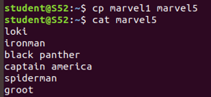

**2. cp –r**

This command in Linux allow us to copy an entire directory into another directory

**Syntax:-** $ cp –r source_directory destination_directory

**Output:-**

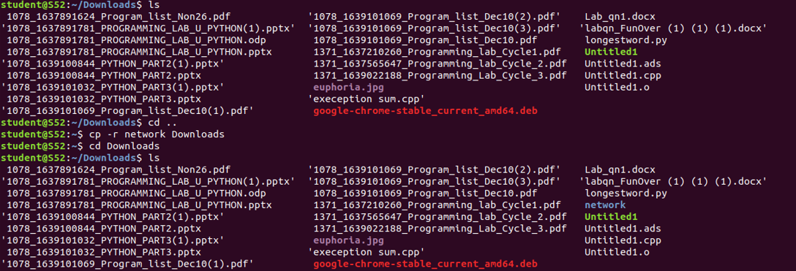

**3.** **cp - i**

This command helps to make a decision regarding overwrite that may happen in case of copying a same named file (but different in content) from the source folder to the destination folder.

**Syntax:-** $ cp - i filename destination_folder

**Output:-**



**4. mv**

This command will move a specific file or directory to another directory

**Syntax:-** $ mv file_name/directory_name destination_directory

**Output:-**



**5. mv -i**

This command enables a dialog to take a wise decision about overwrite in case of moving

A file with the same name as that of one already exist in the destination directory.

**Syntax:-** $ mv - i filename destination_path

**Output:-**

