|  |
| --- |
| **Name: Vishnu sadasivan**  **Roll No: 52**  **Batch: mca-B**  **Date: 25-04-2022** |

**NETWORKING & SYSTEM ADMINISTRATION LAB**

**Experiment No.: 8**

**Aim**

Familiarization of Linux Commands – Part 08

# Procedure

**Note : sudo:** “super user do” : This command is used to access/perform admin privileged activities.

1. **sudo useradd :** This command is used to add a user to the system and create an account with the specified username.

**Syntax:** $sudo useradd <username>

**Output:**



1. **sudo passwd :** It lets you to change the password of the mentioned user account if it exists.

**Syntax:** $sudo passwd <username>

**Output:**

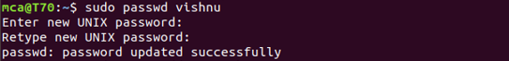

1. **sudo groupadd -g :**This command helps to create a new group in the system with specified unique ID and with new non-existing Group Name.

**Syntax:** $sudo groupadd -g <unique-no> <group-name >

**Output:**



1. **sudo usermod -G :** This command helps to add an existing created user to the mentioned group.

**Syntax:** $sudo usermod -G <group-name><username>

**Output:**



**5.id :** This helps to get the status of the mentioned user like to which group that user belongs, what is the unique number, etc.

**Syntax:** $id <username>

**Output:**



**6.compgen -g:** This helps to list out all the existing groups in the system.

**Syntax:** $compgen -g

**Output:**

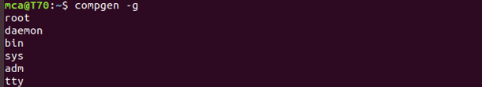

**7.compgen -g :** This command is used to list only the mentioned group name if it exists.

**Syntax:** $compgen -g <group-name>

**Output:**





**8.sudo userdel “user-name”:** This command helps to delete an existing mentioned user from the system.

**Syntax:** $sudo userdel <user-name>

**Output:**

** **

**9.sudo groupdel:** This command helps to delete an existing mentioned group from the system.

**Syntax:** $sudogroupdel <group-name>

**Output:**



**10.chmod:** This is command used to change/edit the privileges of the files/folders.

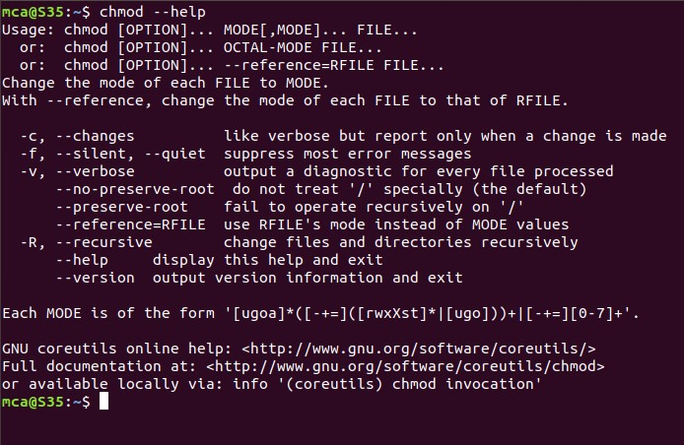

**11.chmod –(rwx) :** This command helps to restrict the mentioned privileges for the mentioned file or folder.

**NOTE:**

* + 1. **r** -> read
    2. **w** -> write
    3. **x** -> execute

**Syntax:** $chmod –(rwx) [filename/foldername]

**Output:**



**12.chmod +(rwx) :**This command helps to give mentioned privileges for the mentioned file or folder.

**Syntax:** $cmod +(rwx) [filename/foldername]

**Output:**



**13.sudo chown:**This command enables you to transfer the ownership of the mentioned file from current user to another mentioned user.

**Syntax:** $sudo chown “group-name” [filename]

**Output:**

