**Name: Vishnu sadasivan**

**Roll No: 52**

**Batch: MCA-B**

**Date: 06-06-2022**

**NETWORKING & SYSTEM ADMINISTRATION LAB**

**Experiment No.: 27**

**Aim**

To familiarize with the installation of wireshark

**Procedure**

1. Open the terminal on Ubuntu

2. Install Wireshark

**$ sudo apt-get install wireshark**

**Output:-**

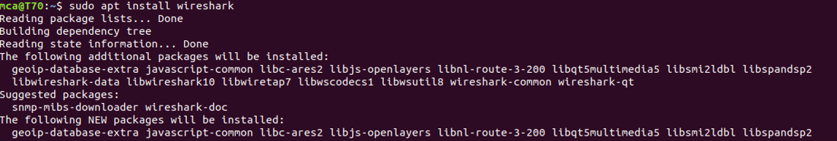

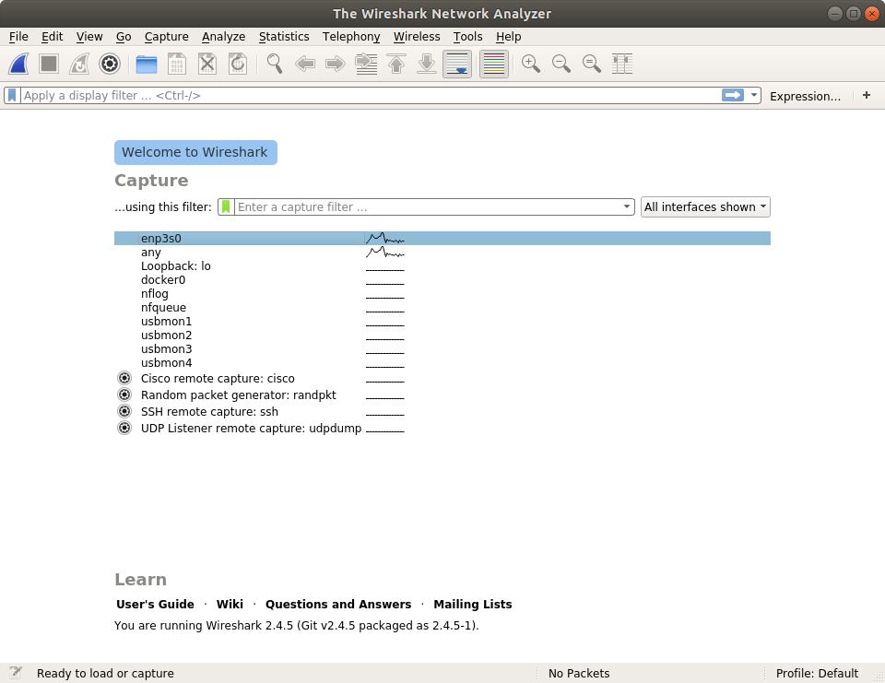

3. add the user mca to the wireshark:

**$ sudo user add mca**

**Output:**



4. $ sudo wireshark

This will open a wireshark interface on the system through which we can see packet information

**$ sudo wireshark**

**Output:-**

**

