**Name: Vishnu sadasivan**

**Roll No: 52**

**Batch: MCA-B**

**Date: 12-05-2022**

**NETWORKING & SYSTEM ADMINISTRATION LAB**

**Experiment No.: 23**

**Aim**

Docker installation on ubuntu.

**Procedure**

1. Open the terminal on Ubuntu.

2. Remove any [Docker files](https://www.simplilearn.com/tutorials/docker-tutorial/what-is-dockerfile) that are running in the system, using the following command

**command:**

$ sudo apt-get remove docker docker-engine docker.io

After entering the above command, you will need to enter the password of the root and press enter.

**Output:**

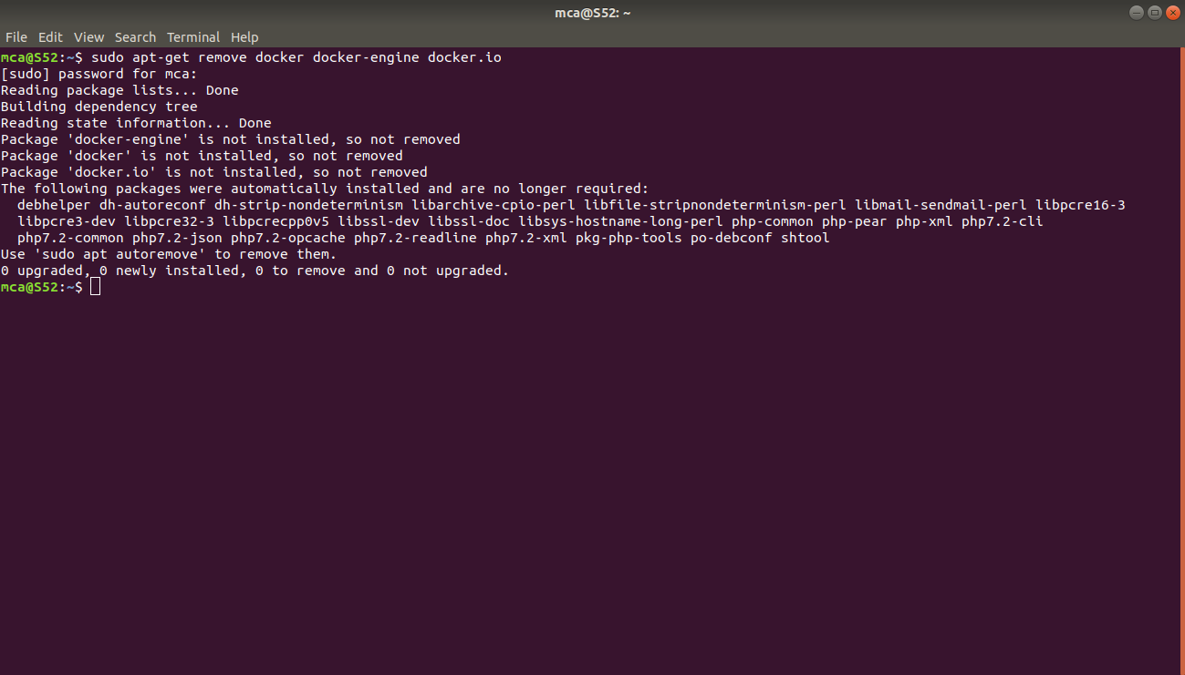

3. Check if the system is up-to-date using the following command:

**command:**

$ sudo apt-get update

**Output:**

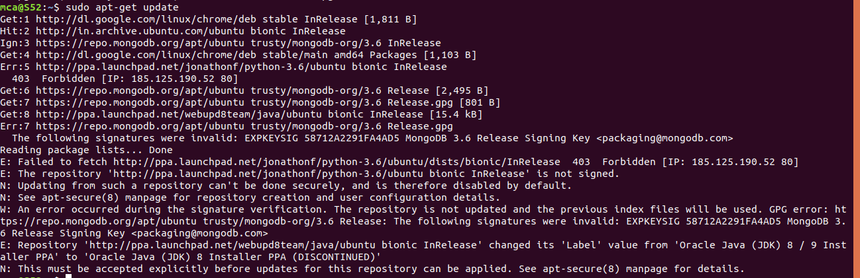

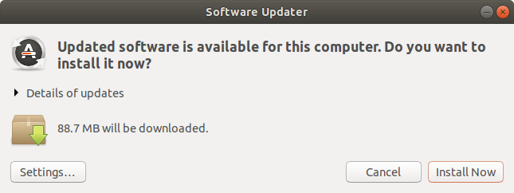

4. Install Docker using the following command:

**command:**

$ sudo apt install docker.io

You’ll then get a prompt asking you to choose between y/n - choose y

**Output:**

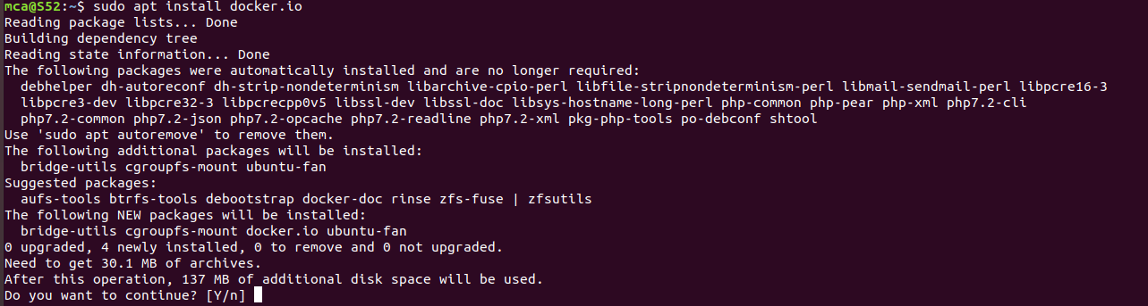

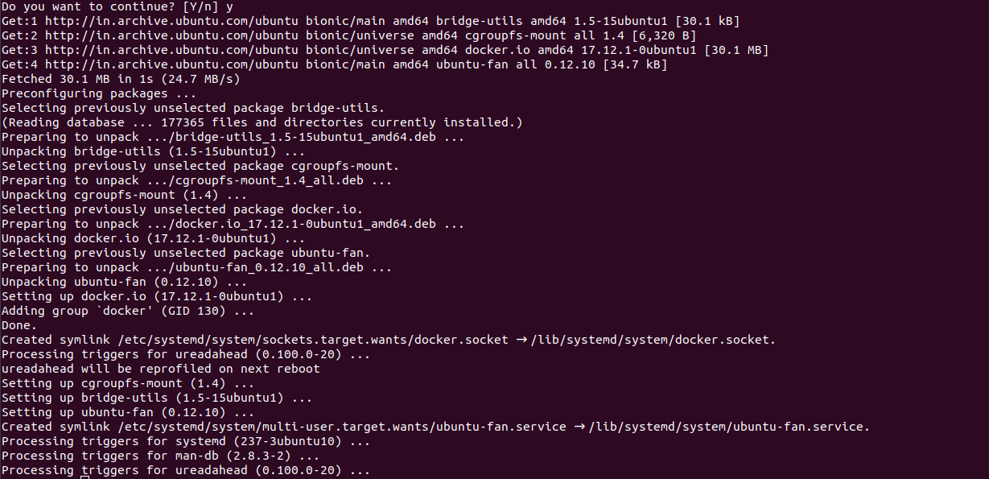

5. Install all the dependency packages using the following command:

**command:**

$ sudo snap install docker

**Output:**



6. Before testing Docker, check the version installed using the following command:

**command:**

$ docker –version

**Output:**



7. Pull an image from the Docker hub using the following command:

**command:**

$ sudo docker run hello-world

Here,hello-world is the docker image present on the Docker hub.

**Output:**

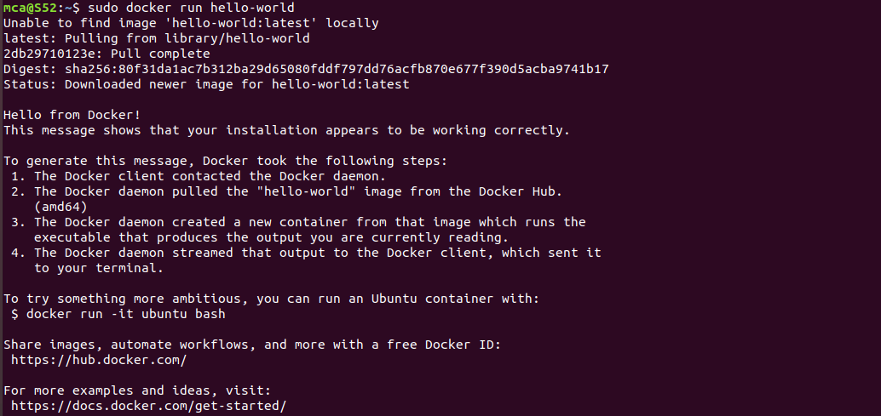

8. Check if the docker image has been pulled and is present in your system using the following command:

**command:**

$ sudo docker images

**Output:**



9. To display all the containers pulled, use the following command:

**command:**

$ sudo docker ps -a

**Output:**



10. To check for containers in a running state, use the following command:

**command:**

$ sudo docker ps

**Output:**

