**Name: VISHNU SADASIVAN**

**Roll No: 52**

**Batch: B**

**Date: 01/04/2022**

**NETWORKING & SYSTEM ADMINISTRATION LAB**

**Experiment No.: 3**

**Aim**

Familiarization of Linux command.

**Procedure**

**1. cat –n filename :** To display line number.

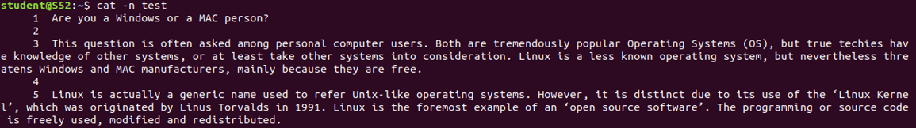

**2. cat –b filename :** To remove empty lines.

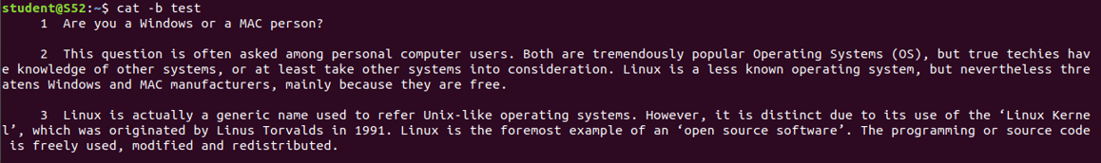

**3. touch filename :** To create a new blank file.



**4. head filename :** To display first ten lines of specified file.

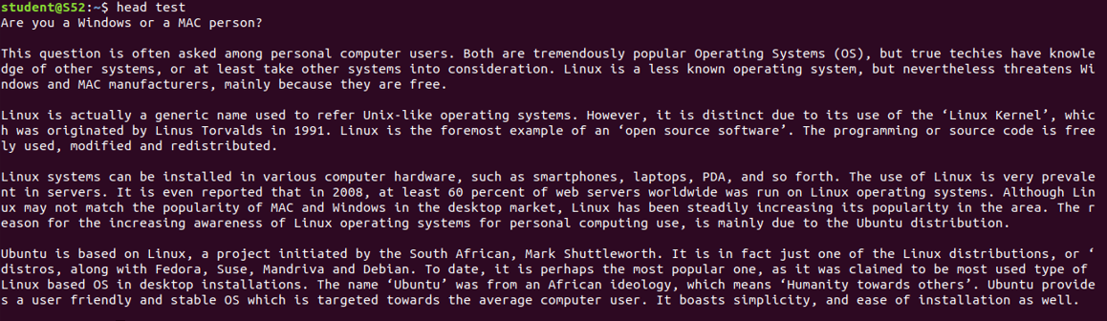

**5. head -n filename :** Todisplay first specified number of lines instead of ten lines.



**6. tail filename :** To display last ten lines of specified file.

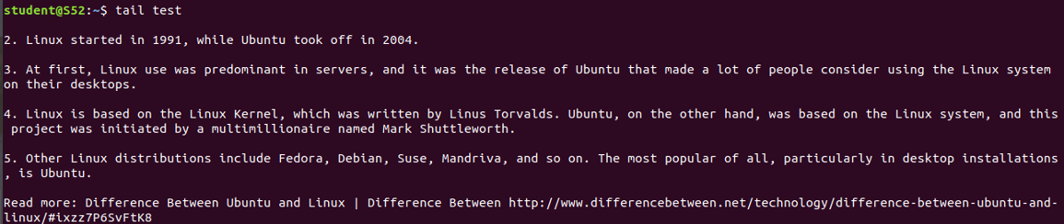

**7. tail -n filename :** Todisplay last specified number of lines instead of ten lines.

