Experiment 11

P.VISHNU SAI

192011177

Step 1 : - Create a Virtual Machine

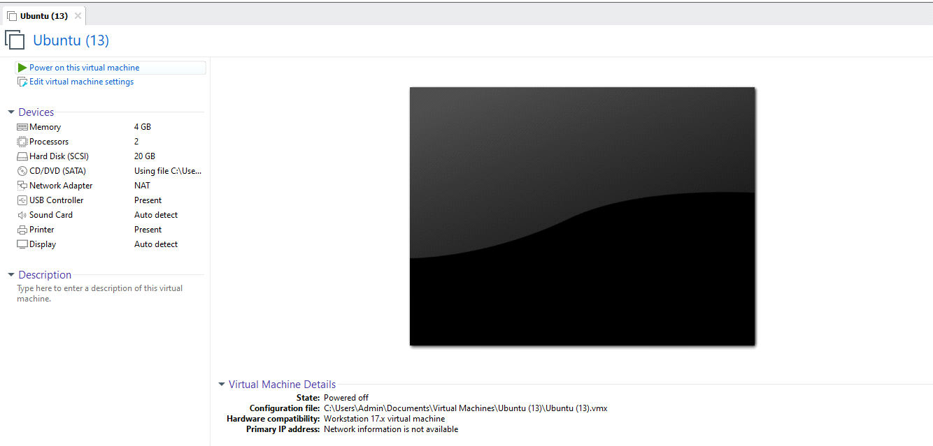

Step2 : Click On **VM** on top left and select **Manage**

**Vm -----> Manage -----> Change HardWare Compatibility**

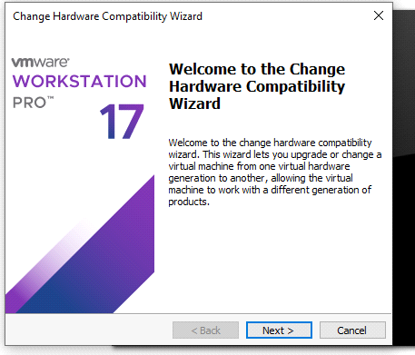

Step 3: Click on **Next**  and **change the HardWare Compatability to Some other Version**( As You wish)

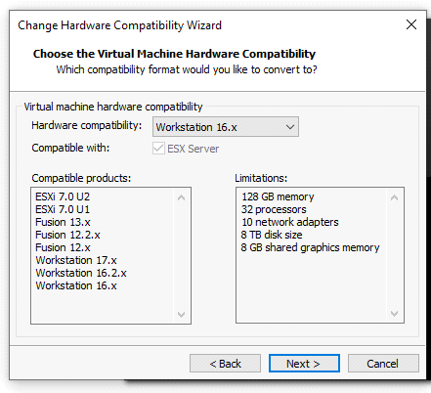

Step 4: Click on **Next**

Select  **Create a New Clone of this Virtual Machine**

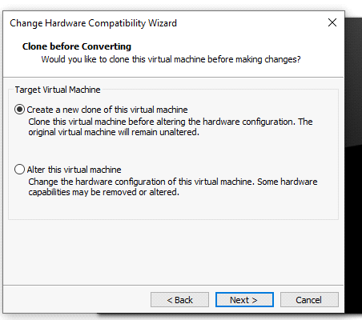

Step 5: Click On **Next and Give a Virtual Machine Name**

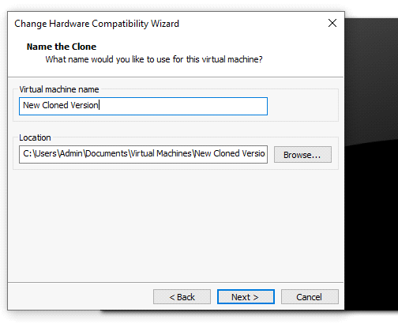

Step 6: Click on **Next**

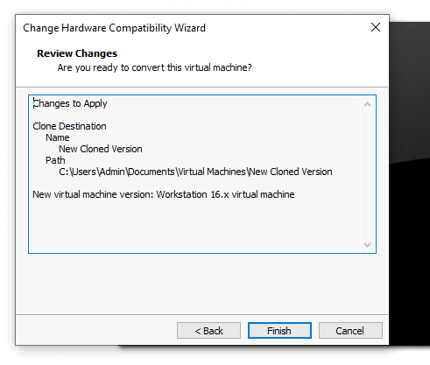

Step 7: Click on **Finish.** Wait for while till it complete setup

