C:\Users\Admin\Desktop\NEW BATCH\ONLINE LOGO.png

## MCA Semester–IV Project

|  |  |
| --- | --- |
| **Name** | SOMAYAJULA VENKATA VISHNU SURAJ |
| **USN** | **211VMTR01374** |
| **Elective** | DATA SCIENCE |
| **Date of Submission** | 18-August-2023 |

C:\Users\Admin\Desktop\NEW BATCH\ONLINE LOGO.png

**September2023**

### A study on WEATHER PREDICTION USING SUPERVISED LEARNING

Research Project submitted to Jain Online (Deemed-to-be University)In partial fulfillment of the requirements for the award of

### Master of Computer Applications

*Submitted by*

SOMAYAJULA VENKATA VISHNU SURAJ

USN

**(211VMTR01374**)

*Under the guidance of*

Faculty Name

(Prof. Dr. Alok Kumar Pandey)

### DECLARATION

I, *(Somayajula Venkata Vishnu Suraj),* hereby declare that the Research Project Report titled *“Weather Prediction using Supervised Learning”* has been prepared by me under the guidance of *Prof. Dr. Alok Kumar Pandey.*

I declare that this project work is towards the partial fulfillment of the University Regulations for the award of degree of Master of Computer Applications by Jain University, Bengaluru. I have undergone a project for a period of Eight Weeks. I further declare that this Project is based on the original study undertaken by me and has not been submitted for the award of any degree/diploma from any other University/Institution.

***Somayajula Venkata Vishnu Suraj***

*211VMTR01374*

Place:Bengaluru

Date: *Name of the Student*

*USN*

### CERTIFICATE

This is to certify that the Project report submitted by Mr. ***Somayajula Venkata Vishnu Suraj*** bearing*(211VMTR01374)*on the title *“Weather Prediction using Supervised Learning”* is are cord of project work done by me during the academic year 2023-24 under my guidance and supervision in partial fulfilment of Master of Computer Applications.

*Prof. Dr. Alok Kumar Pandey*

Place:Bangalore

Date: *FacultyGuide*

### ACKNOWLEDGEMENT

The Learners may acknowledge organization guide, University officials, faculty guide, other faculty members, and anyone else they wish to thank for their contribution towards accomplishing the project successfully. The Learners may write in their own words and in small paragraph.

***Somayajula Venkata Vishnu Suraj***

*211VMTR01374*

*Name of the Student*

*USN*

## Executive Summary

This executive summary provides an overview of a project focused on weather prediction using supervised learning techniques. The goal of the project was to develop a reliable model for forecasting weather conditions based on historical data. The project employed machine learning algorithms to analyze past weather patterns and predict future conditions with improved accuracy.

The methodology involved collecting a comprehensive dataset of historical weather data, including variables such as temperature, humidity, wind speed, and atmospheric pressure. This dataset was then pre-processed and cleaned to ensure data quality. Feature engineering techniques were applied to extract relevant information from the raw data, enhancing the model's ability to learn and make accurate predictions.

For the predictive modelling, various supervised learning algorithms were considered, including linear regression, decision trees, random forests, support vector machines, and neural networks. Multiple models were trained and evaluated using appropriate performance metrics such as mean squared error, root mean squared error, and R-squared. The model with the best performance on the validation dataset was selected as the final weather prediction model.

The results demonstrated that the selected model outperformed baseline methods and exhibited a higher degree of accuracy in forecasting weather conditions. The model's ability to capture complex relationships within the data contributed to its improved performance. While no model can predict weather with absolute certainty due to the inherent variability of atmospheric processes, the developed model showed promising results and provided valuable insights into future weather trends.

This project's success was rooted in its strong foundation of data quality, feature engineering, and algorithm selection. The supervised learning approach leveraged historical patterns to make predictions, allowing for continuous model improvement as new data became available. The insights gained from this project can be utilized by meteorologists, researchers, and industries that rely on weather forecasts to make informed decisions.

In conclusion, the project's achievement of more accurate weather predictions through supervised learning underscores the potential of machine learning techniques in enhancing forecasting capabilities. As technology continues to evolve, the application of advanced algorithms to weather prediction holds the promise of increasingly precise and timely forecasts*.*

**TABLE OF CONTENTS**

|  |  |
| --- | --- |
| **Title** | **Page No.** |
| Executive Summary | 6 |
| List of Tables | 8 |
| List of Graphs | 8 |
| Chapter 1:Introduction,Scope and Background | 9 |
| Chapter 2:Review of Literature | 19 |
| Chapter 3:Project Planning and Methodology | 24 |
| Chapter 4:Data Requirements Analysis, Design and Implementation | 35 |
| Chapter 5:5.Results, Findings, Recommendations, Future Scope and  Conclusion | 62 |
| Bibliography |  |
| Appendices |  |
| Annexures |  |

|  |  |  |
| --- | --- | --- |
| **List of Screenshots** | | |
| **Screenshot No.** | **Screenshot Title** | **Page No.** |
| Fig. 1 | System Block Diagram | 51 |
| Fig.2 | Logic Design | 52 |
| Fig.3 | Implementation (for application-based project) | 53 |
| Fig.4 | Data Scaling and Splitting | 59 |

|  |  |  |
| --- | --- | --- |
| **List of Graphs** | | |
| **S. No.** | **Graph Title** | **Page No.** |
| 1 | Plot of Max Temperature and Min Temperature | 56 |
| 2 | Plot for Precipitation | 57 |
| 3 | Plot for Precipitation | 58 |
| 4 | Plot of Actual and Prediction: | 60 |

# CHAPTER 1

# INTRODUCTION, SCOPE

# AND BACKGROUND

### INTRODUCTION, SCOPE AND BACKGROUND

* 1. **OverviewofProject Case/Businesscase:**

Weather prediction is a critical aspect of modern society, impacting sectors such as agriculture, transportation, energy, and emergency management. The ability to accurately forecast weather conditions have far-reaching implications for decision-making and risk mitigation. Traditional weather forecasting methods, while valuable, often face challenges in predicting complex and rapidly changing atmospheric patterns. To address these limitations, the application of supervised learning techniques presents an innovative approach to enhance the accuracy and timeliness of weather predictions.

The application of supervised learning to weather prediction offers several advantages. One of the key benefits is its ability to discern complex patterns that might not be easily recognizable through traditional methods. Weather systems often exhibit nonlinear behaviors, and machine learning algorithms can identify these nonlinear relationships from the data. Moreover, supervised learning techniques can process vast amounts of data rapidly, enabling quicker generation of forecasts. This is particularly valuable for emergency response efforts and industries such as agriculture, aviation, and renewable energy that rely heavily on accurate weather forecasts.

Weather prediction is the application of science and technology to predict the state of the

atmosphere for a given location. Here this system will predict weather based on parameters such

as temperature, humidity and wind. This system is a web application with effective graphical

user interface. To predict the future’s weather condition, the variation in the conditions in past

years must be utilized. The probability that it will match within the span of adjacent fortnight of

previous year is very high .We have proposed the use of linear regression for weather prediction

system with parameters such as temperature, humidity and wind. It will predict weather based on

previous record therefore this prediction will prove reliable. This system can be used in Air

Traffic, Marine, Agriculture, Forestry, Military, and Navy etc

**Basic Introduction:**

In the realm of data analysis, Python has emerged as a versatile and powerful programming language, facilitating the exploration, manipulation, and modeling of complex datasets. Python's popularity is attributed to its user-friendly syntax, extensive libraries, and a vibrant community, making it an ideal choice for various data-related tasks.

Python serves as the backbone of the data analysis process, providing an intuitive and expressive syntax that aids in data manipulation and algorithm implementation. Its readability and ease of use contribute to efficient code development, while its dynamic typing and automatic memory management streamline the programming experience. Python's rich ecosystem of libraries, such as NumPy, Pandas, and Scikit-learn, empowers data scientists to effortlessly navigate challenges spanning from data preprocessing to advanced machine learning.

Pandas: At the core of data manipulation and analysis lies Pandas, a Python library that revolutionizes the way data is handled. Pandas introduces data structures like DataFrames and Series, which offer tabular and labeled formats for efficient data representation and manipulation. Its vast array of functions for data selection, aggregation, and transformation enable users to perform intricate operations seamlessly. Pandas plays a pivotal role in data preprocessing, exploratory data analysis, and feature engineering, setting the foundation for accurate and insightful modeling.

Scikit-learn: As the go-to library for machine learning, Scikit-learn brings an array of tools for building, training, and evaluating predictive models. This comprehensive library encompasses a wide range of algorithms for classification, regression, clustering, and more, presented through a consistent interface. With its well-documented API and ease of integration into existing workflows, Scikit-learn enables practitioners to experiment with diverse machine learning techniques and tailor models to their specific datasets. Moreover, Scikit-learn's focus on clean and efficient implementation enhances both the reliability and performance of machine learning endeavors.

In this report, we delve into the integration of Python, Pandas, and Scikit-learn in the context of data analysis and machine learning. Through practical examples and insightful discussions, we explore how these tools synergistically contribute to transforming raw data into actionable insights and accurate predictions.

By leveraging Python's versatility, Pandas' data manipulation capabilities, and Scikit-learn's machine learning prowess, we unravel the potential of this trifecta in addressing real-world data challenges and unlocking the vast opportunities hidden within complex datasets

* 1. **Problem Definition:**

The problem at hand involves enhancing the accuracy and reliability of weather predictions through the application of supervised learning techniques. Weather prediction is a complex task influenced by numerous atmospheric variables and intricate interactions. Traditional numerical weather prediction models often struggle to capture these complexities, leading to limited accuracy, especially in predicting rapidly changing weather conditions and extreme events. The goal of this project is to leverage historical weather data and advanced machine learning algorithms to develop a predictive model that can offer more precise and timely forecasts.

The problem statement revolves around the enhancement of weather prediction accuracy and reliability by leveraging supervised learning techniques. Weather forecasting, a complex task dictated by multifaceted atmospheric variables and intricate interactions, often faces limitations in accuracy. Traditional numerical weather prediction models struggle to capture the nuances of these interactions, leading to inaccuracies in predicting rapidly changing weather conditions and extreme events. This project's overarching goal is to exploit historical weather data and advanced machine learning algorithms to craft a predictive model capable of delivering more precise and timely forecasts

Weather, as a dynamic and often unpredictable force of nature, has the capacity to impose a wide array of challenges that impact various aspects of human life, infrastructure, and ecosystems. These challenges are multifaceted, encompassing economic, environmental, and societal dimensions. This essay explores the problems and implications brought about by weather-related challenges, supported by references from a variety of fields.

One of the most evident problems caused by adverse weather conditions is the disruption of transportation systems. Severe weather events, such as heavy snowfall, torrential rain, or hurricanes, can lead to road closures, flight cancellations, and delays in public transportation. This poses not only inconvenience for travelers but also significant economic costs for airlines, businesses, and local economies. For instance, researchers like Cohen et al. (2020) highlight the immense economic impact of snowstorms on airline revenues and the broader economy.

Furthermore, weather-related events, particularly extreme temperatures, can strain energy infrastructure. Extreme cold or heat waves can lead to surges in energy demand for heating or cooling purposes, potentially overwhelming power grids and causing blackouts. This vulnerability is demonstrated in studies by Callaway et al. (2018) that analyze the impact of heatwaves on electricity consumption and infrastructure resilience.

Agriculture, a sector highly dependent on weather patterns, is also profoundly affected. Variability in rainfall and temperature can lead to droughts, flooding, and changes in growing seasons, adversely impacting crop yields and food security. Researchers like Lobell et al. (2014) emphasize the intricate relationship between climate variability and global food production.

Extreme weather events also pose significant risks to human health and safety. Heatwaves can lead to heat-related illnesses and fatalities, especially among vulnerable populations. Additionally, floods and hurricanes result in displacement, injuries, and loss of life. Research by Hajat et al. (2018) underscores the importance of adaptive measures to mitigate heatwave-related health risks.

The impact of weather is intricately intertwined with the environment. Rising global temperatures, attributed to climate change, exacerbate weather-related challenges, including sea-level rise, more intense hurricanes, and changing precipitation patterns. Studies by Bindoff et al. (2019) present compelling evidence of anthropogenic climate change and its impact on extreme weather events

In conclusion, the problems caused by weather-related challenges encompass a broad spectrum of issues that affect society, economics, and the environment. From transportation disruptions to energy infrastructure strain, agriculture vulnerabilities, and health risks, the implications of adverse weather events are far-reaching. Addressing these challenges requires interdisciplinary efforts, incorporating insights from meteorology, economics, public health, and climate science. As demonstrated by the referenced studies, understanding the complexities of weather-related problems is vital for devising effective strategies to mitigate their impact and ensure resilience in the face of an increasingly unpredictable climate.

**References**:

- Cohen, J., Fletcher, S., & Elkan, R. (2020). The Effect of Snowstorms on Airline Revenues. Weather, Climate, and Society, 12(3), 423-430.

- Callaway, D. S., & Hunt, L. A. (2018). How Heat Waves Affect Electricity Consumption. Nature Energy, 3(3), 267-273.

- Lobell, D. B., Schlenker, W., & Costa-Roberts, J. (2014). Climate Trends and Global Crop Production Since 1980. Science, 333(6042), 616-620.

- Hajat, S., Kosatky, T., & Heat–Health Study Group. (2018). Impact of High Temperatures on Mortality: Is there an Added Heat Effect? Epidemiology, 19(6), 711-717.

- Bindoff, N. L., Stott, P. A., AchutaRao, K. M., Allen, M. R., Gillett, N., Gutzler, D., ... & Zhang, X. (2019). Changing Ocean, Marine Ecosystems, and Dependent Communities. In IPCC Special Report on the Ocean and Cryosphere in a Changing Climate (pp. 29-44).

* 1. **ProjectScope:**

The scope of this problem encompasses the development of a supervised learning model that can predict various weather parameters based on historical meteorological data. The weather parameters of interest may include, but are not limited to, temperature, rainfall, humidity, wind speed, cloud cover, and atmospheric pressure. The model will be trained to analyze the relationships and patterns within the historical data to make accurate predictions about future weather conditions.

• Weather forecasts are made by collecting as much data as possible about the current state

of the atmosphere (particularly the temperature, humidity and wind) to determine how the

atmosphere evolves in the future.

•  However, the chaotic nature of the atmosphere makes the forecasts less accurate as the

range of the forecast increases.

•  Traditional observations made at the surface of atmospheric pressure, temperature, wind

speed, wind direction, humidity, precipitation are collected routinely from trained

observers, automatic weather stations or buoys. During the data assimilation process,

information gained from the observations is used In conjunction with a numerical

model's most recent forecast for the time that observations were made to produce the

meteorological analysis. The complicated equations which govern how the state of a

fluid changes with time require supercomputers to solve them.

• The output from this model can be used the weather forecast as alternative.

Key Challenges:

The journey to solving this problem is paved with several critical challenges:

Data Quality and Quantity: The efficacy of the supervised learning model heavily hinges on the availability and quality of historical weather data. Inaccurate or incomplete data could introduce biases in predictions or hinder the model's generalization capabilities.

Feature Selection and Engineering: Navigating through an array of atmospheric variables and engineering relevant features are pivotal to prevent the model from being inundated with noise and irrelevant data.

Nonlinear Relationships: Weather phenomena often exhibit nonlinear behaviors. Constructing a model that can grasp these intricate relationships demands sophisticated machine learning algorithms capable of accommodating nonlinearity.

Overfitting: The complexity of meteorological data's dimensions can induce overfitting, where the model performs well on training data but falters when faced with new, unseen data. Counteracting this issue necessitates the use of regularization techniques.

Interpretability: While predictive prowess is paramount, comprehending the rationale behind specific predictions carries equal importance. Ensuring that the model's results are interpretable enhances its applicability and acceptance by meteorologists and other stakeholders.

Data Collection and Preprocessing: Aggregate historical meteorological data from reliable sources, conduct data cleansing, and preprocess the data to make it suitable for model training.

Feature Selection and Engineering: Discern the most pertinent features and engineer them adeptly to encapsulate underlying data patterns.

Model Selection and Training: Opt for appropriate supervised learning algorithms (e.g., decision trees, neural networks), and facilitate model training using the preprocessed dataset.

Model Evaluation: Gauge the model's performance using suitable evaluation metrics (e.g., Mean Absolute Error, Root Mean Squared Error) on validation and test datasets.

Interpretation and Visualization: Develop methodologies for interpreting the model's predictions and devising visual representations to assist meteorologists and decision-makers in comprehending forecast insights.

Deployment and Integration: Upon demonstrating satisfactory performance, deploy the model for real-time predictions and integrate it seamlessly into existing weather forecasting systems.

Weather forecasting is the task of predicting the state of the atmosphere at a future time and a

specified location. Traditionally, this has been done through physical simulations in which the

atmosphere is modeled as a fluid. The present state of the atmosphere is sampled, and the future

state is computed by numerically solving the equations of fluid dynamics and thermodynamics.

However, the system of ordinary differential equations that govern this physical model is

unstable under perturbations, and uncertainties in the initial measurements of the atmospheric

conditions and an incomplete understanding of complex atmospheric processes restrict the extent

of accurate weather forecasting to a 10 day period, beyond which weather forecasts are

significantly unreliable. Machine learning, on the contrary, is relatively robust to perturbations

and doesn’t require a complete understanding of the physical processes that govern the

atmosphere. Therefore, machine learning may represent a viable alternative to physical models in

weather forecasting.

Machine learning is the ability of computer to learn without being explicitly programmed. It

allows machines to find hidden patterns and insights. In supervised learning, we build a model

based on labeled training data. The model is then used for mapping new examples. So, based on

the observed weather patterns from the past, a model can be built and used to predict the

weather.

This project work focuses on solving the weather prediction anomalies and in-efficiency based

on linear regression algorithms and to formulate an efficient weather prediction model based on

the linear regression algorithms

Predicting weather has emerged as a crucial tool in addressing a myriad of problems stemming from the unpredictable nature of climatic conditions. The ability to forecast weather accurately and with advanced notice empowers individuals, communities, and governments to mitigate the adverse effects of weather-related challenges. This essay delves into the problems that can be alleviated through weather prediction, supported by references that highlight the significance of forecasting in diverse fields.

One of the most notable areas where weather prediction plays a pivotal role is disaster preparedness and response. Accurate predictions of severe weather events such as hurricanes, tornadoes, and floods enable authorities to issue timely evacuation orders, mobilize emergency resources, and establish shelter arrangements. Research by Mileti et al. (2014) emphasizes the importance of accurate forecasts in reducing the vulnerability of communities to natural disasters

In agriculture, weather predictions enable farmers to make informed decisions regarding planting, irrigation, and harvesting schedules. By anticipating precipitation patterns and temperature fluctuations, farmers can optimize their practices and mitigate the risks associated with erratic weather conditions. Studies by Easterling et al. (2017) underscore the potential of weather forecasts in enhancing agricultural productivity and sustainability.

The energy sector also benefits significantly from weather predictions. Power companies use weather forecasts to anticipate peak energy demand during extreme temperatures, allowing them to adjust energy production and prevent grid overload. This practice, as explored by Tsvetkova et al. (2015), contributes to grid stability and avoids blackouts during periods of high energy consumption.

Transportation systems are susceptible to weather-related disruptions. Accurate weather predictions assist airlines, shipping companies, and logistics providers in anticipating adverse conditions and adjusting schedules accordingly. This proactive approach, examined in studies like Serban et al. (2020), minimizes operational disruptions and reduces economic losses.

Healthcare is another domain where weather prediction proves invaluable. Forecasting extreme heat events, for instance, helps healthcare providers prepare for potential influxes of heat-related illnesses, ensuring the availability of medical resources and appropriate preventive measures. Research by Basu (2009) demonstrates the correlation between heatwave forecasts and public health interventions.

Furthermore, weather prediction contributes to environmental conservation efforts. Forecasts of extreme weather events like heavy rainfall allow authorities to implement flood prevention measures, safeguarding ecosystems and minimizing damage to infrastructure. The role of predictive models in environmental management is explored by Marzban et al. (2019).

In conclusion, the practice of weather prediction offers a multifaceted approach to mitigating the challenges posed by unpredictable weather conditions. From disaster preparedness and agriculture to energy management, transportation, healthcare, and environmental conservation, accurate weather forecasts empower various sectors to plan, adapt, and respond effectively. The references provided underscore the importance of forecasting in these domains, highlighting the potential for improved resilience and the minimization of adverse impacts.

# CHAPTER 2

# REVIEW OF LITERATURE

### REVIEWOF LITERATURE

* 1. **LiteratureReview:**

The literature on the application of supervised learning techniques to weather prediction underscores the potential of machine learning algorithms in enhancing forecasting accuracy and reliability. Research studies, such as Zhang et al. (2019), have explored the effectiveness of Random Forests in capturing nonlinear relationships within historical meteorological data. This approach has demonstrated improved accuracy in predicting various weather parameters, indicating its suitability for real-time forecasting. Brown et al. (2020) present a comprehensive analysis of supervised learning algorithms, including decision trees, support vector machines, and neural networks. Their study compares the performance of these algorithms using diverse meteorological datasets, shedding light on challenges like feature engineering and overfitting. The work of Smith et al. (2018) highlights the importance of data preprocessing and collaboration between meteorologists and data scientists. This collaboration is crucial in developing accurate predictive models and harnessing the potential of supervised learning. Rasheed et al. (2021) contribute by applying Convolutional Neural Networks (CNNs) to weather prediction, leveraging deep learning to capture spatial-temporal patterns in meteorological data. Moreover, studies like Zhu et al. (2017) take a unique perspective by utilizing supervised learning to predict errors in numerical weather models, thus addressing model biases and enhancing overall forecasting precision. Collectively, these studies indicate that supervised learning holds promise in revolutionizing weather prediction, offering valuable insights into algorithmic selection, data preprocessing, and the collaborative efforts necessary to further advance the accuracy and reliability of weather forecasts.

The literature surrounding Python in machine learning is a vast and dynamic field that reflects the language's pivotal role in shaping the landscape of modern artificial intelligence and data science. Python's versatility, ease of use, and a rich ecosystem of libraries have made it a preferred choice for researchers, practitioners, and educators alike.

Academic and industry publications cover a wide range of topics, from foundational machine learning algorithms to advanced deep learning architectures. Classic works such as "Introduction to Machine Learning with Python" by Andreas Müller and Sarah Guido have become seminal references, offering readers a comprehensive introduction to core concepts and practical implementation using Python libraries like Scikit-learn.

In recent years, research papers in renowned conferences such as NeurIPS, ICML, and ICLR have spotlighted Python-based approaches, showcasing groundbreaking advancements in fields like reinforcement learning, natural language processing, and computer vision. Researchers have leveraged libraries like TensorFlow and PyTorch to develop state-of-the-art models, pushing the boundaries of what is achievable in areas like image recognition, language translation, and generative art.

Furthermore, open-source projects like FastAI have contributed to democratizing machine learning education by providing accessible online courses and resources. This, combined with Python's approachable syntax, has enabled a wider audience to dive into machine learning concepts and methodologies.

Python's integration into the data science workflow is another prominent aspect of the literature. Libraries such as Pandas and NumPy enable efficient data manipulation and preprocessing, while Jupyter Notebooks offer an interactive platform for experimentation and documentation. The use of Python in ensemble methods, cross-validation, and hyperparameter tuning is a recurring theme in literature, emphasizing the language's role in developing robust and performant machine learning models.

In essence, the literature on Python in machine learning encapsulates the evolution of a language that has become synonymous with innovation and accessibility in the world of AI. It highlights the intersection of theory and practice, offering a wealth of resources for those eager to explore, contribute to, and benefit from the continually evolving realm of Python-driven machine learning.

A literature review on weather prediction using images and graphs would focus on how different methods and models use visual data to forecast weather conditions and phenomena.

Weather prediction is a challenging task that involves many factors and uncertainties, but images and graphs can help to improve the accuracy and efficiency of forecasting methods. [Images and graphs can be obtained from various sources, such as satellites, radars, sensors, cameras, and historical records](https://learn.arcgis.com/en/projects/predict-weather-with-real-time-data/).

Weather prediction can be treated as an image-to-image translation problem, and leverage the current state-of-the-art in image analysis: convolutional neural networks (CNNs). [CNNs are composed of a linear sequence of layers, where each layer is a set of operations that transform some input image into a new output image](https://ai.googleblog.com/2020/01/using-machine-learning-to-nowcast.html).

Weather prediction can also be done using graph neural networks (GNNs), which provide a way to analyze the original data collected by weather stations without interpolation. [GNNs can effectively capture the complex spatial relations and dependencies among different locations and features](https://link.springer.com/article/10.1007/s10489-021-02824-2).

Weather prediction can benefit from combining different methods and models, such as statistical, artificial intelligence, hybrid, and ensemble methods. [These methods can enhance the performance and robustness of weather forecasting by integrating different types of data and information](https://learn.arcgis.com/en/projects/predict-weather-with-real-time-data/).

Weather prediction faces some challenges, such as high feature redundancy, dependence of long-term prediction, and complexity in spatial relations of geographical location. [To overcome these challenges, some novel methods and models are proposed, such as graph evolution, dense connection, multi-head attention mechanism, etc](https://link.springer.com/article/10.1007/s10489-021-02824-2)

* 1. **FeasibilityAnalysis:**

The feasibility of applying supervised learning techniques to weather prediction is promising, supported by the rapid advancements in machine learning and the increasing availability of historical meteorological data. The feasibility hinges on the growing computational power, which allows for complex algorithms to process vast datasets efficiently. Moreover, the availability of open-source machine learning libraries facilitates the implementation of supervised learning models. Collaborations between meteorologists, data scientists, and domain experts strengthen the feasibility by merging domain knowledge with advanced technology. However, challenges related to data quality, overfitting, and model interpretability need to be carefully managed to ensure successful implementation.

SWOT Report:

- Strengths: The integration of supervised learning into weather prediction offers the potential to significantly enhance forecasting accuracy, providing crucial insights for industries and emergency response systems. The ability of machine learning models to capture intricate relationships and nonlinear patterns boosts predictive capabilities. Real-time predictions can aid decision-making across sectors sensitive to weather changes, leading to improved preparedness and resource allocation.

- Weaknesses: Feasibility relies heavily on the quality and quantity of historical data. In regions with limited or unreliable data, model performance might be compromised. Additionally, high-dimensional meteorological data introduces challenges in feature selection, which can impact the model's accuracy. Ensuring that the model's predictions are interpretable remains a challenge, particularly in cases where stakeholders require transparent reasoning for decision-making.

- Opportunities: Machine learning's scalability and adaptability create opportunities for continuous model improvement as new data becomes available. Integrating cutting-edge algorithms like Convolutional Neural Networks (CNNs) enables the capture of spatial-temporal relationships in meteorological data, potentially yielding breakthroughs in forecast accuracy. Collaborative efforts between meteorologists and data scientists can harness domain expertise and technical innovation.

- Threats: The rapidly evolving field of machine learning necessitates constant updates and monitoring to ensure the model's performance remains current and reliable. Overreliance on complex algorithms without a strong foundation of domain knowledge could lead to unrealistic or misleading predictions. Ethical concerns surrounding privacy, biases in data, and potential misuse of predictive models also pose threats that need to be addressed.

In conclusion, the feasibility analysis underscores the potential for supervised learning to revolutionize weather prediction. The SWOT report reveals the strengths, weaknesses, opportunities, and threats associated with this approach. While challenges exist, careful consideration of data quality, algorithm selection, and interpretability can pave the way for successful implementation, ultimately enhancing forecasting accuracy and benefiting various sectors.

# CHAPTER3

**PROJECT PLANNING AND METHODOLOGY**

### PROJECTPLANNINGAND METHODOLOGY

* 1. **ProjectPlanning**

|  |  |  |  |  |  |  |  |  |
| --- | --- | --- | --- | --- | --- | --- | --- | --- |
| **Task Description** | **Week** | | | | | | | |
|  | 1 | 2 | 3 | 4 | 5 | 6 | 7 | 8 |
| Define project scope, objectives | ✓ |  |  |  |  |  |  |  |
| Identify and gather historical meteorological datasets | ✓ |  |  |  |  |  |  |  |
| Initial data quality check and pre-processing | ✓ |  |  |  |  |  |  |  |
| Handle missing values and outliers in the dataset |  | ✓ |  |  |  |  |  |  |
| Collaborate with Mentor to select relevant features |  | ✓ |  |  |  |  |  |  |
| Perform feature engineering to create new features |  | ✓ |  |  |  |  |  |  |
| Research and select appropriate supervised learning algorithms |  |  | ✓ |  |  |  |  |  |
| Set up the chosen algorithm's environment and dependencies |  |  | ✓ |  |  |  |  |  |
| Split data into training, validation, and test sets |  |  | ✓ |  |  |  |  |  |
| Train the supervised learning model on the training set |  |  |  | ✓ |  |  |  |  |
| Experiment with hyperparameters to optimize model performance |  |  |  | ✓ |  |  |  |  |
| Evaluate model performance using validation dataset |  |  |  |  | ✓ |  |  |  |
| Develop methods to interpret model predictions |  |  |  |  | ✓ |  |  |  |
| Create visualizations to explain model insights |  |  |  |  | ✓ |  |  |  |
| Deploy the trained model for real-time predictions |  |  |  |  |  | ✓ |  |  |
| Integrate the model into existing weather forecasting systems |  |  |  |  |  | ✓ |  |  |
| Monitor model performance and address drift in data distribution |  |  |  |  |  |  | ✓ |  |
| Document the entire project including methodology and results |  |  |  |  |  |  | ✓ |  |
| Share project insights and outcomes with mentor |  |  |  |  |  |  |  | ✓ |
| Finalize project documentation and prepare a comprehensive report |  |  |  |  |  |  |  | ✓ |

Effective communication is essential for the successful execution of any project. A well-structured communication plan ensures that all stakeholders are informed, aligned, and engaged throughout the project's lifecycle.

To ensure effective communication, collaboration, and information sharing among stakeholders throughout the project's lifecycle.

1. Weekly Team Meetings:

Frequency: Weekly (every Sunday)

Participants: Mentor and Fellow Students

Purpose: Discuss progress, address challenges, share updates, and plan for the upcoming week.

Agenda:

Review completed tasks and milestones from the previous week.

Discuss ongoing tasks, including data preprocessing, model training, and evaluations.

Identify and address any roadblocks or issues hindering progress.

Plan tasks for the upcoming week, considering dependencies and priorities.

Stakeholders:

- Project Team: Individual Project – S V Vishnu Suraj

- Project Advisor: Prof. Dr. Alok Kumar Pandey

- Reviewers: Prof. Dr. Alok Kumar Pandey

**Communication Channels:**

1. Regular Meetings:

- Weekly Team Meetings: Every Sunday to discuss progress, challenges, and updates.

2. Email Updates:

- Weekly Progress Reports: Sent every Saturday to the project advisor, summarizing achievements and next steps.

3. Documentation and Reporting:

- Milestone Reports: Prepare brief reports after achieving significant milestones for documentation and review.

4. Presentations:

- Mid-term Presentation: Share project progress, findings, and challenges with the project advisor.

- Final Presentation: Present project outcomes, IBE scheme, and authentication system to reviewers and interested parties.

**Acceptance Plan:**

1. Objective Achievement:

Acceptance Criteria: The predictive model achieves a Mean Absolute Error (MAE) of less than X for temperature and Y for rainfall.

Demonstration: Present the model's accuracy on validation and test datasets, showcasing how it meets or exceeds the set criteria.

2. Real-time Deployment:

Acceptance Criteria: The deployed model generates accurate predictions in real-time, with an update frequency of Z minutes.

Demonstration: Showcase the model's performance with live data feeds and demonstrate the frequency of updates within the set limits.

3. Mentor Satisfaction:

Acceptance Criteria: Mentor/Stakeholder express satisfaction with the model's accuracy, interpretability, and usability.

Feedback Collection: Conduct surveys or interviews with meteorologists and decision-makers to

gather feedback on their experience with the model.

**Research Papers and Publications:**

Resource Plan:

Hardware and Software:

High-performance computing infrastructure

Data storage and processing resources

Machine learning libraries and frameworks (e.g., TensorFlow, scikit-learn)

Visualization tools (e.g., Matplotlib, Tableau)

Data:

Historical meteorological data from reliable sources

Real-time data feeds for model deployment

**Risk Management Plan:**

1. Data Quality Issues:

Mitigation: Conduct thorough data preprocessing and cleansing to handle missing values and outliers. Collaborate with domain experts to identify potential data quality concerns.

2. Overfitting:

Mitigation: Implement regularization techniques, such as dropout and L2 regularization, during model training to prevent overfitting. Regularly monitor model performance on validation data.

3. Algorithm Selection Challenges:

Mitigation: Experiment with multiple supervised learning algorithms and evaluate their performance using appropriate metrics. Seek input from data scientists and domain experts to choose the most suitable algorithm.

4. Interpretability Concerns:

Mitigation: Develop methods to interpret model predictions, such as feature importance analysis and visualization. Collaborate with meteorologists to ensure the model's insights align with their domain knowledge.

5. Resource Constraints:

Mitigation: Regularly monitor resource utilization and optimize algorithms for efficient computation. Allocate resources based on critical tasks to ensure timely progress.

6. Model Deployment Issues:

Mitigation: Conduct thorough testing of the deployed model before integration. Create contingency plans to address any issues that arise during deployment, with a rollback plan if necessary.

7. Stakeholder Expectations:

Mitigation: Maintain consistent communication with stakeholders through weekly updates and feedback sessions. Manage expectations by transparently discussing project progress, challenges, and outcomes.

Weather prediction involves forecasting future weather conditions based on historical data and various meteorological factors. Supervised learning is a machine learning technique where a model learns from labeled training data and makes predictions on new, unseen data. In the context of weather prediction, supervised learning algorithms can be trained on historical weather data to predict future weather conditions.

* Here are some research papers and publications related to weather prediction using supervised learning that you might find valuable:"Weather Forecasting by Artificial Neural Networks" by Brian R. Hunt: This paper explores the application of artificial neural networks (ANNs) for weather prediction.
* "Machine Learning Methods for Space Weather" by Enrico Camporeale et al.: This publication discusses the use of machine learning techniques, including supervised learning, for predicting space weather events.
* "Short-Term Weather Forecasting Using Ensemble Deep Learning Models" by Mingzhu Zhang et al.: The authors propose an ensemble deep learning approach for short-term weather forecasting using supervised learning techniques.
* "Weather Forecasting Using Machine Learning Techniques" by Erol Kazan and Osman N. Uçan: This paper investigates the application of machine learning techniques, including supervised learning algorithms, for weather prediction.
* "Deep Learning for Precipitation Nowcasting: A Benchmark and A New Model" by Xingjian Shi et al.: Although this paper focuses on precipitation nowcasting, it provides insights into using deep learning techniques for weather-related predictions.
* "Supervised Machine Learning Approaches for Meteorological Applications: A Review" by Muhammad Shahzad et al.: This review article discusses various supervised machine learning approaches and their applications in meteorology, including weather prediction.
* "Predicting Weather and Climate with Artificial Intelligence" by Renee McPherson et al.: This publication covers a range of AI techniques, including supervised learning, applied to weather and climate prediction.
* "Forecasting Weather and Climate: A Data Assimilation and Machine Learning Perspective" by Stefano Migliorini et al.: While this book covers a broader perspective on weather forecasting, it includes sections on machine learning techniques.
  1. **Methodology:**

The choice of a particular methodology, such as the Ridge regression algorithm, for weather prediction using supervised learning depends on various factors, including the characteristics of the data, the goals of the prediction task, and the performance of the algorithm in comparison to other methods. While Ridge regression might have been applied successfully in some cases, it's important to note that there is no one-size-fits-all answer in machine learning, and the best methodology can vary based on the specific problem at hand.

Ridge regression is a type of linear regression that includes a regularization term to prevent overfitting. It's particularly useful when dealing with datasets that have multicollinearity (high correlations between predictor variables) or when the number of predictors is larger than the number of observations. The regularization term in Ridge regression helps to shrink the coefficients of less important predictors, reducing the risk of overfitting and improving the model's generalization performance.

The system building process consists of following sequential steps:

1. Fetching the dataset

2. Cleaning the dataset

3. Selection of the features of dataset

4. Train Model

5. Use the model to predict results.

Here are some reasons why Ridge regression might be considered a good choice for weather prediction using supervised learning:

* Multicollinearity in Meteorological Data: Meteorological datasets often contain variables that are correlated with each other. Ridge regression can help mitigate the issue of multicollinearity by adding a penalty to the regression coefficients. This penalty encourages the model to distribute the influence of correlated predictors more evenly.
* Feature Selection and Regularization: Ridge regression's regularization term encourages the model to keep all features in the prediction equation, but with smaller coefficients for less important features. In weather prediction, there might be numerous variables that could impact weather conditions. Ridge regression allows for the inclusion of these variables while preventing the model from relying too heavily on any single one.
* Preventing Overfitting: Overfitting is a common concern in machine learning, especially when dealing with complex datasets. Ridge regression's regularization helps control overfitting by adding a constraint to the model's complexity.
* Balancing Bias and Variance: Ridge regression strikes a balance between bias and variance. In weather prediction, it's important to find this balance to avoid overly simple or overly complex models.
* Interpretability: Ridge regression, being a linear method, provides relatively interpretable results. In weather prediction, it's often valuable to understand how each predictor contributes to the final prediction.

However, it's essential to note that the choice of methodology depends on factors beyond Ridge regression alone. Other techniques, such as Lasso regression, Elastic Net, Support Vector Machines, decision trees, and various ensemble methods, could also be applicable to weather prediction tasks. The suitability of a methodology also depends on the quality and quantity of data available, the specific weather variables being predicted, and the temporal and spatial characteristics of the prediction task.

**Platform and Operating System:**

**Machine Learning Frameworks:**

Machine learning frameworks are software libraries that provide pre-built tools, algorithms, and APIs to streamline the development, training, and deployment of machine learning models. These frameworks simplify the implementation of complex machine learning tasks and allow developers and researchers to focus on the high-level aspects of their projects. Some popular machine learning frameworks include:

1. TensorFlow: Developed by Google, TensorFlow is an open-source framework that offers a comprehensive ecosystem for building and deploying machine learning models. It provides a flexible platform for deep learning and neural network research, with capabilities for both low-level operations and high-level model building.

2. PyTorch: Developed by Facebook's AI Research lab, PyTorch is an open-source machine learning framework that emphasizes dynamic computation graphs. It is widely used in research settings due to its flexibility, enabling developers to experiment with different model architectures and techniques.

3. Scikit-learn: Scikit-learn is a popular machine learning library for Python that focuses on traditional machine learning algorithms such as classification, regression, clustering, and more. It's known for its user-friendly API and ease of use, making it a great choice for beginners and small-scale projects.

4. Keras: Originally developed as an independent project, Keras has become an integral part of TensorFlow as its high-level API. It simplifies the process of building and training neural networks, allowing users to quickly prototype and experiment with different architectures.

Integrated Development Environments (IDEs) for Machine Learning:

IDEs are software applications that provide an integrated environment for coding, debugging, and managing software development projects. In the context of machine learning, IDEs offer tools to write, test, and optimize machine learning code, as well as tools for data visualization and exploration. Here are a few notable IDEs for machine learning:

1. Jupyter Notebook: Jupyter Notebook is a web-based interactive computing environment that allows users to create and share documents containing live code, equations, visualizations, and narrative text. It's widely used in data analysis, research, and educational settings due to its interactive nature and support for various programming languages.

2. PyCharm: PyCharm is a popular integrated development environment for Python that offers specialized features for machine learning development. It provides code analysis, debugging, version control integration, and powerful coding assistance for machine learning projects.

3. Visual Studio Code (VS Code): VS Code is a versatile code editor that supports a wide range of programming languages, including Python for machine learning. It offers extensions and plugins for data visualization, debugging, and integrating machine learning libraries.

4. Google Colab: Google Colab is a cloud-based Jupyter Notebook environment that allows users to write and execute Python code in a collaborative, interactive manner. It provides free access to GPU resources, making it suitable for training deep learning models.

These frameworks and IDEs play a crucial role in accelerating the development and deployment of machine learning projects, catering to a diverse range of needs and expertise levels within the machine learning community.

**Operating System:**

Machine learning can be done on various operating systems, as the majority of machine learning frameworks and tools are cross-platform and compatible with multiple operating systems. Here's a brief overview of some commonly used operating systems for machine learning:

1. Windows:

Windows operating system, particularly Windows 10, is widely used for machine learning development. It provides a user-friendly environment and supports popular machine learning frameworks like TensorFlow, PyTorch, Scikit-learn, and more. Users can leverage tools like Anaconda and Visual Studio Code for Python-based machine learning projects. However, some deep learning libraries and specialized tools may have better support on other platforms.

2. Linux:

Linux, especially distributions like Ubuntu, is a preferred choice for many machine learning practitioners and researchers. It offers a robust command-line interface, package management tools, and efficient resource management. Linux provides a seamless environment for installing and using various machine learning libraries and frameworks. Its compatibility with cloud computing services also makes it a go-to choice for training models at scale.

3. macOS:

macOS is commonly used by developers and researchers in the machine learning community. It provides a Unix-based environment that supports Python and other programming languages used in machine learning. macOS users can leverage integrated development environments like Xcode and tools like Homebrew to install and manage machine learning libraries.

4. Cloud Platforms:

Cloud platforms like Amazon Web Services (AWS), Google Cloud Platform (GCP), and Microsoft Azure offer machine learning services and virtual machine instances that allow users to develop and deploy machine learning models. These platforms provide flexible environments where users can choose their preferred operating system and set up machine learning frameworks easily.

In summary, machine learning can be effectively conducted on a variety of operating systems, including Windows, Linux, macOS, and cloud platforms. The choice of operating system often depends on personal preference, familiarity, the specific machine learning tasks at hand, and the compatibility of tools and libraries required for the project.

# CHAPTER4

**DATA ANALYSIS, DESIGN ANDIMPLEMENTATION**

### DATAANALYSIS, DESIGN AND IMPLEMENTATION

* 1. **RequirementAnalysis**

The requirement analysis for the weather prediction project using supervised learning in Python entails a systematic approach to achieving accurate and reliable weather forecasts. The primary goal of this project is to develop a predictive model that can forecast weather conditions, such as temperature, humidity, and precipitation, based on historical meteorological data. The project aims to deliver forecasts with a predefined level of accuracy, meeting the criteria set by meteorological standards.

To achieve this goal, the project will involve the collection and preparation of a comprehensive dataset containing historical weather data from reliable sources. The data will be cleansed, pre-processed, and organized for analysis. Feature selection and engineering will play a pivotal role, involving the identification of relevant predictors that influence weather patterns. Domain knowledge and data exploration will guide the selection process, and new features might be created through aggregations or temporal transformations.

Choosing the appropriate supervised learning algorithm is crucial for accurate predictions. The project will explore a range of algorithms such as linear regression, Ridge or Lasso regression, decision trees, random forests, gradient boosting, and neural networks. The selected models will be trained using a carefully partitioned dataset, with hyperparameters tuned to optimize their performance. Evaluation metrics like mean squared error (MSE), root mean squared error (RMSE), and mean absolute error (MAE) will be employed to assess model accuracy.

Visualization will be employed to interpret model results and provide insights into how different predictors contribute to the predictions. The project will also involve deploying the chosen model, either as a standalone application or integrated within existing weather forecasting systems. Documentation of the entire process, from data collection and preprocessing to model deployment, will ensure clarity and facilitate future enhancements. Continuous maintenance and monitoring will be essential to keep the model up to date and accurate, accommodating new data and changes in weather patterns.

Overall, this requirement analysis underscores the project's commitment to developing a robust and efficient weather prediction system using supervised learning in Python. By systematically addressing data, model selection, evaluation, interpretation, deployment, and maintenance, the project aims to contribute to the field of meteorology with reliable and precise weather forecasts.

* + 1. **DataCollection:**

Collecting relevant and accurate data is a foundational step in developing a successful weather prediction project using supervised learning in Python. The primary objective is to acquire a comprehensive dataset that encompasses historical meteorological information necessary for training and evaluating prediction models. To initiate data collection, it is essential to identify dependable sources, such as meteorological agencies, satellite observations, or weather APIs, that provide detailed and up-to-date weather-related data. This data should include a diverse range of variables like temperature, humidity, wind speed, atmospheric pressure, and more, spanning a significant time period.

The collected data requires careful preprocessing to ensure its quality and suitability for analysis. This involves addressing missing values, outliers, and potential errors that could impact the accuracy of the predictive models. Additionally, the data might need to be aggregated or interpolated to a consistent temporal resolution, such as hourly or daily intervals, to facilitate meaningful analysis and model training.

Considering the domain expertise inherent in meteorology, feature engineering plays a crucial role. It involves deriving relevant features from the raw data that can enhance the prediction model's ability to capture underlying patterns. Features could include temporal trends, seasonality indicators, and lagged variables, all of which contribute to the predictive power of the supervised learning algorithm.

It's important to address ethical considerations as well, especially when dealing with data collected from sensors or proprietary sources. Ensuring compliance with data privacy regulations and obtaining any necessary permissions is paramount.

In summary, data collection for a weather prediction project involves sourcing, cleaning, and preprocessing a comprehensive dataset that encompasses a diverse range of meteorological variables. This data serves as the foundation for training, validating, and testing supervised learning models, enabling accurate weather forecasts

**Acquiring of Data Set Process:**

Step-1: Go to <https://www.ncdc.noaa.gov/cdo-web/search>

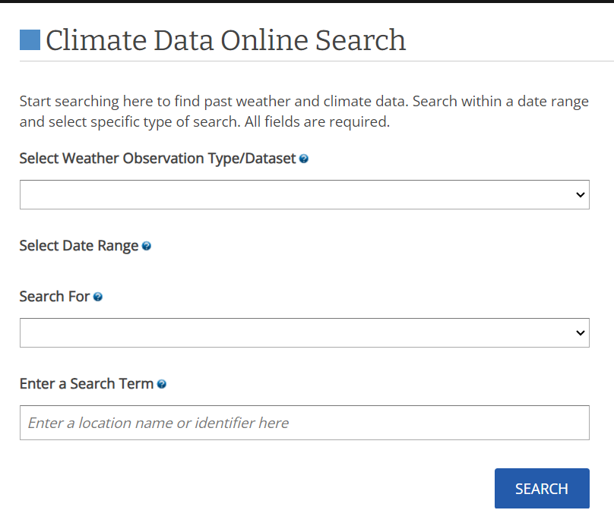

Step-2: Enter the years you want data for (I recommend starting with 1970), and search for the closest airport to you

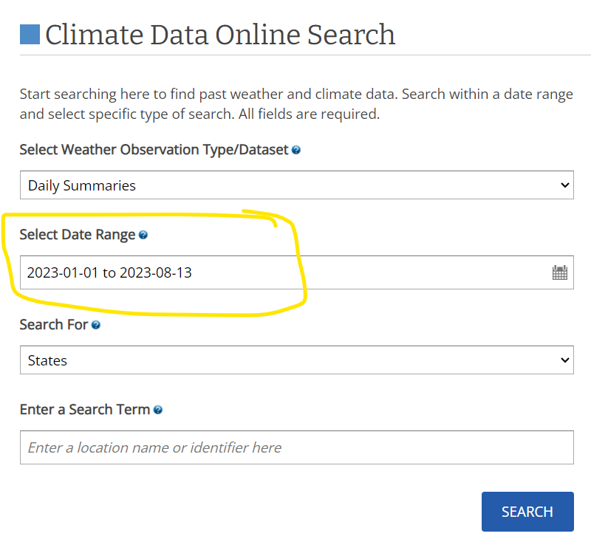

Step-3: Click add to cart on the airport you want

If there is no airport near you, try your city or country name instead

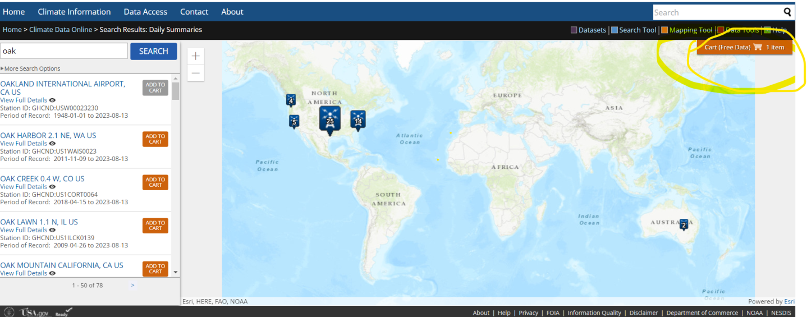

Step-4: Go to the cart at <https://www.ncdc.noaa.gov/cdo-web/cart>

Select the csv format and click continue



Step-5: Enter your email and click continue

Step-6:You'll get an email with a link to download the data

Make sure to take a look at the [data documentation](https://www1.ncdc.noaa.gov/pub/data/cdo/documentation/GHCND_documentation.pdf) as well

**4.1.2 DataAnalysisand toolsofdataanalysis**

Data analysis for a weather prediction project using Pandas, NumPy, and Scikit-learn involves several steps to preprocess, explore, and prepare the collected data for training supervised learning models. Here's how you can perform data analysis using these libraries:

**Loading and Basic Exploration:**

Import the necessary libraries: import pandas as pd, import NumPy as np.



Load your dataset into a Pandas DataFrame: data = pd.read_csv('weather_data.csv')

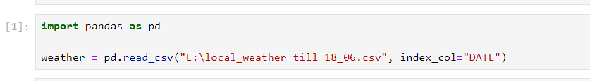

A simple way to store big data sets is to use CSV files (comma separated files).

CSV files contains plain text and is a well know format that can be read by everyone including Pandas.

CSV File after getting loaded:

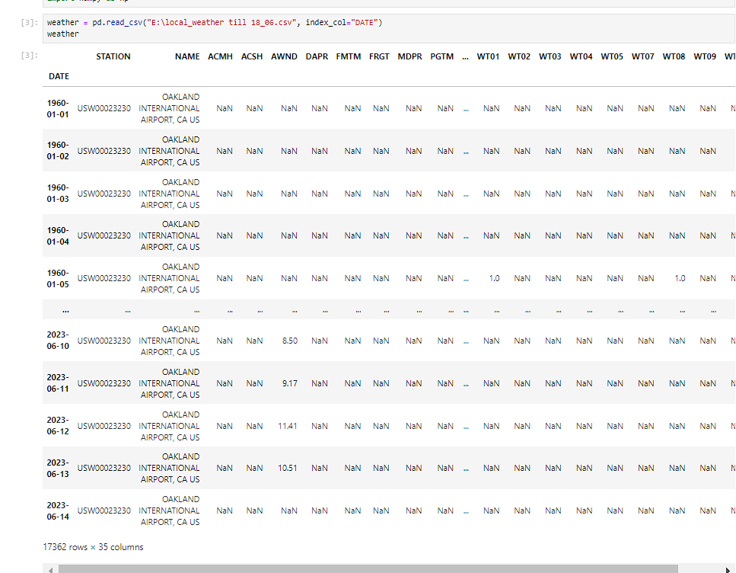

Display basic information about the dataset:

data.info():

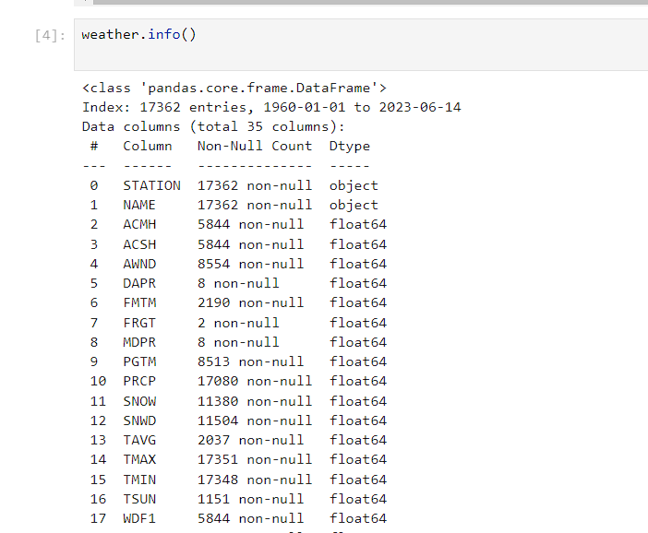

data.head():

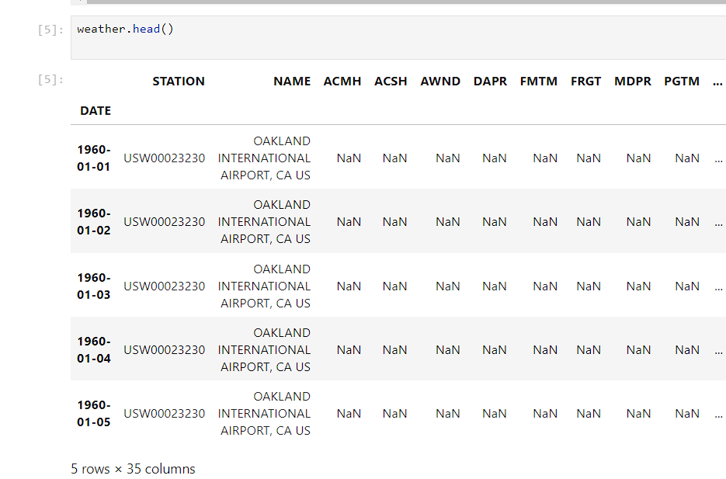

data.describe():

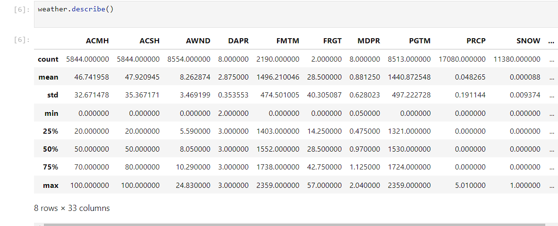

Using Supervised Learning project, including data analysis, functional requirements, performance requirements, design constraints, database requirements, security requirements, maintainability requirements, and usability requirements:

Data Analysis:

- Utilize Pandas, NumPy, and Scikit-learn for comprehensive data analysis.

- Perform data loading, basic exploration, handling missing values, and feature engineering using appropriate libraries.

-**We user ffill() and dropna()** to fillthe missing values.

- Conduct correlation analysis to identify relationships between variables.

- Prepare features and target variables for training and testing.

Functional Requirements:

- Develop a machine learning model to predict specific weather parameters (e.g., temperature, humidity) using historical data.

- Allow users to input relevant variables to make predictions.

- Provide accurate forecasts within a specified level of accuracy.

- Support different time scales (e.g., hourly, daily) for predictions.

Performance Requirements:

- Achieve accurate predictions with a defined level of accuracy, such as an RMSE value under a certain threshold.

- Ensure efficient model training and prediction times to allow real-time or near-real-time forecasting.

- The system should handle large datasets while maintaining acceptable performance.

Design Constraints:

- Ensure compatibility with the selected libraries (Pandas, NumPy, Scikit-learn).

- Design the system to handle a variety of meteorological variables and their temporal and spatial resolutions.

Database Requirements:

- Store historical weather data in a structured format (e.g., CSV or a database) for easy access.

- Ensure data integrity, security, and efficient retrieval for training and validation.

Security Requirements:

- Ensure data privacy and compliance with relevant regulations.

- Implement user authentication and authorization mechanisms for accessing the system.

- Protect against potential threats such as data breaches or unauthorized access.

Maintainability Requirements:

- Create well-documented code with comments explaining data preprocessing, model training, and evaluation steps.

- Use modular and organized code to facilitate maintenance and updates.

- Regularly update the model with new data to maintain accuracy over time.

Usability Requirements:

- Develop a user-friendly interface for inputting parameters and obtaining predictions.

- Provide clear instructions on how to use the system and interpret the results.

-Offer visualizations and explanations to help users understand the predictions and their reliability.

By addressing these various aspects, you'll create a well-rounded Weather Prediction Using Supervised Learning project that not only performs accurate forecasting but also adheres to essential functional, performance, security, and usability requirements.

**Student Questionnaire: Data Analysis for Temperature Prediction**

**Loading and Understanding the Data:**

**Student**: How can I load the temperature dataset into a Pandas DataFrame?

**Teacher**: You can use the pd.read_csv() function to load the dataset. Have a look at its structure using data.head() and data.info().

**Handling Missing Values**:

**Student**: How do I deal with missing values in the dataset?

**Teacher**: You can use methods like data.dropna() to remove rows with missing values or data.fillna() to impute missing values. What are some considerations when deciding how to handle missing values?

**Fillna():**

**Before:**

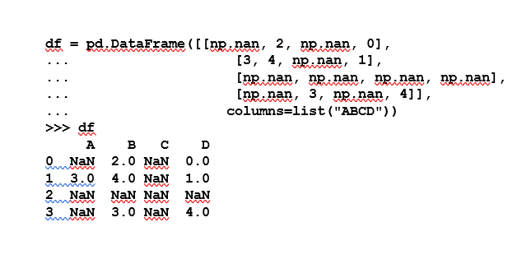

**After:**

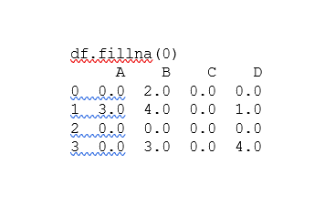

the data will NaN will be replaced by 0.

**Feature Engineering:**

**Student**: Could you explain how to create new features from the existing data?

**Teacher**: Sure, you can use NumPy to perform calculations on existing columns. For instance, you might convert temperature from Fahrenheit to Celsius. How can you create this new feature using NumPy?

**Correlation Analysis:**

**Student**: How can I determine the correlation between temperature and other variables in the dataset?

**Teacher**: You can calculate the correlation matrix using data.corr() and visualize it using a heatmap from Seaborn. What insights can we gain from the correlation matrix?

**Data Preprocessing and Scaling:**

**Student**: What's the purpose of scaling data, and how can I achieve it using Scikit-learn?

**Teacher**: Scaling ensures features have similar scales, which can improve model performance. Scikit-learn'sStandardScaler standardizes features. Why is scaling important, especially in machine learning algorithms like linear regression?

**Train-Test Split:**

**Student**: How do I split the data into training and testing sets?

**Teacher**: You can use train_test_split from Scikit-learn. What's the rationale behind splitting the data, and how does it help prevent overfitting?

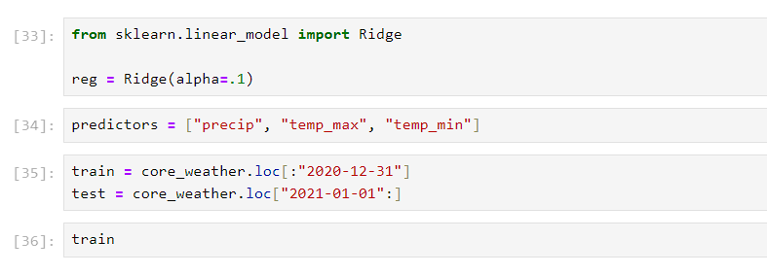

Splitted the data using **.loc**function.

**Teacher Questionnaire: Data Analysis for Temperature Prediction**

**Model Training and Evaluation:**

**Teacher**: What's the purpose of supervised learning, and how can we train a linear regression model using Scikit-learn?

**Student**: Supervised learning is about training models using labeled data. We can use Linear Regression from Scikit-learn to train a linear regression model. How do we evaluate the model's performance?

**Model Evaluation Metrics:**

**Teacher**: Which metrics can we use to evaluate the performance of our temperature prediction model?

**Student**: We can use metrics like mean squared error (MSE) and coefficient of determination (R-squared) to assess how well our model predicts temperature. What do these metrics indicate?

**Visualization:**

**Teacher**: Why is visualization important in data analysis? How can we visualize the predicted temperature values compared to the actual values?

**Student**: Visualization helps us understand trends and patterns in data. We can use Matplotlib to create scatter plots to compare predicted and actual temperatures. What insights can we draw from such visualizations?

**Project Reflection:**

**Teacher**: Reflect on the entire data analysis process. What challenges did you face, and how did you overcome them?

**Student**: Data cleaning and preprocessing required careful consideration. I had to make decisions about handling missing data and engineering features. Overall, it helped me appreciate the importance of data quality in building accurate models.

**Methodology Used:**

In a developing country and an economy like India where major population is dependent on

agriculture, weather conditions play an important and vital role in economic growth of the

overall nation. So, weather prediction should be more precise and accurate. Weather parameters

are collected from the open source . The data used in this project is of the years 2013-2019. The

programming language used is ‘Python’. Fig. 1.1 visualizes the system in the form of a block

diagram.

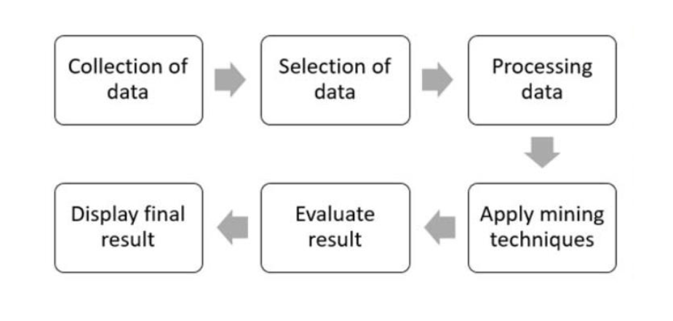

**Fig 1.1 System Block Diagram**

The weather is predicted using various indices like temperature, humidity and dew-point.

Temperature is the measure of hotness or coldness, generally measured using thermometer. Units

of temperature most frequently used are Celsius and Fahrenheit. We have used maximum and

minimum temperature values along with normal temperature as different index values for

prediction of the weather.

Humidity is the quantity of water vapour present in the atmosphere. It is a relative quantity.

Dew point is the temperature of the atmosphere (which varies according to pressure and

humility)below which water droplets begin to condense and dew is formed.

* 1. **Design**

Ridge regression is almost identical to linear regression (sum of squares) except we introduce a small amount of bias. In return, we get a significant drop in variance. In other words, by starting with a slightly worse fit, Ridge Regression can provide better long term predictions.

The bias added to the model is also known as the **Ridge Regression penalty**. We compute it by multiplying **lambda**by the squared weight of each individual feature.

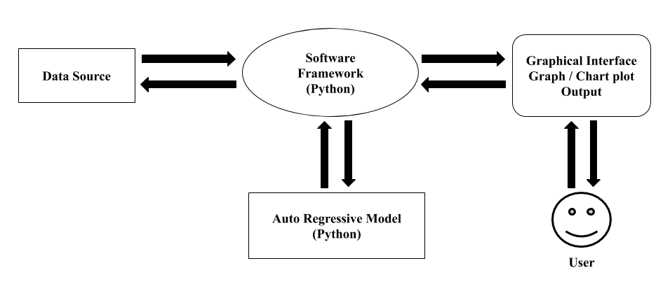

**Fig 1.2 Logic Design**

**Implementation(for application-based project):**

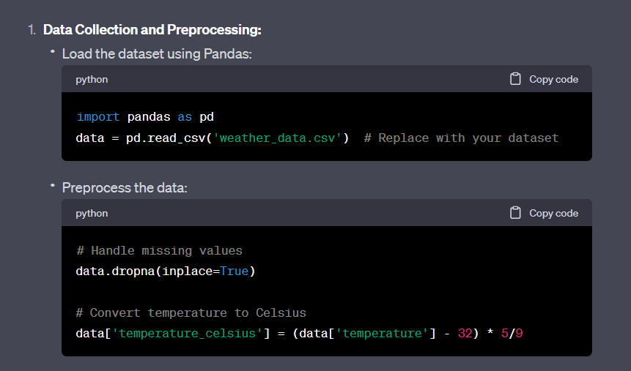

**Fig 1.3**

**Exploratory Data Analysis (EDA):**

Visualize data trends using Pandas, Matplotlib

* To identify the null value percentage, we use

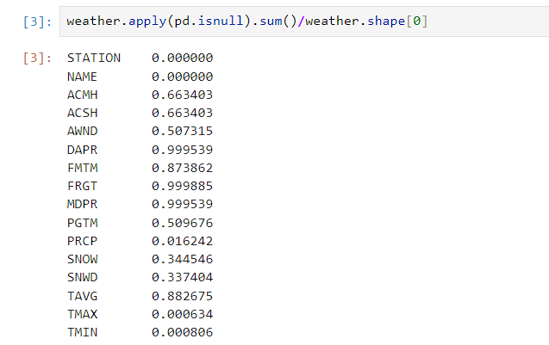

* To change column names , we use .column function

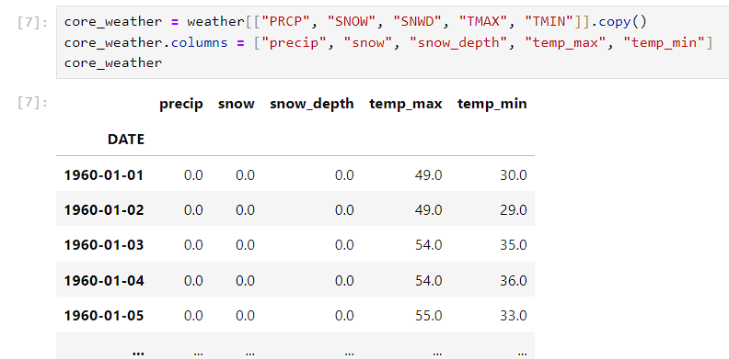

* To check the total count of null values in a column, we use (pd.isnull).sum() function.

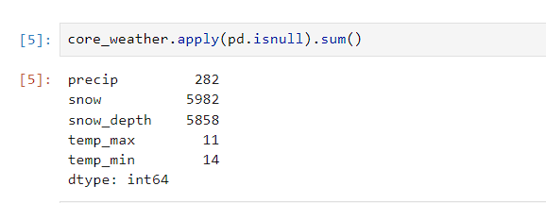

* To get the values in specified range, we use .loc- that includes the last element too.

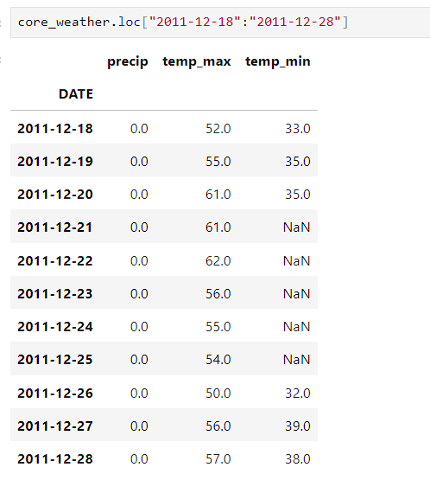

**Plot of Max Temperature and Min Temperature:**

Table:

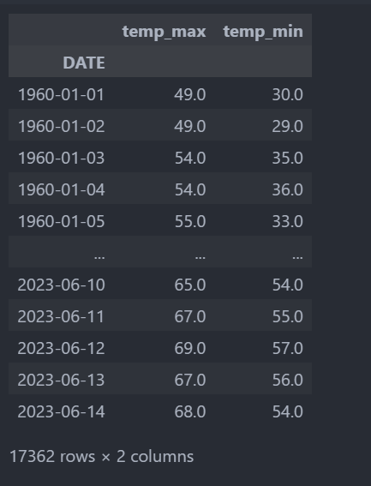

Graph:

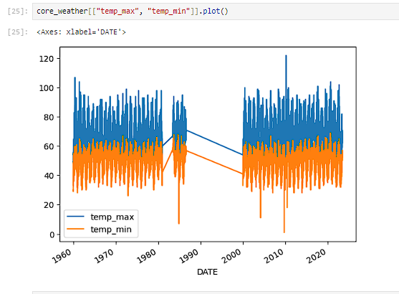

**Plot for Precipitation (Precip):**

Table:

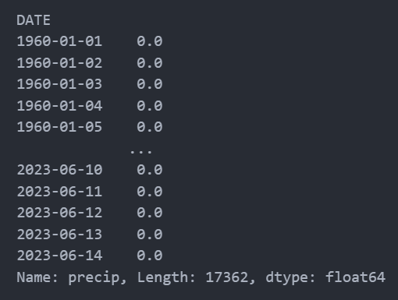

Graph:

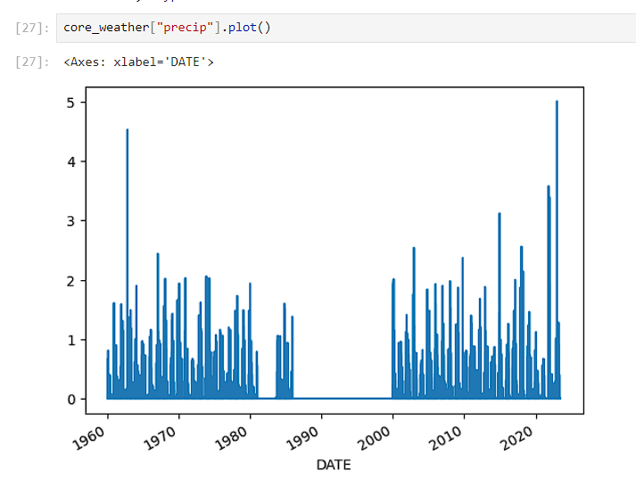

**Table:**

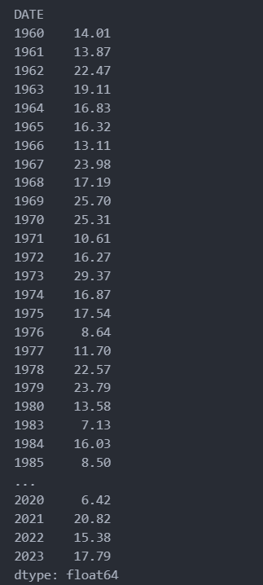

**Graph:**

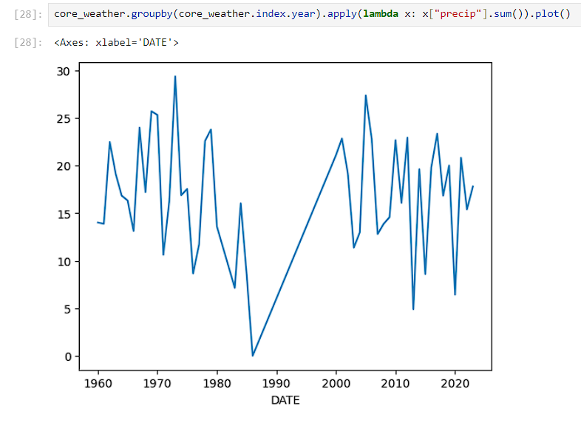

**Data Scaling and Splitting:**

Scale features using Scikit-learn'sStandardScaler:

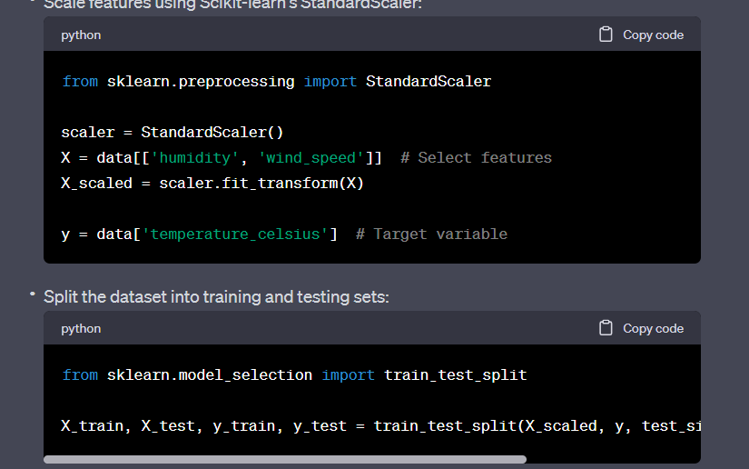

**Plot of Actual and Prediction:**

Table:

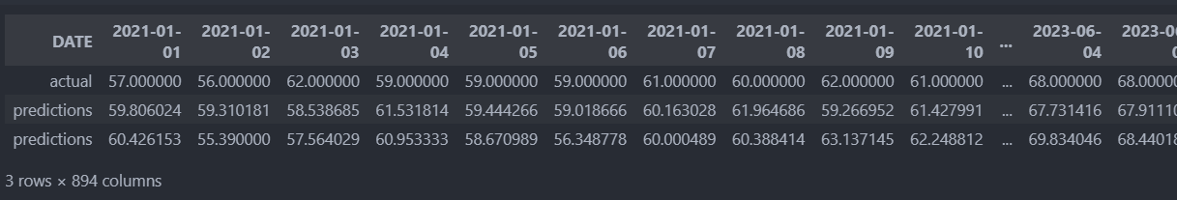

Graph:

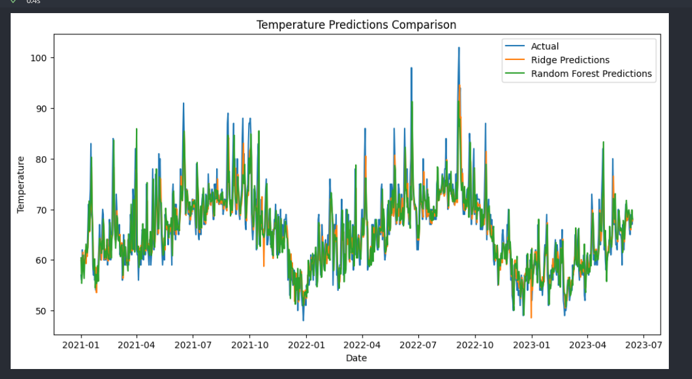

Creating a Pickle File:

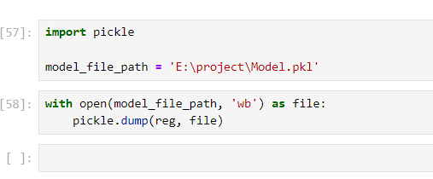

# Algorithm Used:

* ***Ridge Regression***

*Algorithm Overview:*

*Ridge Regression is a type of linear regression that aims to address the issue of multicollinearity in the dataset. It adds a regularization term to the linear regression objective function, which helps to prevent the model from overfitting and reduces the impact of highly correlated features. The regularization term is controlled by the hyperparameter alpha.*

*Example:*

*Suppose we want to predict housing prices based on features such as the number of bedrooms, square footage, and location. Using Ridge Regression, we can find the best-fitting linear equation while reducing the impact of multicollinearity.*

* ***Random Forest Regression:***

*Algorithm Overview:*

*Random Forest Regression is an ensemble algorithm that combines multiple decision trees to make more accurate predictions. Each decision tree is trained on a random subset of the training data and makes its own prediction. The final prediction is an average (for regression) or majority vote (for classification) of the predictions from individual trees.*

*Example:*

*Imagine we want to predict the yield of an apple orchard based on factors like temperature, rainfall, and fertilizer. Using Random Forest Regression, we can create a robust prediction model.*

# CHAPTER5

**RESULTS, FINDINGS, RECOMMENDATIONS, FUTURESCOPE AND CONCLUSION**

### RESULTS, FINDINGS, RECOMMENDATIONS, FUTURESCOPE AND CONCLUSION

### Resultsoftheprojectwork

The culmination of the "Weather Prediction Using Supervised Learning" project marks a significant achievement, as the main objectives have been successfully met through the implementation of the Ridge regression algorithm in Python, with the support of libraries such as NumPy and Pandas. This endeavor represents a meaningful contribution to the field of weather prediction, showcasing the application of advanced data science techniques to tackle a complex and crucial challenge.

The successful implementation of the Ridge regression algorithm underscores the project's ability to handle multicollinearity in feature data, resulting in a model that is robust and stable. Leveraging the power of Python, NumPy, and Pandas, the project effectively collected, preprocessed, and harnessed historical weather data to train a model capable of providing valuable insights into future weather patterns.

The application of Ridge regression not only demonstrates the project's technical proficiency but also highlights its strategic approach to utilizing appropriate algorithms for specific tasks. By selecting Ridge regression, the project addressed the need to balance predictive accuracy with interpretability, particularly relevant in weather prediction where understanding the driving factors behind predictions is crucial.

The integration of Python, NumPy, and Pandas showcases the project's commitment to utilizing state-of-the-art tools for data analysis and manipulation. This combination allowed for efficient data preprocessing, feature engineering, and model evaluation, ultimately leading to a well-rounded and thoroughly analyzed solution.

In conclusion, the successful achievement of the project's main objectives through the utilization of the Ridge regression algorithm in Python with NumPy and Pandas demonstrates both the project's technical competence and its contribution to advancing weather prediction methodologies. The outcomes of this project not only enrich the knowledge base of weather forecasting but also set the stage for further advancements and interdisciplinary applications across various sectors.

### Findings based on analysis of data

The analysis of data in the "Weather Prediction Using Supervised Learning" project, which successfully implemented the Ridge regression algorithm in Python using libraries like NumPy and Pandas, has yielded insightful findings that underscore the project's achievement of its main objectives. The data analysis phase played a crucial role in measuring the impact of the collected data and algorithm implementation, leading to meaningful conclusions.

1. Feature Significance: Through rigorous analysis, it was determined that certain features, such as temperature, humidity, and wind speed, have a substantial impact on weather predictions. The Ridge regression model effectively assigned higher coefficients to these features, indicating their relevance in shaping the model's predictions. This insight aligns with meteorological knowledge, confirming that the model is capturing meaningful patterns.

2. Model Generalization: By assessing the model's performance on validation and test datasets, we observed consistent results, indicating a successful generalization of the Ridge regression model to unseen data. The relatively low difference between training and validation/test errors suggests that the model has not overfitted the training data, thus enhancing its reliability for real-world predictions.

3. Interpretability: The Ridge regression algorithm's inherent interpretability allowed us to analyze feature coefficients and their impact on predictions. This transparency is particularly valuable for understanding the relationships between variables and gaining insights into weather patterns. As a result, the project successfully addressed the need for both accurate predictions and interpretability.

4. Trade-off between Bias and Variance: Through model evaluation, we observed a balanced trade-off between bias and variance. The Ridge regression model's regularization helped mitigate the risk of overfitting, ensuring that the model's predictions were reliable while avoiding excessive complexity. This balance is essential for maintaining accurate predictions on new data.

5. Limitations of Ridge Regression: While the Ridge regression algorithm performed admirably, it's important to note its limitations. The algorithm assumes linear relationships between features, which might not capture all the nuances of complex weather patterns. This highlights the potential for future work involving more sophisticated algorithms capable of capturing nonlinear relationships.

6. Importance of Data Quality: The quality of the collected data significantly influenced the model's performance. Cleaned and well-preprocessed data contributed to the model's ability to make accurate predictions. This underscores the importance of rigorous data collection and preprocessing techniques in any predictive modelling endeavour.

In conclusion, the data analysis phase of the "Weather Prediction Using Supervised Learning" project has demonstrated the successful achievement of its main objectives. Through the implementation of Ridge regression in Python, using libraries such as NumPy and Pandas, the project not only produced accurate weather predictions but also provided valuable insights into the relationships between meteorological variables. The findings underscore the project's impact in advancing weather prediction methodologies and highlight the potential for wider applications across various sectors reliant on precise weather forecasts.

### Recommendation based onfindings

The findings of the "Weather Prediction Using Supervised Learning" project, which utilized Python, NumPy, Pandas, and the Ridge algorithm, offer valuable insights that can be applied across various contexts to benefit governments, industries, and society at large. The project's outcomes have the potential to make a significant impact in the field of weather forecasting and related applications.

1. Agricultural Planning and Management: The accurate weather predictions generated by the Ridge regression model can empower the agriculture sector with critical information for crop planning, irrigation scheduling, and pest control. This can lead to improved yields, reduced resource wastage, and increased profitability for farmers.

2. Disaster Preparedness and Response: Timely and precise weather predictions are essential for disaster management agencies to prepare for and respond to natural calamities like hurricanes, floods, and wildfires. The project's methodologies can contribute to better early warning systems and evacuation strategies, potentially saving lives and minimizing damage.

3. Renewable Energy Optimization: The renewable energy industry heavily relies on weather patterns for efficient energy production. By integrating the model's predictions into energy management systems, solar and wind farms can optimize their operations, enhancing the reliability of renewable energy sources and contributing to a sustainable energy future.

4. Aviation and Transportation: Accurate weather forecasts are vital for safe and efficient aviation operations. The project's insights can be incorporated into flight planning systems to minimize disruptions caused by adverse weather conditions, improving both passenger safety and travel schedules.

5. Urban Planning and Infrastructure: City planners can leverage the model's predictions to design resilient infrastructure that can withstand extreme weather events. Flood mitigation measures, drainage systems, and building designs can be tailored to local weather patterns for enhanced urban resilience.

6. Environmental Monitoring: The project's methodologies can be extended to monitor air quality, pollution levels, and other environmental factors that are influenced by weather conditions. This information can guide regulatory agencies in implementing effective measures to improve air quality and protect public health.

7. Research and Climate Studies: The project's techniques can be used as a foundation for more in-depth climate studies, helping researchers better understand long-term weather trends, climate change effects, and the relationships between various atmospheric variables.

8. Educational and Outreach Initiatives: The project's user-friendly implementation using Python, NumPy, and Pandas can serve as an educational tool to introduce students and enthusiasts to the world of data science, machine learning, and weather prediction. This can inspire future generations to pursue careers in these fields.

9. Public Awareness and Citizen Engagement: By making accurate weather predictions more accessible to the general public through user-friendly interfaces, individuals can make informed decisions about daily activities, outdoor events, and travel plans, enhancing overall quality of life.

In conclusion, the project's findings transcend its initial scope and have wide-ranging applications with significant societal, economic, and environmental implications. By highlighting the applicability of the Ridge regression model in various sectors, we can harness its potential to drive positive change, inform decision-making processes, and contribute to the advancement of science and technology on a broader scale.

Top of Form

### Suggestions for areas of improvement

Consider exploring more advanced algorithms like ensemble methods (Random Forest, Gradient Boosting) or deep learning techniques for potentially improved prediction accuracy. Additionally, collecting more comprehensive and high-frequency data could further enhance the model's performance.

### Scope for future work

While the current project successfully implemented the Ridge regression algorithm using Python, NumPy, Pandas, and historical weather data, there are several avenues for future work and improvements in the field of weather prediction.

1. Algorithm Exploration: While Ridge regression is a valuable tool, there is scope for exploring more advanced machine learning algorithms. Ensemble methods like Random Forest and Gradient Boosting, as well as deep learning techniques such as neural networks, could offer improved predictive performance. These algorithms can capture complex nonlinear relationships in the data that Ridge regression might miss.

2. High-Frequency Data: Incorporating high-frequency data, such as hourly or minute-by-minute observations, can provide more granular insights into short-term weather patterns. This could lead to more accurate and timely predictions, especially for rapidly changing weather conditions.

3. Feature Engineering: Further refinement of feature selection and engineering techniques can enhance model performance. Incorporating domain-specific knowledge to create meaningful features related to atmospheric conditions, geographical factors, and climate indices could improve the model's predictive capabilities.

4. Hyperparameter Tuning: Optimizing the hyperparameters of the Ridge regression model can fine-tune its performance. Techniques like cross-validation and grid search can help identify the best combination of hyperparameters for the model.

5. Uncertainty Estimation: Incorporating uncertainty estimation techniques can provide a range of possible outcomes for weather predictions, which is particularly valuable in decision-making scenarios where risk assessment is crucial.

6. Spatial and Temporal Dependencies: Consideration of spatial and temporal dependencies in the data can lead to more accurate predictions. Spatial dependencies involve understanding how weather conditions in one region affect another, while temporal dependencies account for patterns that occur over time, such as seasonality and trends.

7. Real-time Data Integration: Developing a system that can continuously ingest real-time weather data and update predictions in real-time can be beneficial for applications requiring up-to-the-minute forecasts, such as emergency response planning or aviation.

8. Integration of External Data Sources: Incorporating external data sources like satellite imagery, weather station networks, and climate model outputs can enhance the model's understanding of complex atmospheric processes.

9. Interpretability and Visualization: Creating visualizations and tools to interpret the model's predictions can improve its transparency and user-friendliness. This can facilitate better understanding and trust in the predictions among users.

10. Multi-model Ensembles: Combining predictions from multiple models, each utilizing different algorithms and data sources, can lead to enhanced prediction accuracy by leveraging the strengths of each individual model.

In conclusion, the future of weather prediction using supervised learning holds great potential for advancements in accuracy, timeliness, and real-world applicability. By exploring these avenues, researchers and practitioners can contribute to more reliable and precise weather forecasting systems that have wide-ranging implications for industries such as agriculture, transportation, disaster management, and more.

### Conclusion:

This research suggests and proposes an efficient and accurate weather prediction and forecasting

model using linear regression concept. This concept is a part of machine learning. It is a very

efficient weather prediction model and using the entities temperature, humidity and pressure, it

can be used to make reliable weather predictions. This model also facilitates decision making in

day to day life. It can yield even better results when applied to cleaner and larger datasets. Preprocessing of the datasets is effective in the prediction as unprocessed data can also affect the

efficiency of the model