SQL Architect: An AI Agent Built with Gemini Gems
College Project Report · October 13, 2026

Abstract
SQL Architect is a custom AI agent built with Google’s Gemini Gems that helps users design database schemas, write SQL queries and understand them. The agent is configured through a written set of instructions rather than code, so it can be built, tested and changed in minutes. This report describes the problem it addresses, how it was configured, the features it offers, and its limitations. [Add one sentence on your main result, e.g. how many test prompts you ran and how accurate the output was.]

Introduction
An AI agent is a language-model-based system given a role, rules and a goal, so it behaves consistently on a specific kind of task instead of answering as a general chatbot. Large language models such as Gemini can read natural-language requests and produce structured output like code, tables and explanations.
Gemini Gems are customizable versions of Gemini. The creator writes instructions, optionally attaches reference files, and saves the result as a reusable assistant. SQL Architect is one such Gem, specialized for database design and SQL.

Problem Statement
Beginners struggle with SQL because it combines several skills at once: modeling data into tables, normalizing it, writing correct joins and filters, and checking that a query is efficient. A general-purpose chatbot can help, but its answers vary in style, may assume the wrong SQL dialect, and often skip the reasoning behind a design.
The project asks whether a single, instruction-tuned agent can give consistent, explained and dialect-aware SQL help without any programming infrastructure.

Objectives
- Build an AI agent with Gemini Gems that acts as a database and SQL assistant.
- Let users describe a data requirement in plain English and receive a schema design.
- Generate and explain SQL queries for a given schema.
- Suggest optimizations and flag common mistakes.
- Evaluate the agent on sample prompts and document its strengths and limits.

Tools and Technologies
Component | Role in the project
Google Gemini Gems | Platform used to create and save the custom agent
Gemini model | Language model that interprets requests and generates output
Gem instructions | The written role, rules and output format that define the agent

System Design and Methodology
SQL Architect has no code of its own: the Gem’s instructions sit in front of the Gemini model and shape every reply.
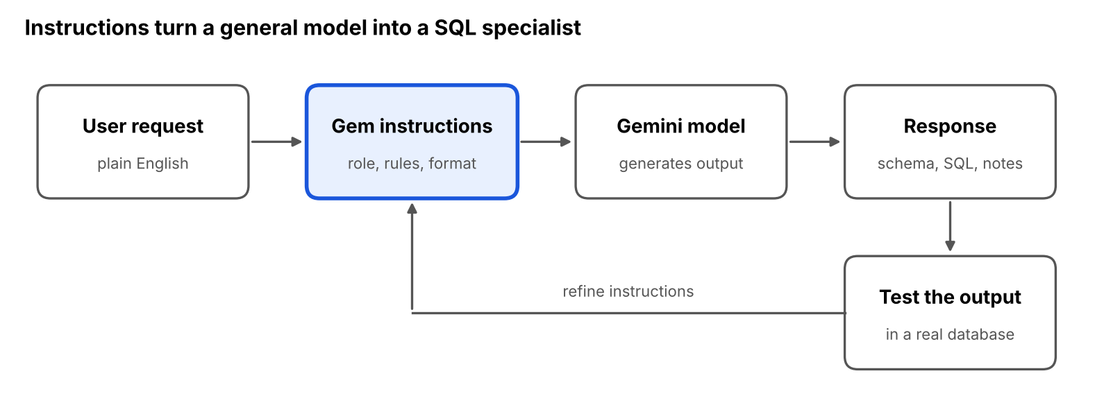
Figure 1. SQL Architect request flow: 5 steps, 1 feedback loop
A request passes through the instructions to the model, and the response is tested in a real database. Problems found in testing lead to edits in the instructions, so the agent was built by repeated test and refinement.

Features
- Schema design: turns a plain-English description into tables, columns, data types, and primary and foreign keys.
- Normalization guidance: points out redundancy and explains how to reach 1NF, 2NF and 3NF.
- Query generation: writes SELECT, JOIN, GROUP BY and subquery statements from a described goal.
- Query explanation: walks through what each clause does, line by line.
- Optimization tips: suggests indexes and rewrites for slow or inefficient queries.
- Error fixing: reads a faulty query and explains what is wrong.
[Edit this list to match what your Gem actually does. Remove anything it does not do.]

Implementation
The agent was created in the Gemini Gems editor. A Gem is defined mainly by its instructions, which fix the agent’s role, tone, rules and output format. Good instructions for this kind of agent cover four things:
- Role: who the agent is, e.g. a senior database architect who teaches as it designs.
- Rules: ask for the SQL dialect first, never invent columns, explain every design choice.
- Output format: schema as a table, SQL in code blocks, a short explanation after each.
- Boundaries: what to do when a request is unclear or outside database work.
[Paste your Gem’s actual instructions here as a quoted block, and note the name you gave it and any files you attached.]

Use Cases
- Students learning database design and SQL, with explanations alongside answers.
- Developers drafting a schema or query quickly before refining it by hand.
- Analysts who know the question but not the exact join logic.
- Teachers generating practice schemas and example queries.

Limitations
- The agent cannot connect to a live database, so it never sees real data or runs the queries it writes.
- Output can contain mistakes, so every query should be tested before use.
- Results depend on how clearly the user describes the requirement and which dialect is named.
- A Gem is shaped by instructions only; it does not learn from past conversations.
- Performance advice is general, since the agent cannot inspect execution plans.

Future Scope
- Attach sample schemas or a data dictionary as knowledge files for more grounded answers.
- Connect the agent to a database through an API so it can validate queries.
- Generate ER diagrams alongside schemas.
- Add support for more dialects and for NoSQL design.
- Build a short quiz mode for learners.

Conclusion
SQL Architect shows that a useful domain agent can be built with instructions alone, without writing application code. It gives consistent, explained help on schema design and SQL, which suits learning and quick drafting. Its main limits are the lack of database access and the need to verify output, both of which point to clear next steps in the future scope.

