Assignment-2

Q. Implement radix sort using counting sort

#include <stdio.h>

#include <stdlib.h>

#include <string.h>

#include <ctype.h>

#include <math.h>

#include <limits.h>

int findMax(int array[], int h){

int max=array[0];

for(int j=1; j<h; j++){

if(max<array[j]){

max=array[j];

}

else{

continue;

}

}

return max;

}

int findDigits(int max) {

int digit = 0;

while (max != 0) {

max = max / 10;

digit++;

}

return digit;

}

int main(){

int n=6;

int radix[6];

int radix2[n];

printf("Specify %d elements\n", n);

for(int i=0; i<n; i++){

scanf("%d", &radix[i]);

}

int max= findMax(radix, n);

int digit = findDigits(max);

int it=1;

int exp=1;

int countarray[10];

while(digit>0){

for(int i=0; i<10; i++){

countarray[i]=0;

}

for(int i=0; i<n; i++){

countarray[(radix[i]/exp)%10]++;

}

for(int i=1; i<=10; i++){

countarray[i] = countarray[i] + countarray[i-1];

}

for (int i = n - 1; i >= 0; i--) {

int currentDigit = (radix[i] / exp) % 10;

radix2[countarray[currentDigit] - 1] = radix[i];

countarray[currentDigit]--;

}

for(int i=0; i<n; i++){

radix[i]=radix2[i];

}

digit--;

exp=exp\*10;

printf("\nIteration: %d\n", it);

for(int j=0; j<n; j++){

printf("%d\t", radix[j]);

}

it++;

}

printf("\nSorted array:\n");

for(int j=0; j<n; j++){

printf("%d\t", radix[j]);

}

return 0;

}

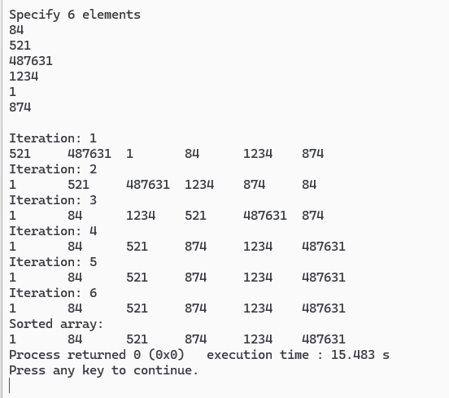

Q. Implement radix sort using

#include <stdio.h>

#include <stdlib.h>

int checkDigit(int number, int max) {

int count = 0;

do {

count++;

number /= 10;

} while (number != 0);

if(max < count) {

max = count;

}

return max;

}

struct radix {

int ele;

struct radix \*next;

};

struct radixhead {

int number;

struct radix \*list;

struct radixhead \*next;

};

void appendToBucket(struct radixhead \*\*bucket, int digit, int number) {

struct radixhead \*travel = \*bucket;

struct radixhead \*prev = NULL;

while(travel != NULL && travel->number < digit) {

prev = travel;

travel = travel->next;

}

if(travel == NULL || travel->number != digit) {

struct radixhead \*newBucket = (struct radixhead\*)malloc(sizeof(struct radixhead));

newBucket->number = digit;

newBucket->list = NULL;

newBucket->next = travel;

if(prev == NULL) {

\*bucket = newBucket;

} else {

prev->next = newBucket;

}

travel = newBucket;

}

struct radix \*newElement = (struct radix\*)malloc(sizeof(struct radix));

newElement->ele = number;

newElement->next = NULL;

if(travel->list == NULL) {

travel->list = newElement;

} else {

struct radix \*listTravel = travel->list;

while(listTravel->next != NULL) {

listTravel = listTravel->next;

}

listTravel->next = newElement;

}

}

void freeBuckets(struct radixhead \*bucket) {

struct radixhead \*tempBucket;

while(bucket != NULL) {

struct radix \*tempList;

while(bucket->list != NULL) {

tempList = bucket->list;

bucket->list = bucket->list->next;

free(tempList);

}

tempBucket = bucket;

bucket = bucket->next;

free(tempBucket);

}

}

struct radix\* collectAndSort(struct radixhead \*bucket, int \*isEmpty) {

struct radix \*head = NULL;

struct radix \*tail = NULL;

while(bucket != NULL) {

struct radix \*listTravel = bucket->list;

while(listTravel != NULL) {

struct radix \*newElement = (struct radix\*)malloc(sizeof(struct radix));

newElement->ele = listTravel->ele;

newElement->next = NULL;

if(head == NULL) {

head = newElement;

tail = newElement;

} else {

tail->next = newElement;

tail = newElement;

}

listTravel = listTravel->next;

}

bucket = bucket->next;

}

\*isEmpty = (head == NULL);

return head;

}

void radixSort(struct radix \*\*head, int maxdigit) {

int exp = 1;

for(int i = 0; i < maxdigit; i++) {

struct radixhead \*bucket = NULL;

struct radix \*sort = \*head;

while(sort != NULL) {

int digit = (sort->ele / exp) % 10;

appendToBucket(&bucket, digit, sort->ele);

sort = sort->next;

}

int isEmpty = 0;

\*head = collectAndSort(bucket, &isEmpty);

freeBuckets(bucket);

exp \*= 10;

if(isEmpty) break;

}

}

void printList(struct radix \*head) {

struct radix \*temp = head;

while(temp != NULL) {

printf("%d ", temp->ele);

temp = temp->next;

}

printf("\n");

}

int main() {

int maxdigit = 0;

struct radix \*head = NULL;

struct radix \*temp = NULL;

printf("Enter elements to sort\n-1 to end\n");

int c = 0;

while(c >= 0) {

scanf("%d", &c);

if(c < 0) break;

struct radix \*block = (struct radix\*)malloc(sizeof(struct radix));

block->ele = c;

block->next = NULL;

if(head == NULL) {

head = block;

temp = head;

} else {

temp->next = block;

temp = block;

}

maxdigit = checkDigit(c, maxdigit);

}

printf("Before sorting: ");

printList(head);

radixSort(&head, maxdigit);

printf("After sorting: ");

printList(head);

return 0;

}

