**Project interfaces**

**Project topic:Bike showroom management**

**Submitted by, Submitted To,**

**VISHNU BABU MS MERIN MANOJ**

**S5 MCA REG ASSISTANTPROFESSOR**

**NO:42 DEPT OF COMPUTER**

**APPLICATIONS**

**Login page**

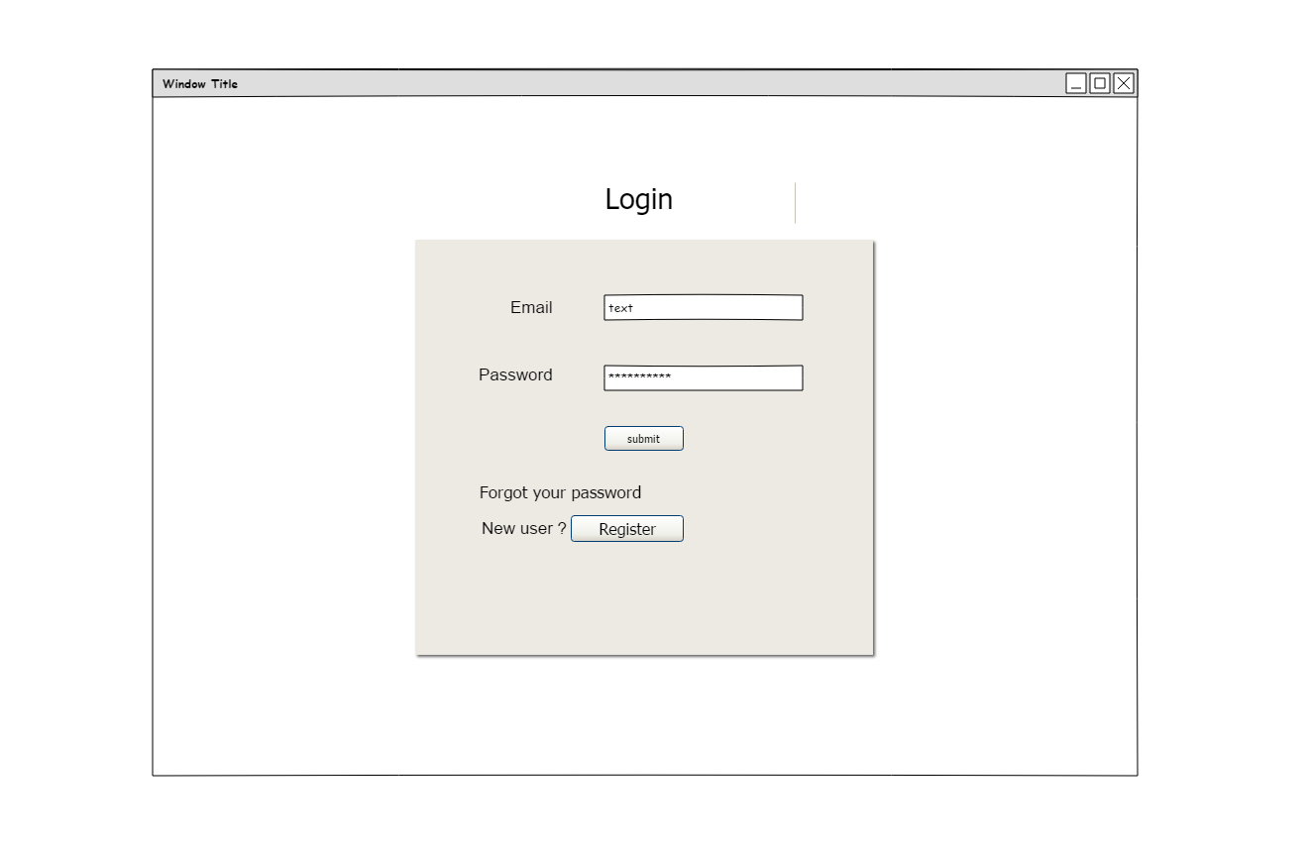

**Registration**

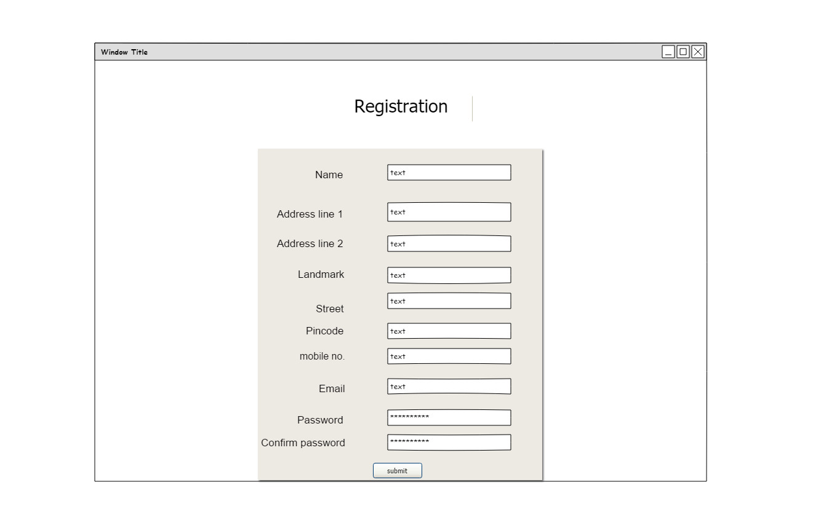

**Home**

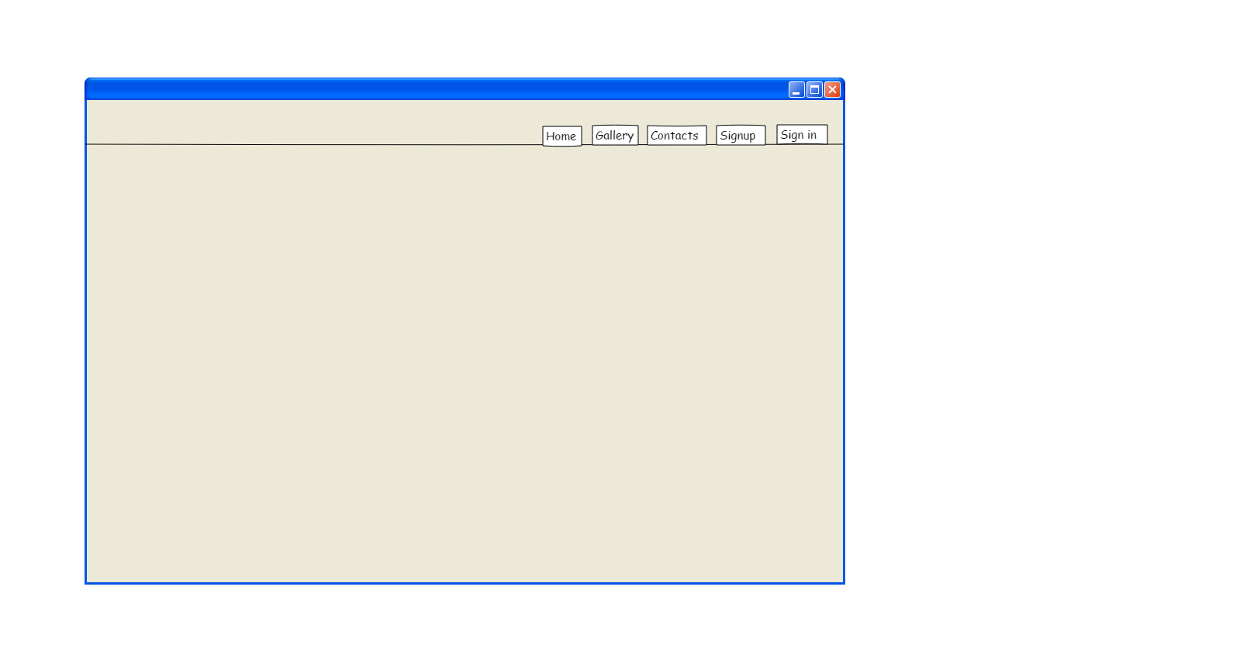

**Admin home**

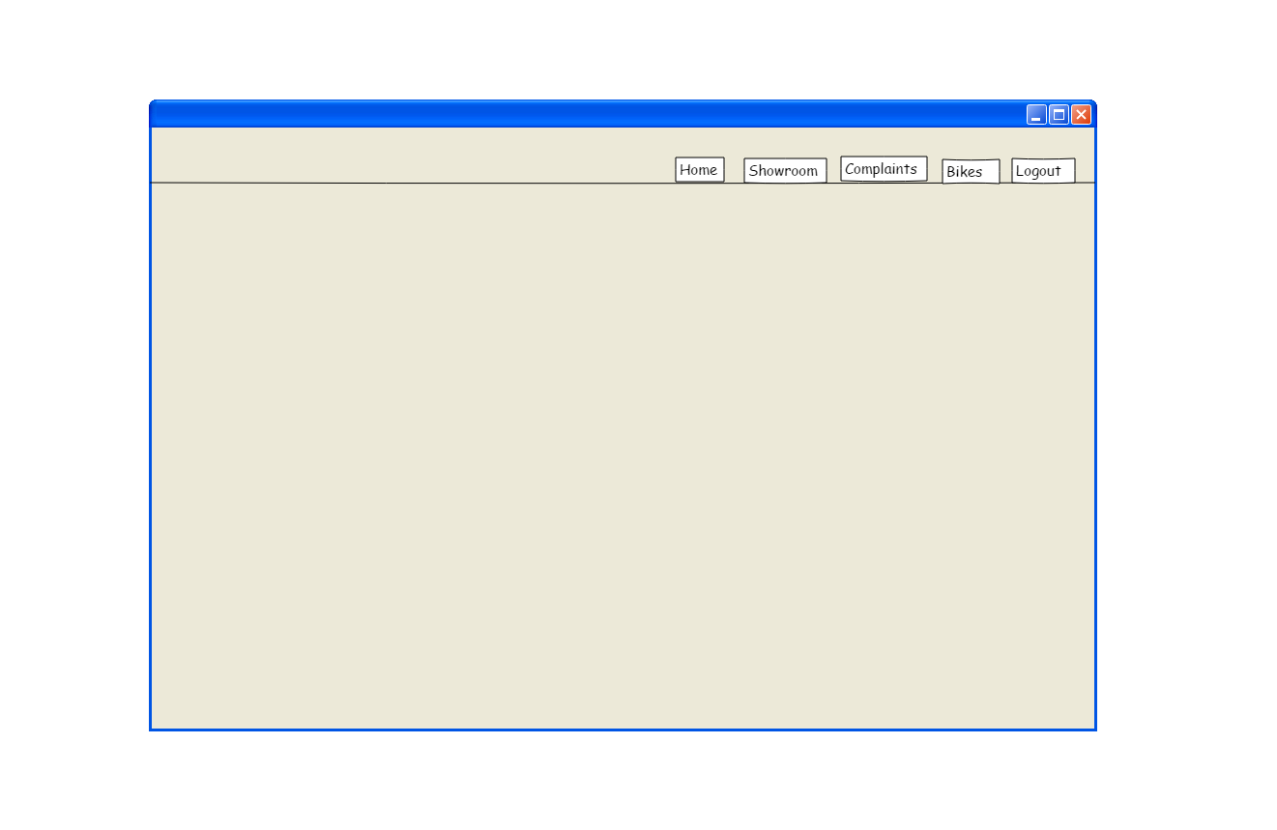

**User home**

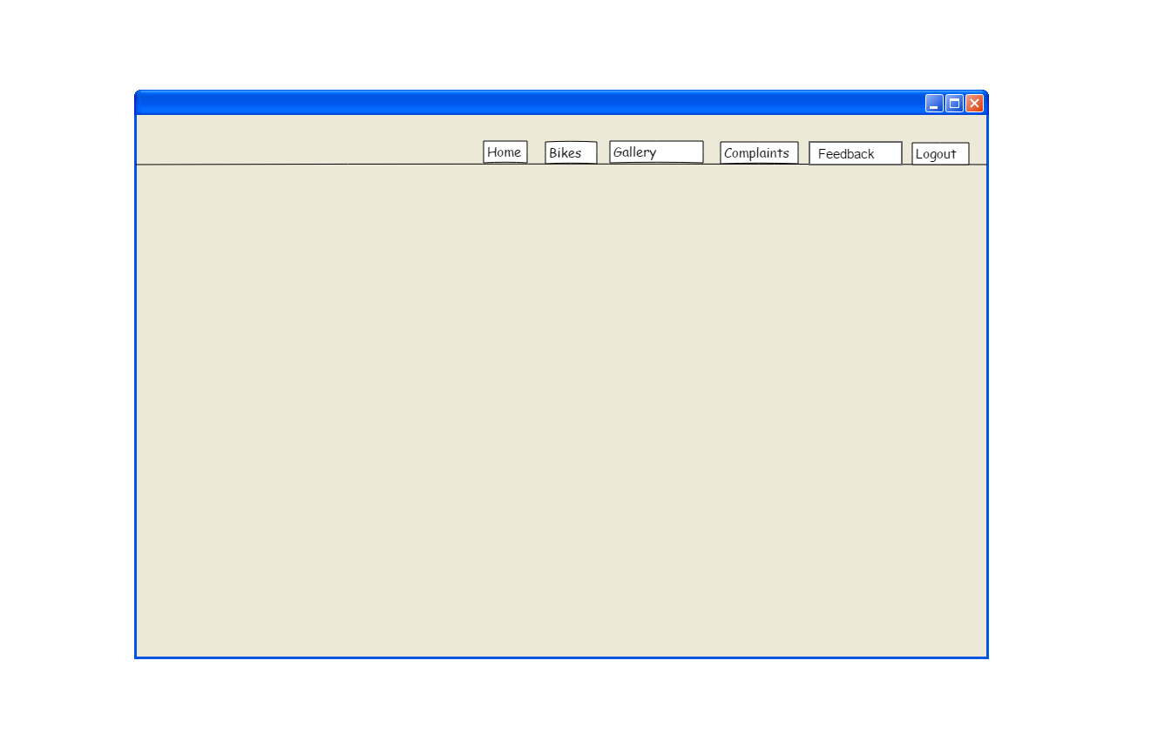

**Manager home**

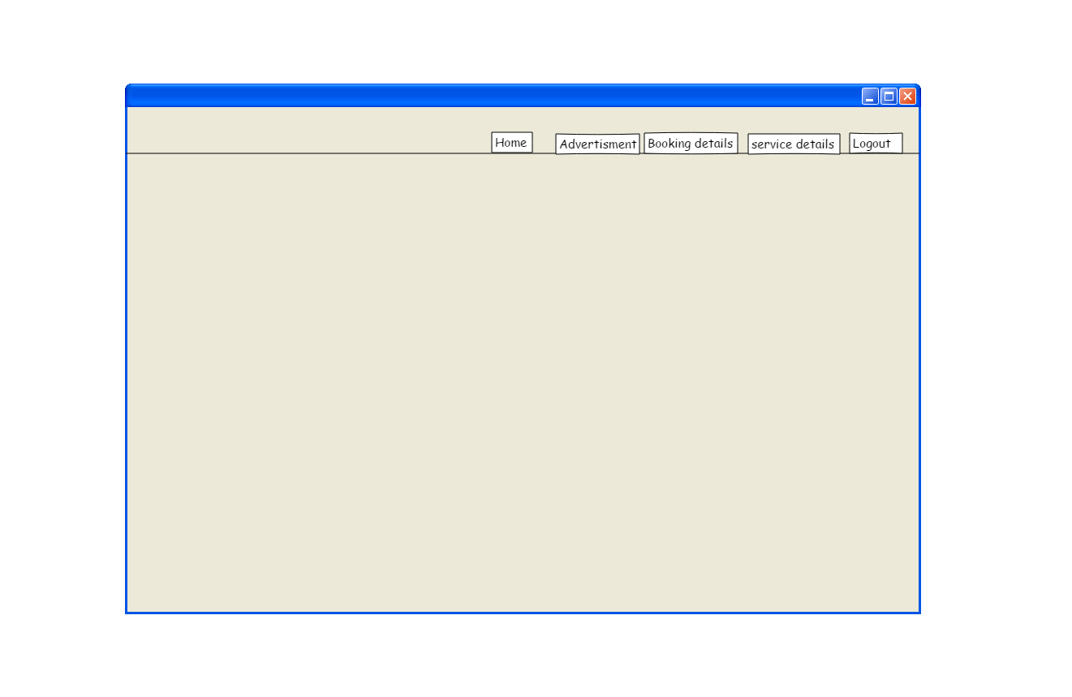

**Add showroom**

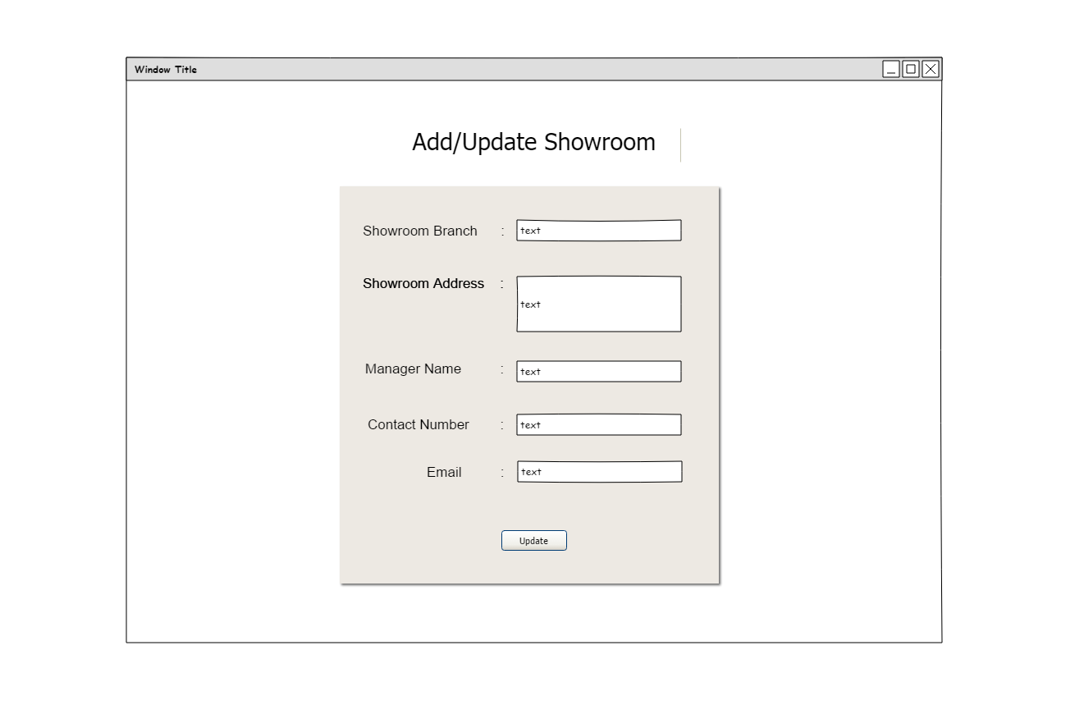

**Add Advertisement**

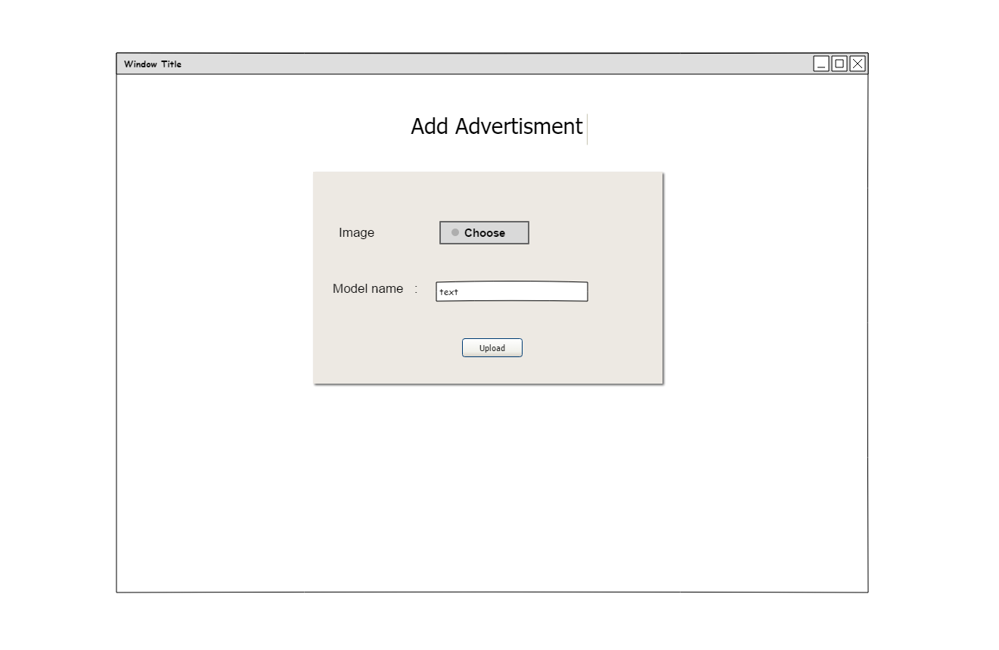

**User Complaints**

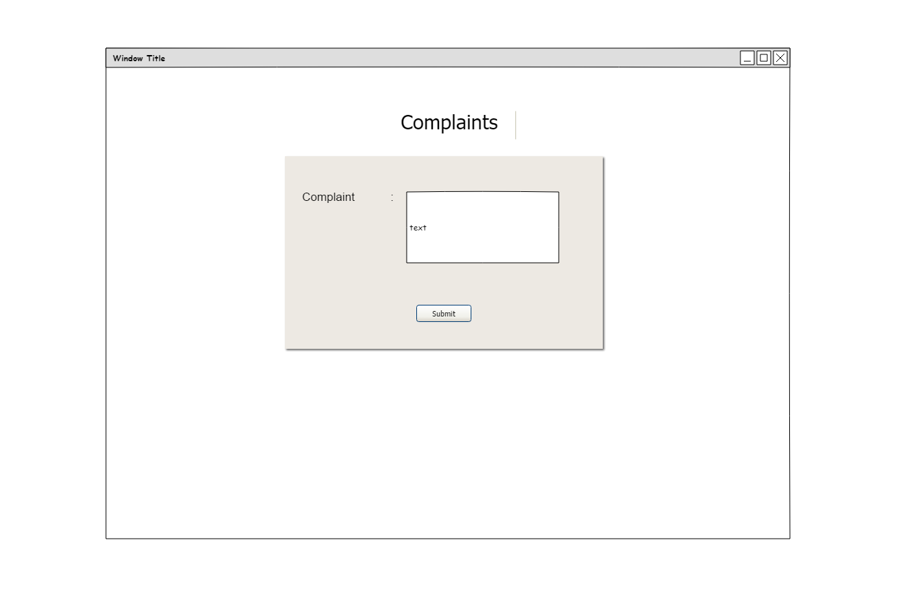

**User service request**

