**Major Project - Synopsis**

Development of an Arduino-based Temperature Data Acquisition System for Real-Time Monitoring



Under the guidance of

**Prof. Dr Rintu Khanna**

Submitted By:

**Dheeraj Batra (21104030)**

**Lakshay Batra (21104031)**

**Vishnu Bansal (21104042)**

**Arshit Verma (21104051)**

Submitted to

**Department of Electrical Engineering**

Punjab Engineering College (Deemed To Be University), Chandigarh

**ABSTRACT**

This project focuses on the development of an Arduino-based temperature monitoring and control system designed for applications involving variable heating elements. The system employs a temperature sensor to measure the temperature of the heating element. These measurements are processed by an Arduino microcontroller, which serves as the central processing unit. The system is capable of real-time data monitoring, with temperature readings displayed on a connected screen. Simultaneously, the data is logged and exported to a CSV file for further analysis. To enhance safety and automation, a relay is integrated into the system, which automatically shuts off the heating element when the temperature exceeds a predefined threshold. This setup provides a reliable, cost-effective solution for temperature regulation, making it suitable for various industrial and experimental applications requiring precise thermal management.

Introduction:

Temperature control is a critical aspect of various industrial processes, where even minor deviations can lead to significant impacts on product quality and safety. In the context of teeth manufacturing in furnace factories, maintaining a precise and consistent temperature is essential to ensure that the final products meet stringent quality standards. Overheating or underheating during production can lead to defects, compromising the structural integrity and functionality of the teeth.

To address this challenge, this project aims to develop a temperature monitoring and control system using an Arduino microcontroller. The system is designed to accurately measure the temperature of a variable heating element through a temperature sensor. The Arduino acts as the central processing unit, responsible for real-time data acquisition, processing, and control. The temperature data is displayed on a connected screen for immediate monitoring and is also logged into a CSV file, providing a comprehensive record of the temperature during the production process.

A key feature of this system is the integration of a relay, which automatically shuts off the heating element when the temperature exceeds a predefined reference value, thereby preventing overheating. The CSV file generated by the system serves as a valuable tool for post-production analysis, allowing factory operators to verify that the teeth were produced at the required temperature and to detect any errors that may have occurred during the process.

This project offers a cost-effective, reliable, and user-friendly solution for temperature management in teeth furnace factories, with potential applications in other industries where precise thermal regulation is required.

Objective:

The primary objective of this project is to develop an Arduino-based temperature monitoring and control system tailored for the precise thermal regulation required in teeth furnace manufacturing. The system aims to achieve the following specific goals:

1. **Accurate Temperature Measurement:** Utilize a LM35 temperature sensor to measure the temperature of a variable heating element with high precision.
2. **Data Logging:** Convert the temperature data into a CSV file format for record-keeping and post-production analysis, enabling verification of the production process and identification of any errors.
3. **Automated Temperature Control:** Integrate a relay that automatically shuts off the heating element when the temperature exceeds a predefined threshold, ensuring safety and preventing overheating.
4. **Application to Teeth Furnace Manufacturing:** Implement the system in a teeth furnace factory setting to ensure that teeth are produced at the required temperature, thereby maintaining product quality and consistency.

Methodology:

The development of the temperature monitoring and control system will be conducted in four key steps:

1. Comprehensive System Analysis and Specification: The project will begin with a detailed analysis of the teeth furnace manufacturing process to understand the specific temperature control requirements. System specifications, including temperature ranges, accuracy levels, response times, and safety thresholds, will be defined. Potential challenges in integrating the system into the existing production line will also be identified to ensure that the design meets all operational needs.
2. Custom Circuit Design and Simulation: A custom circuit schematic that integrates the LM35 temperature sensor, Arduino microcontroller, relay, thyristor, Diac . Simulation software will be used to model the circuit’s behaviour under various conditions, allowing for optimization before physical assembly. This phase will emphasize creating a robust, interference-free design that ensures reliable data acquisition and control.
3. Iterative Software Development and Prototyping: The Arduino code will be developed in an iterative manner, starting with basic functionality (e.g., reading temperature data) and progressively adding features such as relay control, real-time display, and CSV data logging. Each iteration will be tested on a breadboard prototype to verify functionality and identify potential issues. This approach will allow for continuous refinement of both the code and hardware setup.
4. Precision Calibration and Environmental Testing: Calibrate the LM35 sensor to ensure accurate temperature measurements and validate the proper functioning of the relay mechanism. Conduct thorough testing of the entire system to verify that all components operate as expected, particularly focusing on the accuracy of temperature readings, the responsiveness of the relay, and the reliability of data logging.

**Components Used & details :**

1. LM35 sensor:
   1. 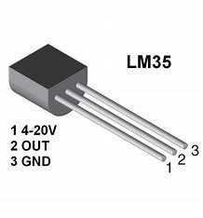Operating temperature range (°C): -55 to 150
   2. Supply voltage (min) (V): 4
   3. Supply voltage (max) (V): 30
   4. Supply current (max) (µA): 114
   5. Sensor gain (mV/°C): 10
2. 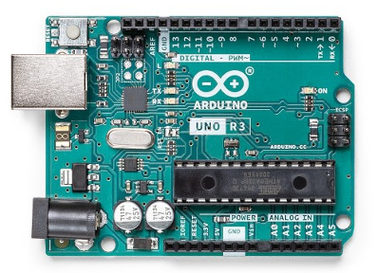Arduino Uno R3:
   1. ATMega328P Processor
   2. AVR CPU at up to 16 MHz
   3. 32KB Flash
   4. 2KB SRAM
   5. 1KB EEPROM
3. 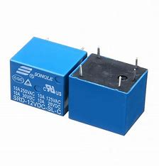12V 10A PCB mounted relay:
   1. Coil voltage: 12 V (DC)
   2. Current rating: 10 amp
   3. Operating temperature: – 55 °C – 85 °C
   4. Insulation Resistance: 250M ohm
   5. Coil Power Consumption: 0.36W
4. BC547 NPN transistor:
   1. 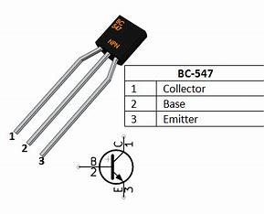DC Current Gain (h FE): 110-800
   2. Collector current (I C): 100mA
   3. Collector Base Voltage (VCB): 50V
   4. Collector-Emitter voltage (V CE): 45V
   5. Emitter Base Voltage (V EB): 6V
   6. Maximum Power dissipation: 500mW
   7. Junction temperature: 150⁰C
5. 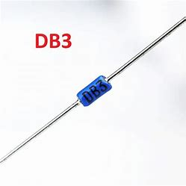DB3 Diac:
   1. Dynamic breakover voltage: 5V
   2. Output voltage: 5V
   3. Breakover current: 50microAmp
   4. Rise time: 2microSec
6. BTA16 Thyristor:
   1. 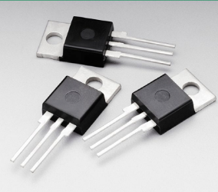Blocking Voltage to 800 V
   2. On-State Current Rating of 16 A RMS at 25°C
   3. Uniform gate trigger for Quadrants I, II, and III.
   4. High Immunity to dv/dt − 1000 V/µs minimum

at 125°C.

1. 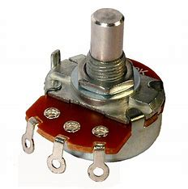Potentiometer:
   1. Resistance: 10 Ohms
   2. Power (Watts): 0.75W, 3/4W
   3. Tolerance: ±10%
   4. Temperature Coefficient: ±5ppm/°C

Block Diagram:

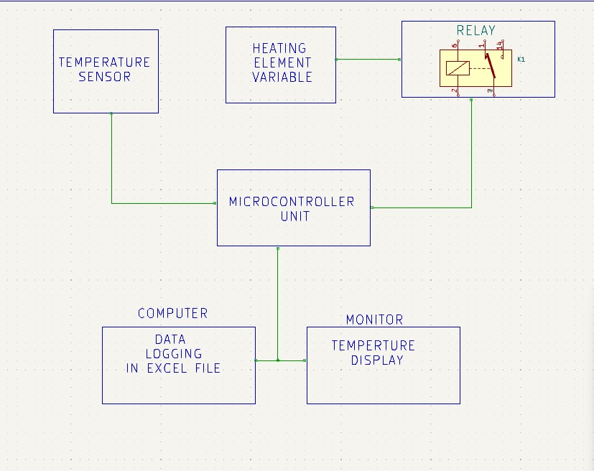

Circuit diagram:

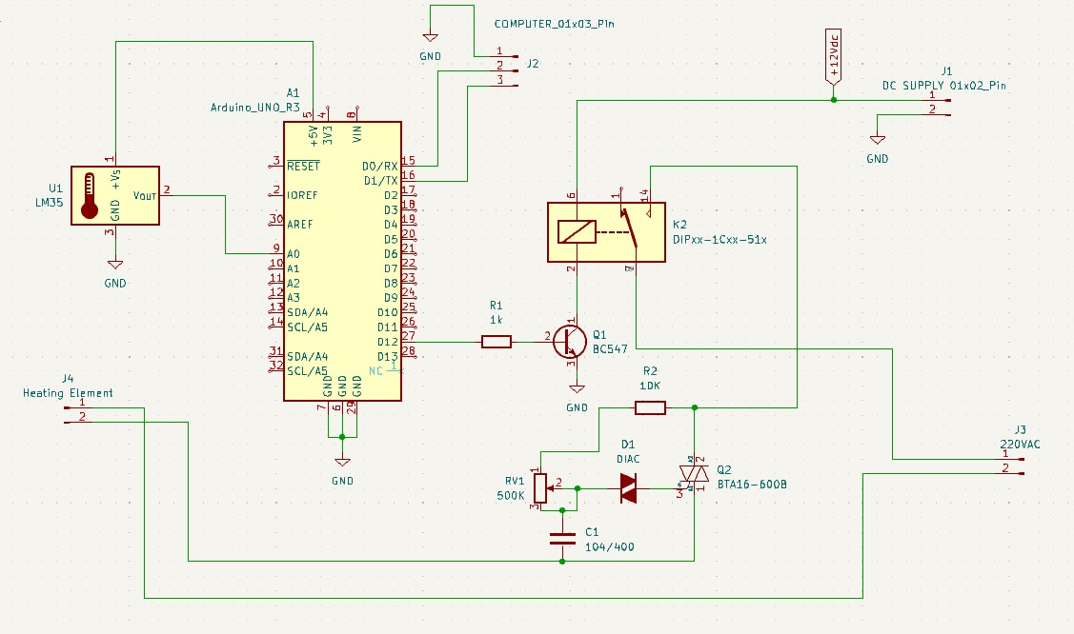

**Project Outcomes:**

1. **Enhanced Temperature Control:** The developed system will provide precise control over the temperature of the heating element, ensuring that it remains within the desired range during the teeth manufacturing process. This will contribute to higher quality and consistency in the final products.
2. **Real-Time Monitoring Capability:** The project will deliver a functional system that displays temperature readings in real-time on a connected screen. This feature will allow factory operators to monitor the production process closely and make immediate adjustments if necessary.
3. **Automated Safety Mechanism:** The integration of a relay in the system will automate the process of turning off the heating element if the temperature exceeds a set reference value. This will prevent overheating and potential damage to both the equipment and the products.
4. **Comprehensive Data Logging:** The system will generate CSV files that log temperature data throughout the production process. These files will serve as valuable records for post-production analysis, helping to verify that the teeth were produced at the correct temperature and aiding in the detection of any anomalies or errors.
5. **Improved Production Reliability:** By ensuring consistent temperature regulation and providing detailed records of the process, the system will improve the overall reliability of the teeth manufacturing process. This will lead to fewer defects and higher quality products, ultimately benefiting the production line’s efficiency and output.
6. **Potential for Broader Application:** While the system is specifically designed for teeth furnace manufacturing, its principles and components can be adapted for use in other industrial applications requiring precise temperature control and data logging.

Conclusion: This project successfully demonstrates the development of an Arduino-based temperature monitoring and control system designed for the specialized needs of teeth furnace manufacturing. By integrating an LM35 temperature sensor with an Arduino microcontroller, the system provides accurate and real-time temperature monitoring, essential for maintaining the high standards required in the production process. The inclusion of a relay ensures automated safety by preventing overheating, while the CSV data logging feature allows for thorough post-production analysis and verification of temperature consistency.

The implementation of this system not only enhances the reliability and quality of teeth manufacturing but also offers a scalable and adaptable solution for other industries that demand precise thermal regulation. The project outcomes indicate that this system can significantly reduce the risk of defects, improve production efficiency, and provide valuable data for continuous process improvement.

Overall, this project represents a meaningful advancement in temperature management technology, with practical applications that extend beyond the initial use case. The system's cost-effectiveness, ease of use, and adaptability make it a valuable tool for any industry where precise temperature control is paramount.

References:

1) https://www.electroschematics.com/wp-content/uploads/2010/02/LM35-DATASHEET.pdf

2) <https://www.electricallearner.in/product/12v-10a-power-relay/>

3) <https://docs.arduino.cc/resources/datasheets/A000066-datasheet.pdf>

4) <https://www.st.com/resource/en/datasheet/db3.pdf>

5) <https://link.springer.com/chapter/10.1007/978-3-319-25860-3_11>

6) https://link.springer.com/chapter/10.1007/978-981-15-1480-7_18