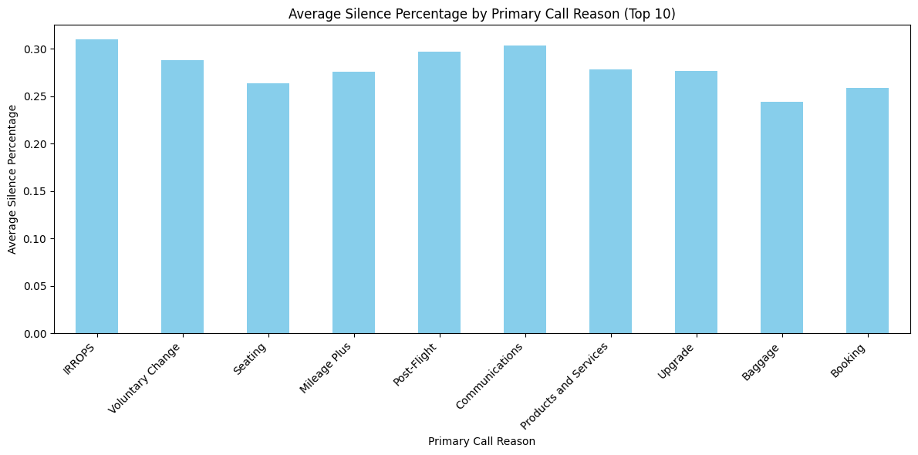

This bar chart shows the **Average Silence Percentage by Primary Call Reason (Top 10)**. Here are some insights based on the visualization:

**1. **IRROPS (Irregular Operations)** and **Communications\*\*** have the highest average silence percentages, both hovering around 30%. This suggests that these types of calls involve more pauses or silences, possibly indicating complex scenarios where agents or customers need extra time to process or discuss information.

**2. **Voluntary Change** and **Upgrade\*\*** calls also have relatively high silence percentages, close to 30%. These types of calls may involve detailed procedures or customer decision-making, leading to more silence.

**3. **Seating and **Baggage\*\*** calls have lower silence percentages compared to other categories. This could indicate that these call types are more straightforward, with less need for long pauses or moments of silence.

**4. **Booking\*\*** calls, although common, have a slightly lower average silence percentage. It suggests that customers and agents might quickly resolve these issues, requiring less processing time or reflection.

**5. **Post-Flight** and **Mileage Plus\*\*** calls also fall in the mid-range, indicating moderate silence, possibly because these call types could involve follow-ups or reward queries, which may not require as much time as the more complex topics but still involve some detailed discussions.

**General Insights:**

- Categories with higher silence percentages may point to more intricate processes or decision-making situations. Calls related to irregular operations or communication issues likely involve more information exchange or troubleshooting, causing longer silences.

- Simpler requests like **Seating** and **Baggage** likely have more direct interactions, leading to less silence.

Understanding these patterns can help improve training for customer service agents or suggest areas where call efficiency could be enhanced.

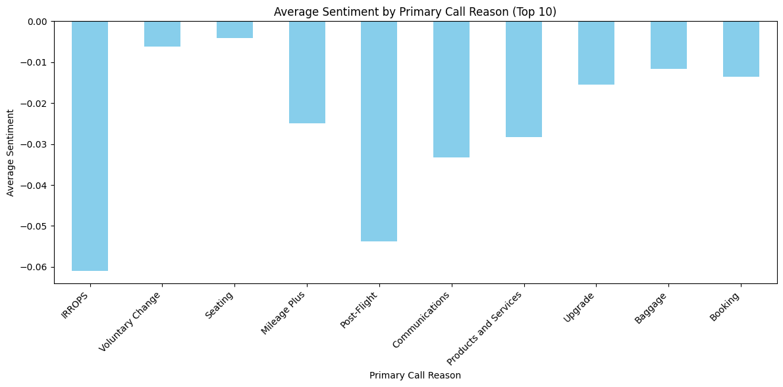

The bar chart shows the \*\***average sentiment** for different **primary call reasons**.

**1. **Negative Sentiment Across All Reasons**:**

- All primary call reasons have negative average sentiment values, implying that overall customer interactions related to these reasons are associated with dissatisfaction.

**2. **Most Negative Sentiment - IRROPS**:**

- The most negative sentiment is seen for **IRROPS** (Irregular Operations, typically referring to flight delays or cancellations), with an average sentiment close to -0.06.

- This suggests that customers are highly dissatisfied when calling about disruptions in operations.

**3. **Other Strongly Negative Areas**:**

- \*\***Post-Flight** and **Mileage Plus**\*\* also show significant negative sentiment (around -0.04 and -0.03 respectively).

- Post-Flight issues likely relate to problems that occurred after traveling, such as missing baggage or delayed refunds.

- \*\***Mileage Plus**\*\* could indicate dissatisfaction with loyalty program issues.

**4. **Moderately Negative Sentiment**:**

- **Voluntary Change**, **Seating**, **Products and Services**, **Upgrade**, and **Baggage** have moderately negative sentiment, indicating that these areas also face dissatisfaction, but not as severely as IRROPS.

- \*\***Seating**\*\* and \*\***Voluntary** Change** may reflect frustrations over comfort, availability, or fees for changing reservations.

- \*\***Upgrade**\*\* dissatisfaction may stem from issues with the availability or cost of premium services.

**5. **Least Negative Sentiment - Communications**:**

- \*\***Communications**\*\* has the least negative average sentiment, slightly below 0, which could imply that customers are less frustrated with communication-related issues compared to the other categories.

**6. **Booking**:**

- Although \*\***Booking**\*\* is one of the least negative in this chart, it still reflects some level of dissatisfaction, possibly due to issues with reservations or difficulties in booking processes.

**General Observation:**

- Customer dissatisfaction is widespread across all the primary reasons, with some areas (like IRROPS and Post-Flight) standing out as critical areas that may need more attention from a service improvement standpoint.

**Key Takeaway**: **Flight disruptions**, **loyalty program issues**, and **post-flight problems** are the leading sources of negative customer experiences. Improving service in these areas may help enhance overall customer satisfaction.

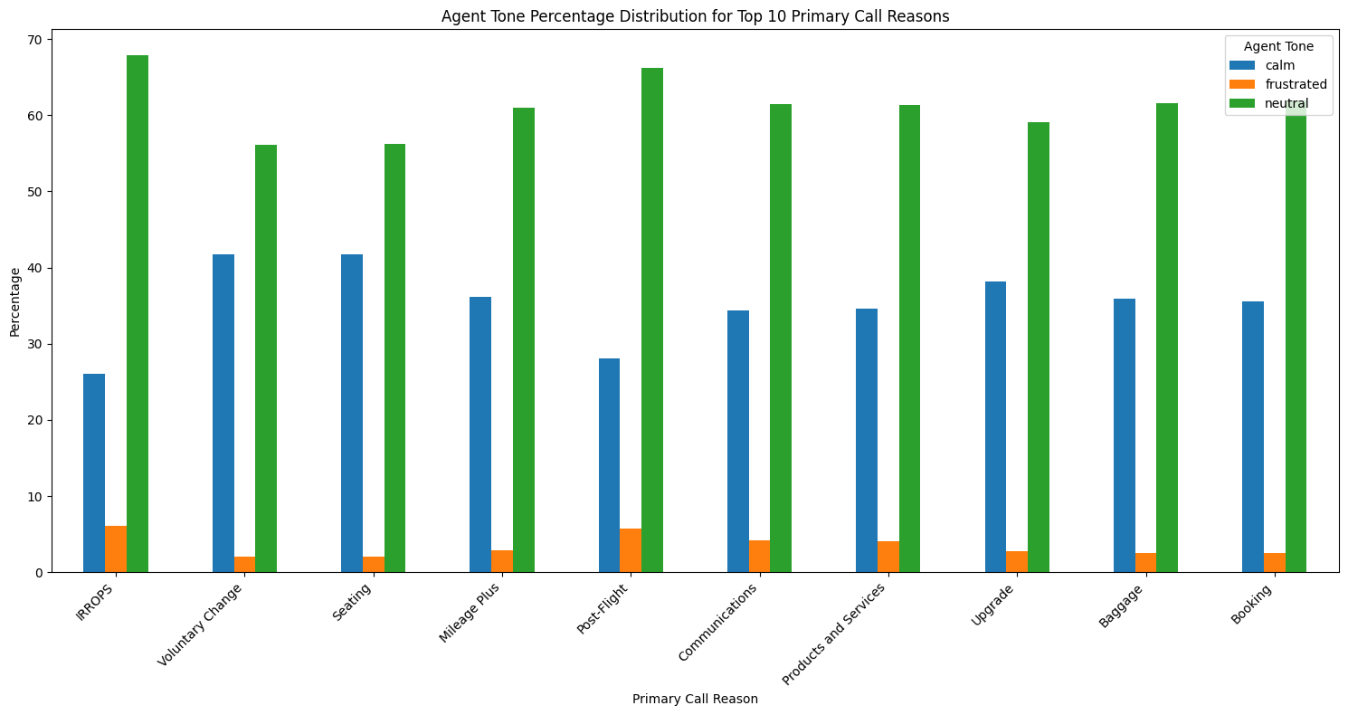

**Key Observations:**

1. **Dominance of Neutral Tone:**
   * The majority of call categories, particularly **Communications**, **Products and Services**, **Seating**, and **Mileage Plus**, show a high percentage of the neutral tone (green) used by agents. In most categories, neutral tone accounts for over 60% of interactions, indicating that agents tend to adopt a neutral stance in handling these calls.
   * **IRROPS** and **Post-Flight** have a relatively lower share of neutral tone compared to others.
2. **Calm Tone Usage:**
   * **IRROPS**, **Post-Flight**, and **Baggage** have a higher proportion of calm tone (blue) in comparison to the other categories. This suggests that agents frequently handle these types of calls with a calm demeanor, possibly because these situations may require reassurance and calm communication to resolve customer issues.
3. **Frustrated Tone:**
   * The frustrated tone (orange) has a very small percentage across all categories. This indicates that agents rarely express frustration, regardless of the primary reason for the call.
   * **Voluntary Change** and **Seating** have slightly higher frustrated tone percentages than other categories, implying that these areas might involve more emotionally charged conversations, perhaps due to customer dissatisfaction.
4. **Categories Requiring More Calm Tone:**
   * **IRROPS**, **Post-Flight**, and **Baggage** stand out for the higher calm tone usage. These are typically more critical service-related categories where maintaining calm could be essential in resolving complex or stressful issues for customers.
5. **Neutral and Calm Balance:**
   * Some categories, like **IRROPS**, **Post-Flight**, and **Baggage**, show a more balanced split between calm and neutral tones, which may reflect the nature of these interactions requiring both a reassuring yet objective approach.

**Insights:**

* **Neutral Tone Prevalence:** Agents are predominantly neutral, which is appropriate for handling factual and routine issues, like **Seating** and **Mileage Plus** queries, where emotional response might not be necessary.
* **Call Categories with Higher Calm Tone Needs:** **IRROPS**, **Post-Flight**, and **Baggage** appear to require more calm communication, likely due to the more critical nature of these calls. These categories could be prioritized for training focused on maintaining calmness under pressure.
* **Frustration Minimal:** The low incidence of frustrated tone suggests that the agents are well-trained to manage their emotions or the systems in place allow for smoother call handling, reducing the likelihood of frustration.

Overall, agents appear to manage their tone professionally across different call reasons, but there could be more emphasis on increasing calm tones in categories like **Voluntary Change** and **Seating** to further enhance customer satisfaction.

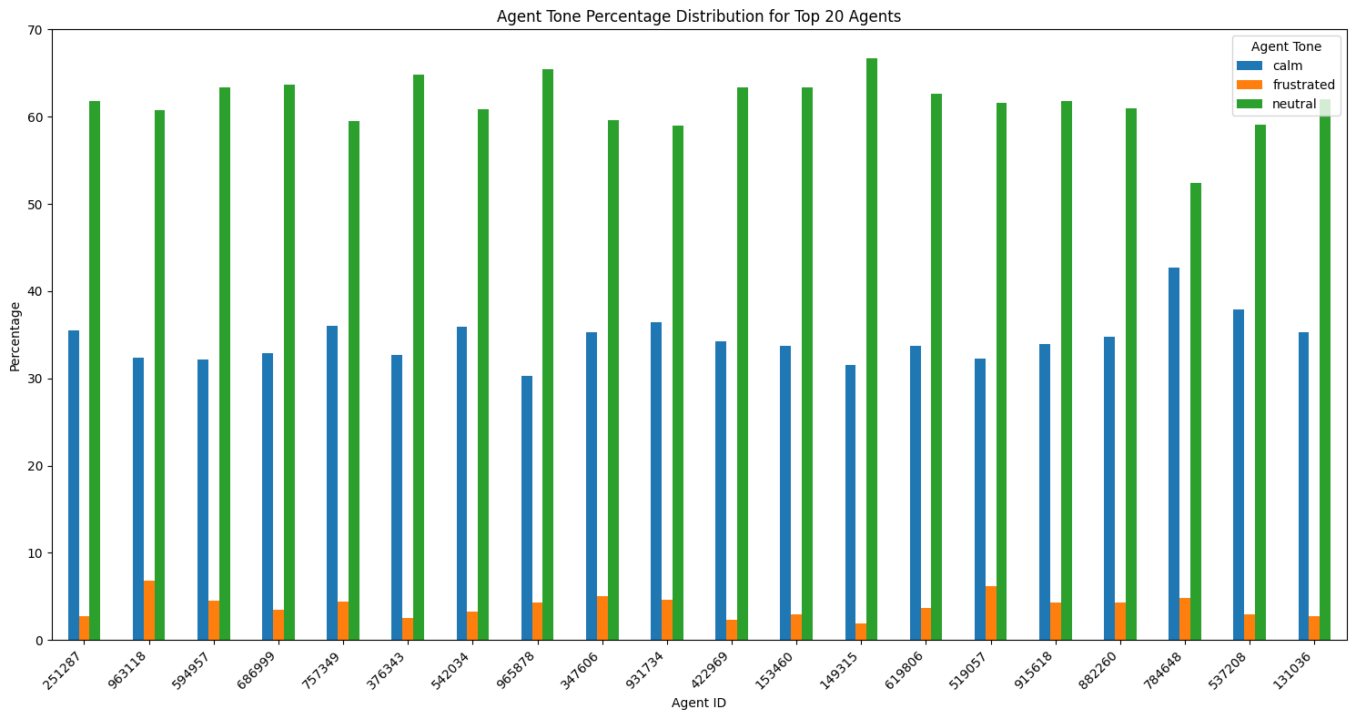

**Insights:**

1. **Dominance of Neutral Tone:**
   * Neutral tone remains the most frequently used tone among agents, indicating that most calls are routine, and agents are trained to approach them with an objective and professional tone.
2. **Agents with More Calm Tones:**
   * Agents like **251287**, **753149**, and **615006** stand out for their higher calm tone percentages. These agents may be better at maintaining composure during stressful situations and could be used as examples for training others in handling difficult calls.
3. **Frustrated Tone Minimization:**
   * The consistently low percentage of frustrated tone usage across all agents reflects positive behavior management strategies within the team. However, agents like **931314** and **612158** might need additional support to reduce frustration, perhaps by focusing on techniques to manage stressful calls or escalations.
4. **Potential for Training and Balance:**
   * Agents with high neutral and low calm tone (e.g., **953460**, **542034**) may benefit from training in how to introduce more calming elements into their calls, especially in situations that require empathy or emotional reassurance.

In conclusion, the chart indicates a generally well-trained group of agents with neutral tones being the norm, but some agents could benefit from training in incorporating more calm tones to enhance customer experience in challenging scenarios.

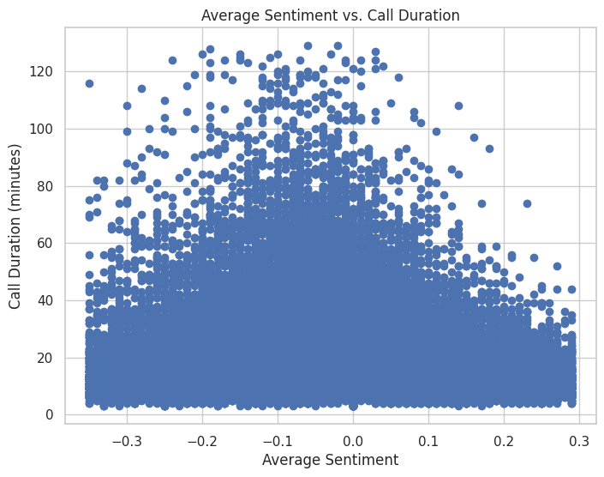

**Insights:**

* **Neutral Sentiment Calls** are more likely to have longer durations. These conversations may be more balanced, leading to extended discussions.
* **Negative Sentiment Calls** tend to cluster at shorter durations, suggesting that conversations with more negative tones may end sooner, but there are some exceptions where negative conversations last longer.
* **Positive Sentiment Calls** are not necessarily shorter but seem to follow a similar duration pattern to neutral calls, peaking around mid-range durations.
* There is no strong trend indicating that sentiment directly correlates with increasing or decreasing call duration, but neutral to slightly positive sentiment calls tend to have longer durations on average.

This pattern might indicate that the quality of conversation (sentiment) has more subtle effects on the duration, with extreme sentiments not drastically affecting call length.

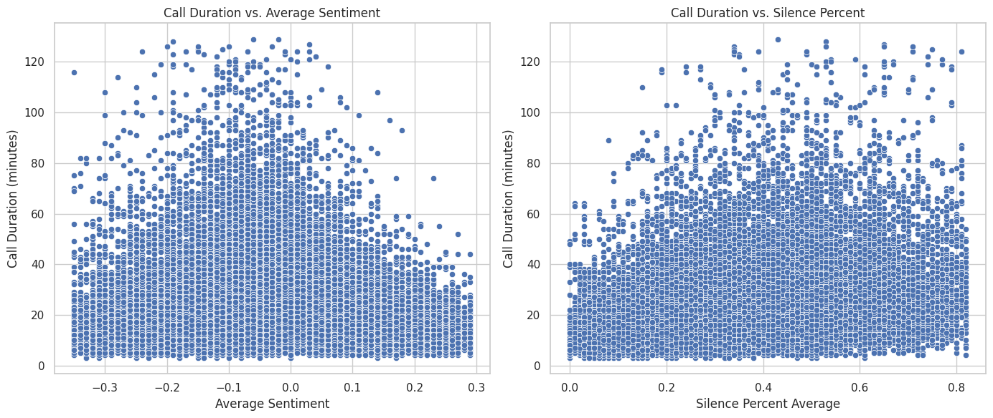

* **Sentiment and Silence**: The two plots suggest that longer calls are associated with both **neutral-to-positive sentiment** and **lower silence percentages**, hinting at more balanced, engaged conversations leading to extended durations.
* **Shorter Calls**: These are more likely to exhibit **negative sentiment** or **higher silence percentages**, which could indicate less engaging or difficult conversations that end sooner.

This dual analysis shows that the interplay of sentiment and engagement (silence) both affect call durations, with more active and neutral-to-positive conversations generally lasting longer.

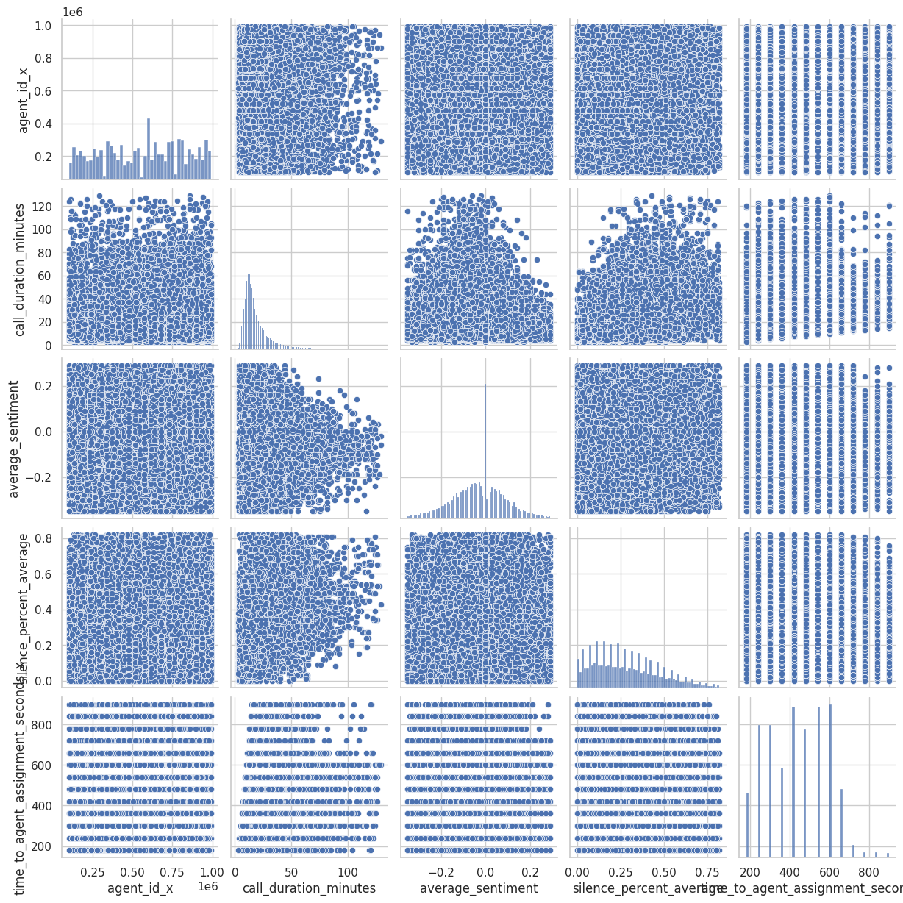

Fig. *pairplot for merged dataset of calls and sentiments (valuable columns only)*

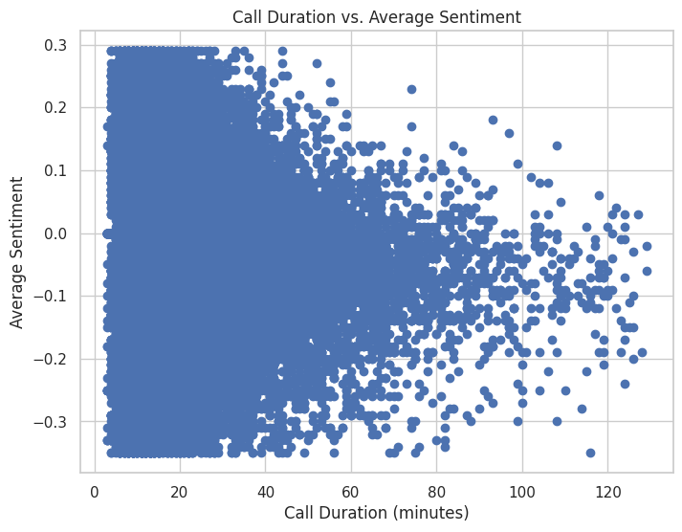

**Insights:**

* **Shorter Calls (0-20 minutes)** have the broadest spread in terms of sentiment, indicating that even brief conversations can range from highly negative to highly positive.
* **Neutral Sentiment** is most prevalent in conversations of all lengths, particularly in calls lasting between 20 and 60 minutes.
* **Longer Calls (60+ minutes)** tend to feature more balanced (neutral to slightly positive) sentiments, suggesting that more engaged and balanced conversations result in extended call durations.
* There is **no strong correlation** between increasing call duration and a shift toward either positive or negative sentiment. However, the densest area of calls across different durations tends to lean toward neutrality, indicating that most conversations tend to be balanced in tone.

**Conclusion:**

* **Call Duration** is influenced primarily by the **sentiment of the conversation**, with **neutral and positive** tones leading to longer discussions.
* **Silence** plays a major role, with more active conversations (less silence) correlating with longer calls.
* Higher levels of **engagement and interaction** generally result in longer call durations, while disengagement, negative sentiment, or frequent pauses shorten conversations.