B.N.M. Institute of Technology
An Autonomous Institution under VTU
Approved by AICTE, Accredited as grade A Institution by NAAC.
UG Branches – CSE, ECE, ISE and EEE are accredited by NBA and valid upto June 2028
URL: www.bnmit.org

DEPARTMENT OF COMPUTER SCIENCE AND ENGINEERING
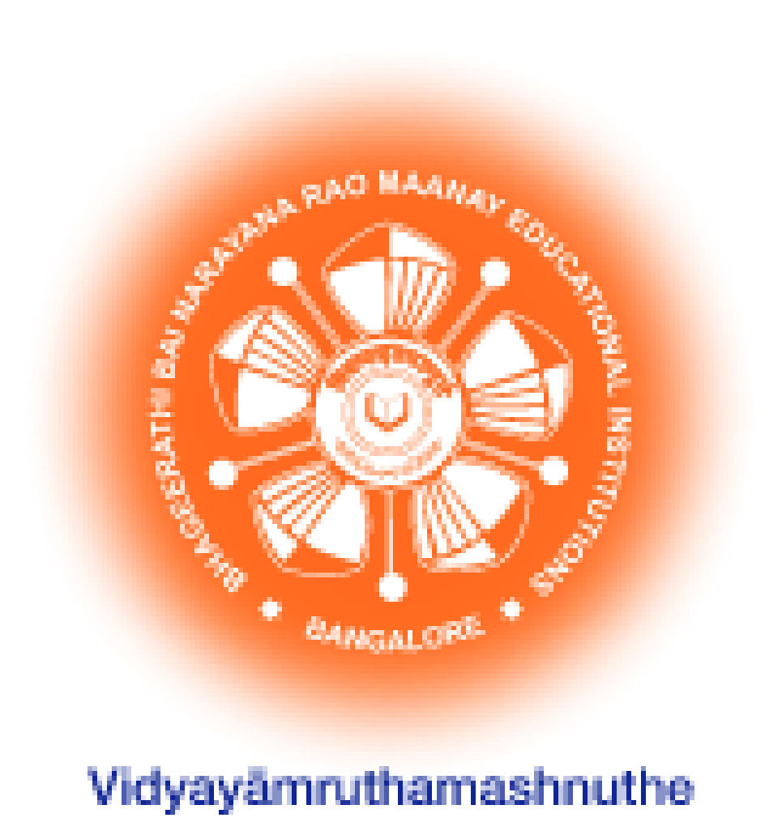

CERTIFICATE

Certified that the fourth Semester internship entitled Athenaeum-Library Management System carried out by Mr. Vishnu Prasad (1BG24CS183) bonafide student of 4th Semester B.E., B.N.M Institute of Technology, an Autonomous Institution under Visvesvaraya Technological University, Belagavi submitted in partial fulfillment for the Bachelor of Engineering in COMPUTER SCIENCE AND ENGINEERING, during the year 2025-26. It is certified that all corrections/suggestions indicated for Internal Assessment have been incorporated in the report. The Internship report has been approved as it satisfies the academic requirements in respect of the internship prescribed.

Dr. Kavitha Jayaram | Prof. Priyanka Padki | Dr. Chayadevi M L | Dr. S Y Kulkarni
Associate Professor, | Assistant Professor, | Professor and HOD, | Additional Director
Dept. of CSE, | Dept. of CSE, | Dept. of CSE, | and Principal,
BNMIT, Bengaluru | BNMIT, Bengaluru | BNMIT, Bengaluru | BNMIT, Bengaluru

Name Signature with Date

Examiner 1:

Examiner 2:

ACKNOWLEDGEMENT

We consider it a privilege to express through the pages of this report, a few words of gratitude to all those distinguished personalities who guided and inspired me in the completion of this Internship.

We would like to thank Shri. Narayan Rao R Maanay, Secretary, BNMEI, Bengaluru for providing an excellent academic environment in college.

We would like to thank Prof. T.J. Rama Murthy, Director, BNMIT, Bengaluru for having extended his support and encouragement during the course of work.

We would like to thank Dr. S.Y. Kulkarni, Principal and Additional Director, BNMIT, Bengaluru for his extended support and encouragement during the course of work.

We would like to express my gratitude to Prof. Eishwar N Maanay, Dean, BNMIT, Bengaluru for his relentless support, guidance, and encouragement.

We would like to thank Dr. Krishnamurthy G.N., Deputy Director, BNMIT, Bengaluru for his constant encouragement.

We would like to thank Dr.Chayadevi M L, Professor and Head of the Department of Computer Science and Engineering, BNMIT, Bengaluru, for her support and encouragement towards the completion of the Internship-1.

We would like to express our gratitude to our guide Dr. Kavitha Jayaram, Associate Professor, Department of Computer Science and Engineering, BNMIT, Bengaluru, who has given us all the support and guidance in completing the Internship-1 successfully.

We would like to thank our Internship -1 coordinators Prof. Devi Naveen, Assistant Professor, and Prof. Priyanka Padki, Assistant Professor, Department of Computer Science and Engineering., BNMIT, for being the guiding force towards the successful completion of our Internship-1

Vishnu Prasad
1BG24CS183

