Name: RTL JOULES OPT TOOLS
githubUrl: https://github.com/Vishnukamali3/RTL_JOULES_OPT_TOOLS
description: This project focuses on the design and verification of an 8-bit Universal Shift Register using Verilog HDL and Vivado. The design supports multiple operations such as Hold, Shift Left, Shift Right, and Parallel Load through mode selection signals. Along with functional verification, the project performs simplified PPAC (Power, Performance, Area, and Congestion) analysis using switching activity estimation, synthesis reports, and timing analysis. The project demonstrates optimization-aware RTL design concepts inspired by industrial Joules RTL optimization methodologies in an FPGA-based environment.

Functional Requirements

RTL Power Analysis
- Cadence Joules analyzes power consumption at the RTL stage of digital design. It helps designers estimate power usage early before chip fabrication.

Switching Activity Detection
- The tool identifies unnecessary switching activity in circuits. This helps reduce dynamic power consumption and improve efficiency.

Clock Gating Support
- Joules supports clock gating techniques to control unnecessary clock signals. This reduces power wastage in idle circuit blocks.

Power Report Generation
- The tool generates detailed power analysis reports. These reports help designers understand power distribution in the design.

High-Power Block Identification
- Joules detects modules that consume excessive power. Designers can optimize these blocks for better performance and lower energy usage.

Design Optimization
- The tool helps improve power, performance, and area (PPA). It supports efficient low-power semiconductor chip design.

Non-Functional Requirements
- Non-Functional Requirements of Cadence Joules
- Perform power analysis quickly and efficiently.
- Provide accurate and reliable power estimation results.
- Support both small and large-scale VLSI designs.
- Operate consistently without crashes or data loss.
- Provide an easy-to-use interface and clear reports.
- Integrate smoothly with RTL, synthesis, and simulation tools.
- Maintain stable performance during complex design analysis.

Support standard VLSI design flows and file formats.
problem_statement: Modern digital systems require efficient RTL designs that achieve low power consumption, high performance, reduced hardware area, and optimized switching activity. Traditional educational RTL projects mainly focus on functionality verification and often ignore PPAC (Power, Performance, Area, and Congestion) analysis used in industrial ASIC and FPGA design flows. There is a need for a simplified and FPGA-accessible methodology to study industrial RTL optimization concepts using standard tools like Vivado. Therefore, the challenge is to design an 8-bit Universal Shift Register capable of multiple data operations while also analyzing its PPAC characteristics through RTL-level estimation and synthesis reports.

proposed_solution: To address this problem, an 8-bit Universal Shift Register is designed using Verilog HDL with support for Hold, Shift Left, Shift Right, and Parallel Load operations through mode selection signals. The design is simulated and verified in Vivado to ensure correct functionality. A simplified PPAC analysis methodology inspired by Joules RTL Design Studio is implemented using toggle-rate based switching activity estimation, mode activity monitoring, timing analysis, and FPGA resource utilization reports. Optimization-aware RTL techniques such as clock-enable based activity reduction and structured coding are incorporated to reduce unnecessary switching activity and improve overall design efficiency. Vivado synthesis and implementation reports are used to evaluate power, timing, area utilization, and congestion-related behavior in an educational FPGA environment.

technologies_used: Verilog HDL, Vivado Design Suite, Xilinx FPGA Flow, RTL Design Methodology, PPAC Analysis Techniques, VCD Switching Activity Analysis, Behavioral Simulation, Synthesis and Timing Analysis, and Optimization-Aware RTL Coding.

system_architecture: The system architecture consists of an 8-bit Universal Shift Register designed using Verilog HDL, controlled by clock, reset, mode selection signals, serial inputs, and parallel data inputs. The architecture supports four operations: Hold, Shift Left, Shift Right, and Parallel Load. A control logic block selects the required operation based on mode inputs. The RTL design is simulated and synthesized in Vivado, where switching activity, timing performance, power consumption, and area utilization are analyzed using VCD files and synthesis reports. The PPAC analysis block estimates Power, Performance, Area, and Congestion characteristics to study optimization-aware RTL behavior.

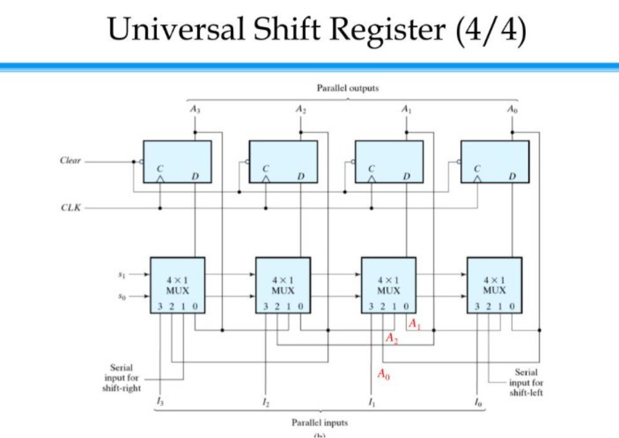
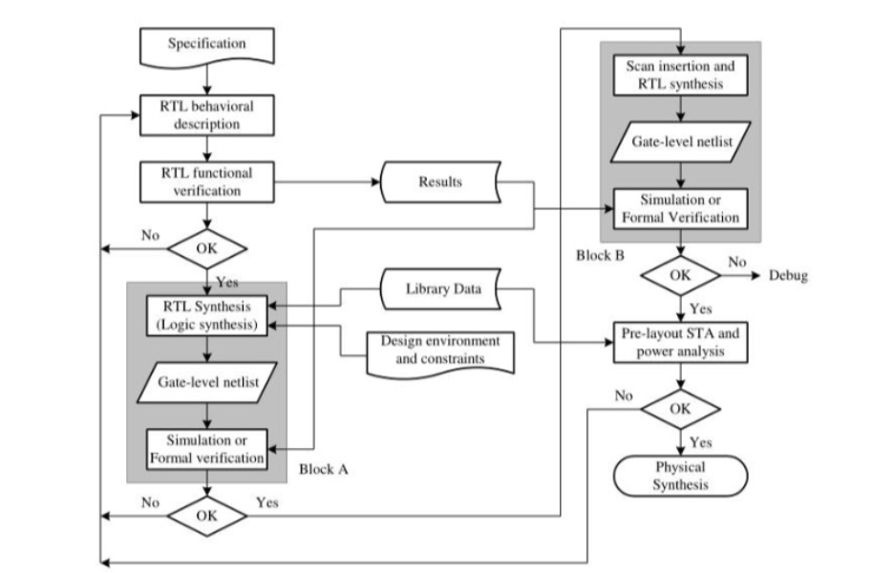

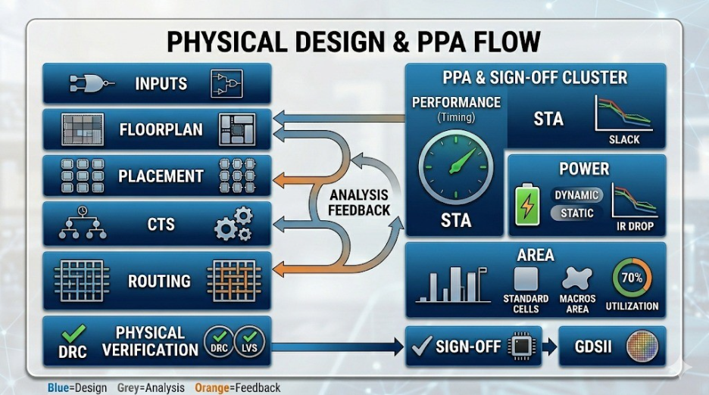

Outputs:
Waveforms:
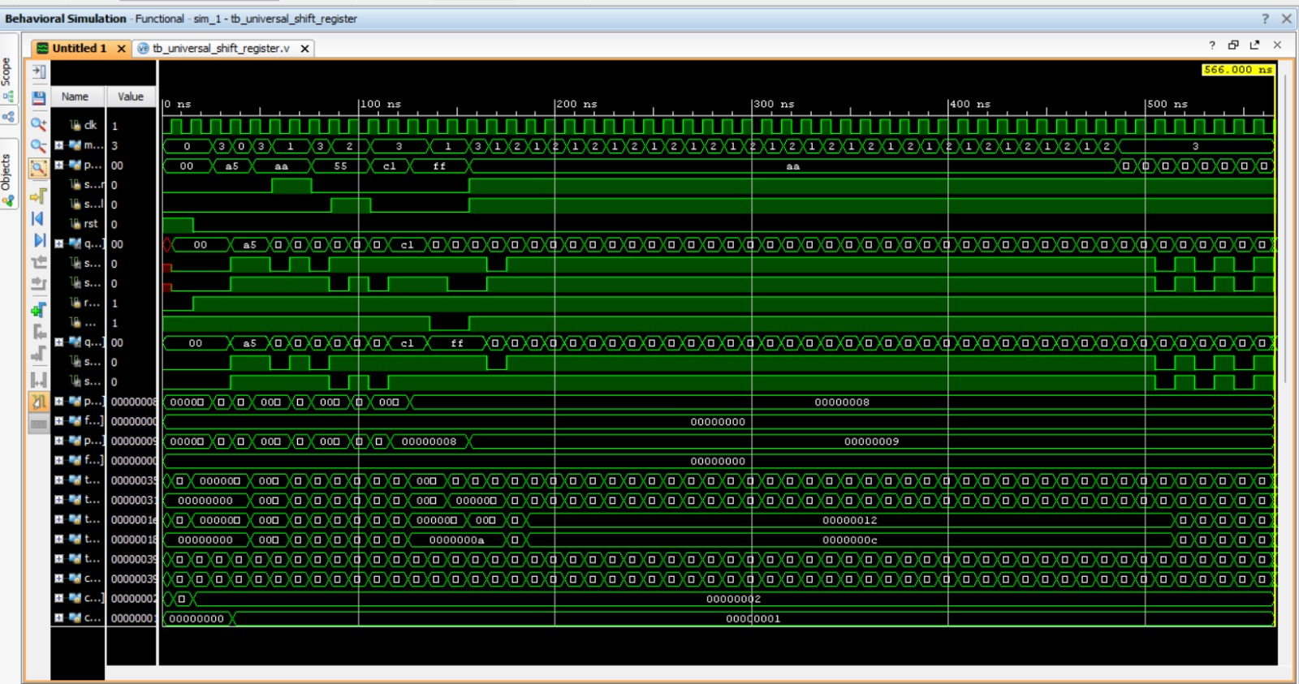

Performance:
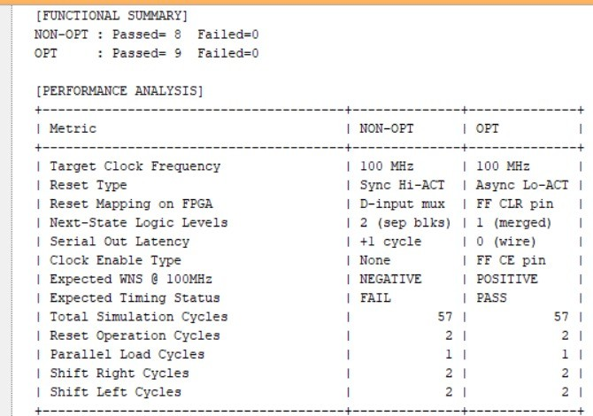

Area and power:
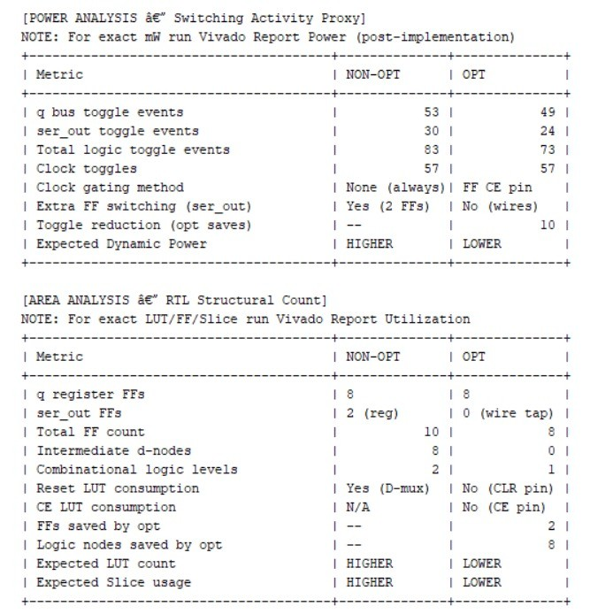

Congestion:
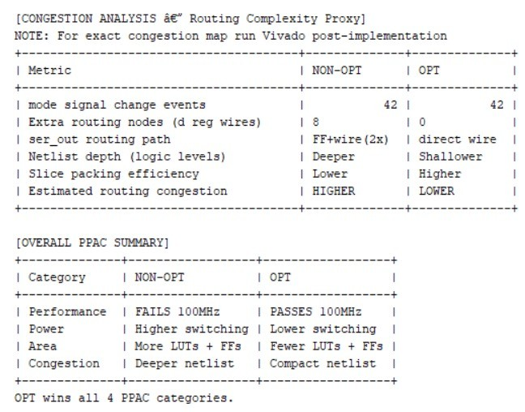
in_scope: The scope of this project includes the design, simulation, synthesis, and PPAC analysis of an 8-bit Universal Shift Register using Verilog HDL and Vivado. The project focuses on studying power consumption, timing performance, area utilization, and switching activity using FPGA-based RTL design techniques. It also demonstrates optimization-aware coding methods inspired by industrial Joules RTL optimization flows, providing practical understanding of RTL verification and hardware efficiency analysis in an educational environment.

out_scope: The project does not include ASIC fabrication, advanced physical design implementation, real-time hardware prototyping, or detailed industrial congestion analysis. It also excludes advanced low-power techniques such as clock gating, power gating, dynamic voltage scaling, and machine learning-based optimization methods. The work is limited to FPGA-based RTL-level PPAC estimation and functional verification using Vivado tools.
future_enhancements:
Enhancement 1 — VCD-Based Power Analysis Flow: Add a Tcl script that reads the sim_dump.vcd file generated by the testbench and feeds it into Vivado’s read_vcd and report_power commands. This replaces the current toggle-counter proxy approach with actual mW-level dynamic power numbers from Vivado’s internal power model, directly fulfilling the VCD Switching Activity Analysis claim stated in the specification.
Enhancement 2 — Committed Vivado Reports: Run synthesis and implementation for both the optimized and non-optimized designs and commit the resulting Vivado reports (timing summary, utilization, and power report) to the repository under a reports/ folder. This provides concrete evidence for all PPAC claims—positive vs. negative WNS, LUT/FF counts, and dynamic power—that currently exist only as expected values in comments and the testbench console output.
Enhancement 3 — Automated Tcl Build Script: Develop a run_all.tcl script that automates the full flow: create project, add sources and constraints, run synthesis, run implementation, and export timing, utilization, and power reports to the reports/ folder in one command. This makes the build reproducible and eliminates manual GUI steps in Vivado.
Enhancement 4 — Scalable Width (16-bit / 32-bit): Leverage the existing parameterized WIDTH parameter in both RTL modules to instantiate 16-bit and 32-bit variants and re-run the full PPAC analysis. Comparing area, power, and timing across bit-widths demonstrates design scalability and gives quantitative insight into how PPAC trade-offs grow with data width.
Enhancement 5 — README and Build Documentation: Add a README.md to the repository root that documents the project structure, simulation steps (xvlog/xelab/xsim commands), Vivado synthesis and implementation flow, how to read the PPAC reports, and expected console output from the testbench. This is the entry point any reviewer or collaborator needs to reproduce the results independently.

conclusion: The project successfully implements and verifies an 8-bit Universal Shift Register using Verilog HDL and Vivado. Along with functional operations such as Hold, Shift Left, Shift Right, and Parallel Load, the project performs simplified PPAC analysis to study Power, Performance, Area, and Congestion characteristics at the RTL level. The use of optimization-aware coding and switching activity analysis provides practical understanding of industrial RTL optimization concepts in an FPGA-based environment. Overall, the project demonstrates an effective and educational approach for learning power-aware and performance-aware digital system design using accessible FPGA tools.

projectType: FPGA-Based RTL Design and PPAC Analysis Project using Verilog HDL and Vivado.

