Collection Framework: Combination of interface and class that are used to store and manipulate the data.
Collection: Representing a group of objects as a single entity.
Collections: Provides Utility methods to work with collections.
Array vs Collection:
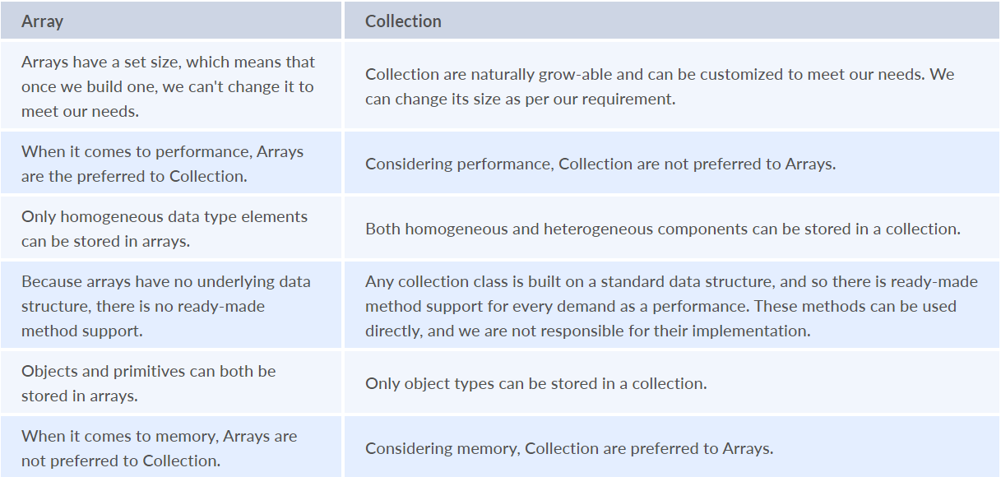
Interfaces in Collection framework:
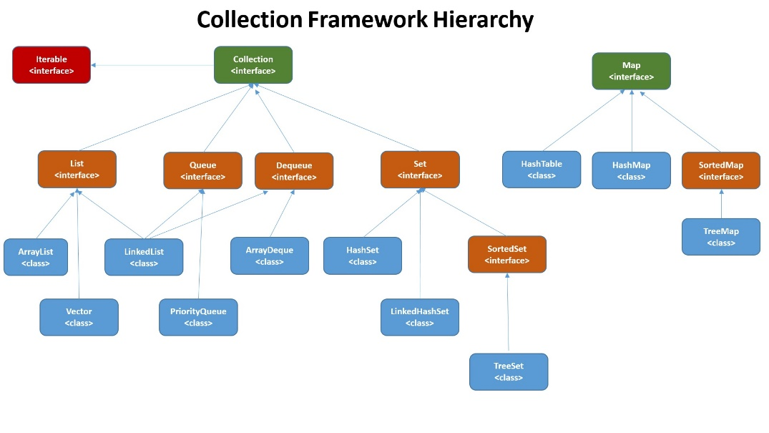
Array: Fixed data structure used to store a list of elements of the same datatype(homogeneous). Arrays are fixed in size and their elements are ordered. An index refers to an element’s position within an array. The index of an array starts from 0 and goes up to one less than the total length of the array.
<datatype>[] <variablename> = {element1,element2} // initialize with elements (or)
<datatype> <variablename>[] = new <datatype> [4]; // initialize with size
List: Ordered collection of objects and contains duplicate and can be accessed randomly.
Arraylist: It is an ordered collection of objects uses dynamic array. It can automatically grow and shrink with respect to requirement. It is not synchronized and we cannot use primitive datatypes.
ArrayList is not synchronized. Use Collections.synchronizedList(new ArrayList<>()) for thread-safe operations. Can store null and duplicates.
Internal Working of ArrayList: 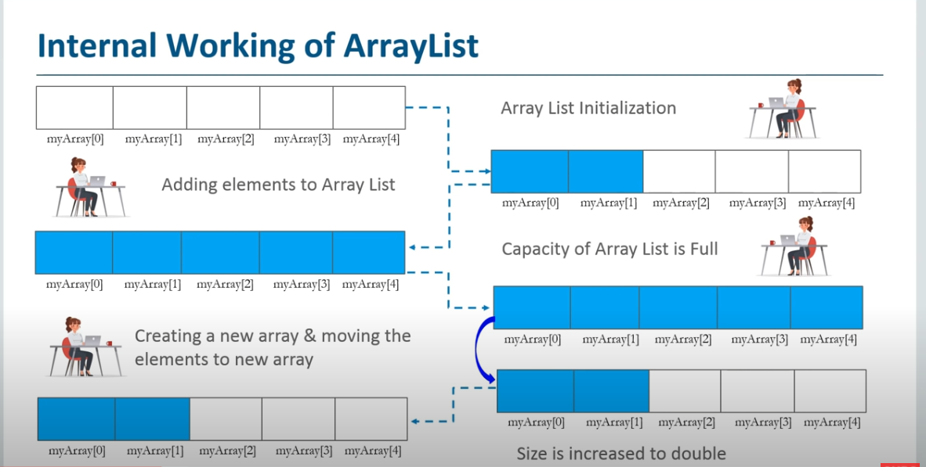
- Default capacity of Arraylist is 10 and after Java 8 empty array is created by default constructor.
- When we add a new element to the empty array it will expand to size 10 by lazy initialization.
- It can store data till the ArrayList size is full, after that the size of ArrayList is 50% increased if we want to store any more elements.
- The new array is created internally and elements are copied to a new array.
CopyOnWriteArrayList: This class implements the list interface. It is an enhanced version of ArrayList in which all the modifications (add, set, remove, etc.) are implemented by making a fresh copy of the list. It is failsafe
LinkedList: LinkedList is implemented using Doubly Linked List.
Internal Implementation:
LinkedList represents it’s elements as Nodes
- Left side Node Part is used to point to the previous Node (Or Element) in the LinkedList.
- Right side Node Part is used to point to the next Node (Or Element) in the LinkedList.
- Center Node Part is used to store actual data.
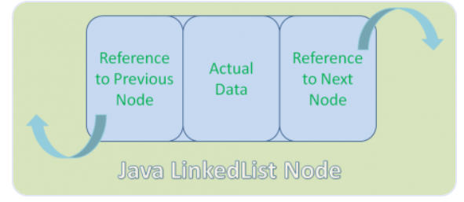
LinkedList does NOT store its elements in consecutive order. It stores its elements at any available space and they are connected each other using Left and Right side Node portions.
In case of insertion/deletion the node portions will point/depoint to newly added/deleted element index https://www.digitalocean.com/community/tutorials/java-linkedlist-linkedlist-java
Vector: Vector class implements a growable array of objects. It is same as arraylist but it is synchronized in nature. So, it is thread safe.
Vector follows insertion order, can have null and duplicates and used when we need a synchronized list.
Array vs Vector
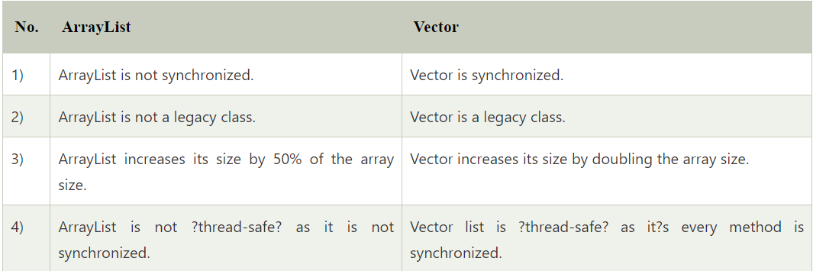
ArrayList vs LinkedList
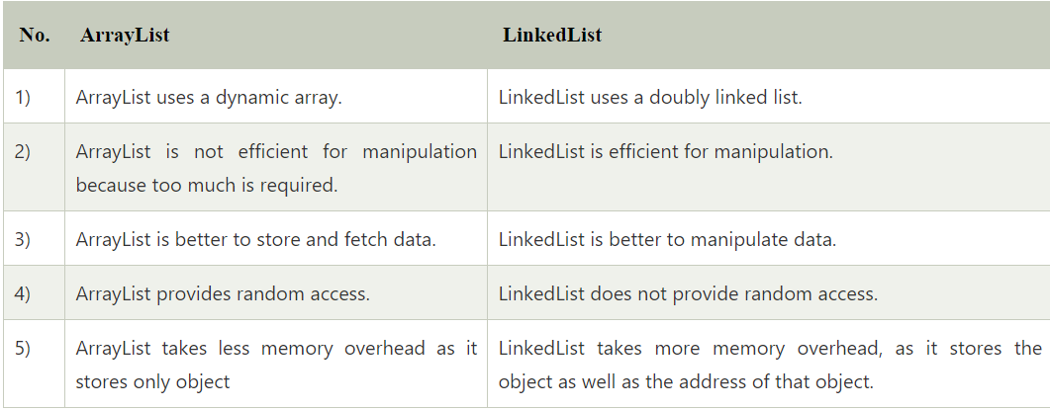
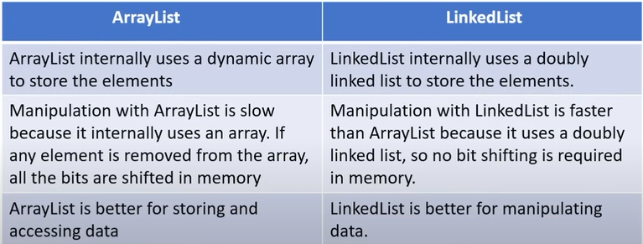
Iterator vs ListIterator
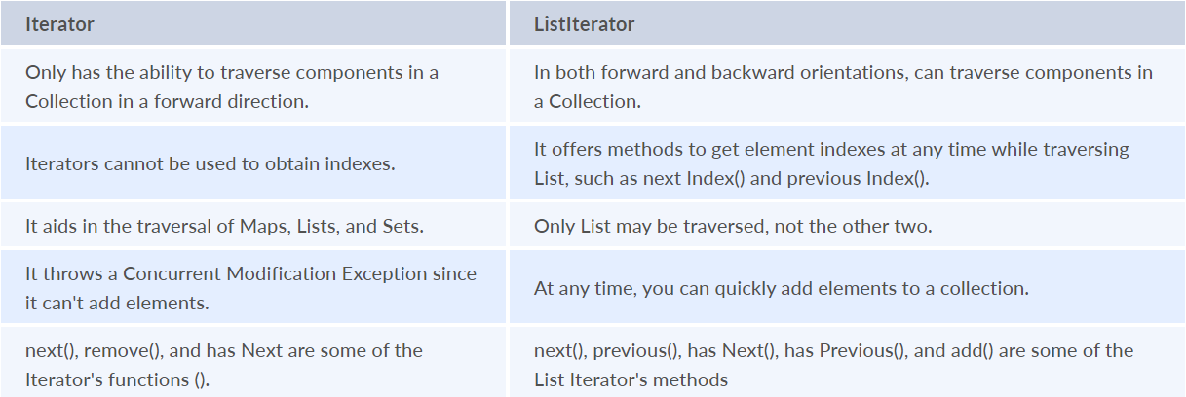
Iterator vs Enumeration
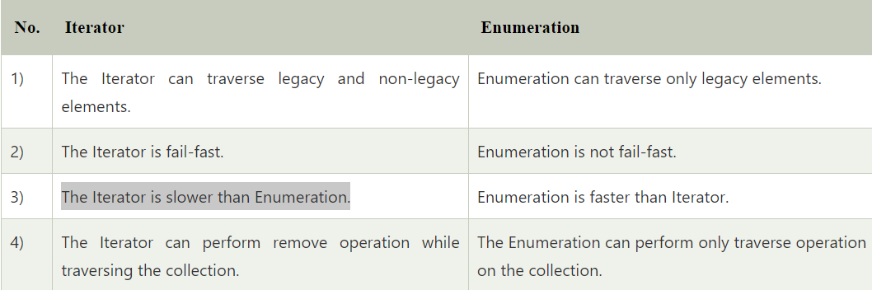
Set: Unordered collection of objects and cannot contains duplicate. Can have one null element.
HashSet: Unordered collection of objects and cannot contains duplicate. Uses HashMap for internal implementation and can have one null element. Initial Capacity is 16 and load factor is .75
Internal Working of HashSet:
HashSet internally uses HashMap for the implementation. When you create a HashSet there are three implementations with the constructors. The values passed in the parameterized constructor of HashSet will be passed to the parameterized constructor of HashMap
- Empty/Default Constructor
- Parameterized Constructor with capacity
- Parameterized Constructor with capacity and loadfactor
- Parameterized Constructor with Collection object
Key will be the object we pass as the argument in add() method and value will be PRESENT, a constant
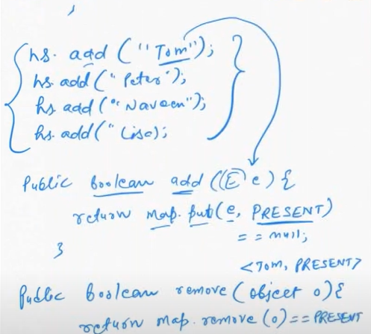
LinkedHashSet: Ordered collection of objects and cannot contains duplicate. It internally uses a HashMap and Doubly linked list to store the elements in the set. Initial Capacity is 16 and load factor is 0.75.
Internal Working of LinkedHashSet:
Internally LinkedHashSet uses LinkedHashmap

Stacks: A stack is a linear data structure that follows the Last In, First Out (LIFO) principle. This means that the last element added to the stack is the first one to be removed.
Operations in Stack:
- Push: Adds an element to the top of the stack.
- Pop: Removes and returns the top element of the stack.
- Peek (or Top): Returns the top element of the stack without removing it.
- IsEmpty: Checks if the stack is empty.
- Size: Returns the number of elements in the stack.
Queue: Linear data structure that stores the elements in the form FIFO (first in first out).
Operations in Queue:
- Enqueue: Adds an element to the end (rear) of the queue.
- Dequeue: Removes and returns the front element of the queue.
- Front (or Peek): Returns the front element of the queue without removing it.
- IsEmpty: Checks if the queue is empty.
- Size: Returns the number of elements in the queue.
Types of Queues:
- Simple Linear Queue We can only insert the element at the back and remove the element from the front of the queue
- Dequeue: Double-ended-queue allows the insertion and removal of elements from both ends. It implants the properties of both Stack and queue so it can perform LIFO (Last in first out) stack and FIFO (first in first out) queue, operations.
- Circular Queue: Last position is connected back to the first position and perform FIFO (first in first out)
- Priority Queue: Elements are accessed based on the priority assigned.
  - Ascending Priority Queue: The elements are arranged in increasing order of their priority values. Element with smallest priority value is popped first.
  - Descending Priority Queue: The elements are arranged in decreasing order of their priority values. Element with largest priority is popped first.
Why and when should we use Stack or Queue data structures instead of Arrays/Lists:- When you need to manage data in a specific order like task scheduling printing documents and messaging queues
List vs Set vs Map
List | Set | Map
Ordered collections of objects with indexed sequence | Unordered collections of objects with non-indexed sequence | Key, value pair storage of elements
Allows duplicate elements | Does not allow duplicate elements | Contains a unique key but can have duplicate elements.
Elements can be accessed by their positions | Elements cannot be accessed by their positions | Elements cannot be accessed by key pair values
Multiple null elements can be stored | Only one null element can be stored | Map allows a single null key at most and any number of null values.
HashMap vs HashTable vs HashSet:
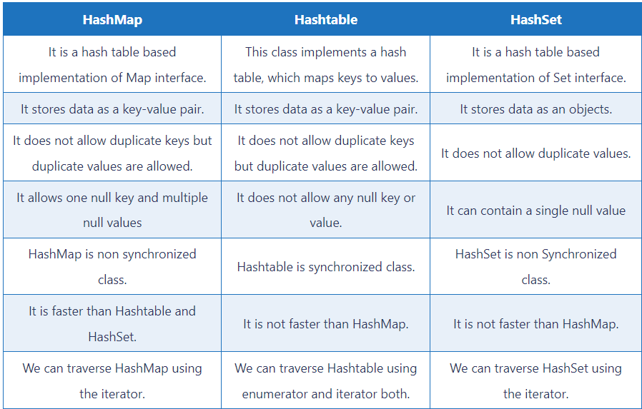
Set() vs Add() method in Arraylist:
Set replaces the element at the given index. add inserts the element at the given index and moves all elements ahead of it one position
Hashing: Hashing is a process of converting an object into integer form by using the method hashCode()
Hashcode(): Returns the memory reference of an object in integer form.
Hash collision: A hash collision in Java occurs when two or more keys have the same hash code and are stored in the same bucket in a hash table
Map: Map represents a key, value pair storage of elements. Map interface does not implement the Collection interface. It can only contain a unique key but can have duplicate elements.
Internal Working of Hash Table:
- If you use put method it will create the hash code of the key hashcode(key), find the index and store in the segments.
- 11 segments/buckets will be created in heap memory where the key value pair is stored for the below code. HashTable<String,Integer> hashtable =new HashTable<String,Integer>();
- Finds the hashcode of the key and use modulus operator of 11 to find the index.
- If the hash collision occurs with the hashcode and it will give you the same index number then it will check for the objects present in the index or not
- If there is not key present in index it will store the objects there if index is occupied with key it will compare using equals method and it will create a new of linked list and add the object to it and continues forever.
Linked List : Key | Hashcode | Value | null
Linked List if the index is occupied already :
Key 1 | Hashcode | Value1 | null –Points--> Key 2 | Hashcode | Value2 | null
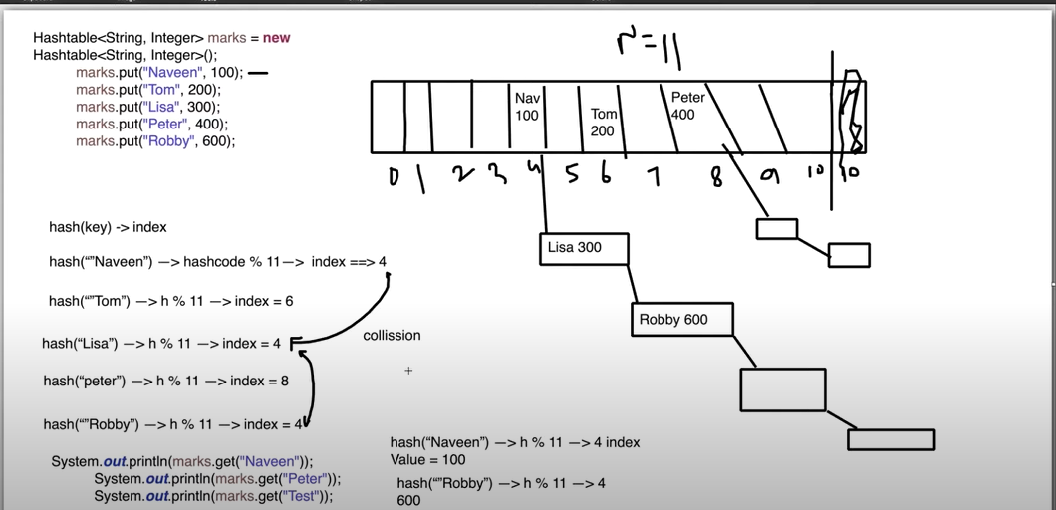
Internal Working of Hash Map:
- If you use put method it will create the hash code of the key hashcode(key), find the index and store in the segments.
- It is not synchronized
- 16 segments/buckets from 0 – 16 will be created in heap memory where the key value pair is stored for the below code.
- Finds the hashcode of the key and (n-1) to find the index. n=16.
- If the hash collision occurs with the hashcode and it will give you the same index number then it will check for the objects present in the index or not
- If there is not key present in index it will store the objects there if index is occupied with key it will compare using equals method and it will create a new of linked list and add the object to it and continues forever.
Linked List : Key | Hashcode | Value | null
Linked List if the index is occupied already :
Key 1 | Hashcode | Value1 | null –Points--> Key 2 | Hashcode | Value2 | null
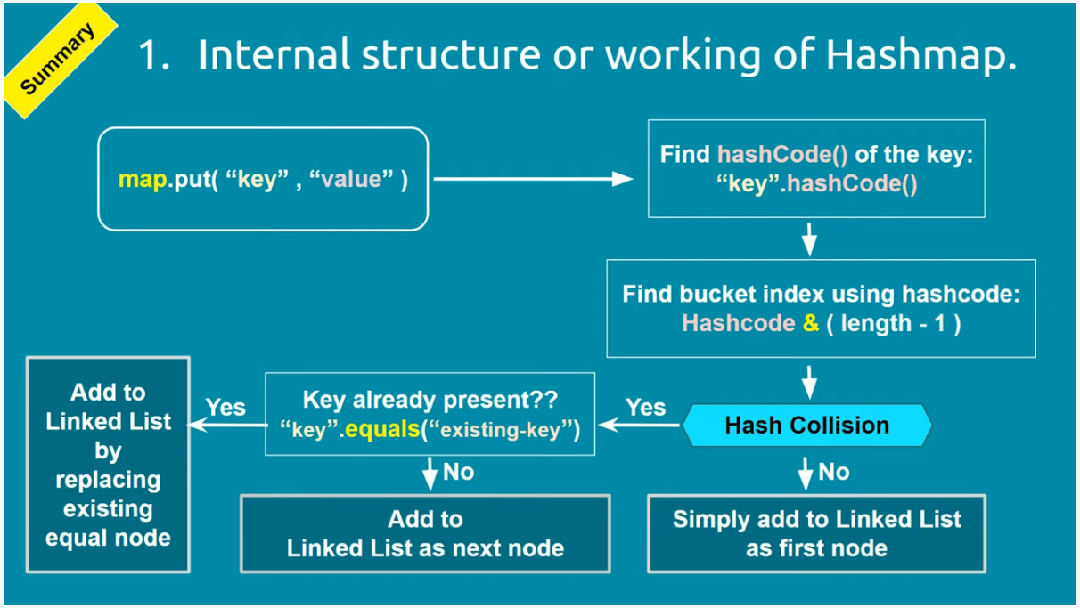
If the number of elements is increasing in linked list the searching will be a tedious task. So once the linked list reaches the Treefy threashold linked list will be converted to a tree. For objects JVM will use compareto() method to compare the object and store the objects.
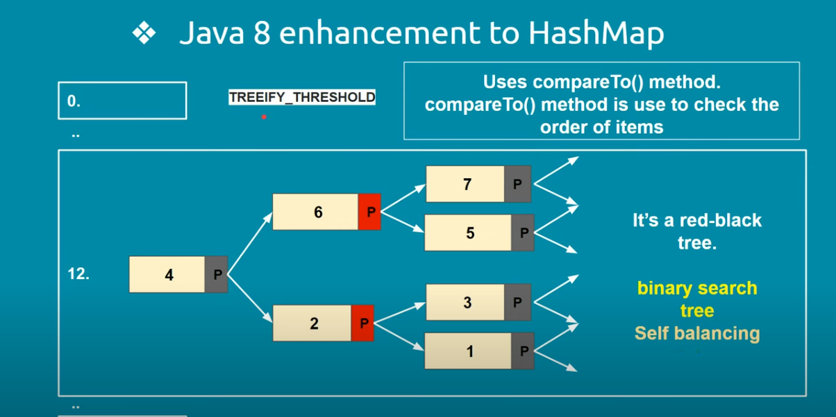
If the key is null the object will be stored in the 0th Segment
Load Factor = *2 when the limit reaches 75%
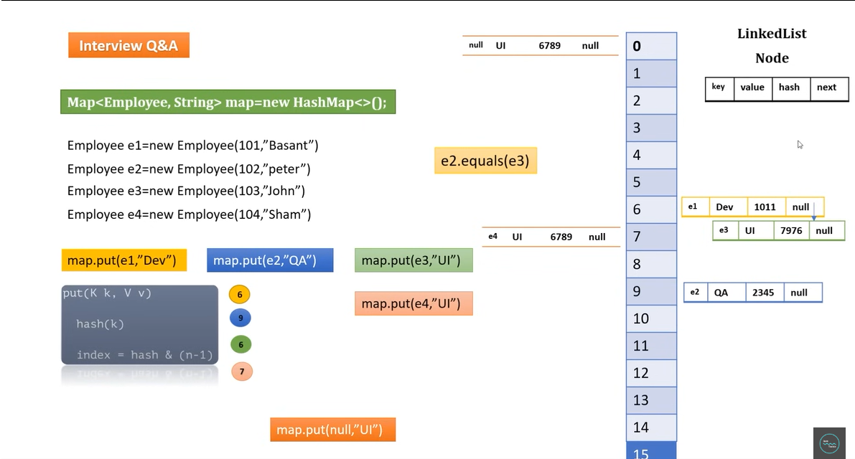
Internal Working of TreeMap:
- It implements the NavigableMap interface and extends AbstractMap class
- It cannot have null key but null values can be present.
- It won’t use hashing implementation to store the elements.
- Red-Black Tree, each node is either Black or Red. Root is mostly black but can be changes accordingly.
- All Leaves NIL are black. And if root is red child are black.
- It will compare using the comparator method and place the values in the TreeMap
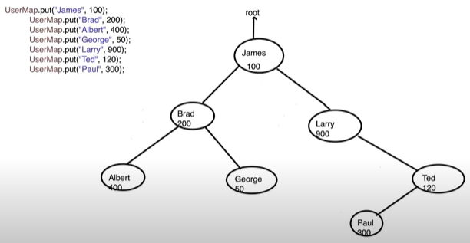
Internal Working of LinkedHashMap:
- LinkedHashMap extends HashMap class and implements Map interface
- Insertion Order: Stores a value in node (Doubly Linked List) and not synchronized and combination of both LinkedList and HashMap
- If you use put method it will create the hash code of the key hashcode(key), find the index and store in the segments. There are 16 segments/buckets from 0 – 16 will be created in heap memory where the key value pair is stored when you create the LinkedHashMap
- Finds the hashcode of the key and (n-1) to find the index. n=16.
- If the hash collision occurs with the hashcode and it will give you the same index number then it will check for the objects present in the index or not
- It will have Key | Hashcode | Value | null | Before | After, tail head function. So, if you add any element, it will be linked to before and after with respect to the insertion order
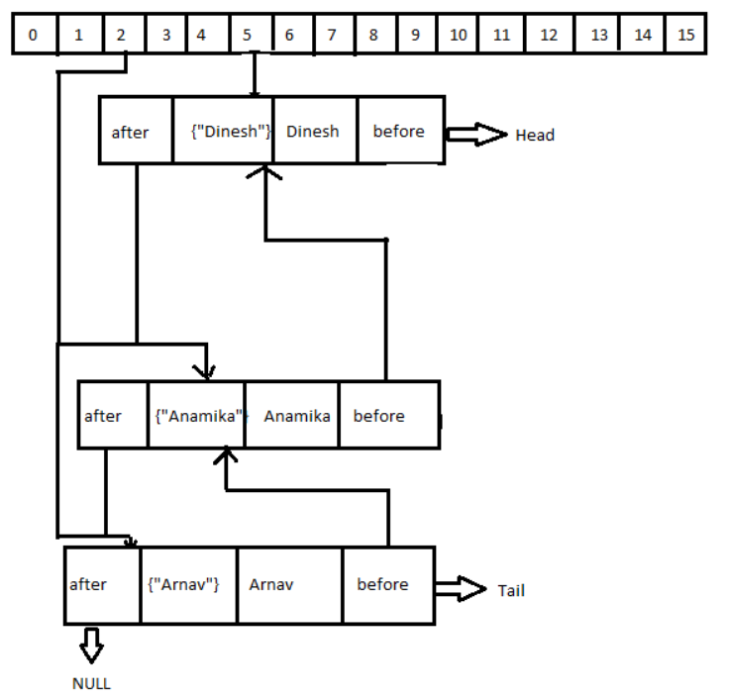
If we add null element to a TreeSet it will use compareto() method so it will throw null pointer exception.
ConcurrentHashMap: Thread Safe implementation of Hashmap that allows multiple threads to access and modify the map concurrently.
It avoids Race Condition in threads and concurrent modification exception.
Internal Working of ConcurrentHashMap:
- Uses segmented or bucket level or fine-grained locking
- Each segment acts as hash table
- Read operations are fully concurrent as multiple threads can read simultaneously from any segments
- Write operations are synchronized at segments level
- Each segment has the lock of its own while doing write operations.
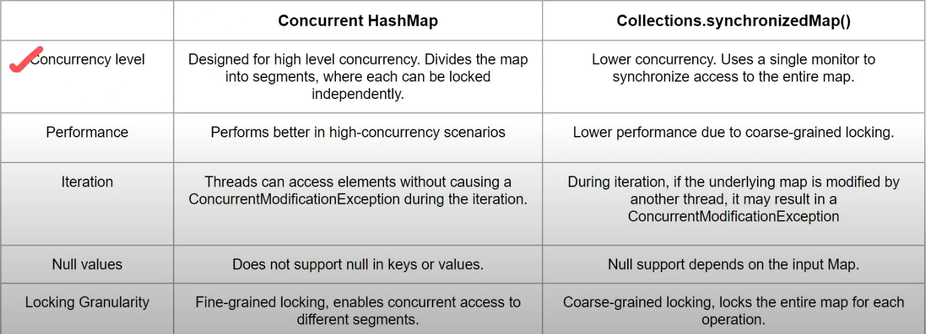
HashSet | LinkedHashSet | TreeSet
Uses HashMap internally to store elements | Uses LinkedHashMap internally to store elements | Uses TreeMap internally to store elements
Does not Maintain insertion order | Maintain insertion order | Uses comparator to order the element if comparator is not passed will use ascending order
Used to store the unique elements without duplicate | Used to store the unique elements in order | Used to sort and store the unique elements in order
Performance is Higher | Performance is similar to HashSet | Performance is Slower
Allows only one null value | Allows only one null value | If you add null value it will throw null pointer exception
HashSet gives performance of order O(1) for insertion, removal and retrieval operations. | LinkedHashSet also gives performance of order O(1) for insertion, removal and retrieval  operations. | TreeSet gives performance of order O(log(n)) for insertion, removal and retrieval  operations.
Comparable and Comparator:
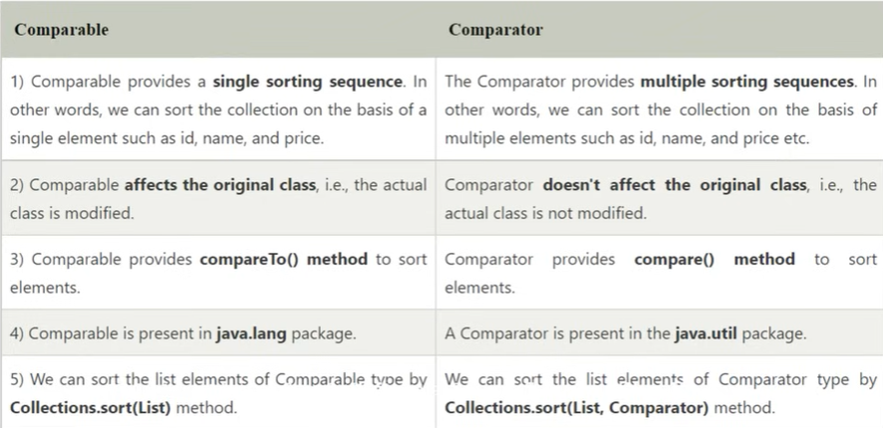
Generics: Generics means parameterized types. Generics allow you to create classes, interfaces, and methods that operate on types specified as parameters.
Type Parameter in generics:
- T — Type
- E — Element
- K — Key
- N — Number
- V — Value
Generics uses:
- To provide type safety, Type-Safe is checked in compile time
- No explicit Typecasting is needed
- Generic confirms the stability of the code by making it bug detectable at compile time.
Hash Collision:
Two different keys with the same hash value are known as hash-collision. Two separate entries will be kept in a single hash bucket to avoid the collision.
FailFast and FailSafe Iterators:
Failfast:
A Iterator which will fail fast when you do modification while iterating a collection(Arraylist, Hashmap, vector)
FailSafe:
A Iterator which will allow you do modification while iterating a collection(CopyonwriteArraylist, CopyonwriteArrayset, ConcurrntHashmap), It will check for modCount if any mismatch it will create a clone of the collection and modify and won’t modify the actual object
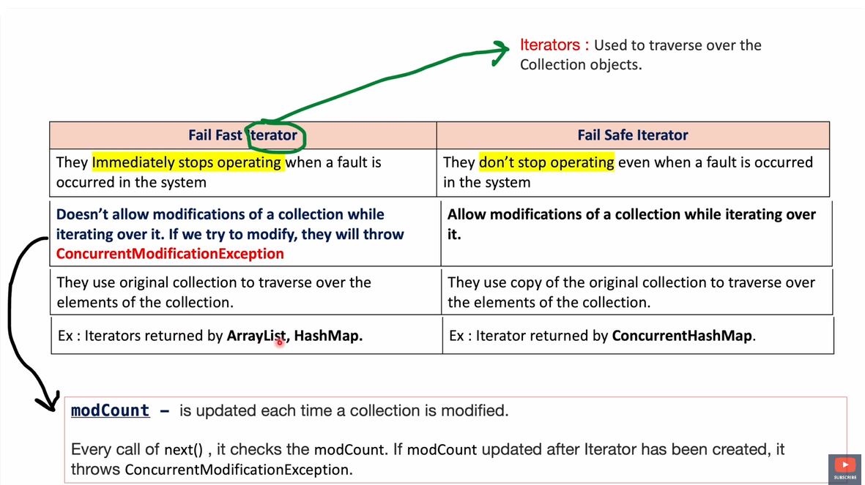

Equals and Hashcode contract:
- If you override equals() method, you must override hashCode().
- If two objects are equal using the equals() method, then they must return the same hash code value using the hashCode() method
- The hashCode() method must return the same number each time it's called on the same object
- If two objects have same hascode() does not mean both the objects should be equal(). This is has collision.
- If two objects are not equal according to the equals() method, then it is not necessary that they must return the same hash code value
HashTable extends both equals and hashcode method so null elements cannot be added.
When to override equals() and hashcode():- when you plan to use a class as a key in a hash table, or when working with collections like HashMap, HashSet, or Hashtable.
The objects used as keys must implement the hashCode and equals methods in order to successfully save and retrieve objects from a HashTable. These methods cannot be implemented by null because it is not an object
If using a custom object as a key in HashMap, considerations / changes in the Custom Object and reasons why you would do them:- Make it immutable and override equals/hashcode methods)
What happens if equals is not there and hashcode (and vice-versa) is implemented for a Hashmap.?
- Only hashCode: Efficient bucket location, but unreliable equality checks within buckets
- Only equals: Accurate equality check, but inefficient and incorrect bucket location and high hash collision
What are the changes you will make in the class to use it as key in hashmap? To use a custom class as a key in a HashMap, you need to ensure that the class implements the hashCode() and equals() methods properly.
== and. equals():
- == --> Reference Comparison (When two object have same reference returns true).
- equals() --> Content Comparison (Wrapper class has overridden equal method). Used to check two objects is equal or not. Based on the properties of the object
Enumeration: User defined integrated constants that has more or nested components. A special data type that consists of a set of pre-defined named values separated by commas, represented in uppercase.
ArrayList can be synchronized by
- Collections. synchronizedList(Object)
- copyonwriteArrayList()
Set can be synchronized by - copyonwritearrayset()
HashMap | ConcurrentHashMap | HashTable
Non-Synchronzied | Synchronized | Synchronized
Applies lock on Whole Map (Whole Map Lock) | Segment/Bucket Level Lock | Applies lock on whole underlying DS (Whole Map Lock)
HashMap vs Concurrent HashMap
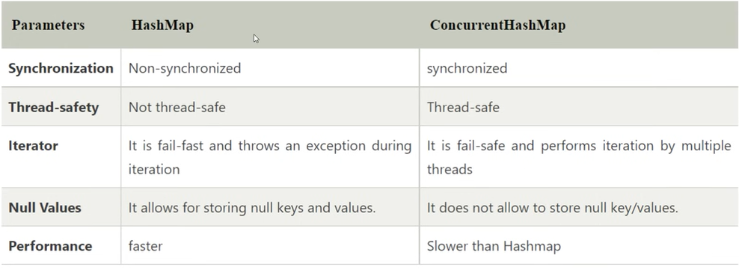
Synchronize List, Set and Map elements
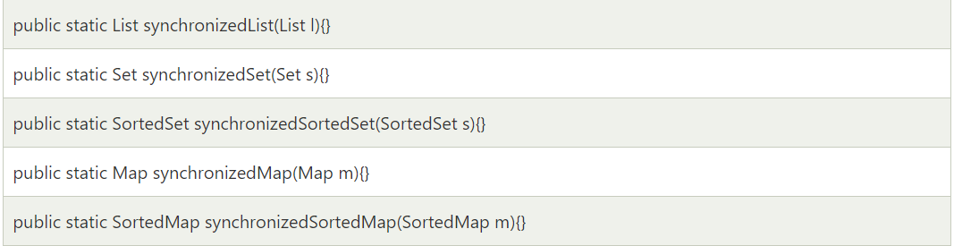
Array to ArrayList and viceversa:
- Arrays.asList(element) -> Array to ArrayList
- List.toArray(object) -> ArrayList to Array
LinkedLists are better to use for the update operations whereas ArrayLists are better to use for the search operations.
Suffle – Collections.suffle(object)
Reverse ArrayList:
- Collection.reverse(list) -> Reverse a list
- Collection.reverseorder() -> Reverse a list
Collection.sort(list) -> Sort a list
List Object Creation:
Arraylist arraylist = new ArrayList<String>(); - Actual and tight Coupling
List<String> arraylist = new ArrayList<>(); - Interface ref of object uses runtime polymorphism
List field with final keyword:
Same reference cannot create another object. It is modifiable but cannot reassign. If you want to make Arraylist modifiable create a Readonly ArrayList
How to remove an element from a list?
- Using remove() method by indexes(default)
- Using remove() method by values
- Using remove() method over iterators
Readonly ArrayList: Collections.unmodifiableList(objectlist)
To make custom arraylist without any duplicates:
- Create custom class by extending arraylist
- Override add() method and write a condition to check whether the object contains the new object to be added
Set does not allow duplicates:
- add() method internally uses map Key, Value pair. The key is the element we pass in the add method and value will be PRESENT a constant.
- Won’t be followed for custom object as each object will have the different address and hash code is created using that so in order to work, we should override hash code and equals methods to the custom class.
- It will work only for wrapper class/primitives as it overrides hash code and equals methods
Default size load factor for collection-based hashing is 0.75.
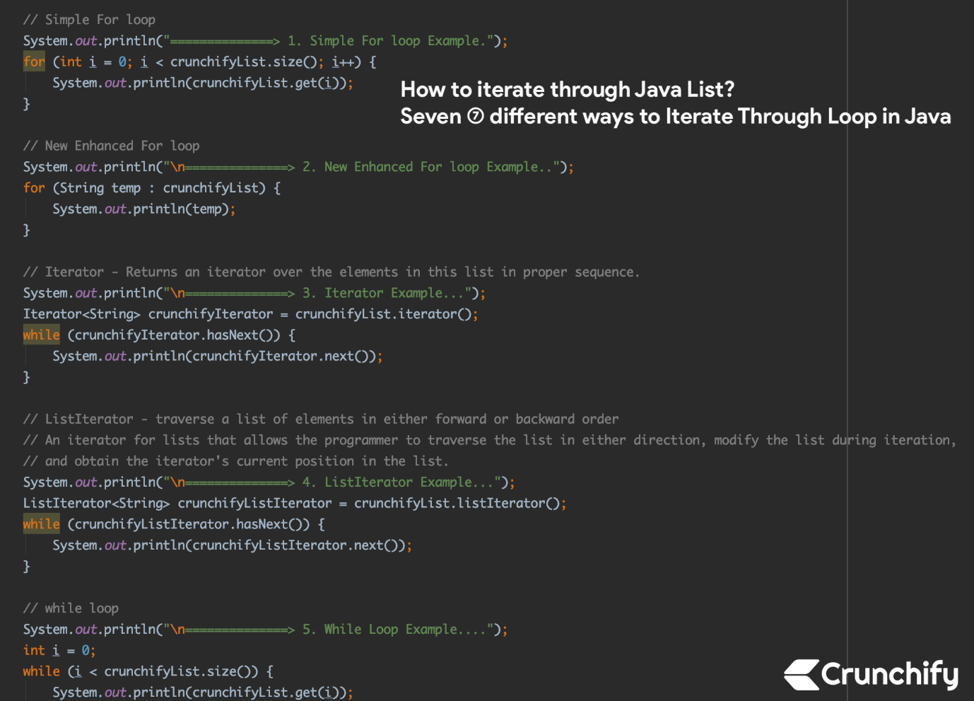
Youtube Videos: https://www.youtube.com/watch?v=GO67C7V-IbQ
How to iterate a Hashmap and Hashset?
- keyset (Iterate Only Over Keys),
- entryset(Iterate Over Key-Value Pairs),
- values (Iterate Only Over Values).

