Multithreading: It is process of running the multiple threads in same time. The process has the multiple threads to be runs at same time to achieve performance.
Multitasking: Multitasking is process of running multiple independent processes or tasks concurrently. Multithreading divides a single process into multiple threads that can execute concurrently. In multitasking, multiple processes or tasks run simultaneously, each with its own processor and resources.
Process: A Program in the execution is called the process and it is independent from other process.
Thread: Lightweight sub set of the process that can be managed independently by a scheduler.
Inter Thread Communication: Process of communication between the synchronized threads is called inter-thread communication. Wait,notify and notifyall are used for intercommunication in threads and from object class
Sleep: Static method that pause the execution of the thread for the defined time in milliseconds. It’s from thread class and locks the object and won’t release the lock
Wait: Non static method that stops or wait for the execution of current thread until it’s called by notify or notifyAll.
It is present in object class and releases lock, used for inter-threadcommunication. We must call wait() method from the synchronized block or it will throw IllegalMonitorStateException. As it is used for inter thread communication it should be present inside the synchronized block.
Notify: Sends notification to the single thread that waits among the thread waiting for the lock.
NotifyAll: Sends notification to the all thread that waits among the thread waiting for the lock.
Thread life Cycle:
New: In this state, a Thread class object is created using a new operator, but the thread is not alive. Thread doesn't start until we call the start() method.
Runnable: In this state, the thread is ready to run after calling the start() method. However, the thread is not yet selected by the thread scheduler.
Running: In this state, the thread scheduler picks the thread from the ready state, and the thread is running.
Waiting/Blocked: In this state, a thread is not running but still alive, or it is waiting for the other thread to finish.
Dead/Terminated: A thread is in terminated or dead state when the run() method exits.
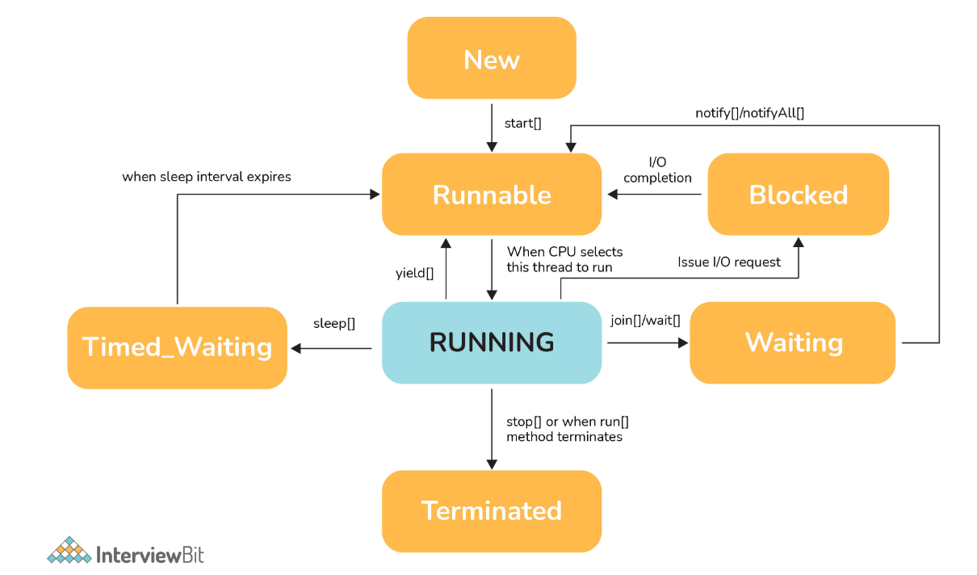
Ways to implement Thread:
- Extending from Thread class
- Implementing from Runnable Interface
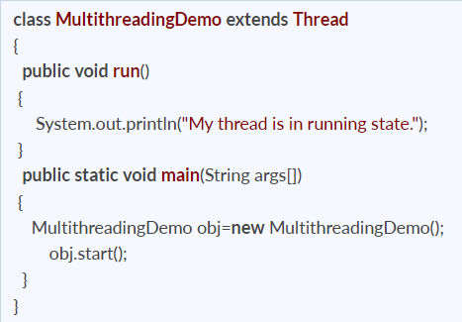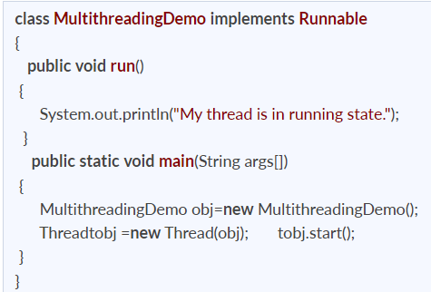
Thread Scheduler: It will decide which threads to be executed, Two types were mentioned below
Premitive Scheduing: Under premitive scheduling, the highest priority task executes until it enters the waiting or dead states or a higher priority task comes into existence.
Time Slicing: Under time slicing, a task executes for a predefined slice of time and then re-enters the pool of ready tasks. The scheduler then determines which task should execute next, based on priority and other factors
Context Switching: Switching of CPU from one thread or process to another one. State of the process/thread is stored so that it can be restored and execution can be resumed after some time.
Join (): join () method allows the one thread to wait for other thread and pause the execution of a current thread unless and until the specified thread on which join is called is dead or completed. Make sure all the threads created by the program is dead before finishing the main function.
If we start a thread twice, we will get IllegalThreadStateException and if we run the method twice it will act as normal method and it will execute twice.
Start () - A new thread is created and then the run () method is executed. But if we directly call the run () method then no new thread will be created and run () method will be executed as a normal method call on the current calling thread itself and no multi-threading will take place
Yeild(): A yield() method is a static method of Thread class and it can stop the currently executing thread and will give a chance to other waiting threads of the same priority. Other thread has same priority as the yielding thread
User Thread: Threads that have specific lifecycle and life is independent of other thread
Daemon Thread: The daemon threads are the low priority threads that provide the background support and services to the user threads. Daemon thread gets automatically terminated by the JVM if the program remains with the daemon thread only, and all other user threads are ended/died.
public void setDaemon(boolean status): It used to mark the thread daemon thread or a user thread.
public boolean isDaemon(): It checks the thread is daemon or not.
If you try to make a thread as daemon after starting it will throw IllegalThreadStateException.
Shutdownhook: It’s a thread invoked implicitly before JVM Shutdown, it will clean all the resources or save the state before JVM shutdown normally or abnormally.
Interrupt (): We can use interrupt () to interrupt the thread from wait or sleep state
Class Lock: In java, each and every class has a unique lock usually referred to as a class level lock. These locks are achieved using the keyword ‘static synchronized’ and can be used to make static data thread-safe. It is generally used when one wants to prevent multiple threads from entering a synchronized block.
Every class in Java has a unique lock which is nothing but a class level lock. If a thread wants to execute a static synchronized method, then thread requires a class level lock. Once a thread got the class level lock, then it is allowed to execute any static synchronized method of that class.
Object Lock: In java, each and every object has a unique lock usually referred to as an object-level lock. These locks are achieved using the keyword ‘synchronized’ and can be used to protect non-static data. It is generally used when one wants to synchronize a non-static method or block so that only the thread will be able to execute the code block on a given instance of the class.
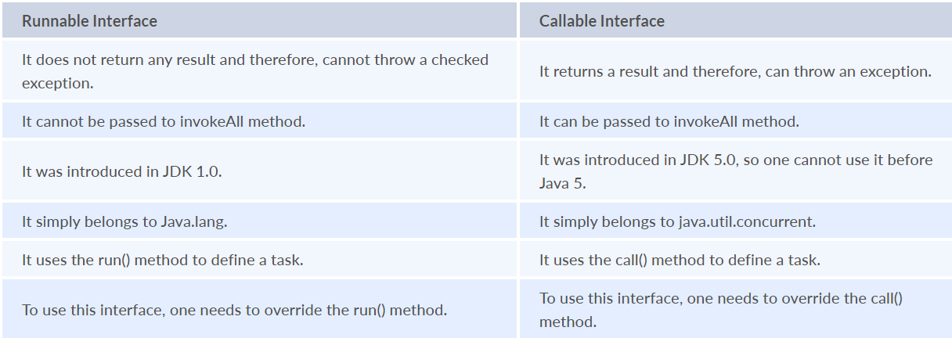
Synchronization: Synchronization is the capability to control the access of multiple threads to any shared resource. Only one thread can access a resource at a time.
- by the synchronized method
- by synchronized block
- by static synchronization
Synchronized block: Synchronized block is used to perform synchronization on any specific resource of the method. Only one thread at a time can execute on a particular resource, and all other threads which attempt to enter the synchronized block are blocked.
Locks the objects for any shared resource in the block and scope is also limited within the block
Synchronized method: Synchronized method is used to perform synchronization on any method. It will lock the entire method and will release the lock after execution or by throwing exception while leaving the method.
We can use Synchronized block over Synchronized method as it give more performance and apply lock only for a particular resource in a method
Static synchronization: To synchronize the static method, the lock will be on the class not on the object.
If we use the synchronized keyword before a method so it will lock the object (one thread can access an object at a time) If we use static synchronized so it will lock a class (one thread can access a class at a time).
Feature | Synchronized Method | Synchronized Block | Static Synchronized Method
Lock Level | Instance level (the specific object) | Instance or specific object | Class level
Scope | Locks the entire method body | Locks only a specific code section | Locks the entire static method body
Concurrency | Less concurrency (blocks other instance synchronized methods) | More granular control, potentially better performance | Less concurrency across all instances of that class
Lock Object | Implicitly this (the current instance) | Explicitly specified (object reference) | Implicitly ClassName.class

Volatile: Volatile keyword is used to achieve the thread safety, as a change in one volatile variable is visible to all other threads so one variable can be used by one thread at a time. Signals to a thread that a variable is stored in the main memory(RAM), not the CPU cache.
Deadlock: When multiple threads are blocked forever. It generally occurs when multiple threads hold locks on different resources and are waiting for other resources to complete their task. Ex: If Thread A holds Lock 1 and waits for Lock 2, while Thread B holds Lock 2 and waits for Lock 1, a deadlock occurs.
To prevent deadlock below should be avoided:
- Avoid Mutual Exclusion/Non-Sharable by making resources sharable
- Avoid No Preemption/Cannot deallocate by making resources allocatable
- Avoid Hold and wait by request and allocate the resources before execution begins
- Avoid Circular wait by ordering all the resource and process in increasing order.
Thread safe can be obtained by
Synchronization, Volatile Keyword, Lock based mechanism and atomic wrapper class
Race Condition: Various threads execute simultaneously accessing a shared resource at the same time, can be avoided by synchronization. Ex: If two threads simultaneously increment a shared counter without synchronization, the final value may be incorrect due to overlapping operations.
Thread Starvation: The situation where the low priority tasks won’t be able to get access to the resource and only high priority tasks access and occupy the resources for the long time.
Thread Pools: Java Thread Pools are group of worker threads waiting for the task to be allocated. It is supervised by a service provider, which pulls the thread and assign. Once the task is completed it will be moved to thread pool. The size of the thread pool depends on the total number of threads kept at reserve for execution
If you submit a task in which Thread Pool is already filled it will throw RejectedExecutionException
Live lock: Similar to deadlock, live lock is also another concurrency problem. The state of threads changes between one another without making any progress. Threads are not blocked but their execution is stopped due to the unavailability of resources
Producer Consumer Problem: It has two threads, that shares a common fixed size buffer. One Thread is a Producer Thread and it's job is to generate data, put it into the buffer multiple times. And the Second Thread is Consumer Thread and its job is consuming the data, one component at a time. That includes removing that element from the buffer also.Both these Threads will run concurrently. So, this is our scenario now we have make sure that the producer won’t try to add data into the buffer if it’s full and the consumer won’t try to remove data from an empty buffer.
Blocking Queue: It is a queue with thread-safe. Producer thread inserts resource/element into the queue using put () method unless it gets full and consumer thread takes resources from the queue using take () method until it gets empty.
When a thread tries to insert the queue which is full the particular thread is blocked until the other threads takes the elements from the queue or a thread try to dequeue a queue which is empty the particular thread is blocked until some othe0r thread inserts an item into the queue
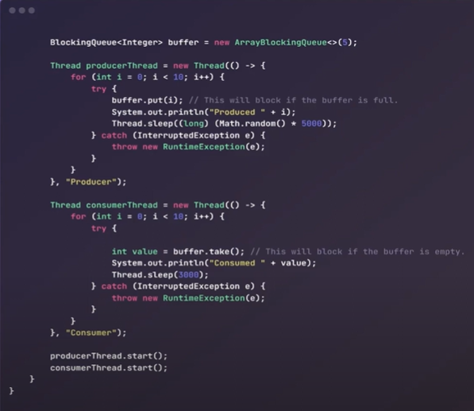
CyclicBarrier: Tool to synchronize threads processing using some algorithm. It enables a set of threads to wait for each other till they reach a common execution point or common barrier points, and then let them further continue execution. One can reuse the same CyclicBarrier even if the barrier is broken by setting it
CountDownLatch: Tool that enables main threads to wait until mandatory operations are performed and completed by other threads. it makes sure that a thread waits until the execution in another thread completes before it starts its execution. Cannot reuse the same CountDownLatch once the count reaches 0.
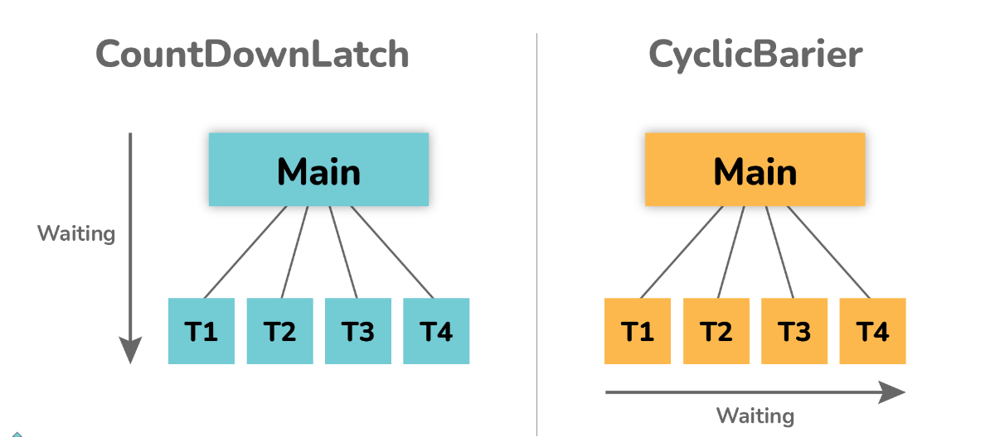
Busy Spinning/Busy-waiting: Technique in which one thread waits for some condition to happen, without calling wait or sleep methods and releasing the CPU. In this condition, one can pause a thread by making it run an empty loop for a certain time period, and it does not even give CPU control. Therefore, it is used to preserve CPU caches and avoid the cost of rebuilding cache.
Thread priority: Priority in which how the threads need to executed or given preference. Low to High [1-10]
Thread Local: Special Kind of variable created and provided from Thread Local class. These variables are only allowed to be read and written by the same thread. Two threads cannot be able to see each other’s Thread Local variable, so even if they will execute the same code, then there won't be any race condition and the code will be thread-safe
Thread Groups: Thread Group is a class that is used to create multiple groups of threads in a single object. This group of threads is present in the form of three structures in which every thread group has a parent except the initial thread. Thread groups can contain other thread groups also. A thread is only allowed to have access to information about its own thread group, not other thread groups.
Share data between two threads by
- Inter Thread Communication
- Blocking Queue
- Producer and Consumer
wait(), notify() and notifyall() is not in thread class as it works on locks. Each objects have one lock or monitor. Locks are associated with object. Java provides the lock at object level not the thread level.
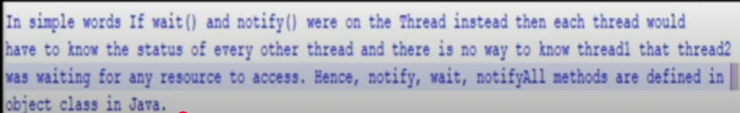
In Java every Object has a monitor and wait, notify methods are used to wait for the Object monitor or to notify other threads that Object monitor is free now. There is no monitor on threads in java and synchronization can be used with any Object, that's why it's part of Object class so that every class in java has these essential methods for inter thread communication.
Thread sleep() and yield() methods work on the currently executing thread. So there is no point in invoking these methods on some other threads that are in wait state. That’s why these methods are made static so that when this method is called statically, it works on the current executing thread and avoid confusion to the programmers who might think that they can invoke these methods on some non-running threads.
Callable vs Future vs CompletableFuture:
Callable – It is similar to Runnable interface but it can return a result and throw an exception. It has a single method call() that returns result from a task executed on a separate thread.
Future – Result of the concurrent process, it is the value that callable returns. Produces the results if ready or block the threads.
CompletableFuture - An enhanced version of Future that allows for more complex asynchronous operations and chaining of tasks. Provides methods to handle results without blocking the current thread, enabling non-blocking asynchronous programming.
Starting a threads is easy, but shutting them down require a lot of attention and efforts. There is a flag called Interrupt status flag in every java thread that we can set from the outside i.e. parent or main thread.
- interrupt() : It will interrupt the thread which is in sleeping/waiting state. When we call interrupt(), an Interrupt status flag is set to true.
- interrupted() : It is static method and checks the interrupt status flag of current thread. When we call interrupted(), the flag is returned and immediately set to false.
- isInterrupted() : There is one more method about which you should know is isInterrupted(). It is an instance method which returns the value of Interrupt status flag of a Thread object for which it is called on.
Semaphore: Controls access to a shared resource through the use of a counter. Limit the number of threads that want to access a shared resource by a counter.
Counting Semaphore: The counter value can range from 0 to N, where N is the number of process or thread that has to enter the critical section.
- If counter > 0, access to shared resources is provided.
- If counter = 0, access to shared resources is denied.
Binary Semaphore: 0 means that a process or a thread is accessing the critical section, other process should wait for it to exit the critical section. 1 represents the critical section is free.
Executor Framework: Running tasks in asynchronous mode, used to run the Runnable/Callable objects without creating new threads every time and mostly re-using the already created threads. Framework having bunch of controls to manage threads.
Executor API decouples/supress the execution of the task from the actual task and execute with executor.
Types of thread pool: YouTube Video
Executors: Running asynchronous threads and managing pool of threads
Executor Class: Create and setup thread pool with different types of executors.
Executor Interface: Provide objects to execute the submitted tasks without explicitly creating threads
Executor Service Interface: Provides methods to terminate and monitor threads, submit() to create and return the future for runnable tasks.

Component | Type | Purpose | Example Use
Executor | Interface | Basic abstraction; runs submitted Runnable tasks. | executor.execute(task)
ExecutorService | Interface | Extends Executor; adds lifecycle control, Callable, Future. | service.submit(callable)
Executors | Class | Utility factory for creating different executor implementations. | Executors.newFixedThreadPool(5)

Types of Executor: YouTube Video
Executor Type | Description | Syntax Example
SingleThreadExecutor | Creates a thread pool with a single thread that executes tasks sequentially. | ExecutorService executor = Executors.newSingleThreadExecutor();
FixedThreadPool | Creates a pool with a fixed number of threads. Excess tasks are queued until a thread becomes available. | ExecutorService pool = Executors.newFixedThreadPool(2);
CachedThreadPool | Creates threads as needed and reuses idle ones. Suitable for many short-lived asynchronous tasks. | ExecutorService pool = Executors.newCachedThreadPool();
ScheduledThreadPool | Executes tasks periodically or after a specified delay. | ScheduledExecutorService scheduler = Executors.newScheduledThreadPool(1);

Submit vs Execute:
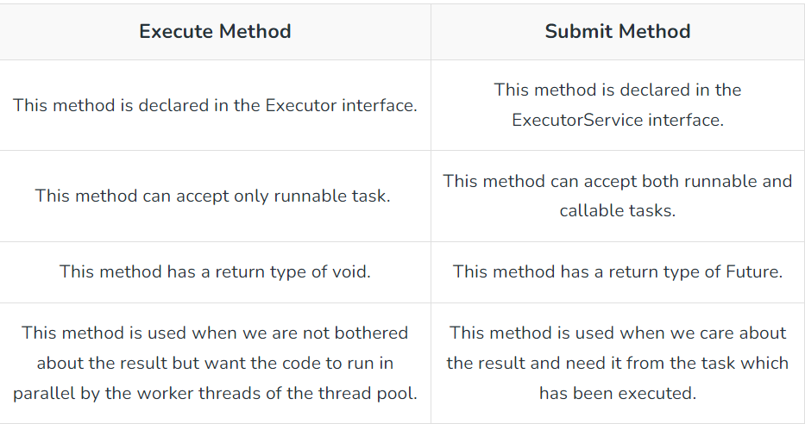
To implement a high-performance cache which allow multiple readers and single writer – Concurrent HashMap
Thread Dump: A thread dump is a snapshot of the state of all threads that are part of the process or List of all threads alive in JVM
Lock Interface: It is used to achieve synchronization and work same as synchronized block. It will provide guaranteed sequence of the threads waiting for accessing a resource, It has the timeout option if the lock is not granted volatile

Types of Locks:
Object and Class Level Locks, ReentrantLock Locks, Stamped Locks and ReadWriteLocks
Reentrance Lock: The synchronized keyword is another way to achieve thread synchronization in Java, which can be applied to a method or a block of code and uses an implicit lock associated with the object or the class.
Compared to the ReentrantLock, the synchronized keyword is more restrictive since it automatically locks and unlocks at the beginning and end of the scope, while the ReentrantLock allows you to lock and unlock at any point in your code.
Additionally, the ReentrantLock provides more features such as interrupting a waiting thread, trying to acquire a lock for a specified time, and checking if the lock is held by the current thread or any thread. Furthermore, the ReentrantLock can be fair or unfair, whereas the synchronized keyword is always unfair.
Only one thread can lock the resource simultaneously with nested locks(Locks of Locks) and we need to use same number of lock and unlocks.
Completable Future vs Future:https://www.hungrycoders.com/blog/difference-between-completablefuture-and-future-in-java
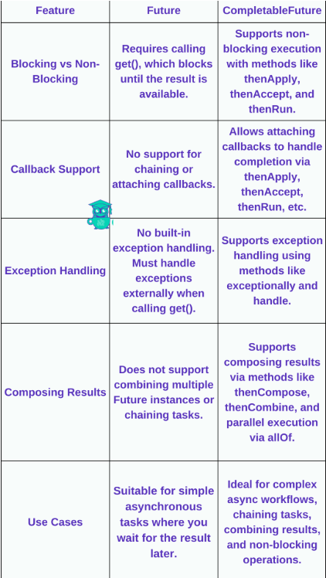
You have thread T1, T2, and T3, how will you ensure that thread T2 run after T1 and thread T3 run after T2? - Using Join(), countdownlatch() and semaphore() ensure that thread T2 run after T1 and thread T3 run after T2.
Snippets: https://www.scholarhat.com/tutorial/java/java-multithreading-interview-questions
Pause the execution of a Thread for specific time: sleep(int milliseconds)
Stop the execution of a Thread: Thread.interrupt();

