Object Oriented Programming [OOPS]
OOPS: It is a programming paradigm defined using the objects having the data and methods defined in the class.
- Follows bottom-up Approach
- Enables data hiding and encapsulation
- Provides reusability of code
Object: Instance of the class.
Real world entity having state and behaviour of the class. Data-members and methods cannot be accessed directly without creating object.
Object obj = new Object();
Initial state of object is null and new is the keyword to create the object.
Class: Blueprint/ template describe the details of the object.
Constructor: Special type of method used to initialize the state of the class. Invoked when class is instantiated and memory is allocated to an object. Have same name as class. Doesn’t have any return type.
No Return type is there for Constructor, it will return instance of the class.
Default - Does not accept any value, used to initialize the instance with default values.
Non-Parameterized: Doesn’t Accept arguments and used to initialize the code block in constructor.
Parameterized: Accept arguments, used to initialize the instance with given values.
Constructor Overloading:
Class having more than one constructor with different parameters.
Constructor vs Method:
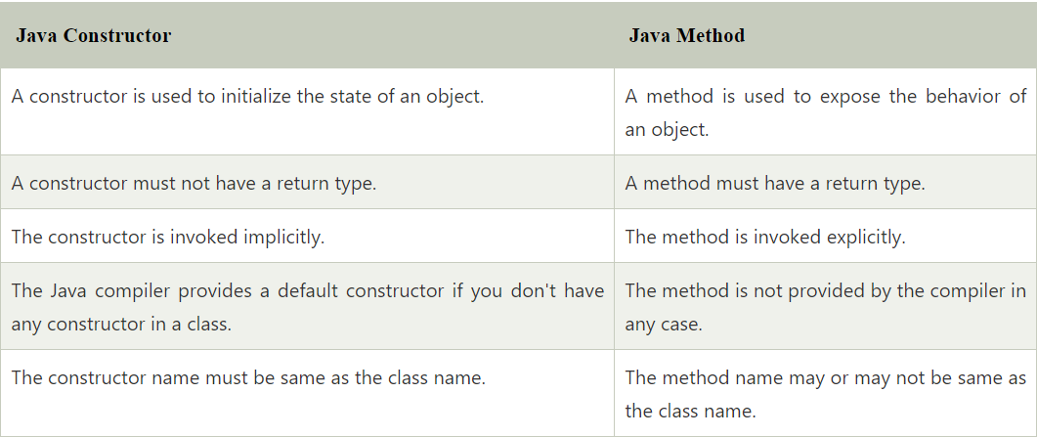
Copy Constructor: Used to construct an object by copying another object of same class / create the exact copy on an existing object of the same class that changes made on the existing object don’t affect the new copy. Copy value to another constructor.
- By copy constructor
- By assigning the value of one object to another
- By clone () method
https://www.scaler.com/topics/copy-constructor-in-java/
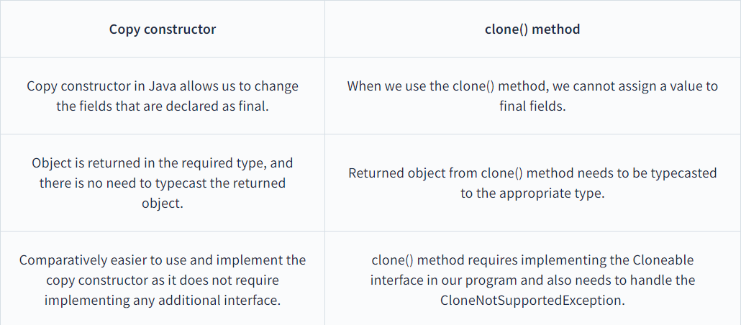
Constructors cannot be inherited and made as final; it can be overloaded.
Constructor Chaining: Enables us to call the one constructor to another constructor of the class with respect to current class object using this keyword and super class by using super keyword.
Object class is the super class of all classes in java.
Static Keyword: Static - Shared amongst class and not object. And common to all the object in the class. Used for memory management in java.
Static Variable: Used to refer the common property/variable of all the objects. The memory is allocated only once in class area in time of class loading. So, it is memory efficient.
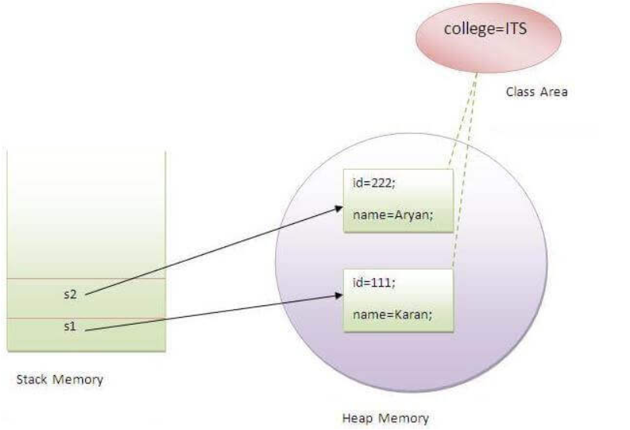
Static Method: Belong to class rather than an object, no instance is required, invoked without creating an instance of class. Static method can access and change the static variable.
Restrictions of static method: this, super, cannot be used as they are non-static. Non static member or method cannot be called directly. Cannot be over-ridden only can be hidden
Method Hiding: Subclass defines a static method with the same signature as a static method in the super class.
Method resolution is taken care by Compiler based on reference time/object.
Static Main Method: Main method is made static as no need to create object. If we use not static method JVM need to create object so memory allocation is needed.
No Such Method Error will be thrown if we remove the static modifier in main method
Static Block: Used to initialize the static data member of the class and executed before the main method at the time of class loading.
Without main class we can execute the program. Using static block. Before 1.7 JDK. Using null reference can we call a static method in java. A a = null; null.staticmethod();
Static blocks executes first even before main method as in Java Language specification. If there are multiple static blocks, they execute one by one in the order of declaration, executed when class is loaded in JVM memory
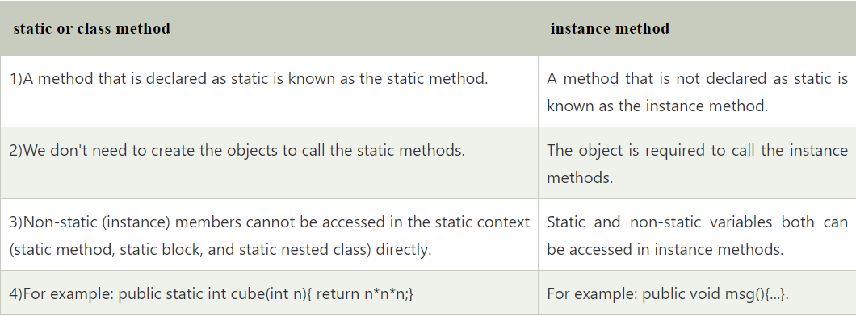
Static Constructor: Will result in error, constructor is invoked once the object instance is created so no use of static in constructor.
Static Abstract method: Will become the part of class and called directly so unnecessary call of unimplemented method can be avoided. Calling undefined method is useless so not allowed.
Inner Class: The nested class can be defined as the class which is defined inside another class or interface. It accesses all the data members of the outer class including private data members and methods and makes code readable. If you want to implement the abstract class or interface only once we can go for inner class.
Static Class: The top-level class cannot be static in java, to create a static class we must create a nested class and then make it static.
- A static nested class may be instantiated without instantiating its outer class.
- Inner classes can access both static and non-static members of the outer class. A static class can access only the static members of the outer class.
This Keyword: Reference variable which refers the current object reference, can be sent as arguments to constructor/method call, invoke current class method, returned from the method as current class instance. Used to differentiate instance variable with constructor parameter.
- Refer current class instance variable
- Invoke current class method
- this () invoke the current class constructor
- passed as an argument as method and constructor call.
- return current class instance from the method
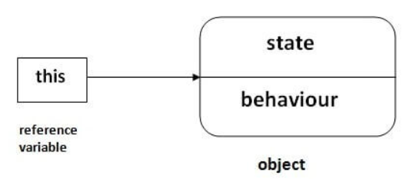
Advantages of passing this into method instead of current instance object: this is a final variable cannot be referenced/assigned to a new variable but current instance can be assigned to a new variable. This can be used in synchronized block
Restrictions: this keyword cannot be assigned to a variable and can be used for static variable also but not a good practice.
Inheritance: Process of one object acquiring all the properties and behaviour of another object from another class [Parent-Child Relationship]. Reusable code, IS-A relationship. Single, Multiple, Multilevel, hybrid, hierarchal.
Inheritance uses: reusable code, to achieve runtime polymorphism, data hiding to the child class. To achieve method overriding.
extends: extends is a keyword that is used for developing the inheritance between two classes and two interfaces.
implements: implements keyword is used for developing the inheritance between a class and interface.
Multiple Inheritance: To reduce the complexity/ambiguity while inheriting the parent class has same methods.
Association: Relationship between the two classes that are set up through their objects
Aggregation: Relationship between the classes when aggregate class contains a reference of the class it owns and can exist without the container object. HAS-A relationship.
Composition: Relationship between the classes when aggregate class contains a reference of the class it owns and cannot exist without the container object
Aggregation – Weak relationship, Composition – Stronger relationship
Upcasting: Typecast child object to parent object
Down casting: Typecast parent object to child object
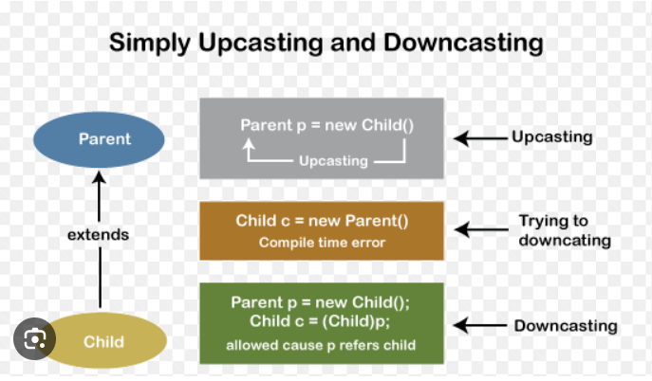
Pointer: is a variable that holds the memory address. It makes complex and unsecure so not used in java.
Super Keyword: Used to refer the immediate parent class object. When you create the instance of the subclass it implicitly calls the parent class. The super() is called in the class constructor implicitly by the compiler if there is no super or this.
Uses: Used to refer the immediate parent class object and used to invoke the immediate parent class variable/method, super() is used to invoke the immediate parent class constructor
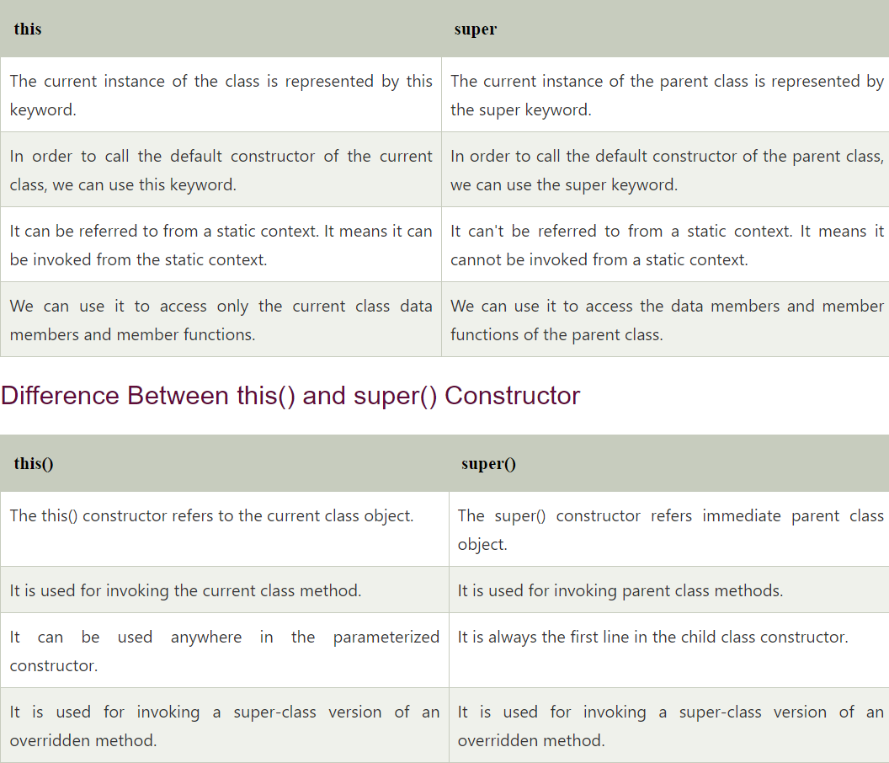
Super and this in constructor: Super points to parent class context, used for initializing the base class variable to derived class constructor/variable and should be the first statement or will throw error. this keyword - points to current class context. And used to differentiate the local and instance variable passed to the constructor and should be the first statement or will throw error. Cannot use super and this in constructor at same time.
Object Cloning: Used to create the exact clone of the object. https://howtodoinjava.com/java/cloning/a-guide-to-object-cloning-in-java/
Should implement cloneable interface or clone() method will give Clone not supported exception.
Method Overloading: Polymorphism technique in which the same method name is used for more than one method with different signature (changing no of arguments/data types).
Can be achieved by changing
1) Number of arguments
2) Data type of the arguments
Method Overloading is not possible by only changing the return type and using the same number and datatype of arguments. I will cause ambiguity. Main method can be overloaded.
Type Promotion: One datatype is promoted to another implicitly is no matching datatype is found
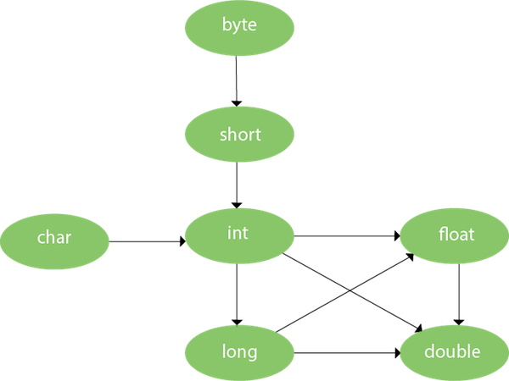
Method Overriding: Subclass provides implementation of the same method present in parent class is called method overriding. Used to achieve run time polymorphism and implement interface methods
Method name should be same as parent class method name, should be inherited class IS-A relationship, same signature as parent class.
Method resolution is taken care by JVM in run time with respect to runtime object
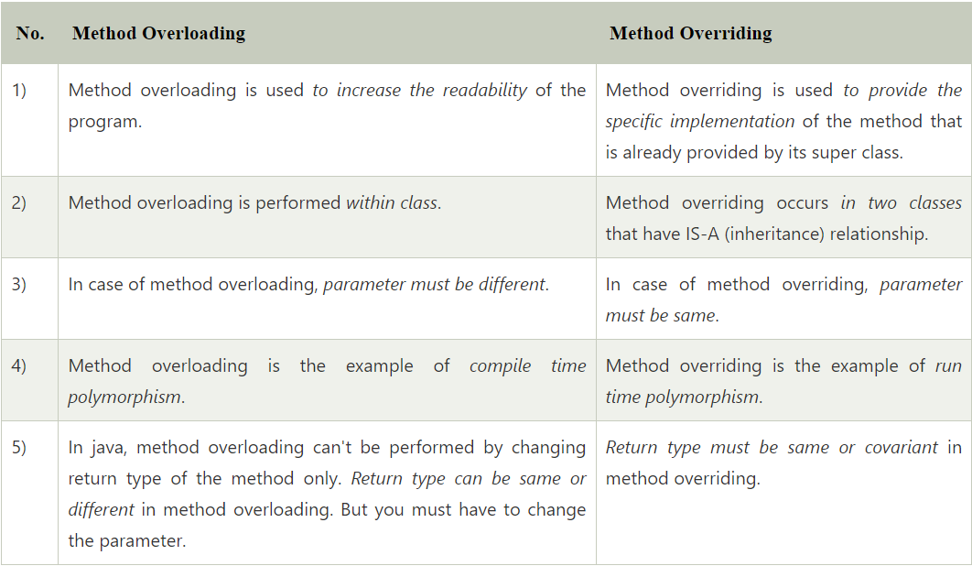
Static methods cannot be override, static method is part of the class instance method is bound with object so gets memory in heap so not necessary to override. No runtime polymorphism is achieved.
Private methods cannot be overridden, as scope is limited and cannot be accessed outside the class.
Changing the scope of overridden methods in subclasses: The private can be changed to protected, public, or default, The protected can be changed to public or default. The default can be changed to public. The public will always remain public.
Covariant Return type: The covariant return type specifies that the return type may vary in the same direction as the subclass
Final Variable: Restrict it from user updating, once assigned it cannot be changed.
Uses of final keyword: Stop inheritance, overriding, value change.
Final method: cannot be over ridden
Final class: cannot be inherited
Final Blank variable: Not initialized at the time of the declaration, cannot initialize directly and will be done only by constructor.
Static Final Blank variable: Not initialized at the time of the declaration, cannot initialize directly and will be done only by static block.
Static Final block: Can be initialized by static block. If non static initialize can be done by constructor.
Main method can be declared as final, Constructor cannot be inherited and Interface/Abstract cannot be declared as final as it need to implemented.
Do all properties of an Immutable Object need to be final in java?||[All about Immutability in Java]
Garbage Collection: Mechanism in the Java Virtual Machine (JVM) that automatically reclaims memory occupied by objects that are no longer needed or referenced by the program. This process eliminates the need for manual memory management, reducing the risk of memory leaks and errors. Used to destroy the unused memory in runtime. Null, referring to another reference, anonymous object.
Finalize: method invoked before the garbage collected, perform clean up processing.
GC Algorithm: mark and sweep
Mark Phase: Find the unreachable object (set false) if reachable set (true)
Sweep Phase: Sweeps the unreachable object and reclaims the memory
gc() method: System.gc()/Runtime.gc() invokes the garbage collector for clean-up. JVM will free the space of the unused object memory to be reused.
If the heap memory is full JVM will not allow to create an object and throws OutOfMemoryError
Unreference the objects:
- By nulling the reference
- By assigning a reference to another
- By anonymous object etc.
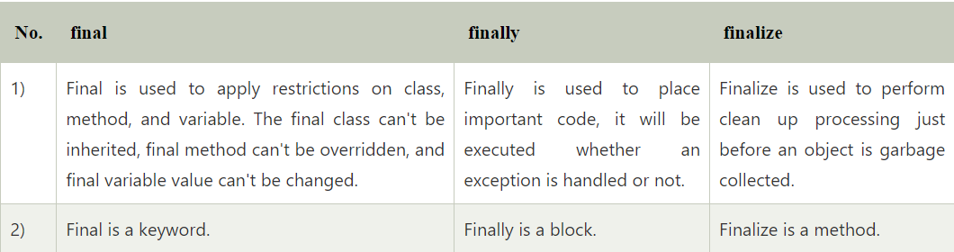
Instanceof Operator: The instanceof in Java is also known as type comparison operator because it compares the instance with type
Polymorphism: Polymorphism in Java is the ability of an object to take many forms/behaviours
Dynamic method dispatch: Mechanism in which a call to an overridden method is resolved at run time instead of compile time. Irrespective to what type of object or parent class reference in object method resolution is done in runtime dynamically.
Binding: Connecting a method call to the method body is known as binding.
Static Binding: Type of object is determined in the compile time
Dynamic Binding: Type of object is determined in the run time
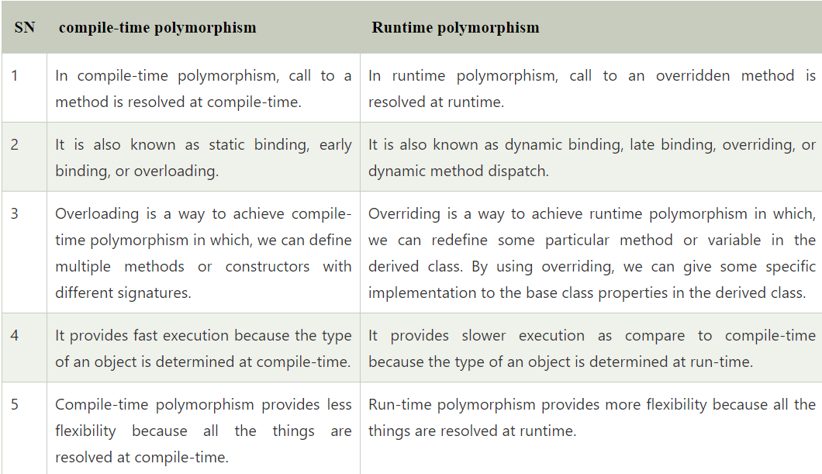
Abstraction: Process of hiding the implementation and showing only functionality to the user.
Abstraction can be achieved by Abstract Class (0-100%) and Interface (100%).
Abstract Class: Class which is declared with abstract keyword is called abstract class. It can have abstract and non-abstract methods, constructors, static methods and final methods that will force the subclass not to change the body of the method and cannot be initiated and call methods directly by creating object as they are not implemented fully. Implementation is not complete/partially implemented or dummy implementation it is called abstract class.
After inherit the abstract class we can partially implement methods in the sub classes.
Abstract class can have 0 abstract methods also. Ex: HTTP Servlet.
Abstract Method: Method which is declared with abstract keyword and does not have any implementation is called abstract method. Has no implementation and has only declaration.
Cannot use final in abstract methods as they cannot be inherited
Can abstract class have constructor if yes how to call it :- Abstract classes can have constructors, and they are called when an instance of a concrete subclass is created.
Interface: Blueprint of a class that can provide 100% abstraction.
- Used to achieve Multiple inheritance.
- If we implement the interface, we cannot partially implement methods in the class that implements the interface, we need to implement fully. Ex: We are declaring 2 methods in interface both should be implemented in the class that implements the interface (or) if you don’t know the implementation of the method from add the scope of the class as abstract class that implements the interface.
- While implementing Interface we should always add the scope as public and We should not reduce the scope.
- Interface cannot be static as we cannot use both static and abstract and cannot be final as we cannot implement if we made it as final

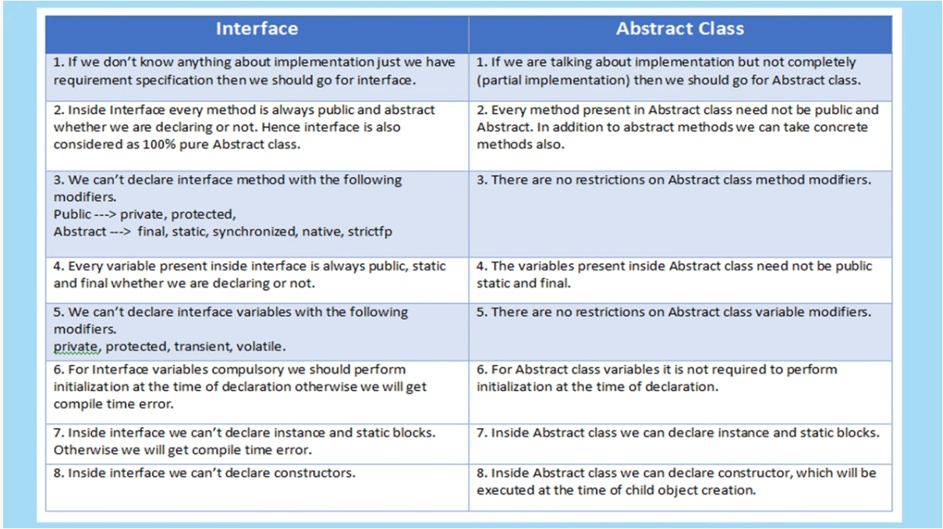
What will happen if Class A extends B, B extends C and C extends A?
error: cyclic inheritance involving class A
Private and static methods in inheritance.
Read-Only Class: The class that have the fields with private scope and have only getter methods. So, we cannot modify the properties as we don’t have setter methods.
Write-Only Class: The class that have the fields with private scope and have only setter methods. So, we cannot read the properties as we don’t have getter methods.
Encapsulation: Grouping data as methods in a class and allow access only by getter setter methods. It is the process of binding the data and object in single unit. It is used to achieve data hiding. It can be achieved by Private members.
Import vs Static Import: The import allows the java programmer to access classes of a package without package qualification whereas the static import feature allows to access the static members of a class without the class qualification.
The import provides accessibility to classes and interface whereas static import provides accessibility to static members of the class.
Objects cannot be transferred to the network directly so we need to convert the object into bytes and transfer in network or IO streams.
Marshalling: Convert xml file to java objects and vice versa
Wrapper Class:
Wrapper classes are classes that allow primitive types to be accessed as objects. Can access primitive datatypes as objects.
The process of converting primitives to objects is called autoboxing.
The process of converting objects to primitives is called unboxing
Object clone:
The object cloning is a way to create an exact copy of an object. clone() is a method from object class that creates clone of object and it should implement Cloneable interface or it will throw CloneNotSupportedException
protected Object clone() throws CloneNotSupportedException
Immutable in Java: Cannot be changed once it’s the obj is created. Wrapper class like int, Boolean, long and short.
Class is set as final, Data members are private/final cannot be accessed, Deep copy – creates an actual copy of the obj and returns only copy. Will not affect the original variable.
Create Immutable class with mutable field: https://www.youtube.com/watch?v=sKV1yfERBgA
- Don’t provide setter methods – Restrict modify the fields or objects
- Make all fields private and final and initialize all fields using a constructor method performing deep copy so that they cannot be modified after initialization in constructor.
- Don’t allow subclass to override methods - Declare the class as final - Restrict to extend the class
- Special attention for mutable instances variables by making it final so that a field’s value can be assigned only once.
- Perform cloning of objects in the getter methods to return a copy rather than returning the actual object reference.
How to Handle Immutable Class with Mutable Reference (Date) - YouTube
Reflection: Allows us to manipulate classes, interfaces, constructors, methods and fields in runtime.
In order to reflect a Java class, we first need to create an object of Class.
- Using .class extension
- Using getClass() method
- Using forName() method
For Classes:
- getName() - returns the name of the class
- getModifiers() - returns the access modifier of the class in integer form
- getSuperclass() - returns the super class of the class
Use Method class for reflection of methods:
- Create an object of Class using getClass()
Class obj = d1.getClass();
- Using object of Class to get all the declared methods of Dog
Method[] methods = obj.getDeclaredMethods();
Constructor[] constructor = getDeclaredConstructors() – returns used to get the constructors of this class
- getName() - returns the name of a method
- getModifiers() - returns the access modifier of methods in integer form
- getReturnType() - returns the return type of methods
Shallow and Deep Copy: https://www.tpointtech.com/shallow-copy-vs-deep-copy-in-java
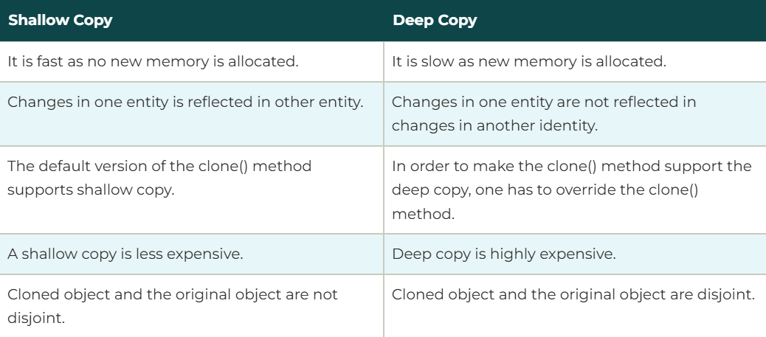
Using Null reference can we call any method?
No, there is no way to call a method on a null reference (unless the method is static!). (null does not represent some "base" object, it represents a reference which does not point to any object at all.)
What is the possible scope of access modifiers for an overridden method in child class? The access specifier for an overriding method can allow more, but not less, access than the overridden method. For example, a protected instance method in the superclass can be made public, but not private, in the subclass.
Why non static variable is not allowed inside the static block? A non-static variable cannot be used inside a static block because a static block is executed when the class is loaded, before any instances of the class are created, meaning there is no "object" to reference the non-static variable from; essentially, the compiler doesn't know which instance's value to use as non-static variables belong to specific objects, not the class itself.
Can we declare constructor as private? Yes, A private constructor prevents other classes from creating instances of a class. (Uses Singleton Class)
Can you make a constructor final: No Constructor cannot be final because you can't overwrite/extend a constructor anyway.
Life Cycle of Java object:
- Creation: The object is created using the new keyword, which allocates memory for it on the heap. The constructor of the class is then called to initialize the object's state.
- Usage: The object is used by the program to perform its intended tasks. This involves accessing its methods and fields. The object remains "alive" as long as there are references pointing to it.
- Unreachable: When there are no more references to the object, it becomes unreachable. This means that the program can no longer access it.
- Garbage Collection: The garbage collector (GC) is a process that reclaims memory occupied by unreachable objects. When the GC runs, it identifies and removes these objects, freeing up memory.
- Finalization (Optional): Before an object is garbage collected, the finalize() method can be called (if overridden). This method allows the object to perform any cleanup actions before it is destroyed. However, the use of finalize() is discouraged in modern Java development.
- Destruction: After garbage collection (and optional finalization), the object is destroyed, and the memory it occupied is released.

