Marker Interface: A marker interface is an interface that doesn’t have any methods or constants inside it. It provides run-time type information about objects, so the compiler and JVM have additional information about the object and supports special operations.
A marker interface is also called a tagging interface. Interface that doesn’t have any method declaration that acquires some special capability from the interface it implements Ex: Serializable and Cloneable Interface.
To indicate serialization: The Serializable interface indicates that a class can be serialized, or converted into a byte stream for storage or transmission. This interface is often used when saving and loading objects to and from files.
To indicate clonability: The Cloneable interface indicates that a class can be cloned, or duplicated.
To indicate remote access: The Remote interface indicates that a class can be accessed remotely, enabling method invocation on remote objects.
To indicate custom behaviors: Developers can create their own marker interfaces to indicate specific characteristics or behaviors in their applications.
Serialization: Process of converting the java object into a byte stream is serialization.
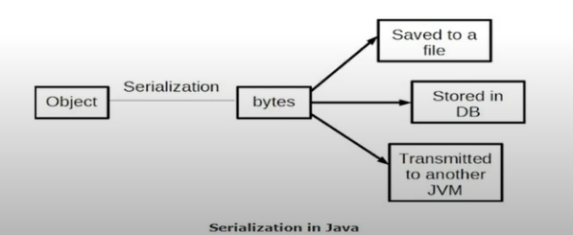
Deserialization: Deconstructing the byte stream into java object is called as deserialization
The byte stream is platform independent and can be transferred over network/IO stream and deconstructed and run on any JVM.
Uses: Save the object state and recreate when needed.
To make a class serializable the class should implement Serializable Interface
Private and final can be serializable and Static fields cannot be serialized as they belong to class and not the object.
Serializable Interface – Tag/Marker Interface does not have any methods
- If you need to serialize 2 classes which has inheritance relationship:
  - If superclass implement serializable interface, then subclass is automatically serializable. So, without implement serializable interface in subclass we can serialize the subclass object.
  - If superclass doesn’t implement serializable interface, then subclass needs to manually implement serializable interface. So, without implement serializable interface in superclass we can serialize the superclass object/members with default serialization and assign default values to superclass fields.
  - If you try to serialize class in which superclass implements serializable interface and child does not implement serializable interface serialization can be avoided by implementing the writeObject() or readObject() methods in the subclass and throw NotSerializableException from these methods.
- If you need to serialize 2 classes which does not have any relationship both super and child class should be implement serializable interface.
- If you try to serialize a static member that cannot be done because the static members are related to class not the object. Only object/instance of class and its related members can be serialized.
Constructor will be called for serialization and not for deserialization as it deconstructs from the serialized object (byte stream)
Transient: To avoid serialization we can add the modifier as transient/static
Serialization UID: Unique ID of each serializable class or hash code of the object. Version control of object should be Public static final long datatype.
- It is a 64-bit hash code of class name and interface class name and class methods and fields.
- Used as the version of the serialized streams. During serialization process serialization id is stored and while serialization the generated serialization id is matched with stored serialization id.
- If we use not declared or use default serialization id any change in class will fail while deserialization.
- If we use generated serialization id any change in class then we should generate new serialization id.
Parameterized Constructor is called for serialization and not for deserialization
The serialization and deserialization happen with reference with the serial version uid and comparing the versions. Ensure security of class during network/io transmission
Externalization: The externalizable interface is not a marker interface and thus it defines two methods writeExternal() and readExternal().
- Used for customized serialization. Needs No Arg Constructor for deserialization
- Needs No Arg Constructor/ Default Constructor for serialization using externalizable interface. Default Constructor is not called for serialization and called
- for deserialization using externalizable interface.
If you try to serialize class using externalizable/serializable interface in which superclass does not implements externalizable/serializable interface and child implements externalizable/serializable interface super class serialization can be done by overriding the private void writeExternal() /writeObject() or private void readExternal()/readObject() methods in the subclass. Or otherwise, it will use default serialization and assign default values to superclass fields. Ex: For int – 0 and String – null.

