Spring: Spring is a lightweight, opensource java framework used to develop enterprise level applications.
- Lightweight
- Dependency Injection
- Inversion of control
- Aspect of Programming
- Transaction Management etc.
Inversion of Control: Dependency Injection (DI) is achieved through the Inversion of Control (IoC) container. The container manages the creation and manages the lifecycle of objects(beans) and injects the required dependencies into the object when it is created.
Types of IOC:
BeanFactory Container: This is a simple container that provides basic support for dependency injection.
Implementation: It is implemented using the BeanFactory interface and XmlBeanFactory.
ApplicationContext Container:This is a more advanced container than BeanFactory with additional features such as event propagation, and application layer integration.
Implementation: It is implemented using the ApplicationContext interface, and there are several implementations like ClassPathXmlApplicationContext, FileSystemXmlApplicationContext, and AnnotationConfigApplicationContext.
Dependency Injection:
Dependency injection is a fundamental concept in the Spring framework. It refers to a design pattern where objects are provided with their dependencies rather than creating them internally and loosely coupled components.
Types of Dependency Injection:
- Constructor-based dependency injection - Container invoking a constructor with a number of arguments, each representing a dependency. If single dependency is present no autowired annotation is needed and useful when dependency injection needs to be mandatory and immutable.
- Setter-based dependency injection - Container calling setter methods on your beans after invoking a no-argument constructor or no-argument static factory method to instantiate your bean. Useful when dependency injection needs to be optional and mutable.
- Field-based dependency injection - Injecting dependencies directly into the object's fields.
Circular Dependency:
A circular dependency occurs when a bean A depends on another bean B, and the bean B depends on bean A as well: Bean A → Bean B → Bean A. So it will get confused which bean should be created first and injected to another.
To Avoid Circular Dependency: Don’t Use Constructor Injection
Use @Lazy or Setter Injection and @PostConstruct

If u have 4 bean classes (A,B,C,D) out of it Which is the best way to do dependency injection Out of it A and B mandatorily need to be present rest may be optional like may be present or may not be present: Use Setter injection as there are optional beans to be injected.
Spring Core Container provides the fundamental functionality of the Spring framework, including dependency injection and bean management.
- Spring Core: Provides the foundation of the IoC container. It manages object creation, wiring, and configuration through dependency injection.
- Spring Beans: Defines the BeanFactory, responsible for creating and managing bean instances. It also provides the BeanWrapper for configuring and accessing bean properties.
- Spring Context: Extends BeanFactory with enterprise-level services like internationalization, resource loading, event publication, and annotation-based configuration through ApplicationContext.
- Spring Expression Language (SpEL): Offers a powerful expression language to query and manipulate objects at runtime. Ex: @Value
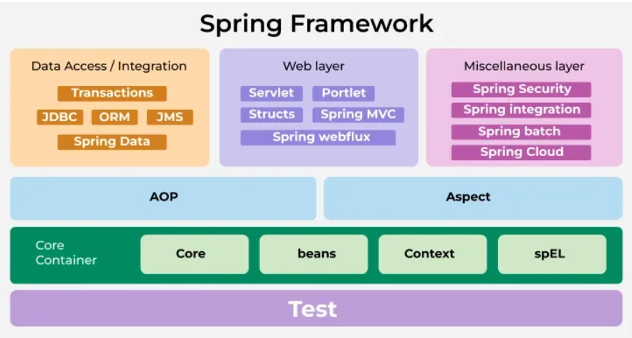
Spring IOC: Spring controls the object creation and lifecycle.
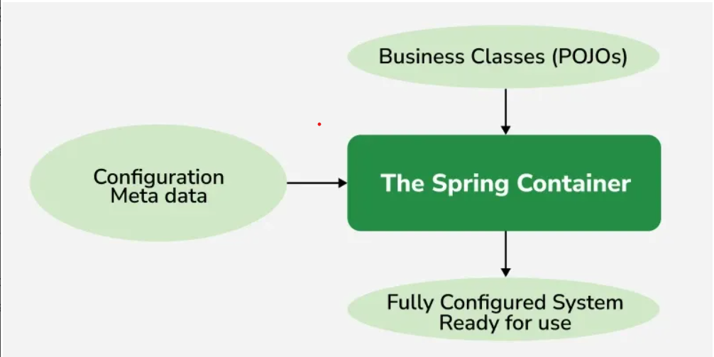
BeanPostProcessor: Gives us hooks into the Spring bean lifecycle to modify its configuration. We add utility methods before and after bean creation.
Bean Factory:
BeanFactory is the root interface for accessing the Spring IoC (Inversion of Control) container. It provides the basic functionalities for managing beans, including instantiation, configuration, and dependency management.
Key Features of BeanFactory:
- Lazy Initialization: Beans are created only when they are requested.
- Lightweight: Suitable for lightweight applications, where memory usage is a critical concern.
- Basic Container: Provides only fundamental functionalities like dependency injection and bean lifecycle management.
ApplicationContext: ApplicationContext is an extension of BeanFactory that provides additional functionalities, making it more suitable for enterprise applications. It includes all the features of BeanFactory along with several advanced features.
Key Features of ApplicationContext:
- Eager Initialization: Beans are created at the time of container startup by default.
- Internationalization: Provides support for i18n (Internationalization) messages.
- Event Propagation: Allows registering and propagating events.
- AOP: Provides integration with Spring's AOP functionality.
- Convenient Access: Provides easy access to ApplicationEvent publishers, MessageSource, and more.
- Environment Management: Manages properties and profiles.
Spring Bean: Java Object managed by Spring IOC container.
Create Spring Bean:
- @Component (Uses default constructor to create a bean and inject)
- @Configuration and @Bean (Uses parameterized constructor to create a bean and inject)
Bean Initialization:
- Eager: When application is started (Loads both the parent entity and its child entity)
- Lazy: When beans are needed @Lazy (Loads only the parent entity and don’t load all its child entity until its needed.
Spring Life cycle Bean: Bean life cycle is managed by the spring container. Container is used to create, initialize, wire and destroy the bean automatically with the configurations.
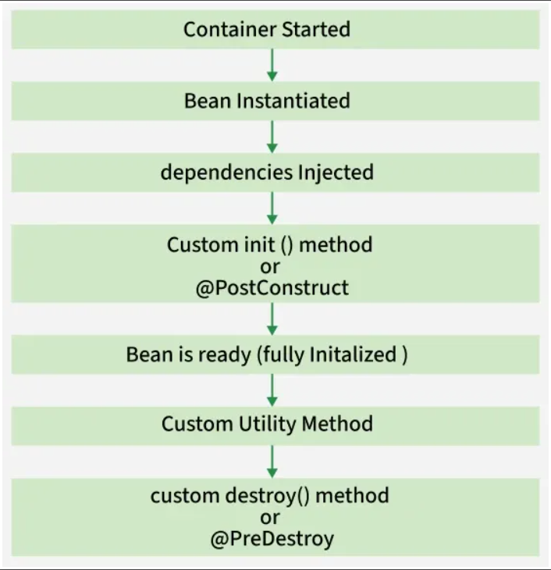
Spring Beans with private constructor - Cannot initiate using @Component and @Bean we need to use static factory method.
Create Spring Bean without @Component - Java Based Configuration - Create a class and annotate with @Configuration and use @Bean definition
Spring can have multiple beans of same type/same name but when you autowire it it will throw NoUniqueBeanDefinitionException. So, use @Primary or @Qualifier to specify one.
Spring does not allow multiple beans with the same name. If two beans share the same name, the second one will override the first.
@Configuration will use cglib proxies which makes the bean singleton and @Component will work as prototype. https://www.youtube.com/shorts/QR5H6UX7aI4
If have some codes inside a static block and some code inside a @PostConstruct block which will run first? Code present in static block with run first as static block will execute the code while loading the application before the objects are created. @PostConstruct will execute the code after the DI created the spring bean fully.
Ways to configure Spring Beans:
XML method, Java Programmatic method(@Configuration with @Bean ), Annotation method(@Autowired).
XML method | Java Programmatic method | Annotation method
Init() | Implements interface (InitializingBean,DisposableBean) , afterPropertiesSet() | @PostConstruct – calls the method annotated with PostConstruct once the bean is created and runs the code inside it.  Ex: FundManagement Email Service has PostConstruct to load the logos from the resources using inputstream
Destroy () | Destroy() | @Predestroy – calls the method annotated with Predestroy once the bean is destroyed and runs the code inside it.  Ex: FundManagement Email Service has PreDestroy to close the inputstream that’s load the logos from the resources as part of PostConstruct

Spring Beans Scope:
Scope | Description
singleton | Single instance of the bean for the entire application context. Default Scope of bean and Eager initialized
prototype | A new instance of the bean is created every time it is requested from spring container and Lazily initialized.
request | A new instance of the bean is created for each HTTP request. After processing the request, the bean instance is typically discarded and lazily initialized. Use proxymode to inject request scope bean to singleton bean
session | It creates a single instance of the bean per user session. The instance persists throughout the user’s session and is typically discarded when the session ends and lazily initialized. Use proxymode to inject session scope bean to singleton bean
application | Scopes a single bean definition to the lifecycle of a ServletContext. Only valid in the context of a web-aware Spring ApplicationContext.
websocket | Scopes a single bean definition to the lifecycle of a WebSocket. Only valid in the context of a web-aware Spring ApplicationContext

When to use Singleton vs Prototype:
- Singleton can be used for Db Configuration, Service Layer and Application Configuration.
- Prototype can be used for user sessions Thread Safety and Heavy initialization.
When we inject prototype scoped bean in singleton scoped bean what will happen? Prototype bean will loose it scope and acts as singleton scope. To overcome this Autowire the ObjectFactory <Class of Prototype bean> and return the ObjectFactory autowired instance (or) use a method annotated with @Lookup and return null (or) use proxyMode. So it will consider that the bean is not created and will create a new instance.
When we inject request or session scoped bean in singleton scoped bean what will happen? Will throw exception to overcome this Use proxymode to inject request/session scope bean to singleton bean. - @Scope(value="<scopetype>", proxyMode=ScopedProxyMode.TARGET_CLASS)
Aspects of Programming: It is the module of spring that increases the modularity by allowing the separation of cross-cutting concerns. And it is different from business logic as they are maintained in a different place.
Aspect is a module that encapsulates a concern (or cross-cutting concern) that affects multiple classes or methods in an application
Cross-Cutting Concern: A cross-cutting concern is a concern that can affect the whole application and should be centralized/segregated in one location in code as possible, such as transaction management, authentication, logging, security and sanitize the data etc.
AOP Concepts:
Advice: Action taken by an aspect at a particular join point or the code that runs when a pointcut is matched
- Before: Executed before the method call.
- After: Executed after the method call, regardless of its outcome.
- AfterReturning: Executed after the method returns a result, but not if an exception occurs.
- Around: Surrounds the method execution, allowing you to control the method execution and its result.
- AfterThrowing: Executed if the method throws an exception.
Join Point: A specific point in the execution of a program, such as method execution or exception handling, where an aspect can be applied.
Pointcut: A predicate that matches join points. A pointcut expression specifies where an advice should be applied.
Whole class is Aspect, Methods present inside the Aspect Class is Advice, the expression that we write in the method with Advice Annotation is Pointcut, Pointcut evaluated the Jointpoints
Flow:
@Before(Controller) -> @Before(Service) -> @AfterReturning/@AfterThrowing -> @After(Service) -> @After(Controller)

