**#ICP 9**

**Name: Vishnumonish Kankanala**

**Email:** [**VKM5P@umsystem.edu**](mailto:VKM5P@umsystem.edu)

**Github link:** [**https://github.com/Vishnumonish/web-development/tree/main/ICP_9**](https://github.com/Vishnumonish/web-development/tree/main/ICP_9)

**Partner name: Rajendra Kumar Ganji**

**Partner email:** [**RGN42@umsystem.edu**](mailto:RGN42@umsystem.edu)

**Partner github link:** [**https://github.com/Rajendraganji/WebCourse2022/tree/main/WebPart/ICP9**](https://github.com/Rajendraganji/WebCourse2022/tree/main/WebPart/ICP9)

1)Added checkboxes for size of Pizza, what toppings to choose, meat options with a submit button to display on the frontend of the application (to the User) also added a textfield to input the name of the user on their order.

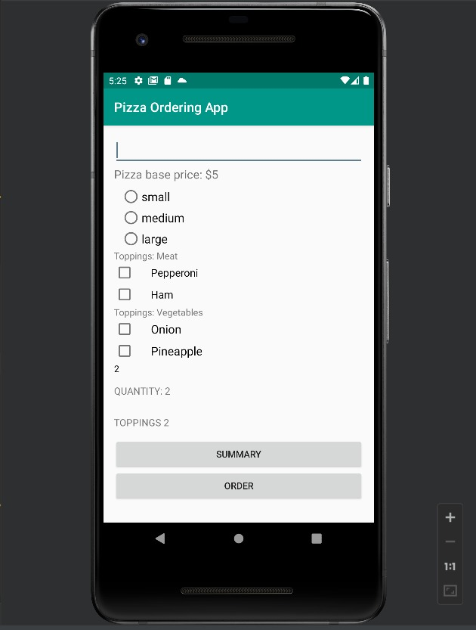

2) Using the checkboxes we have implemented, the user when chooses 2 toppings, it is shown as below.

3) Here, as we can see in the image below, we had added the “**order**” and “**summary**” buttons for the user to make the order after choosing the pizza size and toppings .

4) User gets to see the summary in the listview as shown in the below format upon clicking the Summary Button on the application.

5)we have Created the “**go to order**” button, which navigates back to the order screen when the user clicks on this button, by which the user can review what he is ordering before placing it. This basically acts as ‘cart’ option in many e-commerce applications.

6)At last, The user after reviewing what he is ordering, then he finally uses the “**order”**  button, which sends the data to the particular restaurent he has chosen, and an email of summary will be mailed stating that order is successfully placed.

This is the final Email screenshot which the user receives after placing the order from the restaurant.

