Seeedstudio Grove - TF Mini LiDAR Datasheet

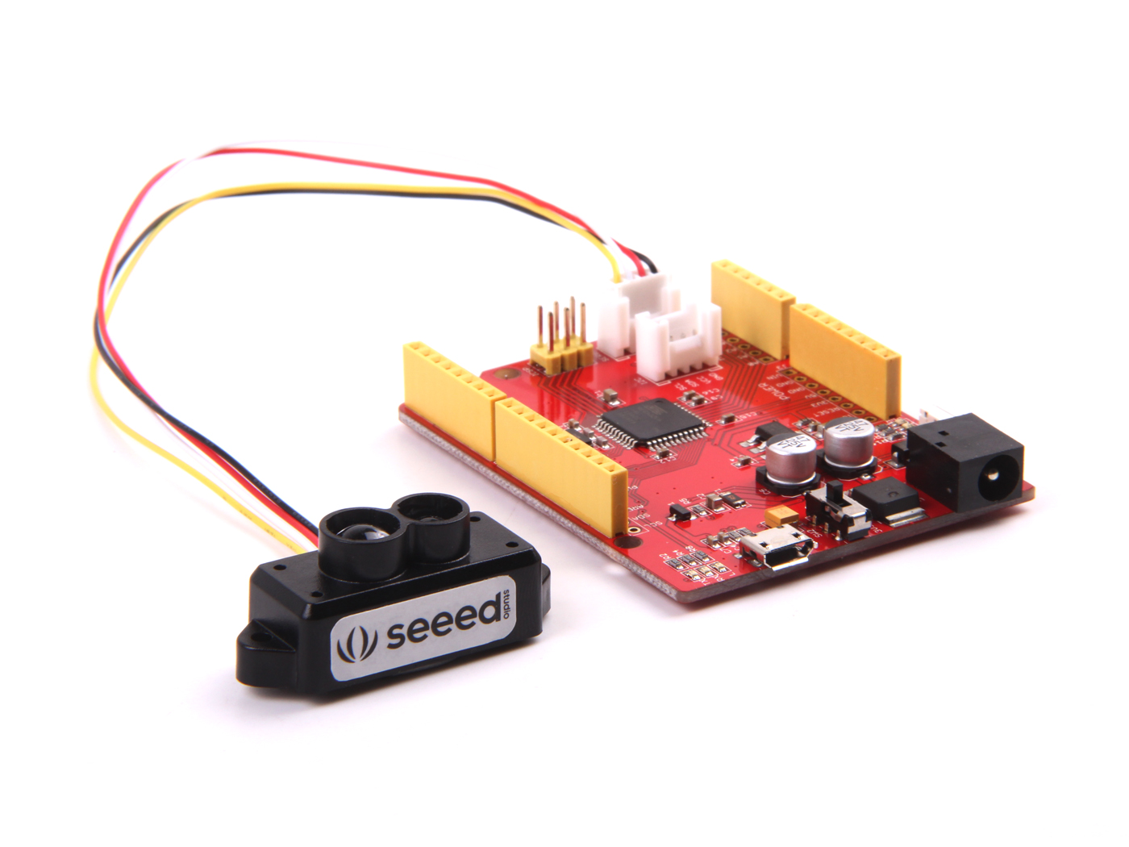

Seeed Development Limited

www.seeedstudio.com

Table of Contents

1. Main Product Characteristics 4

2. Optical Principle 4

3. Electrical Characteristics 5

4. Optical Characteristics 5

5. Measurement Range and FOV 5

6. Serial Port Data Communication Protocol and Line Sequence 6

6.1 Standard Data Format of Serial Port 7

6.2 Line sequence description 8

7. Interface Description of Serial Port Upper Computer 8

8. Product Size Specifications 9

9. Application Notice 9

# 1. Main Product Characteristics

This product is based on ToF (Time of Flight) principle and integrated with unique optical and electrical designs, so as to achieve stable, precise, high sensitivity and high-speed distance detection.

|  |  |
| --- | --- |
| **Product Name** | **TFmini** |
| Operating range | 0.3m-12m |
| Maximum operating range at 10% reflectivity | 5m |
| Average power consumption | 0.12W |
| Applicable voltage range | 4.5V-6V |
| Acceptance angle | 2.3° |
| Minimum resolution ratio | 5mm |
| Frequency | 100Hz |
| Accuracy | 1% (less than 6m), 2% (6m-12m) |
| Distance detection unit | mm |
| Wavelength | 850nm |
| Size | 42mm×15mm×16mm |
| Operating temperature | -20℃-60℃ |
| Light sensitivity | 70,000lux |
| Weight | 6.1g |
| Communication interface | UART |
| Main applications | Drone altitude holding and terrain following  Machine control and safety sensor  Robot distance detection |

Table 1 Product characteristics and applications

# 2. Optical Principle

ToF is the abbreviation of Time of Flight technology, and its operating principle is as follows: a modulated near-infrared light is sent from the sensor and reflected by an object; the distance to the object to be shot can be converted with the sensor by calculating the time difference or phase difference between the light sending and the light reflection, so as to produce the depth information.

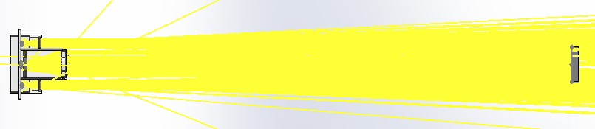

*Fig. 1 TF_mini optical simulation of the optical path*

# 3. Electrical Characteristics

|  |  |  |  |
| --- | --- | --- | --- |
| **Item** | **Symbol** | **Typical value** | **Unit** |
| Input voltage | DC | 5 | V |
| Average power | P | ≤120 | mW |
| LED peak current | Imax | 800 | mA |
| Serial port TTL voltage level | V­­TTL | 3.3 | V |

Table 2 TF_mini electrical characteristics

# 4. Optical Characteristics

|  |  |  |  |  |
| --- | --- | --- | --- | --- |
| **Parameter** | **Symbol** | **Condition or description** | **Typical value** | **Unit** |
| FOV | β |  | 2.3 | Degree |
| Resolution | Re | Sensitivity to distance change | 5 | mm |
| Wavelength | λ |  | 850 | nm |

Table 3 Optical characteristics

# 5. Measurement Range and FOV

**TFmini measurement range**

Indoor conditions:

The object to be detected has 90% reflectivity and the effective detection distance is 12m;

The object to be detected has 10% reflectivity and the effective detection distance is 5m;

Outdoor conditions:

Under the general sunshine condition (with illumination of lower than 70klux), the effective detection distance is 7m;

Under the high sunshine condition in summer (with illumination of above 100klux) or the condition with outdoor black background board, the effective detection distance is 3m.

Note: All distance parameters are set under the opposite direction with the object to be detected.



Fig. 2 Measurement range schematic diagram

**TFmini FOV**

The FOV of TFmini is 2.3˚, which determines the side lengths of different detection ranges of LiDAR (the detection range is similar to a square shape).

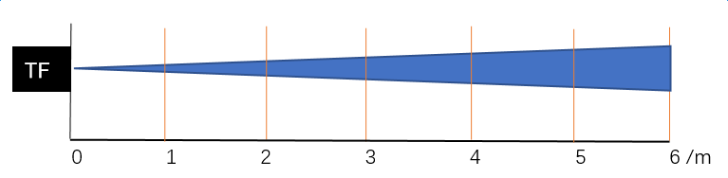

Fig. 3 Detection range (acceptance angle) schematic diagram

|  |  |  |  |  |  |  |
| --- | --- | --- | --- | --- | --- | --- |
| Distance/m | 1 | 2 | 3 | 4 | 5 | 6 |
| Detection range side length/mm | 40 | 80 | 120 | 160 | 200 | 240 |

Table 4 Relationship between detection range and distance

Description: The distance in the table represents the vertical length between the detection object and the sensor, expressed in meters; the side length of detection range is expressed in millimeters. In general, only if the side length of the object to be detected is more than the detection range side length, the output data from LiDAR can be trusted; if the side length of the object to be detected is less than the detection range side length, the output data of LiDAR may be fluctuated and the error may be increased.

Note: The detection range side length is not equal to the object resolution ratio at the corresponding distance.

# 6. Serial Port Data Communication Protocol and Line Sequence

The following section describes the connections and communications between TFmini and external devices, including the encoding format of the sending data, the communication protocol between the module and the external devices, the hardware line connection indications, and the related precautions.

|  |  |
| --- | --- |
| Communication protocol | UART |
| Baud rate | 115200 |
| Data bit | 8 |
| Stop bit | 1 |
| Parity bit | 0 |

Table 5 External communications

## 6.1 Standard Data Format of Serial Port

The module data is a hexadecimal output data; each frame data is encoded with 9 bytes, including 1 distance data (Dist); each distance data has corresponding signal strength information (Strength); the frame end is the data parity bit.

|  |  |  |  |  |  |  |  |
| --- | --- | --- | --- | --- | --- | --- | --- |
| Byte1-2 | Byte3 | Byte4 | Byte5 | Byte6 | Byte7 | Byte8 | Byte9 |
| 0x59 59 | Dist_L | Dist_H | Strength_L | Strength_H | Reserved | Raw.Qual | CheckSum_L |
| **Data encoding interpretation** | | | | | | | |
| **Byte1** | 0x59, frame header, all frames are the same | | | | | | |
| **Byte2** | 0x59, frame header, all frames are the same | | | | | | |
| **Byte3** | Dist_L distance value is a low 8-bit. Note: The distance value is a hexadecimal value, for example, Distance 1,000cm = 03 E8 (HEX) | | | | | | |
| **Byte4** | Dist_H distance value is a high 8-bit. | | | | | | |
| **Byte5** | Strength_L is a low 8-bit. | | | | | | |
| **Byte6** | Strength_H is a high 8-bit. | | | | | | |
| **Byte7** | Reserved bytes. | | | | | | |
| **Byte8** | Original signal quality degree. | | | | | | |
| **Byte9** | Checksum parity bit is a low 8-bit, Checksum = Byte1 + Byte2 + ... + Byte8, Checksum is the sum of the first 8 bytes of actual data; here is only a low 8-bit. | | | | | | |

Table 6 Data encoding format and detailed description

## 6.2 Line sequence description

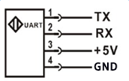

Fig. 4 TFmini line sequence description

TFmini line sequence is shown in “TF_mini line sequence description” in Fig. 4; generally, there are provided with the wiring terminals, among which, the green line corresponds to TX, the white line corresponds to RX, the red line corresponds to +5V, and the black line corresponds to GND.

# 7. Interface Description of Serial Port Upper Computer

The upper computer is currently supported with the windows system and applied for TF series of products output from Benewake (Beijing) Co. Ltd. in accordance with the serial communication protocol; the specific operations are detailed as below.

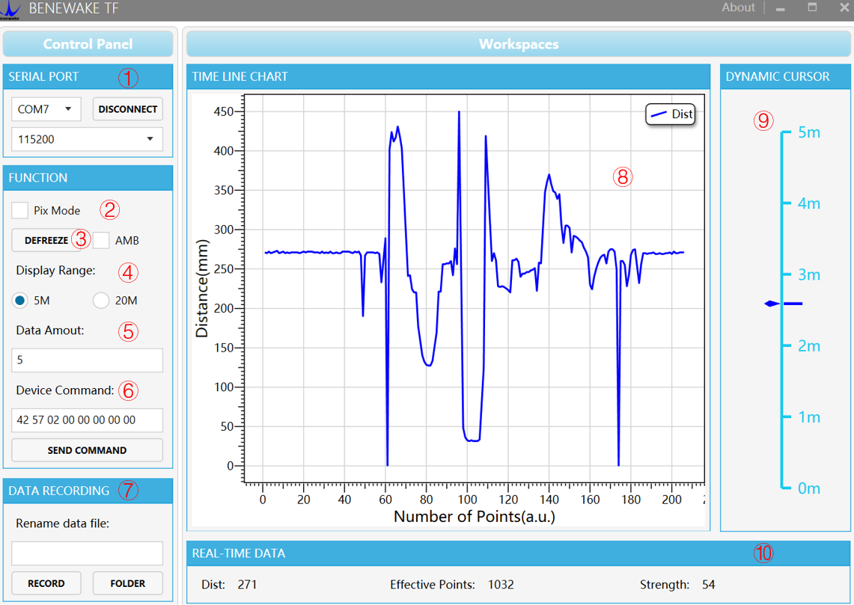

Fig. 5 Client Interface of Distance Measurement Demonstration in Windows

① Serial transmission port and baud rate selections: Plug in TTL-USB adapter plate, select the corresponding port number and baud rate, and click the “CONNECT” button to establish the connection;

② Mode selection: It is the special mode specified for Pix version of TF01 and TF02 products, which is not provided on TF_mini;

③ Pause button: Click it to pause the upper computer for analysis on the images in ⑧; “AMB” is used for the internal debugging under special cases and cannot be set in any case;

④ Measurement range area selection: Click 5m or 20m, the range scale in area ⑨ will be adjusted to the corresponding value.

⑤ Data average: The default value is 5; that is, the values of every 5 points accepted by the upper computer are averaged and output at a point value. After modified, the command will be sent with “Enter” key on the keyboard;

⑥ Serial port command sending area: This window is used to send hexadecimal TF serial port command and modify or set the function;

⑦ Data recording bar. This text window is used to name the data to be saved; after the name is input, press “Enter” key to record TF data by clicking “RECORD” button and end the record by clicking the button again; the folder with saved data can be opened by clicking “FOLDER” button;

⑧ Data image display area: the upper computer can draw a continuous ranging image with the received data;

⑨ Measurement range scale: Display the real-time detection distance value;

⑩ Data display area: Dist indicates the distance detection value in mm; EffectivePoint indicates the total effective data output by TF; Strength indicates the signal strength, under the pix mode, Strength is defaulted as 0 because there is no strength input.

# 8. Product Size Specifications

The following is the module outline size drawing.

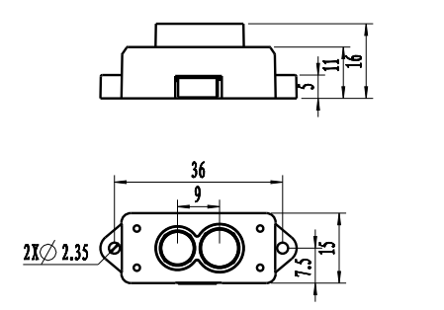

Fig. 6 TF_mini left module size drawing (unit: mm)

# 9. Application Notice

* This product is a custom precision optical instrument and must be maintained by our engineers.
* Prevent dust or any other foreign matter from entering the lens; otherwise it may affect the light transmission.