Exercise 3: Google App Engine SDK and Web App Development

Aim
To install the Google App Engine SDK and develop a Hello World / simple web application using Python.

Procedure

Step 1: Install Google Cloud CLI & Python
Ensure Python 3 is installed on the system.
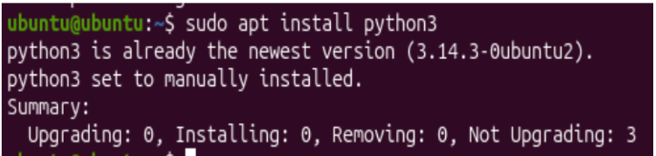
Download and install the Google Cloud CLI (contains the modern App Engine SDK) from cloud.google.com/sdk/docs/install:
curl -O https://dl.google.com/dl/cloudsdk/channels/rapid/downloads/google-cloud-cli-linux-x86_64.tar.gz
tar -xf google-cloud-cli-linux-x86_64.tar.gz
./google-cloud-sdk/install.sh

Step 2: Initialize GCloud & Install Components
gcloud init
Sign in to your Google account when prompted.
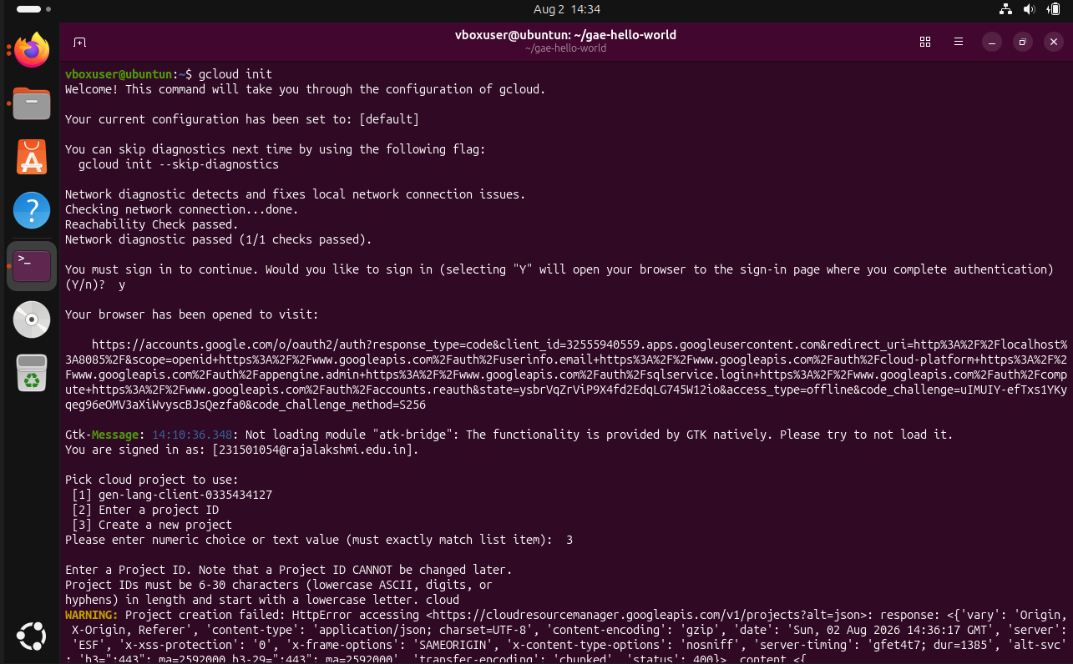
gcloud components install app-engine-python

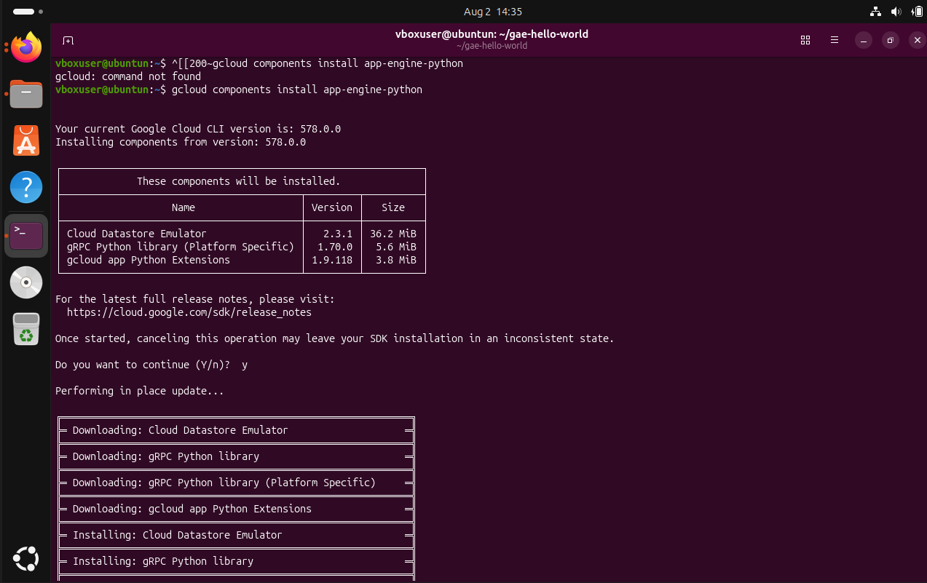

Step 3: Create the App Directory
mkdir gae-hello-world
cd gae-hello-world

Step 4: Create Application Code (main.py)
from flask import Flask
app = Flask(__name__)
@app.route("/")
def hello():
return "Hello World from Google App Engine!"
if __name__ == "__main__":
app.run(host="127.0.0.1", port=8080, debug=True)

Step 5: Create Configuration File (app.yaml)
runtime: python39
handlers:
- url: /.*
script: auto

Step 6: Create requirements.txt
Flask==2.0.1

Output
Files created in project directory (main.py, app.yaml, requirements.txt):
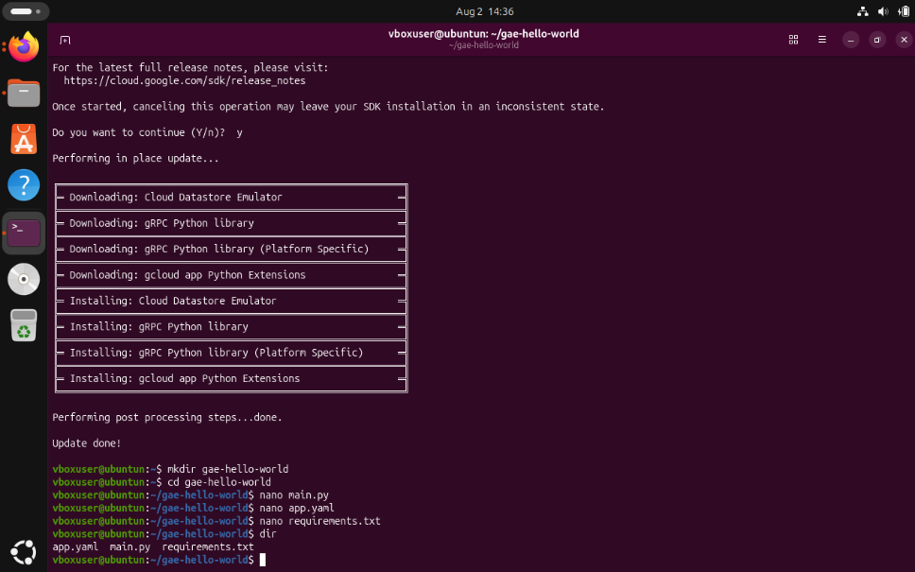

Result
Thus, the Google App Engine SDK was installed and a simple Hello World web application was developed using Python and Flask.

