Exercise 4: Launching Web Applications using App Engine Tools

Aim:
To launch and run a web application locally using Google App Engine tools (Flask) and verify it in a browser.

Procedure:

Step 1: Upgrade Flask and Werkzeug
pip install --upgrade flask werkzeug
This upgrades Flask and its dependencies (Werkzeug, blinker, etc.) in the virtual environment.

Step 2: Verify Installed Package Versions
pip show flask
pip show werkzeug
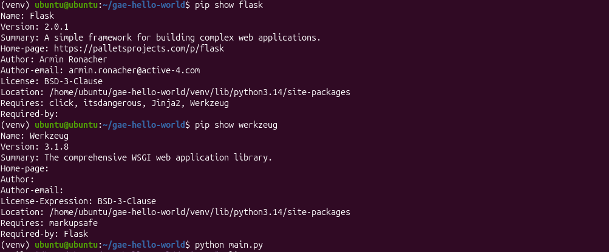

Step 3: Review Application Code (main.py)
main.py defines a simple Flask route that returns a Hello World message:
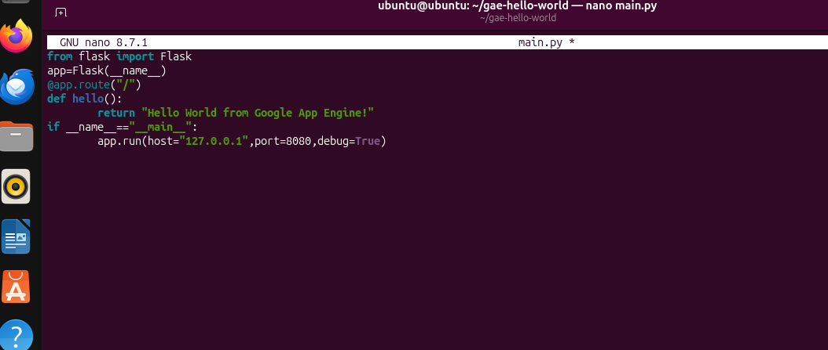

Step 4: Run the Application
python main.py
Flask starts the development server on http://127.0.0.1:8080 with debug mode enabled.
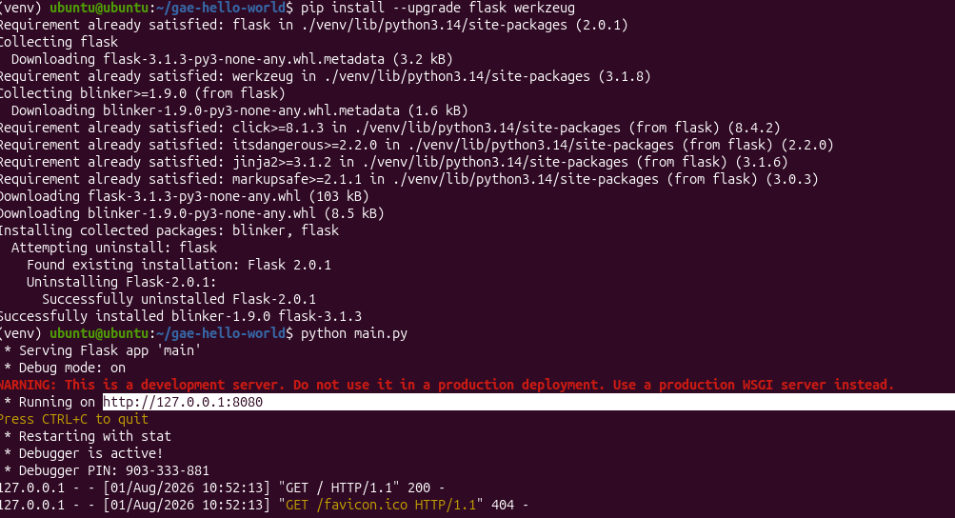

Output:
The application was accessed from the browser at 127.0.0.1:8080, confirming successful deployment:

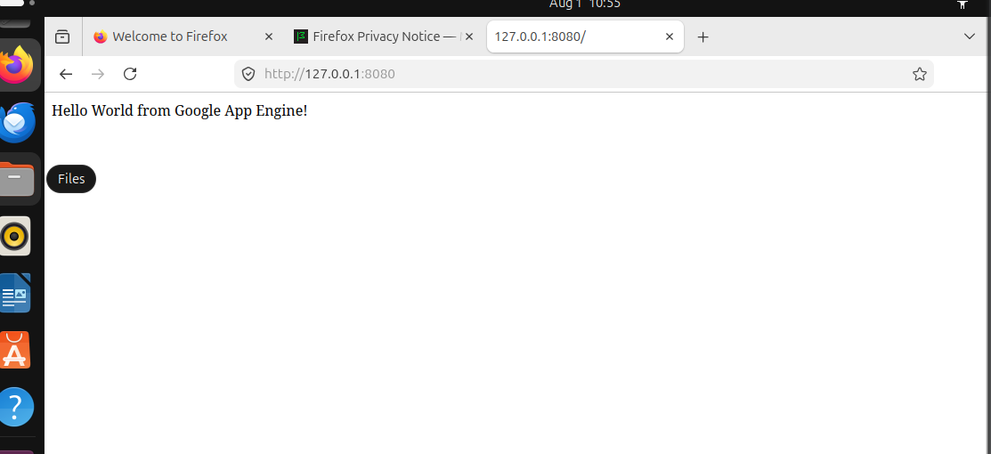

Result:
Thus, the Flask-based web application was successfully launched and tested locally using Google App Engine tools.

