**A CRM APPLICATION TO MANAGE THE MALL**

**OUTPUT:**

**PICTURE 1:**

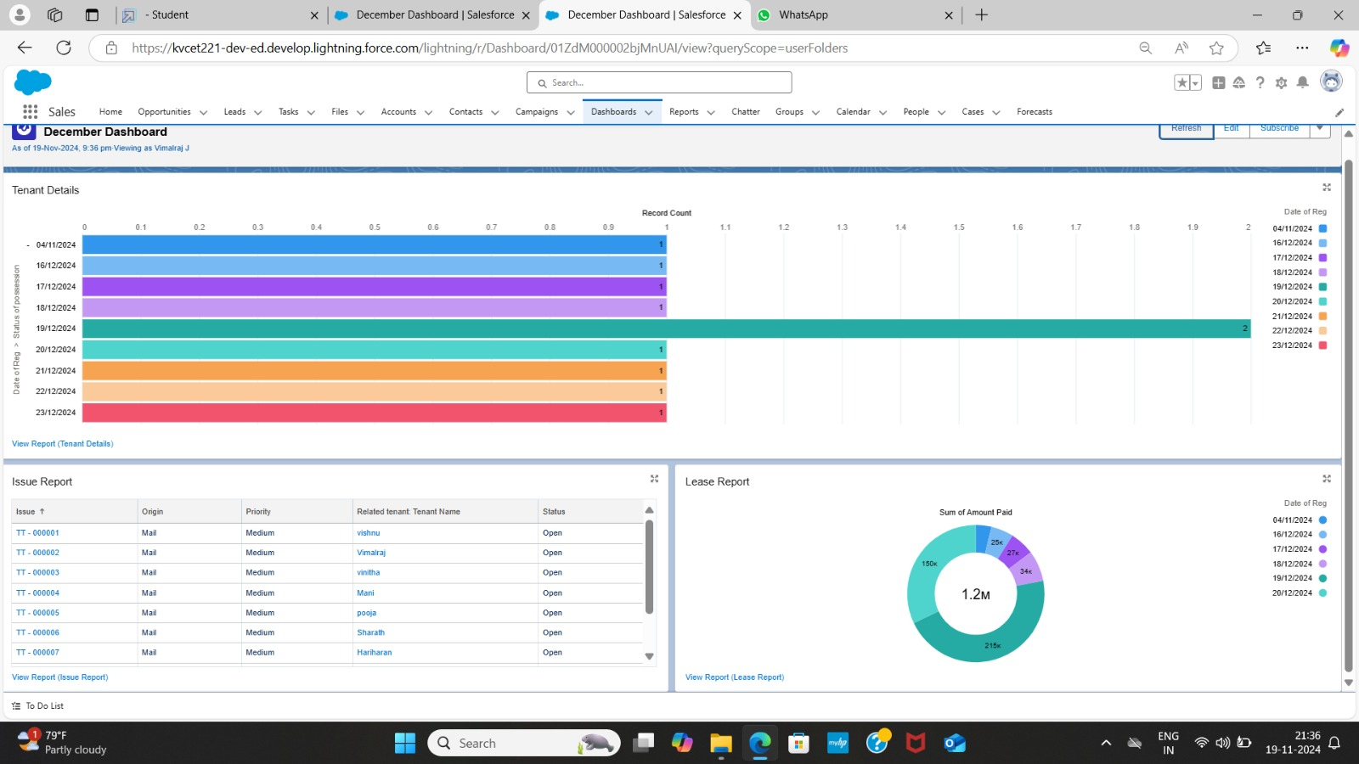

**PICTURE 2:**

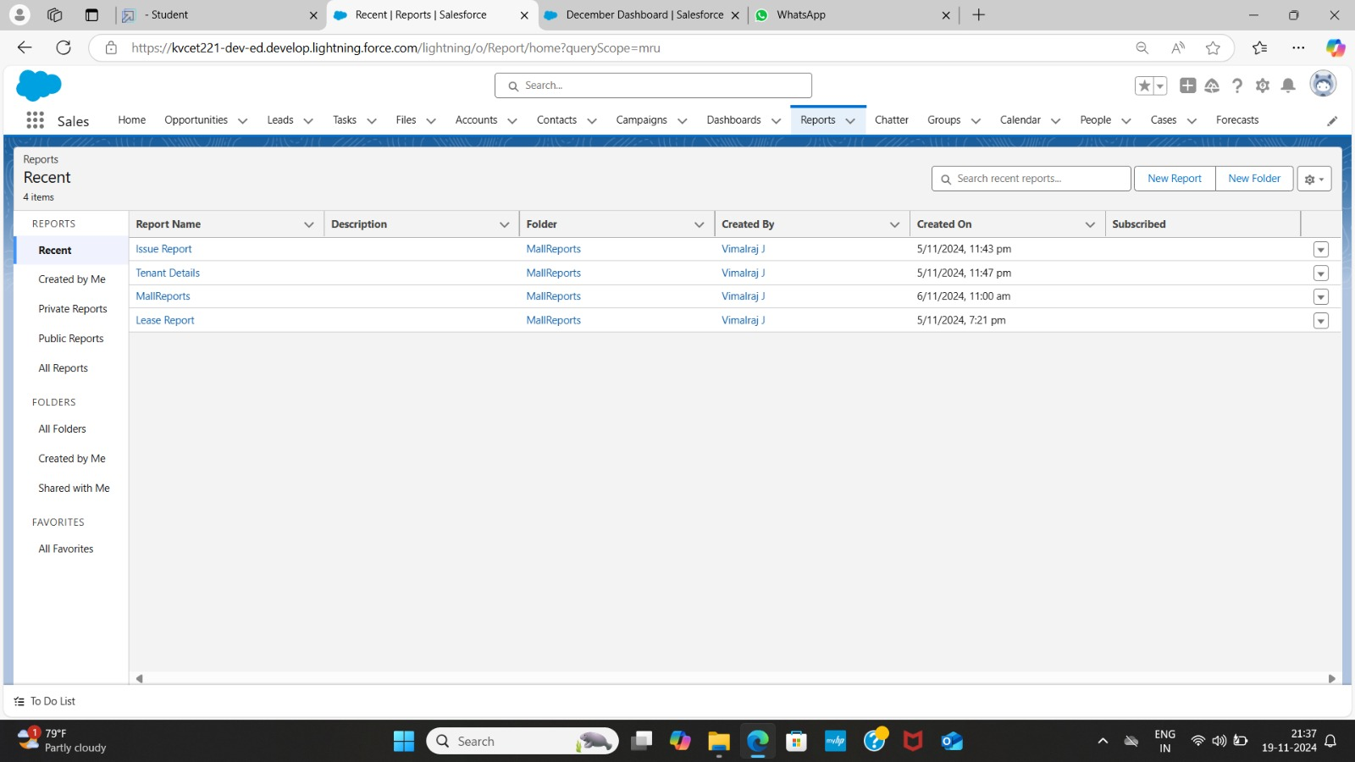

**PICTURE 3:**

