Day 2 – Data Preprocessing and Exploratory Data Analysis (EDA)
1. Understand data preprocessing and why it is necessary.
2. Perform Exploratory Data Analysis (EDA).
3. Identify and handle missing values.
4. Detect and handle outliers.
5. Understand correlation between variables.
6. Perform feature engineering.
7. Build a telemetry data quality and exploration module.

WORKFLOW
Raw telemetry data
(Temperature, voltage, pressure, vibration)

Data inspection
(Shape, data types, statistics)

Data cleaning
(Missing values, duplicates, outliers)

Exploratory Data Analysis
(Visualizations, distributions, correlations)

Feature engineering and prepared dataset
(Ready for machine learning)

CODE
import pandas as pd
import numpy as np
import matplotlib.pyplot as plt
import seaborn as sns

# STEP 1: Create illustrative spacecraft telemetry data
data = {
"Time": [1, 2, 3, 4, 5, 6, 7, 8, 9, 10],
"Temperature": [25.2, 25.5, 25.8, np.nan, 26.1,
26.4, 26.7, 45.8, 27.2, 27.5],
"Voltage": [5.1, 5.2, 5.1, 5.3, np.nan,
5.2, 5.1, 5.3, 5.2, 5.1],
"Pressure": [101, 102, 100, 103, 101,
102, 101, 104, 102, 101],
"Vibration": [0.12, 0.14, 0.13, 0.15, 0.14,
0.13, 0.15, 0.65, 0.14, 0.13]
}
df = pd.DataFrame(data)
print("----- ORIGINAL TELEMETRY DATA -----")
print(df)

# STEP 2: Inspect the dataset
print("\nDataset shape:", df.shape)

print("\nDataset information:")
df.info()

print("\nStatistical summary:")
print(df.describe())

# STEP 3: Check missing values
print("\nMissing values:")
print(df.isnull().sum())

# STEP 4: Handle missing numerical values
# Use median as a simple demonstration
clean_df = df.copy()
sensor_columns = [
"Temperature", "Voltage", "Pressure", "Vibration"
]
for column in sensor_columns:
clean_df[column] = clean_df[column].fillna(
clean_df[column].median()
)
print("\nData after missing-value treatment:")
print(clean_df)

# STEP 5: Detect potential outliers using IQR
for column in sensor_columns:
Q1 = clean_df[column].quantile(0.25)
Q3 = clean_df[column].quantile(0.75)
IQR = Q3 - Q1
lower = Q1 - 1.5 * IQR
upper = Q3 + 1.5 * IQR
outlier_rows = clean_df[
(clean_df[column] < lower) |
(clean_df[column] > upper)
]
print(f"\nPotential outliers in {column}:")
print(outlier_rows[["Time", column]])

# STEP 6: Correlation analysis
correlation = clean_df.corr(numeric_only=True)
print("\nCorrelation matrix:")
print(correlation)
plt.figure(figsize=(8, 5))
sns.heatmap(
correlation,
annot=True,
cmap="coolwarm",
fmt=".2f"
)
plt.title("Telemetry Correlation Heatmap")
plt.tight_layout()
plt.show()

# STEP 7: Feature engineering
clean_df["Temperature_Change"] = (
clean_df["Temperature"].diff()
)
clean_df["Vibration_Change"] = (
clean_df["Vibration"].diff()
)
clean_df["Temperature_Rolling_Mean"] = (
clean_df["Temperature"].rolling(window=3).mean()
)
print("\nDataset with engineered features:")
print(clean_df)

# STEP 8: Visualize temperature readings
plt.figure(figsize=(8, 5))
plt.plot(
clean_df["Time"],
clean_df["Temperature"],
marker="o",
label="Temperature"
)
plt.xlabel("Time")
plt.ylabel("Temperature")
plt.title("Spacecraft Temperature Monitoring")
plt.legend()
plt.grid(True)
plt.tight_layout()
plt.show()

# STEP 9: Save the processed dataset
clean_df.to_csv("cleaned_telemetry.csv", index=False)
print("\nCleaned telemetry data saved successfully!")

OUTPUT
- Dataset inspection
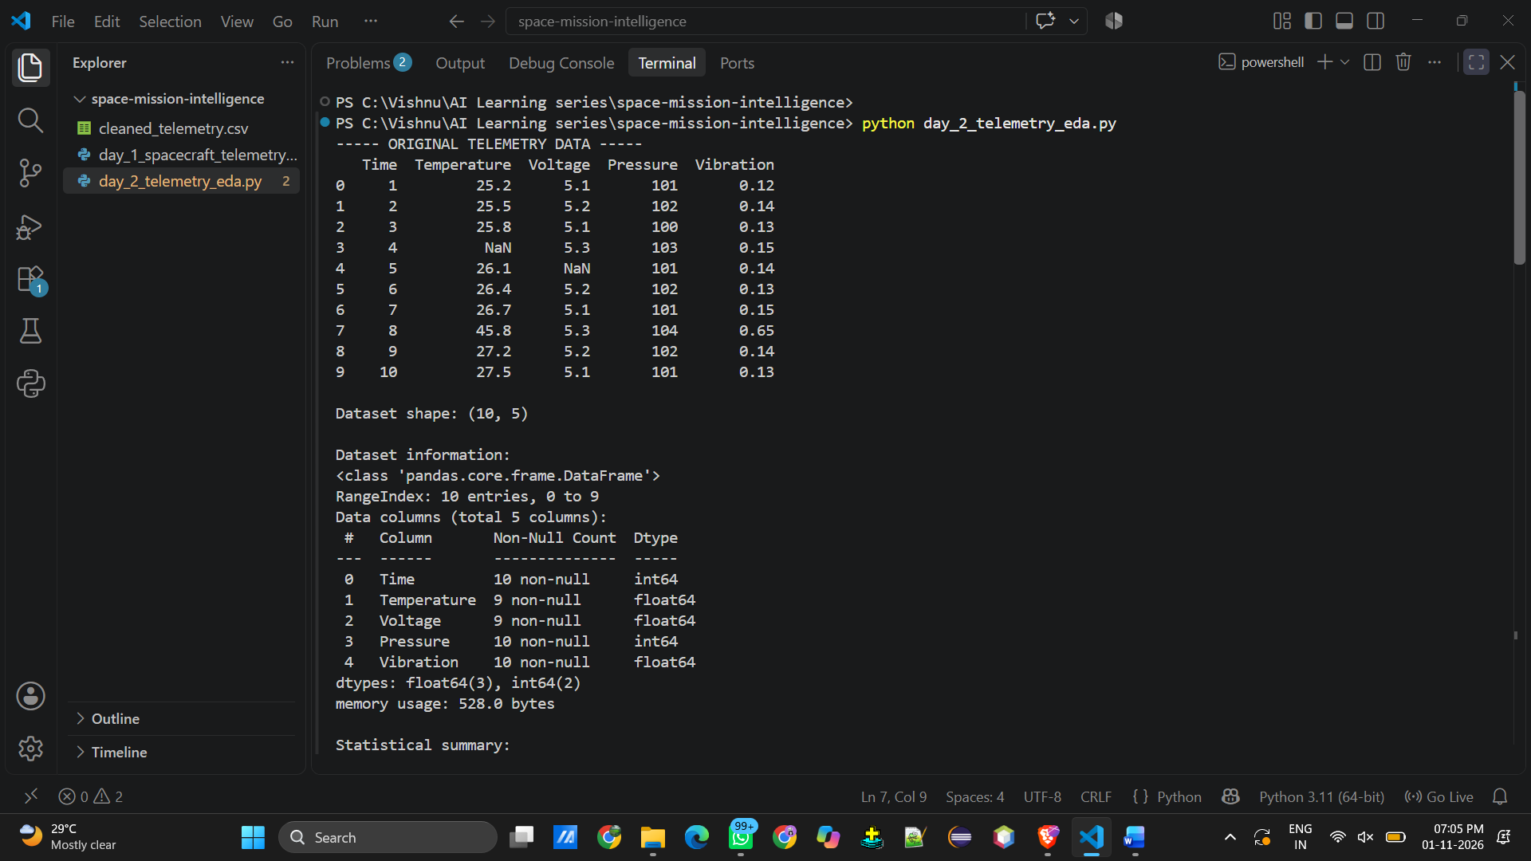

- Statistical info
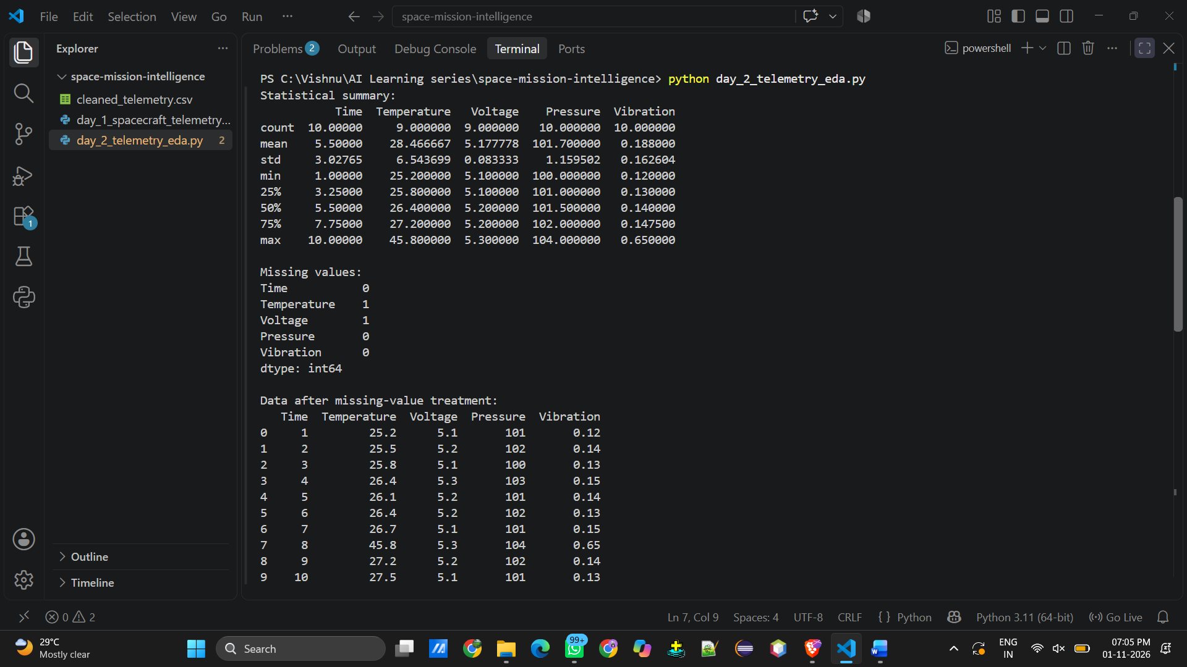

- Outliers
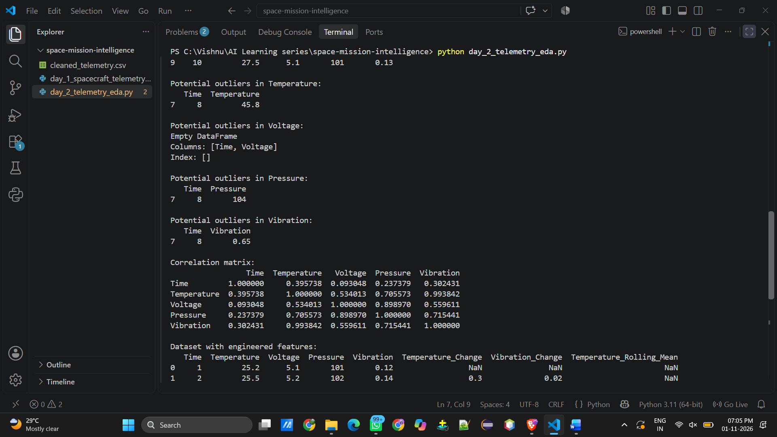

- Feature engineering
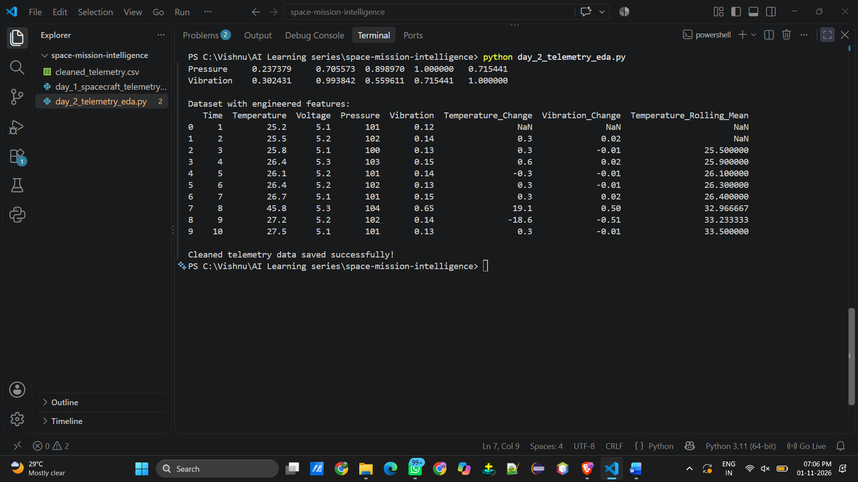

- Cleaned telemetry_csv
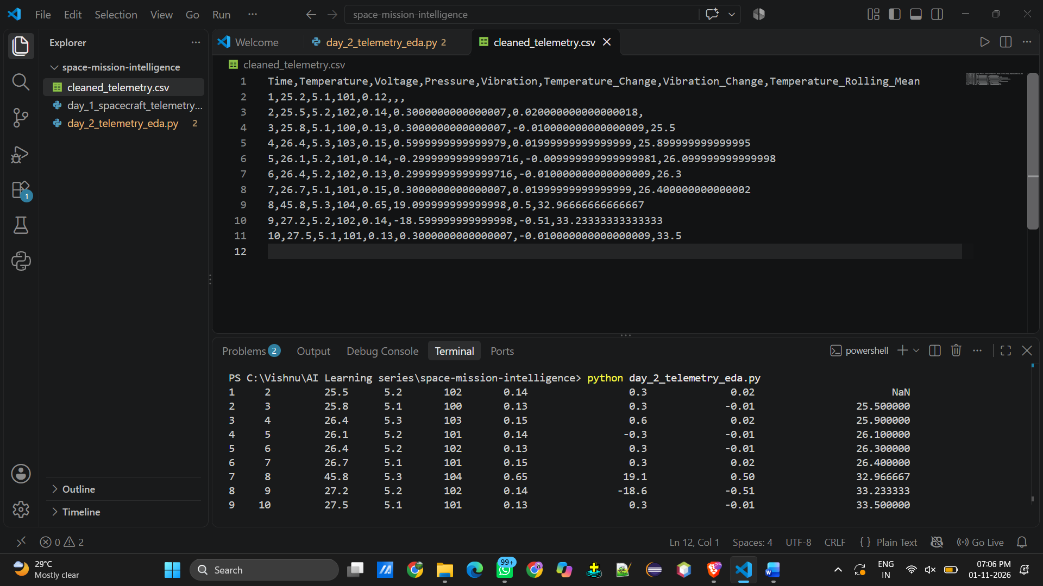

- Heatmap
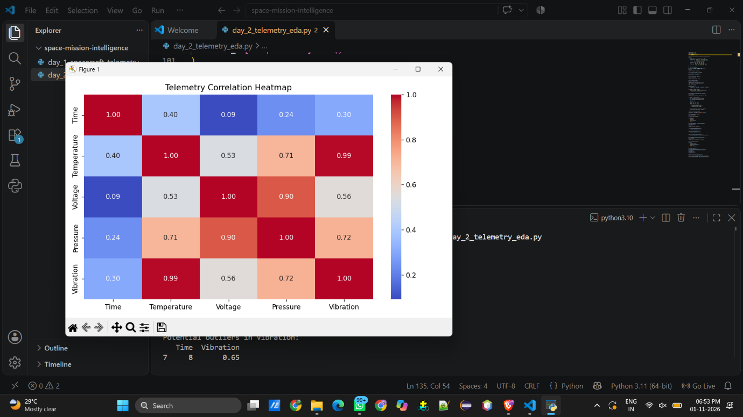

- Spacecraft_monitoring


