Vishnu Priya Thammina  
1. How many total combinations are possible? Show the math along with the code!  
Total possible combinations are 36  
as a die has faces  
possible combinations could be 6\*6=36

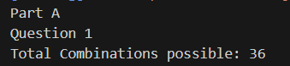

2. Calculate and display the distribution of all possible combinations that can be

obtained when rolling both Die A and Die B together. Show the math along with

the code!

Hint: A 6 x 6 Matrix.  
probability for each combination to be picked is 1/36  
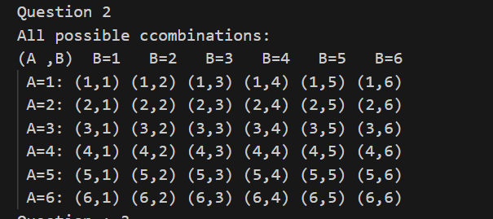

3. Calculate the Probability of all Possible Sums occurring among the number of

combinations from (2).

Example: P(Sum = 2) = 1/X as there is only one combination possible to obtain

Sum = 2. Die A = Die B = 1.

I calculated the count and maintained a unordered map such that   
I have <sum, (a,b)> //sum=a+b

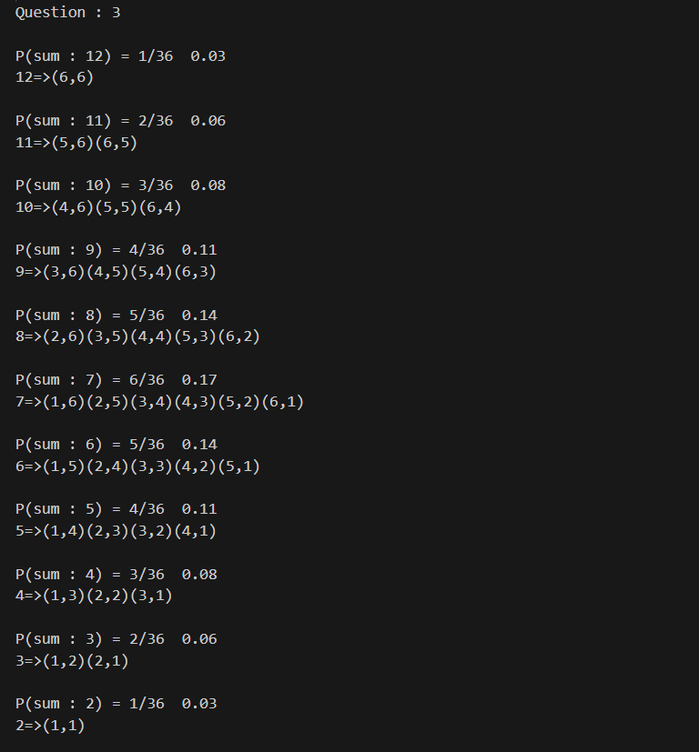

Part B:  
we are generating all combinations possible from [1,2,3,4] on rolling a dice

and we are generating all combinations possible on rolling dice with digigts from 1 to 8

because 8+4=12 the as we are removing 5,6 the highest number that can be considered is 8

now we find all combinations possible for 8

these combinations are combinations of faces on dice

now we take set of faces that can be possible

as such two dice

and we try to calculate the probability

if the prob vectors match

that is the perfect dice combinations  
