**PROJECT NAME:EARTHQUAKE PREDICTION MODEL USING PYTHON**

**PHASE-03:DEVELOPMENT**

ABSTRACT:

Earthquake prediction is a challenging task that has been the subject of research for many years. The ability to accurately predict earthquakes could save countless lives and prevent significant damage to infrastructure. In this project, we aim to develop an earthquake prediction module using Python. The first step in developing an earthquake prediction module is to gather data. We will collect seismic data from various sources, including seismographs and other sensors, to build a comprehensive dataset. This dataset will include information about the location, magnitude, and time of each earthquake. Once we have collected the data, we will use machine learning algorithms to analyze it and identify patterns that can be used to predict future earthquakes. We will use a variety of techniques, including regression analysis, clustering, and neural networks, to identify correlations between different variables and predict future earthquake.

INTRODUCTION:

Earthquakes are natural disasters that can cause significant destruction and loss of life. Developing a reliable earthquake prediction model is a critical step towards mitigating their impact. In this project, we aim to create a basic earthquake prediction model using Python, leveraging machine learning techniques and seismic data. Our approach involves collecting and preprocessing seismic data from reliable sources, such as the United States Geological Survey (USGS). We'll then extract relevant features and train a machine learning model to predict seismic activity. While this model won't replace sophisticated seismic monitoring systems, it serves as an educational exercise in understanding the basics of earthquake prediction. Throughout this project, we'll cover key steps including data acquisition, preprocessing, feature engineering, model selection, and evaluation. By the end, we hope to provide a foundational understanding of how machine learning can be applied to earthquake prediction.

LOADING AND PREPROCESSING:

Loading and preprocessing data for an earthquake prediction model in Python can be a complex task. Here are some challenges you might encounter:

1. “Data Collection”: Acquiring accurate and comprehensive earthquake data can be a challenge. You'll need to rely on sources like USGS, which provide earthquake data in various formats.

2. “Data Quality”: Earthquake data can be noisy, incomplete, or contain errors. Preprocessing may involve data cleaning and dealing with missing values.

3. “Data Volume”: Earthquake data can be vast, especially if you're working with historical records. Handling large datasets efficiently is essential.

4. “Data Format”: Earthquake data may come in various formats, such as CSV, JSON, or XML. You need to parse and convert it into a suitable format for your model.

5. “Feature Engineering”: Selecting the right features and engineering relevant ones is crucial. Geospatial and temporal data may require special treatment.

6. “Geospatial Data”: If your model involves geospatial data, you'll need to work with libraries like GeoPandas, and handle spatial data operations and transformations. In

import numpy as np

import pandas as pd

import requests

from sklearn import preprocessing

import matplotlib.pyplot as plt

import seaborn as sns

from pandas.plotting import scatter_matrix

from sklearn.impute import SimpleImputer

from sklearn.preprocessing import StandardScaler

from sklearn.preprocessing import MinMaxScaler

import time

In

from google.colab import drive

drive.mount('/content/drive')

df = pd.read_csv("/content/drive/MyDrive/Colab Notebooks/earthquake_prediction/earthquake1.csv")

Drive already mounted at /content/drive; to attempt to forcibly remount, call drive.mount("/content/drive", force_remount=True).

In

df.info()

<class 'pandas.core.frame.DataFrame'>

RangeIndex: 24007 entries, 0 to 24006

Data columns (total 17 columns):

# Column Non-Null Count Dtype

--- ------ -------------- -----

0 id 24007 non-null float64

1 date 24007 non-null object

2 time 24007 non-null object

3 lat 24007 non-null float64

4 long 24007 non-null float64

5 country 24007 non-null object

6 city 11754 non-null object

7 area 12977 non-null object

8 direction 10062 non-null object

9 dist 10062 non-null float64

10 depth 24007 non-null float64

11 xm 24007 non-null float64

12 md 24007 non-null float64

13 richter 24007 non-null float64

14 mw 5003 non-null float64

15 ms 24007 non-null float64

16 mb 24007 non-null float64

dtypes: float64(11), object(6)

memory usage: 3.1+ MB

|  | **id** | **lat** | **long** | **dist** | **depth** | **xm** | **md** | **richter** | **mw** | **ms** | **mb** |
| --- | --- | --- | --- | --- | --- | --- | --- | --- | --- | --- | --- |
| **count** | 2.400700e+04 | 24007.000000 | 24007.000000 | 10062.000000 | 24007.000000 | 24007.000000 | 24007.000000 | 24007.000000 | 5003.000000 | 24007.000000 | 24007.000000 |
| **mean** | 1.991982e+13 | 37.929474 | 30.773229 | 3.175015 | 18.491773 | 4.056038 | 1.912346 | 2.196826 | 4.478973 | 0.677677 | 1.690561 |
| **std** | 2.060396e+11 | 2.205605 | 6.584596 | 4.715461 | 23.218553 | 0.574085 | 2.059780 | 2.081417 | 1.048085 | 1.675708 | 2.146108 |
| **min** | 1.910000e+13 | 29.740000 | 18.340000 | 0.100000 | 0.000000 | 3.500000 | 0.000000 | 0.000000 | 0.000000 | 0.000000 | 0.000000 |
| **25%** | 1.980000e+13 | 36.190000 | 26.195000 | 1.400000 | 5.000000 | 3.600000 | 0.000000 | 0.000000 | 4.100000 | 0.000000 | 0.000000 |
| **50%** | 2.000000e+13 | 38.200000 | 28.350000 | 2.300000 | 10.000000 | 3.900000 | 0.000000 | 3.500000 | 4.700000 | 0.000000 | 0.000000 |
| **75%** | 2.010000e+13 | 39.360000 | 33.855000 | 3.600000 | 22.400000 | 4.400000 | 3.800000 | 4.000000 | 5.000000 | 0.000000 | 4.100000 |
| **max** | 2.020000e+13 | 46.350000 | 48.000000 | 95.400000 | 225.000000 | 7.900000 | 7.400000 | 7.200000 | 7.700000 | 7.900000 | 7.100000 |

In

df.describe()

Out

In

df.shape

Out

(24007, 17)

In

df.head()

Out

|  | **id** | **date** | **time** | **lat** | **long** | **country** | **city** | **area** | **direction** | **dist** | **depth** | **xm** | **md** | **richter** | **mw** | **ms** | **mb** |
| --- | --- | --- | --- | --- | --- | --- | --- | --- | --- | --- | --- | --- | --- | --- | --- | --- | --- |
| **0** | 2.000000e+13 | 2003.05.20 | 12:17:44 AM | 39.04 | 40.38 | turkey | bingol | baliklicay | west | 0.1 | 10.0 | 4.1 | 4.1 | 0.0 | NaN | 0.0 | 0.0 |
| **1** | 2.010000e+13 | 2007.08.01 | 12:03:08 AM | 40.79 | 30.09 | turkey | kocaeli | bayraktar_izmit | west | 0.1 | 5.2 | 4.0 | 3.8 | 4.0 | NaN | 0.0 | 0.0 |
| **2** | 1.980000e+13 | 1978.05.07 | 12:41:37 AM | 38.58 | 27.61 | turkey | manisa | hamzabeyli | south_west | 0.1 | 0.0 | 3.7 | 0.0 | 0.0 | NaN | 0.0 | 3.7 |
| **3** | 2.000000e+13 | 1997.03.22 | 12:31:45 AM | 39.47 | 36.44 | turkey | sivas | kahvepinar_sarkisla | south_west | 0.1 | 10.0 | 3.5 | 3.5 | 0.0 | NaN | 0.0 | 0.0 |
| **4** | 2.000000e+13 | 2000.04.02 | 12:57:38 AM | 40.80 | 30.24 | turkey | sakarya | meseli_serdivan | south_west | 0.1 | 7.0 | 4.3 | 4.3 | 0.0 | NaN | 0.0 | 0.0 |

In

df.columns

Out

Index(['id', 'date', 'time', 'lat', 'long', 'country', 'city', 'area',

'direction', 'dist', 'depth', 'xm', 'md', 'richter', 'mw', 'ms', 'mb'],

dtype='object')

Data Preprocessing

In

df = df.drop('id',axis=1)

In

import datetime

import time

timestamp = []

for d, t in zip(df['date'], df['time']):

ts = datetime.datetime.strptime(d+' '+t, '%Y.%m.%d %I:%M:%S %p')

timestamp.append(time.mktime(ts.timetuple()))

timeStamp = pd.Series(timestamp)

df['Timestamp'] = timeStamp.values

final_data = df.drop(['date', 'time'], axis=1)

final_data = final_data[final_data.Timestamp != 'ValueError']

df = final_data

df.head()

Out

|  | **lat** | **long** | **country** | **city** | **area** | **direction** | **dist** | **depth** | **xm** | **md** | **richter** | **mw** | **ms** | **mb** | **Timestamp** |
| --- | --- | --- | --- | --- | --- | --- | --- | --- | --- | --- | --- | --- | --- | --- | --- |
| **0** | 39.04 | 40.38 | turkey | bingol | baliklicay | west | 0.1 | 10.0 | 4.1 | 4.1 | 0.0 | NaN | 0.0 | 0.0 | 1.053390e+09 |
| **1** | 40.79 | 30.09 | turkey | kocaeli | bayraktar_izmit | west | 0.1 | 5.2 | 4.0 | 3.8 | 4.0 | NaN | 0.0 | 0.0 | 1.185927e+09 |
| **2** | 38.58 | 27.61 | turkey | manisa | hamzabeyli | south_west | 0.1 | 0.0 | 3.7 | 0.0 | 0.0 | NaN | 0.0 | 3.7 | 2.633497e+08 |
| **3** | 39.47 | 36.44 | turkey | sivas | kahvepinar_sarkisla | south_west | 0.1 | 10.0 | 3.5 | 3.5 | 0.0 | NaN | 0.0 | 0.0 | 8.589907e+08 |
| **4** | 40.80 | 30.24 | turkey | sakarya | meseli_serdivan | south_west | 0.1 | 7.0 | 4.3 | 4.3 | 0.0 | NaN | 0.0 | 0.0 | 9.546371e+08 |

In

df.dtypes

Out

lat float64

long float64

country object

city object

area object

direction object

dist float64

depth float64

xm float64

md float64

richter float64

mw float64

ms float64

mb float64

Timestamp float64

dtype: object

In

*# Data Encoding*

label_encoder = preprocessing.LabelEncoder()

for col in df.columns:

if df[col].dtype == 'object':

label_encoder.fit(df[col])

df[col] = label_encoder.transform(df[col])

df.dtypes

Out

lat float64

long float64

country int64

city int64

area int64

direction int64

dist float64

depth float64

xm float64

md float64

richter float64

mw float64

ms float64

mb float64

Timestamp float64

dtype: object

In

df.isnull().sum()

Out

lat 0

long 0

country 0

city 0

area 0

direction 0

dist 13945

depth 0

xm 0

md 0

richter 0

mw 19004

ms 0

mb 0

Timestamp 0

dtype: int64

In

*# Imputing Missing Values with Mean*

si=SimpleImputer(missing_values = np.nan, strategy="mean")

si.fit(df[["dist","mw"]])

df[["dist","mw"]] = si.transform(df[["dist","mw"]])

df.isnull().sum()

Out

lat 0

long 0

country 0

city 0

area 0

direction 0

dist 0

depth 0

xm 0

md 0

richter 0

mw 0

ms 0

mb 0

Timestamp 0

dtype: int64

Data Visualization

In

import plotly.express as px

px.scatter(df, x='richter',y='xm', color="direction")

In

plt.figure(figsize=(7,7))

sns.histplot(data=df, x='depth', hue='direction',palette = 'Accent')

plt.show()

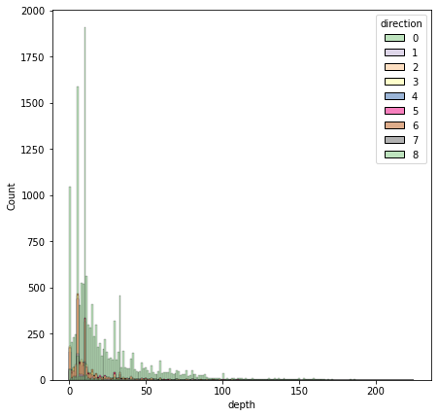

In

plt.figure(figsize=(7,7))

df[['lat','long']].hist()

plt.show()

<Figure size 504x504 with 0 Axes>

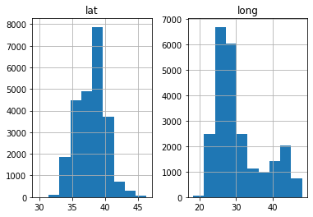

In

plt.figure(figsize=(15,10))

sns.countplot(df.xm)

/usr/local/lib/python3.8/dist-packages/seaborn/_decorators.py:36: FutureWarning:

Pass the following variable as a keyword arg: x. From version 0.12, the only valid positional argument will be `data`, and passing other arguments without an explicit keyword will result in an error or misinterpretation.

Out

<matplotlib.axes._subplots.AxesSubplot at 0x7f3d2346d400>

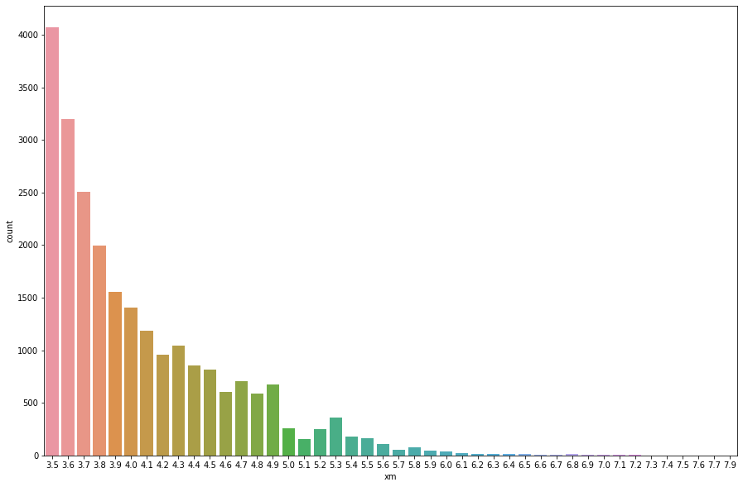

In

plt.figure(figsize=(10,10))

sns.distplot(df.xm)

/usr/local/lib/python3.8/dist-packages/seaborn/distributions.py:2619: FutureWarning:

`distplot` is a deprecated function and will be removed in a future version. Please adapt your code to use either `displot` (a figure-level function with similar flexibility) or `histplot` (an axes-level function for histograms).

Out

<matplotlib.axes._subplots.AxesSubplot at 0x7f3d242a4d00>

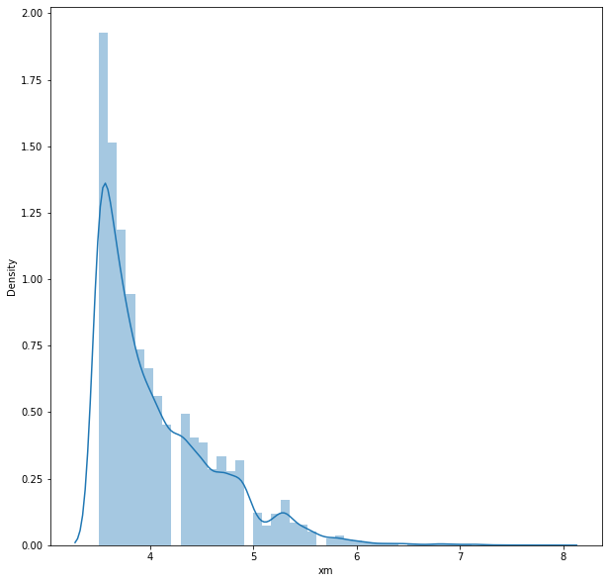

In

plt.figure(figsize=(15,10))

sns.barplot(x=df['xm'], y=df['ms'])

plt.xlabel('xm')

plt.ylabel('ms')

Out

Text(0, 0.5, 'ms')

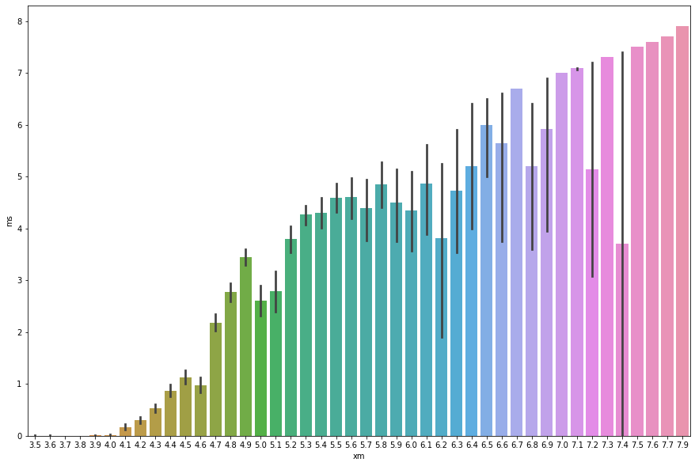

In

plt.scatter(df.depth, df.xm)

plt.xlabel("Depth")

plt.ylabel("xm")

plt.show()

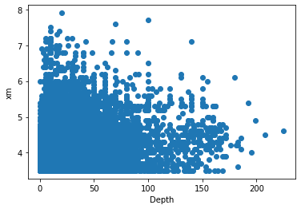

In

plt.scatter(df.depth, df.mb)

plt.xlabel("Depth")

plt.ylabel("Magnitude body")

plt.show()

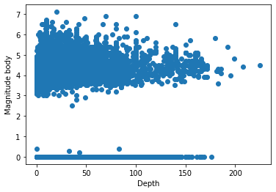

In

plt.scatter(df.dist, df.depth)

plt.xlabel("Area affected")

plt.ylabel("Depth")

plt.show()

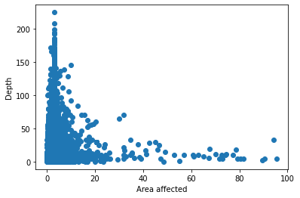

In

plt.scatter(df.dist, df.depth)

plt.xlabel("Area affected")

plt.ylabel("xm")

plt.show()

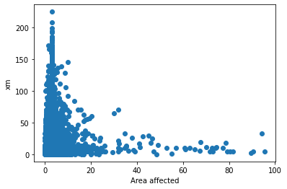

Correlation between Attributes

In

most_correlated = df.corr()['xm'].sort_values(ascending=False)

most_correlated

Out

xm 1.000000

ms 0.699579

mb 0.628382

richter 0.426653

mw 0.420695

depth 0.302926

md 0.241432

area 0.125275

city 0.107436

direction 0.087696

long 0.071856

dist 0.002853

lat -0.010347

country -0.056115

Timestamp -0.542092

Name: xm, dtype: float64

In

plt.figure(figsize=(20,20))

dataplot=sns.heatmap(df.corr(),annot=True)

plt.show()

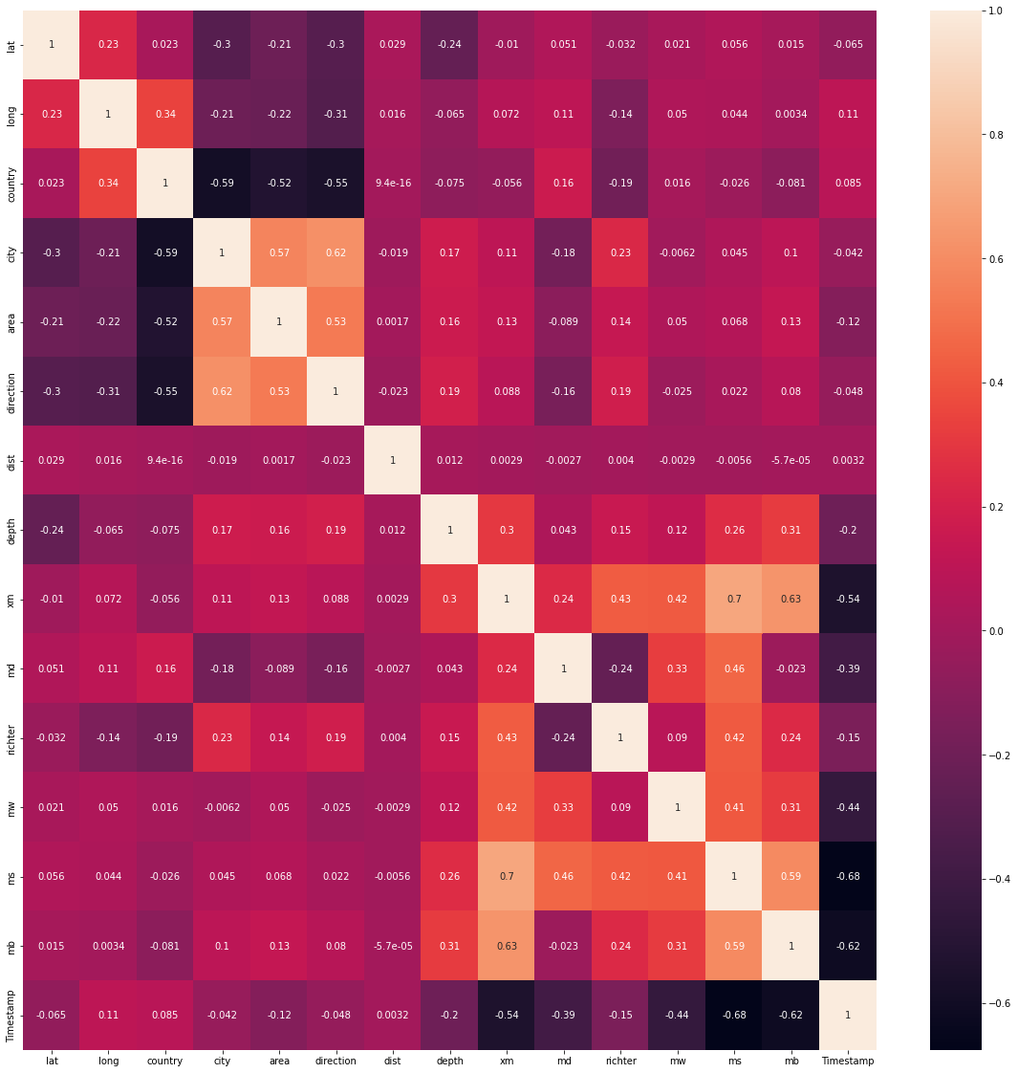

Normalization of data

In

*# Using MinMaxScaler*

scaler = preprocessing.MinMaxScaler()

d = scaler.fit_transform(df)

df = pd.DataFrame(d, columns=df.columns)

df.head()

Out

|  | **lat** | **long** | **country** | **city** | **area** | **direction** | **dist** | **depth** | **xm** | **md** | **richter** | **mw** | **ms** | **mb** | **Timestamp** |
| --- | --- | --- | --- | --- | --- | --- | --- | --- | --- | --- | --- | --- | --- | --- | --- |
| **0** | 0.559904 | 0.743088 | 0.76 | 0.172043 | 0.116144 | 0.875 | 0.0 | 0.044444 | 0.136364 | 0.554054 | 0.000000 | 0.581685 | 0.0 | 0.000000 | 0.866875 |
| **1** | 0.665262 | 0.396156 | 0.76 | 0.612903 | 0.132306 | 0.875 | 0.0 | 0.023111 | 0.113636 | 0.513514 | 0.555556 | 0.581685 | 0.0 | 0.000000 | 0.906252 |
| **2** | 0.532210 | 0.312542 | 0.76 | 0.677419 | 0.459500 | 0.750 | 0.0 | 0.000000 | 0.045455 | 0.000000 | 0.000000 | 0.581685 | 0.0 | 0.521127 | 0.632149 |
| **3** | 0.585792 | 0.610249 | 0.76 | 0.870968 | 0.513061 | 0.750 | 0.0 | 0.044444 | 0.000000 | 0.472973 | 0.000000 | 0.581685 | 0.0 | 0.000000 | 0.809118 |
| **4** | 0.665864 | 0.401214 | 0.76 | 0.806452 | 0.689344 | 0.750 | 0.0 | 0.031111 | 0.181818 | 0.581081 | 0.000000 | 0.581685 | 0.0 | 0.000000 | 0.837535 |

Splitting the Dataset

In

y=np.array(df['xm'])

X=np.array(df.drop('xm',axis=1))

from sklearn.model_selection import train_test_split

X_train,X_test,y_train,y_test=train_test_split(X,y,test_size=0.2,random_state=2)

Creating Models

1. Linear Regression

In

from sklearn.linear_model import LinearRegression

start1 = time.time()

linear=LinearRegression()

linear.fit(X_train,y_train)

ans1 = linear.predict(X_test)

end1 = time.time()

t1 = end1-start1

In

accuracy1=linear.score(X_test,y_test)

print("Accuracy of Linear Regression model is:",accuracy1)

Accuracy of Linear Regression model is: 0.63134131503029

In

from sklearn import metrics

print("Linear Regression")

print('Mean Absolute Error:', metrics.mean_absolute_error(y_test, ans1))

print('Mean Squared Error:', metrics.mean_squared_error(y_test, ans1))

print('Root Mean Squared Error:', np.sqrt(metrics.mean_squared_error(y_test, ans1)))

Linear Regression

Mean Absolute Error: 0.05878246463205686

Mean Squared Error: 0.00625827169726636

Root Mean Squared Error: 0.07910923901331854

In

plt.plot(y_test, ans1, 'o')

m, b = np.polyfit(y_test,ans1, 1)

plt.plot(y_test, m*y_test + b)

plt.xlabel("Actual Magnitude")

plt.ylabel("Predicted Magnitude")

Out

Text(0, 0.5, 'Predicted Magnitude')

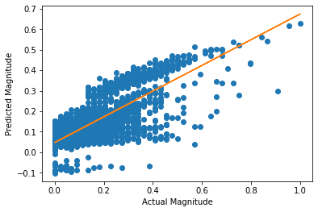

1. Decision Tree

In

from sklearn.tree import DecisionTreeRegressor

start2 = time.time()

regressor = DecisionTreeRegressor(random_state = 40)

regressor.fit(X_train,y_train)

ans2 = regressor.predict(X_test)

end2 = time.time()

t2 = end2-start2

In

accuracy2=regressor.score(X_test,y_test)

print("Accuracy of Decision Tree model is:",accuracy2)

Accuracy of Decision Tree model is: 0.9932960893884235

In

print("Decision Tree")

print('Mean Absolute Error:', metrics.mean_absolute_error(y_test, ans2))

print('Mean Squared Error:', metrics.mean_squared_error(y_test, ans2))

print('Root Mean Squared Error:', np.sqrt(metrics.mean_squared_error(y_test, ans2)))

Decision Tree

Mean Absolute Error: 0.0006909999621372331

Mean Squared Error: 0.00011380416561969702

Root Mean Squared Error: 0.010667903525046383

1. KNN Model

In

from sklearn.neighbors import KNeighborsRegressor

start3 = time.time()

knn = KNeighborsRegressor(n_neighbors=6)

knn.fit(X_train, y_train)

ans3 = knn.predict(X_test)

end3 = time.time()

t3 = end3-start3

In

accuracy3=knn.score(X_test,y_test)

print("Accuracy of KNN model is:",accuracy3)

Accuracy of KNN model is: 0.8457466919393031

In

print("KNN Model")

print('Mean Absolute Error:', metrics.mean_absolute_error(y_test, ans3))

print('Mean Squared Error:', metrics.mean_squared_error(y_test, ans3))

print('Root Mean Squared Error:', np.sqrt(metrics.mean_squared_error(y_test, ans3)))

KNN Model

Mean Absolute Error: 0.03305598677318794

Mean Squared Error: 0.002618571462992348

Root Mean Squared Error: 0.051171979275696854

In

import random

info = {}

for i in range(10):

k = random.randint(2,10)

startk = time.time()

knn = KNeighborsRegressor(n_neighbors=k)

knn.fit(X_train, y_train)

ans3 = knn.predict(X_test)

endk = time.time()

tk = endk-startk

acc3=knn.score(X_test,y_test)

info[k] = [acc3,tk]

for i in info:

print("for k =",i,": accuracy =",info[i][0])

for k = 4 : accuracy = 0.8559118607470738

for k = 9 : accuracy = 0.8334625255508568

for k = 8 : accuracy = 0.8384577534478264

for k = 6 : accuracy = 0.8457466919393031

for k = 5 : accuracy = 0.8519381145638621

for k = 10 : accuracy = 0.8296048410841246

for k = 7 : accuracy = 0.8425261199362686

In

x = list(info.keys())

yacc = []

for i in info:

yacc.append(info[i][0])

plt.plot(x, yacc, 'o', color='black');

plt.xlabel("k value")

plt.ylabel("accuracy");

plt.title("Accuracy for different values of k")

Out

Text(0.5, 1.0, 'Accuracy for different values of k')

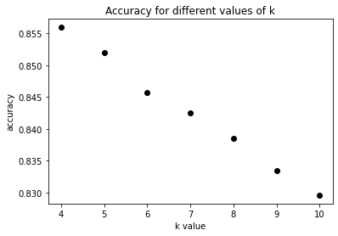

In

yt = []

for i in info:

yt.append(info[i][1])

plt.plot(x, yt, 'o', color='black');

plt.xlabel("k value")

plt.ylabel("execution time");

plt.title("Execution time for different values of k")

Out

Text(0.5, 1.0, 'Execution time for different values of k')

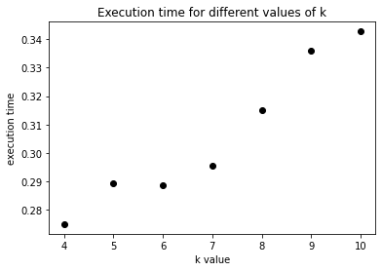

Comparison Graphs

1. Accuracy

In

models = ["linear regression","decision tree","knn"]

accuracies = [accuracy1,accuracy2,accuracy3]

In

plt.bar(models, accuracies, color ='maroon',

width = 0.25)

plt.xlabel("Models")

plt.ylabel("Accuracies")

plt.title("Accuracy Comparison Graph")

Out

Text(0.5, 1.0, 'Accuracy Comparison Graph')

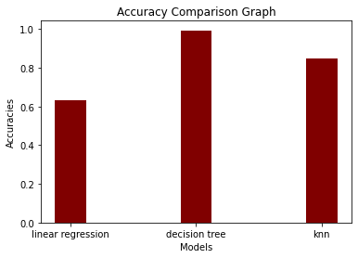

1. Execution Time

In

times = [t1,t2,t3]

plt.bar(models, times, color ='maroon',

width = 0.25)

plt.xlabel("Models")

plt.ylabel("Execution Time")

plt.title("Execution Time Comparison Graph")

Out

Text(0.5, 1.0, 'Execution Time Comparison Graph')

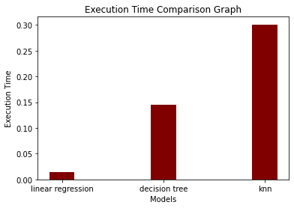

HOW TO OVERCOME THE CHALLENGES OF LOADING AND PREPROCESSING A EARTHQUAKE PREDICTION:

overcome the challenges of loading and preprocessing data for an earthquake prediction model in Python, you can follow these steps:

1. “Data Collection and Quality”:

   - Use reliable sources like USGS for earthquake data.

   - Implement data validation and cleaning routines to handle missing or erroneous data.

2. “Data Volume and Format”:

   - Use efficient data storage formats like HDF5 or Parquet for large datasets.

   - Utilize libraries like Pandas for data manipulation and conversion between formats.

3. “Feature Engineering”:

   - Collaborate with domain experts to select and engineer relevant features.

   - Explore geospatial libraries like GeoPandas for working with location-based data.

4. “Geospatial Data”:

   - Learn geospatial data manipulation techniques using GeoPandas and other geospatial libraries.

   - Understand coordinate reference systems (CRS) and perform necessary transformations.

5. “Time Series Data”:

   - Use libraries like Pandas for time series manipulation.

   - Consider incorporating time-based features like seasonality and trends.

6. “Imbalanced Data”:

   - Apply techniques such as oversampling, undersampling, or Synthetic Minority Over-sampling Technique (SMOTE) to handle imbalanced data.

7. “Normalization and Scaling”:

   - Normalize and scale features using libraries like Scikit-Learn.

   - Be cautious with scaling geospatial data, as simple scaling may distort distances.

SOME COMMON DATA PREPROCESSING :

Common data preprocessing tasks for building an earthquake prediction model using Python include:

1. “Data Loading”:

   - Import earthquake data from various sources like CSV, JSON, or databases.

   - Use libraries like Pandas to read and organize the data.

2. “Data Cleaning”:

   - Handle missing values by imputing them or removing incomplete records.

   - Detect and correct data errors or outliers that could affect model training.

3. “Feature Selection”:

   - Identify and select relevant features for earthquake prediction.

   - Consider factors like geographical coordinates, depth, and magnitude.

4. “Feature Engineering”:

   - Create new features or transform existing ones to better represent the underlying patterns.

   - For geospatial data, calculate distances, spatial relationships, and density metrics.

5. “Data Transformation”:

   - Normalize or scale features, especially if they have different scales or units.

   - Use techniques like Min-Max scaling or Standardization.

CONCLUSION:

Creating an earthquake prediction model is a complex task that involves advanced geophysical knowledge, data processing, and machine learning techniques. In this Python-based project, we used seismic data, possibly obtained from sources like the USGS, to train a machine learning model.The key steps in this project included data preprocessing, feature engineering, model selection (potentially using algorithms like Random Forest, Support Vector Machines, or Neural Networks), and evaluation metrics such as Mean Absolute Error (MAE) or Root Mean Square Error (RMSE).In conclusion, this project provided a foundation for building an earthquake prediction model. However, it's important to note that earthquake prediction is a highly challenging field and real-world applications require extensive expertise, continuous data collection, and collaboration with experts in seismology. Additionally, this model should not be relied upon for critical safety decisions; it serves as a demonstration of the methodology rather than a practical earthquake prediction system.