Screenshot Documentation

1234
QWSA
Date: 26 March 2026 | Total Steps: 1

Step 1
1234 | QWSA | 9:51:59 PM
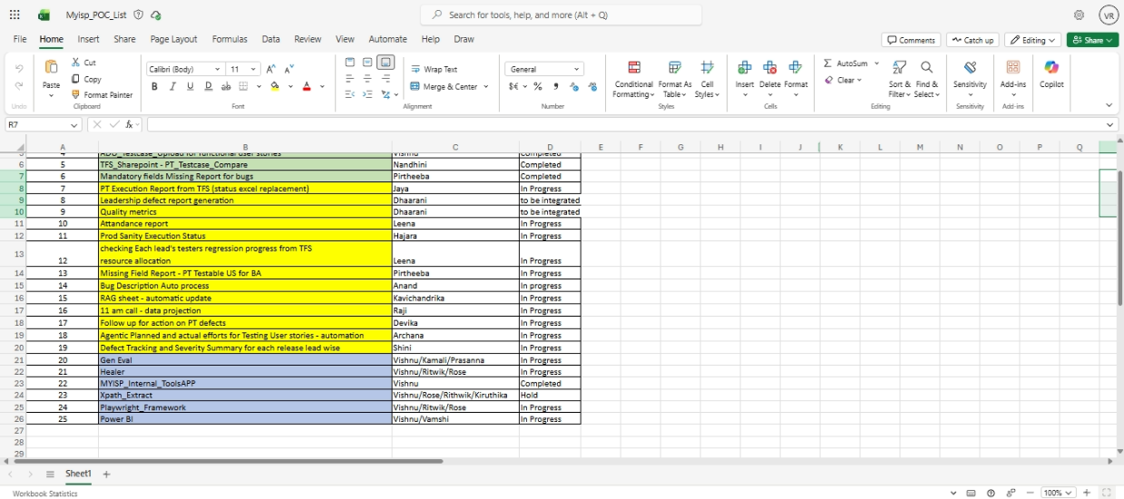
Step 1 of 1

