# Business Process Guide

## Description:

As a customer, I want to receive automated email notifications whenever the status of my shipment changes so that I am always informed about the progress of my order.

## Process Flow:

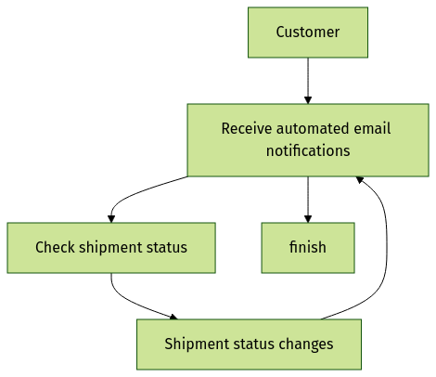

## Common Defects:

|  |  |
| --- | --- |
| Defect | Occurrence |
| Notifications for already delivered/cancelled orders | When an existing order's status is changed to 'delivered' or 'cancelled', the customer might still receive a notification, which should not happen as they already know about the status. |
| Notification frequency | If there are multiple status changes in a short period, the customer might receive too many notifications, which could be annoying. |
| Incorrect or outdated information | If the system uses stale data or does not update the shipment status correctly, the customer might receive incorrect or misleading information. |
| Missing notifications | If the system fails to send a notification when a status changes, the customer might not be aware of the progress of their order. |
| Notification delivery failures | If the email provider fails to deliver the notification to the customer's inbox (spam folder, network issues, etc.), the customer might not be informed about the shipment status change. |
| Language preferences | If the customer's language preference is not considered, they might receive notifications in a language they do not understand. |
| Timezone handling | If the system does not handle timezones correctly, the customer might receive notifications at inconvenient times. |

## Appendix:

|  |  |
| --- | --- |
| Parameter | Value |
| Notification Type | Email |
| Event Trigger | Shipment Status Change |
| Recipient Email | Customer Email |
| Email Template | Shipment Status Update |