V I S H N U S U N D A R K

CONTACT
+91 86100-59720 skvishnu0204@gmail.com
Maruthangudi, Madurai

EDUCATION

UG -(BCA) (CGPA : 6.0287)
2022-2025
MADURAI KAMARAJ UNIVERSITY COLLEGE, Madurai District.

PROFILE
I have studied bachelors of computer application (BCA). I have a strong interest, knowledge in Programming and
Communication. To join a Lead in companies and give My best forward to the industry and developing my skill through that along the organization.

SKILLS

HSC (70.17%)
2020 -2022
Government Higher Secondary School, kallikudi, Madurai.

SSLC (77%)
2019-2020
Government Higher Secondary School Maruthangudi, Madurai.

SOFTSKILLS
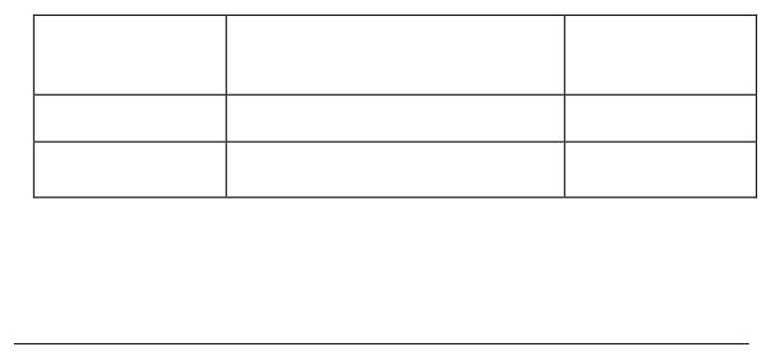

Front
-

Bootstrap , JavaScript ,

Express

JS
Core

PHP

Node

JS

SUMMARY

- Solving Code problem and Quality adaptable to environment changes.

- Solving Code problem and High Motivated to Work in Team.

- Proficient in HTML , CSS , Bootstrap, Responsive Design and Media Queries.

Time Management: Efficiently managing time and prioritizing tasks.
Key Skills: Strong communication skills with the ability to grasp new concepts quickly.
Leadership: Ability to motivate and guide others. Critical Thinking: Evaluating information to make informed decisions. Teamwork: Collaborating effectively with others towards common.

PROJECTS :

- An responsive Bus booking Website using HTML ,CSS , Bootstrap and PHP.

- An Responsive personal portfolio website using HTML,CSS, JavaScript.

- Flight Booking System Using HTML ,CSS , Bootstrap, Javascript and PHP & MySQL

