**Assignment-2**

**Name: S.Vishnu Teja Roll: CS21B2037**

1. **Creation of a Socket**

The Server code is as follows:

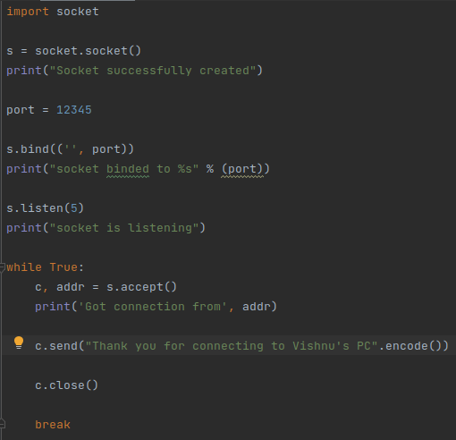

The client code is as follows:

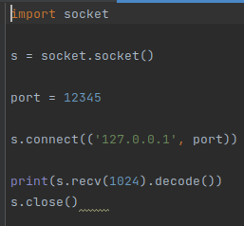

1. **Connect to any server**

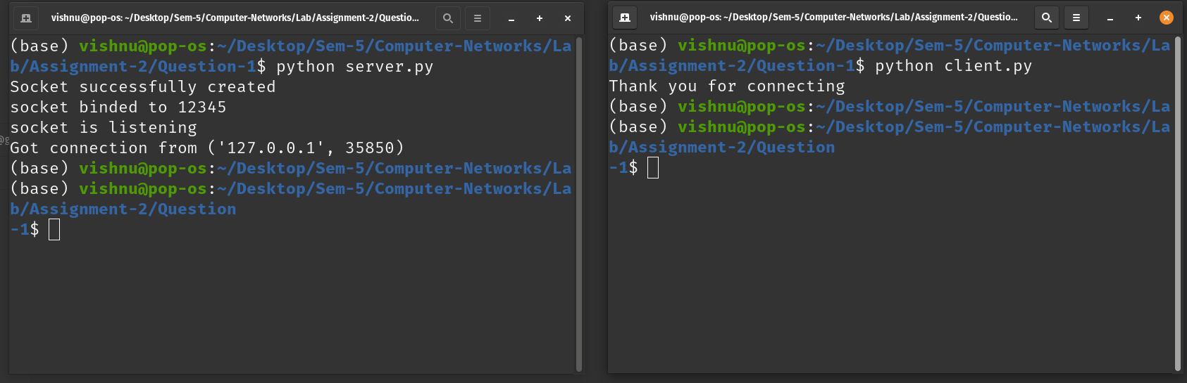

1. **Try to change port number**

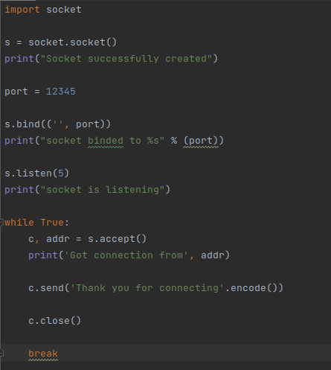

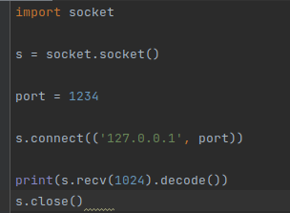

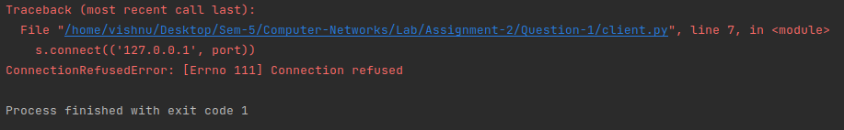

Since the port of the server and the port of the client is different,the connection cannot be established as client tries to connect to a port where there is nothing and server keeps waiting.

1. **Try to Connect one computer to another computer**

Code:-

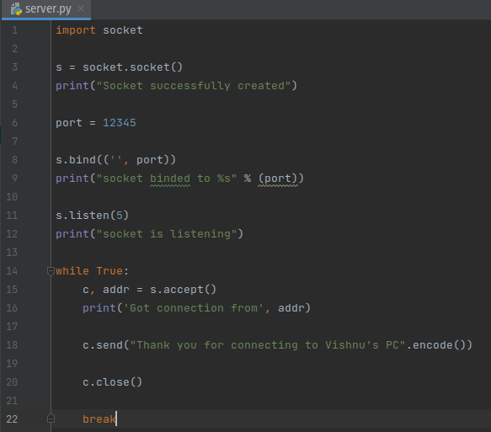

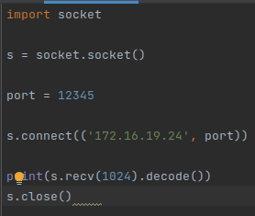

Me as a server:-

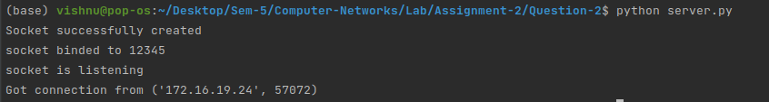

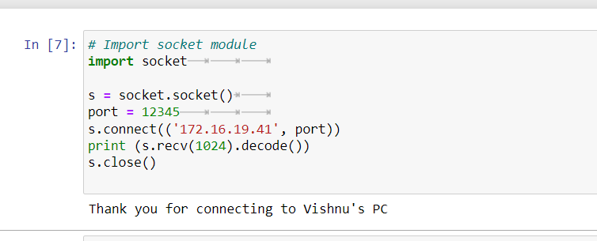

Me as a client:-

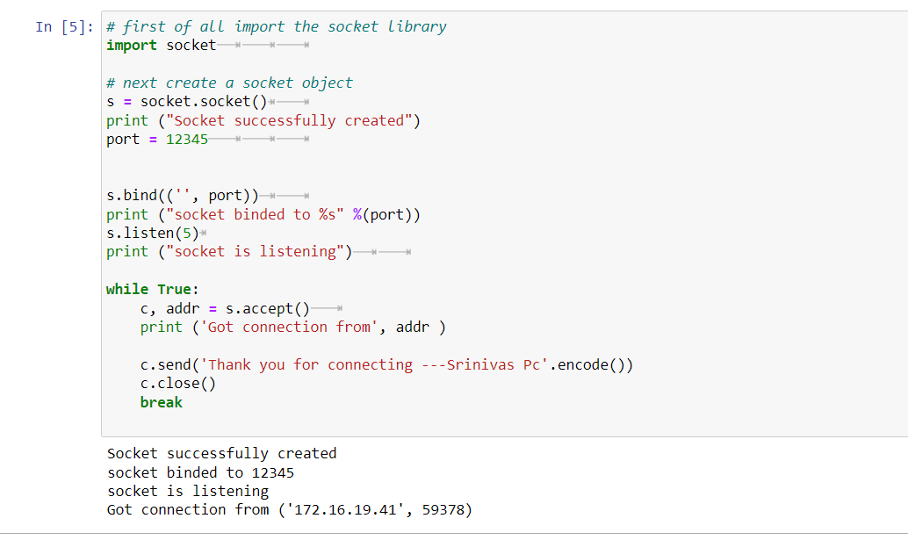

Screenshot from 2023-08-02 17-17-03