CSS Tutorial
CSS is a language that describes the style of an HTML document.
CSS describes how HTML elements should be displayed.
This tutorial will teach you CSS from basic to advance.

What is CSS?
- CSS stands for Cascading Style Sheets
- CSS describes how HTML elements are to be displayed on screen, paper, or in other media
- CSS saves a lot of work. It can control the layout of multiple web pages all at once
- External stylesheets are stored in CSS files

CSS Syntax
A CSS rule-set consists of a selector and a declaration block:
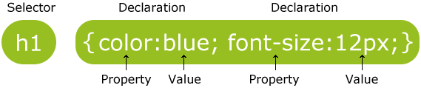
The selector points to the HTML element you want to style.
The declaration block contains one or more declarations separated by semicolons.
Each declaration includes a CSS property name and a value, separated by a colon.
A CSS declaration always ends with a semicolon, and declaration blocks are surrounded by curly braces.

CSS Selectors
CSS selectors are used to "find" (or select) HTML elements based on their element name, id, class, attribute, and more.

The element Selector
The element selector selects elements based on the element name.
p {
text-align: center;
color: red;
}

The id Selector
The id selector uses the id attribute of an HTML element to select a specific element.
The id of an element should be unique within a page, so the id selector is used to select one unique element!
#para1 {
text-align: center;
color: red;
}

The class Selector
The class selector selects elements with a specific class attribute.
.center {
text-align: center;
color: red;
}

CSS Comments
Comments are used to explain the code, and may help when you edit the source code at a later date.
Comments are ignored by browsers.

p {
color: red;
/* This is a single-line comment */
text-align: center;
}
/* This is
a multi-line
comment */

Three Ways to Insert CSS
There are three ways of inserting a style sheet:
- External style sheet
- Internal style sheet
- Inline style

Inline Styles
An inline style may be used to apply a unique style for a single element.

<h1 style="color:blue;margin-left:30px;">This is a heading</h1>

Internal Style Sheet
An internal style sheet may be used if one single page has a unique style.
<head>
<style>
body {
background-color: linen;
}
h1 {
color: maroon;
margin-left: 40px;
}
</style>
</head>

External Style Sheet

With an external style sheet, you can change the look of an entire website by changing just one file!
<head>
<link rel="stylesheet" type="text/css" href="mystyle.css">
</head>

Cascading Order
What style will be used when there is more than one style specified for an HTML element?
Generally speaking we can say that all the styles will "cascade" into a new "virtual" style sheet by the following rules, where number one has the highest priority:
- Inline style (inside an HTML element)
- External and internal style sheets (in the head section)
- Browser default

CSS Colors
Colors in CSS are most often specified by:
- a valid color name - like "red"
- an RGB value - like "rgb(255, 0, 0)"
- a HEX value - like "#ff0000"

RGB (Red, Green, Blue)
RGB color values can be specified using this formula: rgb(red, green, blue).
Each parameter (red, green, blue) defines the intensity of the color between 0 and 255.

Hexadecimal Colors
RGB values can also be specified using hexadecimal color values in the form: #RRGGBB, where RR (red), GG (green) and BB (blue) are hexadecimal values between 00 and FF (same as decimal 0-255).

CSS Backgrounds
The CSS background properties are used to define the background effects for elements.
CSS background properties:
- background-color
- background-image
- background-repeat
- background-attachment
- background-position

Background Color
The background-color property specifies the background color of an element.
body {
background-color: lightblue;
}

Background Image
The background-image property specifies an image to use as the background of an element
body {
background-image: url("paper.gif");
}

Background Image - Repeat Horizontally or Vertically
body {
background-image: url("gradient_bg.png");
background-repeat: repeat-x;
}

Background Image - Set position and no-repeat
body {
background-image: url("img_tree.png");
background-repeat: no-repeat;
background-position: right top;
}

Background Image - Fixed position
body {
background-image: url("img_tree.png");
background-repeat: no-repeat;
background-position: right top;
background-attachment: fixed;
}

Background - Shorthand property
To shorten the code, it is also possible to specify all the background properties in one single property. This is called a shorthand property.
body {
background: #ffffff url("img_tree.png") no-repeat right top;
}

CSS Borders

Border Style
The border-style property specifies what kind of border to display.
The following values are allowed:
- dotted - Defines a dotted border
- dashed - Defines a dashed border
- solid - Defines a solid border
- double - Defines a double border
- groove - Defines a 3D grooved border. The effect depends on the border-color value
- ridge - Defines a 3D ridged border. The effect depends on the border-color value
- inset - Defines a 3D inset border. The effect depends on the border-color value
- outset - Defines a 3D outset border. The effect depends on the border-color value
- none - Defines no border
- hidden - Defines a hidden border

p.dotted {border-style: dotted;}
p.dashed {border-style: dashed;}
p.solid {border-style: solid;}
p.double {border-style: double;}
p.groove {border-style: groove;}
p.ridge {border-style: ridge;}
p.inset {border-style: inset;}
p.outset {border-style: outset;}
p.none {border-style: none;}
p.hidden {border-style: hidden;}
p.mix {border-style: dotted dashed solid double;}
Result:
A dotted border.
A dashed border.
A solid border.
A double border.
A groove border. The effect depends on the border-color value.
A ridge border. The effect depends on the border-color value.
An inset border. The effect depends on the border-color value.
An outset border. The effect depends on the border-color value.
No border.
A hidden border.
A mixed border.

Border Width
The border-width property specifies the width of the four borders.
The width can be set as a specific size (in px, pt, cm, em, etc) or by using one of the three pre-defined values: thin, medium, or thick.
p.one {
border-style: solid;
border-width: 5px;
}
p.two {
border-style: solid;
border-width: medium;
}
p.three {
border-style: solid;
border-width: 2px 10px 4px 20px;
}

Border Color
The border-color property is used to set the color of the four borders.
The color can be set by:
- name - specify a color name, like "red"
- Hex - specify a hex value, like "#ff0000"
- RGB - specify a RGB value, like "rgb(255,0,0)"
- transparent
p.one {
border-style: solid;
border-color: red;
}
p.two {
border-style: solid;
border-color: green;
}
p.three {
border-style: solid;
border-color: red green blue yellow;
}

Border - Individual Sides
p {
border-top-style: dotted;
border-right-style: solid;
border-bottom-style: dotted;
border-left-style: solid;
}

If the border-style property has four values:
- border-style: dotted solid double dashed;
  - top border is dotted
  - right border is solid
  - bottom border is double
  - left border is dashed
If the border-style property has three values:
- border-style: dotted solid double;
  - top border is dotted
  - right and left borders are solid
  - bottom border is double
If the border-style property has two values:
- border-style: dotted solid;
  - top and bottom borders are dotted
  - right and left borders are solid
If the border-style property has one value:
- border-style: dotted;
  - all four borders are dotted

Border - Shorthand Property

- border-width
- border-style (required)
- border-color

p {
border: 5px solid red;
}

Left Border
p {
border-left: 6px solid red;
background-color: lightgrey;
}

Rounded Borders
The border-radius property is used to add rounded borders to an element:
Normal border
Round border
Rounder border
Roundest border

Example
p {
border: 2px solid red;
border-radius: 5px;
}

CSS Margins

CSS Margins
The CSS margin properties are used to generate space around elements.
The margin properties set the size of the white space outside the border.

Margin - Individual Sides
CSS has properties for specifying the margin for each side of an element:
- margin-top
- margin-right
- margin-bottom
- margin-left
All the margin properties can have the following values:
- auto - the browser calculates the margin
- length - specifies a margin in px, pt, cm, etc.
- % - specifies a margin in % of the width of the containing element
- inherit - specifies that the margin should be inherited from the parent element

p {
margin-top: 100px;
margin-bottom: 100px;
margin-right: 150px;
margin-left: 80px;
}

Margin - Shorthand Property
To shorten the code, it is possible to specify all the margin properties in one property.
The margin property is a shorthand property for the following individual margin properties:
- margin-top
- margin-right
- margin-bottom
- margin-left

p {
margin: 100px 150px 100px 80px;
}

If the margin property has four values:
- margin: 25px 50px 75px 100px;
  - top margin is 25px
  - right margin is 50px
  - bottom margin is 75px
  - left margin is 100px
If the margin property has three values:
- margin: 25px 50px 75px;
  - top margin is 25px
  - right and left margins are 50px
  - bottom margin is 75px
If the margin property has two values:
- margin: 25px 50px;
  - top and bottom margins are 25px
  - right and left margins are 50px
If the margin property has one value:
- margin: 25px;
  - all four margins are 25px

The auto Value
You can set the margin property to auto to horizontally center the element within its container.
div {
width: 300px;
margin: auto;
border: 1px solid red;
}

The inherit Value
div.container {
border: 1px solid red;
margin-left: 100px;
}
p.one {
margin-left: inherit;
}

Margin Collapse

h1 {
margin: 0 0 50px 0;
}
h2 {
margin: 20px 0 0 0;
}

CSS Padding

CSS Padding
The CSS padding properties are used to generate space around content.
The padding clears an area around the content (inside the border) of an element.
With CSS, you have full control over the padding. There are CSS properties for setting the padding for each side of an element (top, right, bottom, and left).

Padding - Individual Sides
CSS has properties for specifying the padding for each side of an element:
- padding-top
- padding-right
- padding-bottom
- padding-left
All the padding properties can have the following values:
- length - specifies a padding in px, pt, cm, etc.
- % - specifies a padding in % of the width of the containing element
- inherit - specifies that the padding should be inherited from the parent element

p {
padding-top: 50px;
padding-right: 30px;
padding-bottom: 50px;
padding-left: 80px;
}

Padding - Shorthand Property
To shorten the code, it is possible to specify all the padding properties in one property.
The padding property is a shorthand property for the following individual padding properties:
- padding-top
- padding-right
- padding-bottom
- padding-left

p {
padding: 50px 30px 50px 80px;
}

If the padding property has four values:
- padding: 25px 50px 75px 100px;
  - top padding is 25px
  - right padding is 50px
  - bottom padding is 75px
  - left padding is 100px
If the padding property has three values:
- padding: 25px 50px 75px;
  - top padding is 25px
  - right and left paddings are 50px
  - bottom padding is 75px
If the padding property has two values:
- padding: 25px 50px;
  - top and bottom paddings are 25px
  - right and left paddings are 50px
If the padding property has one value:
- padding: 25px;
  - all four paddings are 25px

CSS Height and Width

Setting height and width
The height and width properties are used to set the height and width of an element.
The height and width can be set to auto (this is default. Means that the browser calculates the height and width), or be specified in length values, like px, cm, etc., or in percent (%) of the containing block.

div {
height: 200px;
width: 50%;
background-color: powderblue;
}

The CSS Box Model
All HTML elements can be considered as boxes. In CSS, the term "box model" is used when talking about design and layout.

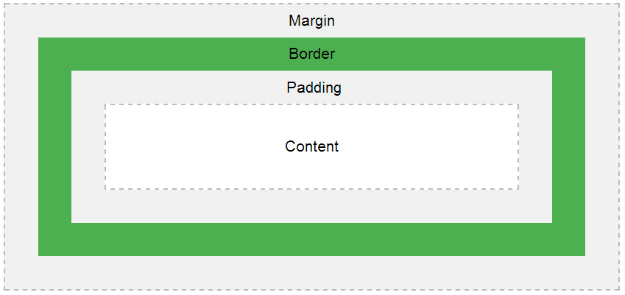
Explanation of the different parts:
- Content - The content of the box, where text and images appear
- Padding - Clears an area around the content. The padding is transparent
- Border - A border that goes around the padding and content
- Margin - Clears an area outside the border. The margin is transparent

div {
width: 300px;
border: 25px solid green;
padding: 25px;
margin: 25px;
}

CSS Outline
The CSS outline properties specify the style, color, and width of an outline.
An outline is a line that is drawn around elements (outside the borders) to make the element "stand out".

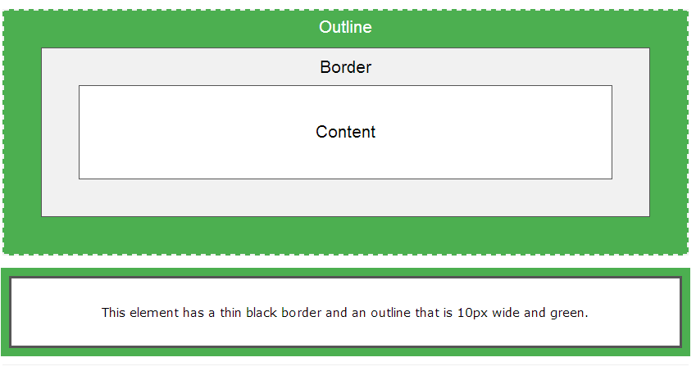

Outline Style
The outline-style property specifies the style of the outline.
The outline-style property can have one of the following values:
- dotted - Defines a dotted outline
- dashed - Defines a dashed outline
- solid - Defines a solid outline
- double - Defines a double outline
- groove - Defines a 3D grooved outline. The effect depends on the outline-color value
- ridge - Defines a 3D ridged outline. The effect depends on the outline-color value
- inset - Defines a 3D inset outline. The effect depends on the outline-color value
- outset - Defines a 3D outset outline. The effect depends on the outline-color value
- none - Defines no outline
- hidden - Defines a hidden outline

p {
border: 1px solid black;
outline-color: red;
}
p.dotted {outline-style: dotted;}
p.dashed {outline-style: dashed;}
p.solid {outline-style: solid;}
p.double {outline-style: double;}
p.groove {outline-style: groove;}
p.ridge {outline-style: ridge;}
p.inset {outline-style: inset;}
p.outset {outline-style: outset;}

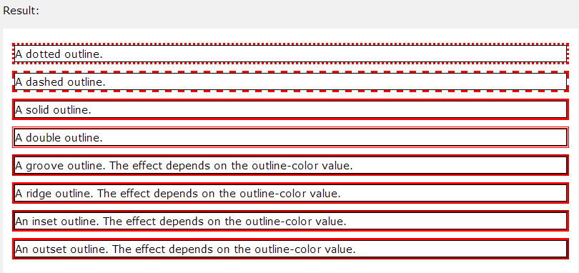

Outline Color
The outline-color property is used to set the color of the outline.
The color can be set by:
- name - specify a color name, like "red"
- RGB - specify a RGB value, like "rgb(255,0,0)"
- Hex - specify a hex value, like "#ff0000"
- invert - performs a color inversion (which ensures that the outline is visible, regardless of color background)
p {
border: 1px solid black;
outline-style: double;
outline-color: red;
}

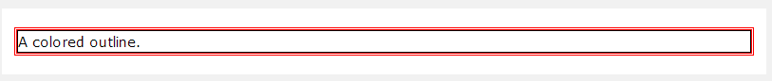

Outline Width

p {border: 1px solid black;}
p.one {
outline-style: double;
outline-color: red;
outline-width: thick;
}
p.two {
outline-style: double;
outline-color: green;
outline-width: 3px;
}

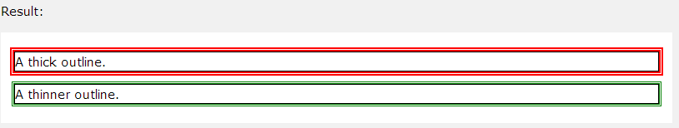

Outline - Shorthand property
To shorten the code, it is also possible to specify all the individual outline properties in one property.
The outline property is a shorthand property for the following individual outline properties:
- outline-width
- outline-style (required)
- outline-color

p {
border: 1px solid black;
outline: 5px dotted red;
}

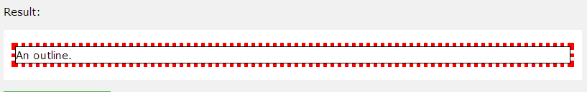

Text Color
The color property is used to set the color of the text.
With CSS, a color is most often specified by:
- a color name - like "red"
- a HEX value - like "#ff0000"
- an RGB value - like "rgb(255,0,0)"

body {
color: blue;
}
h1 {
color: green;
}

Text Alignment

The text-align property is used to set the horizontal alignment of a text.
A text can be left or right aligned, centered, or justified.

h1 {
text-align: center;
}
h2 {
text-align: left;
}
h3 {
text-align: right;
}

Text Decoration
The text-decoration property is used to set or remove decorations from text.
The value text-decoration: none; is often used to remove underlines from links:

a {
text-decoration: none;
}

h1 {
text-decoration: overline;
}
h2 {
text-decoration: line-through;
}
h3 {
text-decoration: underline;
}

Text Transformation
The text-transform property is used to specify uppercase and lowercase letters in a text.

p.uppercase {
text-transform: uppercase;
}
p.lowercase {
text-transform: lowercase;
}
p.capitalize {
text-transform: capitalize;
}

Text Indentation
p {
text-indent: 50px;
}

Letter Spacing
The letter-spacing property is used to specify the space between the characters in a text.

h1 {
letter-spacing: 3px;
}
h2 {
letter-spacing: -3px;
}

Line Height

p.small {
line-height: 0.8;
}
p.big {
line-height: 1.8;
}

Text Direction

div {
direction: rtl;
}

Word Spacing

h1 {
word-spacing: 10px;
}
h2 {
word-spacing: -5px;
}

Text Shadow
The text-shadow property adds shadow to text.

h1 {
text-shadow: 3px 2px red;
}

CSS Font Families
In CSS, there are two types of font family names:
- generic family - a group of font families with a similar look (like "Serif" or "Monospace")
- font family - a specific font family (like "Times New Roman" or "Arial")
Generic family | Font family | Description
Serif | Times New Roman  Georgia | Serif fonts have small lines at the ends on some characters
Sans-serif | Arial  Verdana | "Sans" means without - these fonts do not have the lines at the ends of characters
Monospace | Courier New  Lucida Console | All monospace characters have the same width

Font Family
The font family of a text is set with the font-family property.
The font-family property should hold several font names as a "fallback" system. If the browser does not support the first font, it tries the next font, and so on.

p {
font-family: "Times New Roman", Times, serif;
}

Font Style
The font-style property is mostly used to specify italic text.
This property has three values:
- normal - The text is shown normally
- italic - The text is shown in italics
- oblique - The text is "leaning" (oblique is very similar to italic, but less supported)

p.normal {
font-style: normal;
}
p.italic {
font-style: italic;
}
p.oblique {
font-style: oblique;
}

Font Size
The font-size property sets the size of the text.
Being able to manage the text size is important in web design. However, you should not use font size adjustments to make paragraphs look like headings, or headings look like paragraphs.
Always use the proper HTML tags, like <h1> - <h6> for headings and <p> for paragraphs.
The font-size value can be an absolute, or relative size.
Absolute size:
- Sets the text to a specified size
- Does not allow a user to change the text size in all browsers (bad for accessibility reasons)
- Absolute size is useful when the physical size of the output is known
Relative size:
- Sets the size relative to surrounding elements
- Allows a user to change the text size in browsers

h1 {
font-size: 40px;
}
h2 {
font-size: 30px;
}
p {
font-size: 14px;
}

Set Font Size With Em
To allow users to resize the text (in the browser menu), many developers use em instead of pixels.
The em size unit is recommended by the W3C.
1em is equal to the current font size. The default text size in browsers is 16px. So, the default size of 1em is 16px.

h1 {
font-size: 2.5em; /* 40px/16=2.5em */
}
h2 {
font-size: 1.875em; /* 30px/16=1.875em */
}
p {
font-size: 0.875em; /* 14px/16=0.875em */
}

Use a Combination of Percent and Em

body {
font-size: 100%;
}
h1 {
font-size: 2.5em;
}
h2 {
font-size: 1.875em;
}
p {
font-size: 0.875em;
}

Font Weight

p.normal {
font-weight: normal;
}
p.thick {
font-weight: bold;
}

Font Variant
The font-variant property specifies whether or not a text should be displayed in a small-caps font.
In a small-caps font, all lowercase letters are converted to uppercase letters. However, the converted uppercase letters appears in a smaller font size than the original uppercase letters in the text.

p.normal {
font-variant: normal;
}
p.small {
font-variant: small-caps;
}

CSS Icons

Font Awesome Icons

<!DOCTYPE html>
<html>
<head>
<link rel="stylesheet" href="https://cdnjs.cloudflare.com/ajax/libs/font-awesome/4.7.0/css/font-awesome.min.css">
</head>
<body>
<i class="fa fa-cloud"></i>
<i class="fa fa-heart"></i>
<i class="fa fa-car"></i>
<i class="fa fa-file"></i>
<i class="fa fa-bars"></i>
</body>
</html>

Bootstrap Icons

<!DOCTYPE html>
<html>
<head>
<link rel="stylesheet"href="https://maxcdn.bootstrapcdn.com/bootstrap/3.3.7/css/bootstrap.min.css">
</head>
<body>
<i class="glyphicon glyphicon-cloud"></i>
<i class="glyphicon glyphicon-remove"></i>
<i class="glyphicon glyphicon-user"></i>
<i class="glyphicon glyphicon-envelope"></i>
<i class="glyphicon glyphicon-thumbs-up"></i>
</body>
</html>

Google Icons

<!DOCTYPE html>
<html>
<head>
<link rel="stylesheet" href="https://fonts.googleapis.com/icon?family=Material+Icons">
</head>
<body>
<i class="material-icons">cloud</i>
<i class="material-icons">favorite</i>
<i class="material-icons">attachment</i>
<i class="material-icons">computer</i>
<i class="material-icons">traffic</i>
</body>
</html>

CSS Links

Styling Links

a {
color: hotpink;
}
The four links states are:
- a:link - a normal, unvisited link
- a:visited - a link the user has visited
- a:hover - a link when the user mouses over it
- a:active - a link the moment it is clicked
When setting the style for several link states, there are some order rules:
- a:hover MUST come after a:link and a:visited
- a:active MUST come after a:hover

Text Decoration
a:link {
text-decoration: none;
}
a:visited {
text-decoration: none;
}
a:hover {
text-decoration: underline;
}
a:active {
text-decoration: underline;
}

Background Color
a:link {
background-color: yellow;
}
a:visited {
background-color: cyan;
}
a:hover {
background-color: lightgreen;
}
a:active {
background-color: hotpink;
}

Advanced - Link Buttons
a:link, a:visited {
background-color: #f44336;
color: white;
padding: 14px 25px;
text-align: center;
text-decoration: none;
display: inline-block;
}
a:hover, a:active {
background-color: red;
}

