What is JavaServer Pages?
JavaServer Pages (JSP) is a technology for developing web pages that support dynamic content which helps developers insert java code in HTML pages by making use of special JSP tags, most of which start with <% and end with %>.
A JavaServer Pages component is a type of Java servlet that is designed to fulfill the role of a user interface for a Java web application. Web developers write JSPs as text files that combine HTML or XHTML code, XML elements, and embedded JSP actions and commands.
Using JSP, you can collect input from users through web page forms, present records from a database or another source, and create web pages dynamically.
JSP tags can be used for a variety of purposes, such as retrieving information from a database or registering user preferences, accessing JavaBeans components, passing control between pages and sharing information between requests, pages etc.

Why Use JSP?
JavaServer Pages often serve the same purpose as programs implemented using the Common Gateway Interface (CGI). But JSP offer several advantages in comparison with the CGI.
- Performance is significantly better because JSP allows embedding Dynamic Elements in HTML Pages itself instead of having a separate CGI files.
- JSP are always compiled before it's processed by the server unlike CGI/Perl which requires the server to load an interpreter and the target script each time the page is requested.
- JavaServer Pages are built on top of the Java Servlets API, so like Servlets, JSP also has access to all the powerful Enterprise Java APIs, including JDBC, JNDI, EJB, JAXP etc.
- JSP pages can be used in combination with servlets that handle the business logic, the model supported by Java servlet template engines.

Advantages of JSP:
Following is the list of other advantages of using JSP over other technologies:
- vs. Active Server Pages (ASP): The advantages of JSP are twofold. First, the dynamic part is written in Java, not Visual Basic or other MS specific language, so it is more powerful and easier to use. Second, it is portable to other operating systems and non-Microsoft Web servers.
- vs. Pure Servlets: It is more convenient to write (and to modify!) regular HTML than to have plenty of println statements that generate the HTML.
- vs. Server-Side Includes (SSI): SSI is really only intended for simple inclusions, not for "real" programs that use form data, make database connections, and the like.
- vs. JavaScript: JavaScript can generate HTML dynamically on the client but can hardly interact with the web server to perform complex tasks like database access and image processing etc.
- vs. Static HTML: Regular HTML, of course, cannot contain dynamic information.

JSP is aServlet

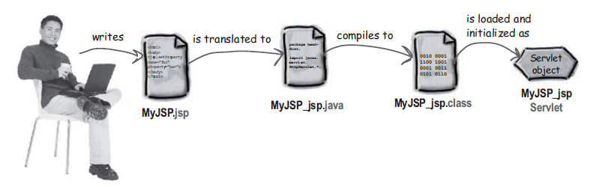

Implicit Object in JSP
JSP supports nine Implicit Objects which are listed below:
Object | Description
request | This is the HttpServletRequest object associated with the request.
response | This is the HttpServletResponse object associated with the response to the client.
out | This is the PrintWriter object used to send output to the client.
session | This is the HttpSession object associated with the request.
application | This is the ServletContext object associated with application context.
config | This is the ServletConfig object associated with the page.
pageContext | This encapsulates use of server-specific features like higher performance JspWriters.
page | This is simply a synonym for this, and is used to call the methods defined by the translated servlet class.
Exception | The Exception object allows the exception data to be accessed by designated JSP.

JSP- Life Cycle
A JSP life cycle can be defined as the entire process from its creation till the destruction which is similar to a servlet life cycle with an additional step which is required to compile a JSP into servlet.
The following are the paths followed by a JSP
- Translation
- Compilation
- Loading Servlet class
- Creating instance of Servlet
- Initialization – jspInit() method
- Execution- _jspService() method
- Cleanup – jspDestroy()method
The four major phases of JSP life cycle are very similar to Servlet Life Cycle and they are as follows:
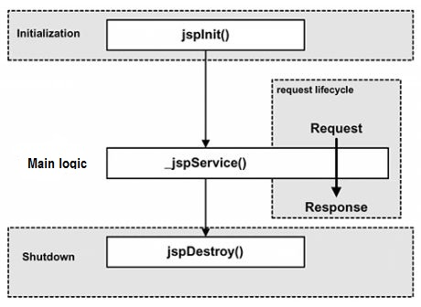

Type of Script
- Scriptlet - <% %> - is written inside the service method.
- Expression <%= %> - is written in out.println() method as arg statements.
- Declaration <%! %> - to written inside the class as member variable and methods
- Directive
<%@ page %> - Customize the web page
<%@taglib %> - Adding tag lib
<%@include %> - Adding another page into current page

first.jsp

<%@ page language="java" contentType="text/html; charset=ISO-8859-1" pageEncoding="ISO-8859-1"
import="java.util.*"
%>
<html>
<head>
<title>First Jsp Page</title>
</head>
<body>
<!-- HTML Comments -->
<%-- JSP Comments --%>
<%! int count; %>
<%
//Java Comments
Date d=new Date();
int hours=d.getHours();
int minutes=d.getMinutes();
int second=d.getSeconds();
int date=d.getDate();
int month=d.getDate();
int year=d.getYear();
%>
<%@include file="second.jsp" %><br>
Server Date is <%=date%>/<%=month%>/<%=year%><br>
Server Time is <%=hours%>:<%=minutes%>:<%=second%><br>
Page has been visited for <%=++count%> times.<br>
</body>
</html>

second.jsp
Welcome to JSP Page

First.jsp page is Translated into Servlet Program.

import javax.servlet.*;
import javax.servlet.http.*;
import javax.servlet.jsp.JspWriter;
import javax.servlet.jsp.PageContext;

import org.apache.jasper.runtime.*;
import java.io.*;
import java.util.*;

public class first_jsp extends
HttpJspBase implements
JspSourceDependent{

int count;

public void _jspService(HttpServletRequest request,HttpServletResponse reponse)
throws IOException,ServletException{

PageContext pageContext=null;
HttpSession session=null;
ServletContext application=null;
ServletConfig config=null;
JspWriter out=null;
Object page=null;
try{
Date d=new Date();
int hours=d.getHours();
int minutes=d.getMinutes();
int second=d.getSeconds();
int date=d.getDate();
int month=d.getDate();
int year=d.getYear();
out.println("Welcome to JSP Page");
out.println("<br>");
out.println("Server Date is");
out.println(date);
out.println("/");
out.println(minutes);
out.println("/");
out.println(year);
out.println("<br>");
out.println("Server Time is");
out.println(hours);
out.println(":");
out.println(minutes);
out.println(":");
out.println(second);
out.println("<br>");
out.println("Page has been visited for");
out.println(count);
out.println("times <br>");
}
catch(Throwable excetpion){

}
}
}

JSP Initparam and override jspInit method

<%@ page language="java" contentType="text/html; charset=ISO-8859-1" pageEncoding="ISO-8859-1"
import="java.util.*"
%>
<html>
<head>
<title>First Jsp Page</title>
</head>
<body>
<%!
String mail;
public void jspInit(){
ServletConfig config=getServletConfig();
mail=config.getInitParameter("mail");
}
%>
<%=config.getInitParameter("mail")%>
</body>
</html>

Web.xml

<servlet>
<servlet-name>j1</servlet-name>
<jsp-file>/first.jsp</jsp-file>
<init-param>
<param-name>mail</param-name>
<param-value>syntel_training@syntelinc.com</param-value>
</init-param>
</servlet>
<servlet-mapping>
<servlet-name>j1</servlet-name>
<url-pattern>/myjsp</url-pattern>
</servlet-mapping>

Send the request using URL NAME of the Page.

Data Scope in Web

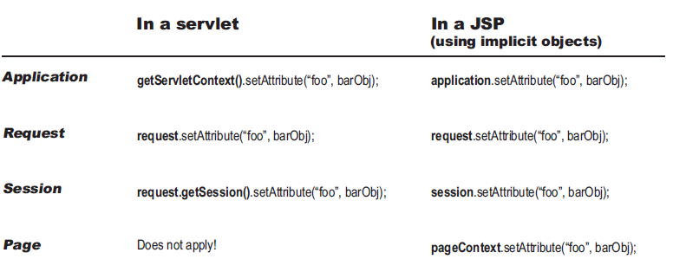

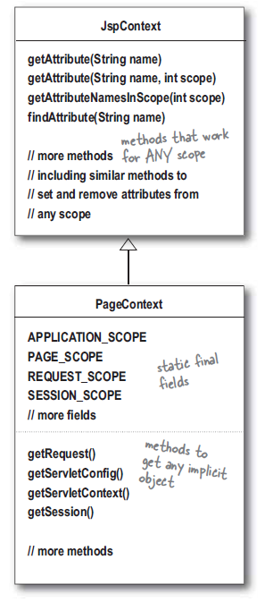

First.jsp

<%
pageContext.setAttribute("s1","One");
request.setAttribute("s2","Two");
session.setAttribute("s3","Three");
application.setAttribute("s4","Four");
%>
<jsp:forward page="second.jsp"></jsp:forward>

Second.jsp

<%@ page language="java" contentType="text/html; charset=ISO-8859-1" pageEncoding="ISO-8859-1"
import="java.util.*"
%>
<html>
<head>
<title>First Jsp Page</title>
</head>
<body>

Readig attribute from the scope object and display
<%
String s1=(String)pageContext.getAttribute("s1");
String s2=(String)request.getAttribute("s2");
String s3=(String)session.getAttribute("s3");
String s4=(String)application.getAttribute("s4");
%>
<%=s1 %><br>
<%=s2 %><br>
<%=s3 %><br>
<%=s4 %><br>

Reading Attributes from all scope using pageContext
<%
String p1=(String)pageContext.getAttribute("s1");
String p2=(String)pageContext.getAttribute("s2",PageContext.REQUEST_SCOPE);
String p3=(String)pageContext.findAttribute("s3");
String p4=(String)pageContext.getAttribute("s4",PageContext.APPLICATION_SCOPE);
%>
<%=p1 %><br>
<%=p2 %><br>
<%=p3 %><br>
<%=p4 %><br>

</body>
</html>

JSP – EL language (Expression Language)
JSP Expression Language (EL) makes it possible to easily access application data stored in JavaBeans components. JSP EL allows you to create expressions both (a) arithmetic and (b) logical. Within a JSP EL expression, you can use integers, floating point numbers, strings, the built-in constants true and false for boolean values, and null.

Enabling and disabling EL in JSP page

<%@ page isELIgnored ="true|false" %>

Enabling and disabling EL in ALL the JSP pages

<jsp-config>
<jsp-property-group>
<url-pattern>/*</url-pattern>
<el-ignored>true</el-ignored>
</jsp-property-group>
</jsp-config>

Basic Operators in EL:
JSP Expression Language (EL) supports most of the arithmatic and logical operators supported by Java. Below is the list of most frequently used operators:
Operator | Description
. | Access a bean property or Map entry
[] | Access an array or List element
( ) | Group a subexpression to change the evaluation order
+ | Addition
- | Subtraction or negation of a value
* | Multiplication
/ or div | Division
% or mod | Modulo (remainder)
== or eq | Test for equality
!= or ne | Test for inequality
< or lt | Test for less than
> or gt | Test for greater than
<= or le | Test for less than or equal
>= or gt | Test for greater than or equal
&& or and | Test for logical AND
|| or or | Test for logical OR
! or not | Unary Boolean complement
empty | Test for empty variable values

JSP EL Implicit Objects:
The JSP expression language supports the following implicit objects:
Implicit object | Description
pageScope | Scoped variables from page scope
requestScope | Scoped variables from request scope
sessionScope | Scoped variables from session scope
applicationScope | Scoped variables from application scope
param | Request parameters as strings
paramValues | Request parameters as collections of strings
header | HTTP request headers as strings
headerValues | HTTP request headers as collections of strings
initParam | Context-initialization parameters
cookie | Cookie values
pageContext | The JSP PageContext object for the current page

Domo 1:

first.jsp

<%@ page language="java" contentType="text/html; charset=ISO-8859-1"
pageEncoding="ISO-8859-1"%>
<html>
<head>
<title>Form Page</title>
</head>
<body>
<%
Cookie c=new Cookie("site","SYNTEL");
c.setMaxAge(24*60);
response.addCookie(c);
%>
Training Mail ID ${initParam.mail} <br>
<form action="second.jsp">
Enter First Name <input type="text" name="fname"><br>
Enter Second Name <input type="text" name="sname"><br>
Enter Age <input type="text" name="age"><br>
Select Technology
C <input type="checkbox" name="tech" value="C"><br>
C++ <input type="checkbox" name="tech" value="C++"><br>
JAVA <input type="checkbox" name="tech" value="JAVA"><br>
.NET <input type="checkbox" name="tech" value=".NET"><br>
<input type="submit" value="Add">
<input type="reset" value="Clear">
</form>
</body>
</html>

second.jsp

<%@ page language="java" contentType="text/html; charset=ISO-8859-1" pageEncoding="ISO-8859-1"
import="java.util.*"
%>
<html>
<head>
<title>Second Jsp Page</title>
</head>
<body>
Site Name is ${cookie.site.value}
Training Mail ID ${initParam.mail} <br>
First Name is ${param.fname}<br>
Second Name is ${param.sname}<br>
Age is ${param.age}<br>
Technology Name ${paramValues.tech[0]}
${paramValues.tech[1]}
${paramValues.tech[2]}
${paramValues.tech[3]}

</body>
</html>

Demo 2:

public class Employee {

private String name;
private String mail;
private String county;
private int age;

public String getName() {
return name;
}
public void setName(String name) {
this.name = name;
}
public String getMail() {
return mail;
}
public void setMail(String mail) {
this.mail = mail;
}
public String getCounty() {
return county;
}
public void setCounty(String county) {
this.county = county;
}
public int getAge() {
return age;
}
public void setAge(int age) {
this.age = age;
}

}

<%@page import="java.util.HashMap"%>
<%@page import="java.util.Map"%>
<%@page import="java.util.LinkedList"%>
<%@page import="com.model.*"%>
<%
String[] array={"Chennai","Banagalore","Delhi","Bombay"};
pageContext.setAttribute("s1",array);
LinkedList<String> list=new LinkedList<String>();
list.add("Chennai");
list.add("Banagalore");
list.add("Delhi");
list.add("Bombay");
pageContext.setAttribute("s2",list,PageContext.REQUEST_SCOPE);
Map<String,String> map=new HashMap<String,String>();
map.put("101","Chennai");
map.put("102","Banagalore");
map.put("103","Delhi");
map.put("104","Bombay");
pageContext.setAttribute("s3",map,PageContext.SESSION_SCOPE);

Employee e=new Employee();
e.setName("Paranthaman");
e.setCounty("India");
e.setAge(33);
e.setMail("paranthaman@sytnelinc.com");
pageContext.setAttribute("s4",e,PageContext.APPLICATION_SCOPE);
%>

<jsp:forward page="second.jsp"></jsp:forward>

<%@ page language="java" contentType="text/html; charset=ISO-8859-1" pageEncoding="ISO-8859-1"
import="java.util.*"
%>
<html>
<head>
<title>Second Jsp Page</title>
</head>
<body>
<%
String[] array={"Chennai","Banagalore","Delhi","Bombay"};
pageContext.setAttribute("s1",array);
%>
Page Scope Data <br>
${pageScope.s1["0"]}<br>
${pageScope.s1["1"]}<br>
${s1["2"]}<br>
${s1["3"]}<br>

Request Scope Data <br>
${requestScope.s2["0"]}<br>
${requestScope.s2["1"]}<br>
${s2["2"]}<br>
${s2["3"]}<br>

Session Scope Data

${sessionScope.s3["101"]}<br>
${s3["102"]}<br>
${s3["103"]}<br>
${s3["104"]}<br>

</body>
</html>

JSP – Actions
JSP actions use constructs in XML syntax to control the behavior of the servlet engine. You can dynamically insert a file, reuse JavaBeans components, forward the user to another page, or generate HTML for the Java plugin.

Action elements are basically predefined functions and there are following JSP actions available:
Syntax | Purpose
jsp:include | Includes a file at the time the page is requested
jsp:useBean | Finds or instantiates a JavaBean
jsp:setProperty | Sets the property of a JavaBean
jsp:getProperty | Inserts the property of a JavaBean into the output
jsp:forward | Forwards the requester to a new page
jsp:plugin | Generates browser-specific code that makes an OBJECT or EMBED tag for the Java plugin
jsp:element | Defines XML elements dynamically.
jsp:attribute | Defines dynamically defined XML element's attribute.
jsp:body | Defines dynamically defined XML element's body.
jsp:text | Use to write template text in JSP pages and documents.

First.jsp

<%@ page language="java" contentType="text/html; charset=ISO-8859-1"
pageEncoding="ISO-8859-1"%>
<html>
<head>
<title>Form Page</title>
</head>
<body>
<form action="second.jsp">
Enter First Name <input type="text" name="fname"><br>
Enter Second Name <input type="text" name="sname"><br>
Enter Age <input type="text" name="age"><br>
Select Technology
C <input type="checkbox" name="tech" value="C"><br>
C++ <input type="checkbox" name="tech" value="C++"><br>
JAVA <input type="checkbox" name="tech" value="JAVA"><br>
.NET <input type="checkbox" name="tech" value=".NET"><br>
<input type="submit" value="Add">
<input type="reset" value="Clear">
</form>
</body>
</html>

Second.jsp

<jsp:useBean id="e1" class="com.model.Employee" scope="request">
<jsp:setProperty name="e1" property="sname" value="P"/>
<jsp:setProperty name="e1" property="fname" value="S"/>
<jsp:setProperty name="e1" property="age" value="24"/>
</jsp:useBean>

<jsp:useBean id="e2" class="com.model.Employee" scope="request">
<jsp:setProperty name="e2" property="fname" param="fname"/>
<jsp:setProperty name="e2" property="sname" param="sname"/>
<jsp:setProperty name="e2" property="age" param="age"/>
<jsp:setProperty name="e2" property="tech" param="tech"/>
</jsp:useBean>

<jsp:useBean id="e3" class="com.model.Employee" scope="request">
<jsp:setProperty name="e3" property="*"/>
</jsp:useBean>

<jsp:forward page="three.jsp"></jsp:forward>

Three.jsp

<%@ page language="java" contentType="text/html; charset=ISO-8859-1"
pageEncoding="ISO-8859-1"%>
<!DOCTYPE html PUBLIC "-//W3C//DTD HTML 4.01 Transitional//EN" "http://www.w3.org/TR/html4/loose.dtd">
<html>
<head>
<meta http-equiv="Content-Type" content="text/html; charset=ISO-8859-1">
<title>Third here</title>
</head>
<body>
<jsp:useBean id="e1" class="com.model.Employee" scope="request">
</jsp:useBean>
First Name is <jsp:getProperty property="fname" name="e1"/><br>
Second Name is <jsp:getProperty property="sname" name="e1"/><br>
Age is <jsp:getProperty property="age" name="e1"/><br>
Technology is <jsp:getProperty property="tech" name="e1"/><br>

<jsp:useBean id="e2" class="com.model.Employee" scope="request">
</jsp:useBean>
First Name is <jsp:getProperty property="fname" name="e2"/><br>
Second Name is <jsp:getProperty property="sname" name="e2"/><br>
Age is <jsp:getProperty property="age" name="e2"/><br>
Technology is <jsp:getProperty property="tech" name="e2"/><br>

<jsp:useBean id="e3" class="com.model.Employee" scope="request">
</jsp:useBean>
First Name is <jsp:getProperty property="fname" name="e3"/><br>
Second Name is <jsp:getProperty property="sname" name="e3"/><br>
Age is <jsp:getProperty property="age" name="e3"/><br>
Technology is <jsp:getProperty property="tech" name="e3"/><br>
${e3.tech[0]}
${e3.tech[1]}
</body>
</html>

