What does web server do?

Server is receiving request from user and check requested resource file and find it and write it in the response object and send it back to user.

What does web browser do?

Browser sends the request to server and receives the response from and render page in the window.

What is HTML and HTTP?

HTML is a markup language to create static web page and HTTP is a communication protocol between Web browser and Web server.

- Exercise
Create Static page
put it inside the server
Make the request from browser and see the output

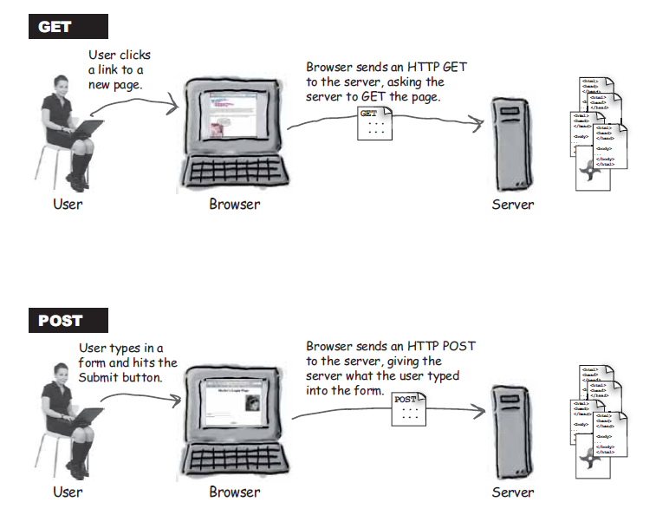

Get Type Request
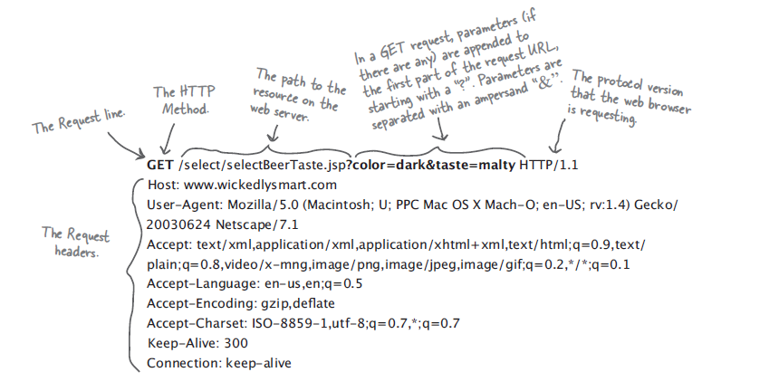

Post Type Request

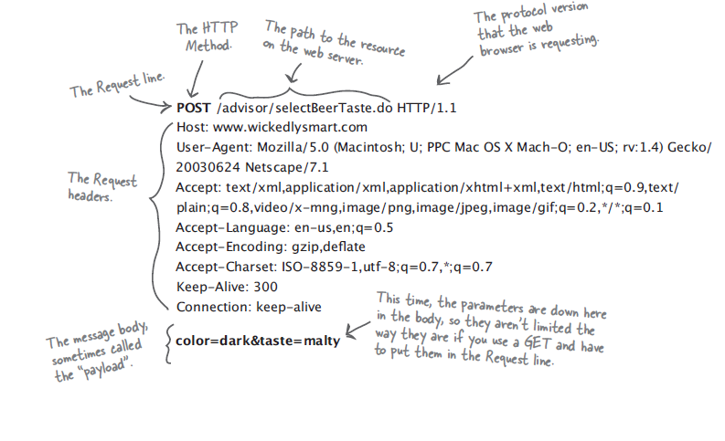

Http Response (Html is the part of Response)

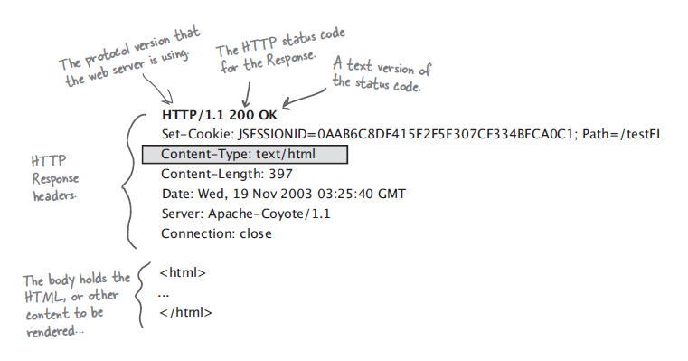

Create Hyperlinks

- Absolute path – giving complete path of the resource
- Relative path – giving path from current location

URL Address

http://localhost:8080/online/home.html

http:// - protocol name
localhost - IP Address of server Machine
8080 - Port Number of the Application
Online/home.html – resource path

What is a Servlet?
A servlet is a Java programming language class that is used to extend the capabilities
of servers that host applications access via a request-response programming
model. Although servlets can respond to any type of request, they are
commonly used to extend the applications hosted by web servers. For such applications,
Java Servlet technology defines HTTP-specific servlet classes.

Why Servlet?
- Read any data sent by the user.
- Look up any other information about the request that is embedded in the HTTP request.
- Generate the results.
- Format the results inside a document.
- Set the appropriate HTTP response parameters.
- Send the document back to the client.
The Advantages of Servlets Over “Traditional” CGI
- Efficient
- Convenient
- Powerful
- Portable
- Secure
- Inexpensive

1) Exercise
How to create a Servlet Program (Create a Web Componet)
package com.first;
import java.io.IOException;
import java.io.PrintWriter;
import java.util.Date;
import javax.servlet.ServletException;
import javax.servlet.http.HttpServlet;
import javax.servlet.http.HttpServletRequest;
import javax.servlet.http.HttpServletResponse;
public class FirstServlet extends HttpServlet {
static int count;
protected void doGet(HttpServletRequest req, HttpServletResponse resp)
throws ServletException, IOException {
PrintWriter out = resp.getWriter();
out.println("<html>");
out.println("<head>");
out.println("<title>My First Servlet Page</title>");
out.println("</head>");
out.println("<body>");
out.println("Servlet Time is " + new Date());
out.println("Page has been visited for " + (++count));
out.println("</body>");
out.println("</html>");
}
}
Configure the Web Component in the Deployment Descriptor file
<web-app
xmlns:xsi="http://www.w3.org/2001/XMLSchema-instance"
xmlns="http://java.sun.com/xml/ns/javaee"
xmlns:web="http://java.sun.com/xml/ns/javaee/web-app_2_5.xsd"
xsi:schemaLocation="http://java.sun.com/xml/ns/javaee
http://java.sun.com/xml/ns/javaee/web-app_2_5.xsd"
id="WebApp_ID" version="2.5">
<servlet>
<servlet-name>first</servlet-name>
<servlet-class>com.first.FirstServlet</servlet-class>
</servlet>
<servlet-mapping>
<servlet-name>first</servlet-name>
<url-pattern>/mypage</url-pattern>
</servlet-mapping>
</web-app>
File Structure of Tomcat server (Deploy the Web Component)
Root Folder of All the Web Application
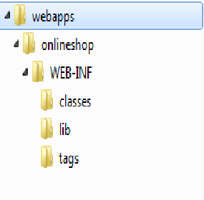
Web.xml
My Application Name (Context Path)
Put all web pages and related items in this folder or in the sub folders (html, Jsp, images, js, css)
Put all Java file here
Put jar files here (lib)

Put all the tld and tag files here

Deployment Descriptor

Mapping between Eclipse Development Environment and Tomcat Deployment structure
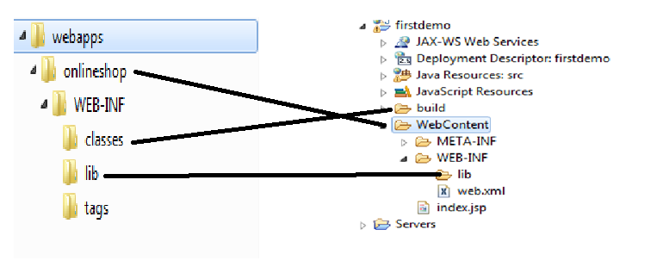

Make the request to below url address and see the output
http://localhost:8080/onlineshop/mypage

How does it Works?
- Request hits the server
- Server pass the request to web container
- Create a Thread object
- Web container consulting with web.xml
- If the Servlet is found
- thread object is calling the service method of that servlet passing request and response
- Service method is calling the corresponding method of your servlet program based on request type
- doGet or doPost method is executed
- return response to user
- destroy request and response and thread object of the current request
- if the servlet is not found send 404 error to user

What is container?
Web container is a special JVM to run web components.
What does it (Container) give?
- Communication Support
- Life cycle management
- Multithreaded Support
- Declarative Security
- Jsp Support

Servlet Life Cycle
- If an instance of the servlet does not exist, the web container
- Load the Class file to Web Container
- Creating Instance of the Servlet
- Calling Construcor of the Servet
- Calling init() method of the object only one time before processing any request
- Calling service method whenever request is received
- Calling Destroy() method when the server is shutdown

How to initialize the Servlet Program?
<servlet>
<servlet-name>first</servlet-name>
<servlet-class>com.first.FirstServlet</servlet-class>
<init-param>
<param-name>role</param-name>
<param-value>Admin,Member,Sales</param-value>
</init-param>
</servlet>
<servlet-mapping>
<servlet-name>first</servlet-name>
<url-pattern>/mypage</url-pattern>
</servlet-mapping>

How to read this value in servlet program

String[] role;
@Override
public void init() throws ServletException {
String roles=getInitParameter("role");
if(roles != null){
role=roles.split(",");
}
}

How to give Binary Response?

@Override
protected void doGet(HttpServletRequest req, HttpServletResponse resp)
throws ServletException, IOException {
resp.setContentType("application/jsp");
ServletContext context=getServletContext();
InputStream is=context.getResourceAsStream("/jdbc.jar");
int read=0;
byte[] raw=new byte[1024];
OutputStream out=resp.getOutputStream();
while((read=is.read(raw))!= -1){
out.write(raw,0,read);
}
out.flush();
out.close();

}

How to redirect the request?
- Forward
- Include
- Send redirect

Servlet A
forward()

Servlet B

Request comes to Servlet A

Only Servlet B Response send to the user

RequestDispatcher dis=req.getRequestDispatcher("/success.jsp");
dis.include(req,resp);
Servlet A include()

Servlet B

Request comes to Servlet A Send to Servlet B
Servlet A & Servlet BResponse send to the user Adding the response to Servlet A

resp.sendRedirect("http://www.yahoo.co.in");
Servlet A
SendRedirect()

Request comes to Servlet A
Sent the another url address response to the user

Data management in Web Applications
Data in Web
- Parameter Data – Data comes from User or web.xml
- Attribute Data – Data are used in the Servlet programming
There are three scopes of data.
- Request – Store the data in request and pass request another web component.
- Session- Store the Data of the each user separately for storing data the multiple request
- Application – Store in the Application it can be shared with all servlet and request

How to read the User Data from Request
<html>
<head>
<title>Insert title here</title>
</head>
<body>
<form action="" method="get">
<input type="text" name="username">
<input type="submit" value="Submit">
</form>
</body>
</html>

String name=req.getParameter(“username”);
How to read the Servlet Data from web.xml
<servlet>
<servlet-name>first</servlet-name>
<servlet-class>com.first.FirstServlet</servlet-class>
<init-param>
<param-name>role</param-name>
<param-value>Admin,Member,Sales</param-value>
</init-param>
</servlet>
<servlet-mapping>
<servlet-name>first</servlet-name>
<url-pattern>/mypage</url-pattern>
</servlet-mapping>

ServletConfig config=getServletConfig();
String roles=config.getInitParameter("role");
Declare Context Param Data
<context-param>
<param-name>role</param-name>
<param-value>Admin,Custoemr,SalesMan</param-value>
</context-param>
So the all the servlet can read this Data using ServletContext object
ServletContext context=getServletContext();
String role=context.getInitParameter("role");
How to Store the Programming Data in Request Scope and retrieve it from
Student s=new Student();
req.setAttribute("mystud",s);//store it

Student s1=(Student)req.getAttribute("mystud"); // retrieve it

How to Store the Programming Data in Application Scope and retrieve it from
Student s=new Student();
ServletContext context=getServletContext();
context.setAttribute("mystud",s);

Student s1=(Student)context.getAttribute("mystud");

Session Management in the Web Application
- Hidden Field
- HttpSession Object
- Cookie Object
- URL Rewritten
How to Store the Programming Data in Session Scope and retrieve it from
Student s=new Student();
HttpSession session=req.getSession();//create a new session or get the existing session
HttpSession session=req.getSession(false);//does not create a new session
session.setAttribute("mystud",s);

Student s1=(Student)session.getAttribute("mystud");

Cookie Demo
How Create a new Cookie
Cookie c=new Cookie(“userName”,””);
How to Add Cookie to Response and sent it to user
resonse.setCookie(c);
How to Read Cookie from Request
PrintWriter out=resp.getWriter();
resp.setContentType("text/html");
String name=null;
Cookie[] cookies=req.getCookies();
for(Cookie c:cookies){
if(c.getName().equals("userName")){
name=c.getValue();
break;
}
}
if(name!=null)
out.println("<b> Dear "+name+"</b>");
else {
out.println("<b> Dear Guest</b>");
}
How to append the session id to the URL
resp.encodeRedirectURL("second.jsp");

Listener Interface and Event Handling
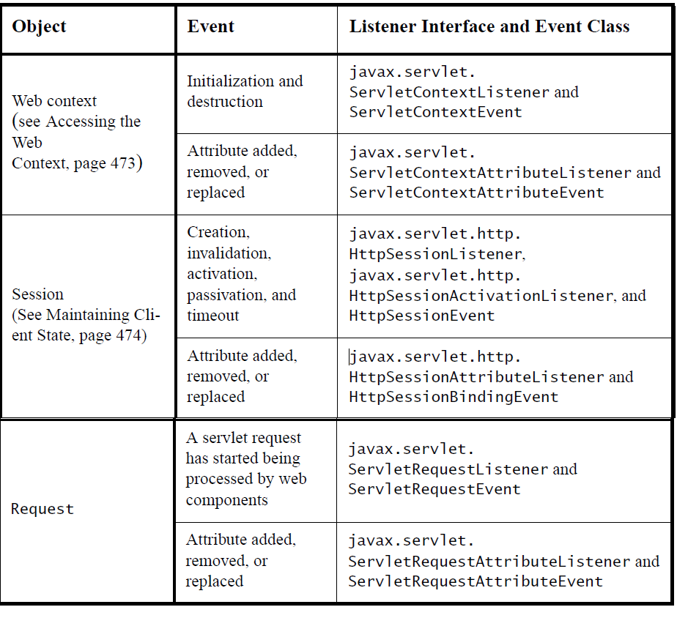

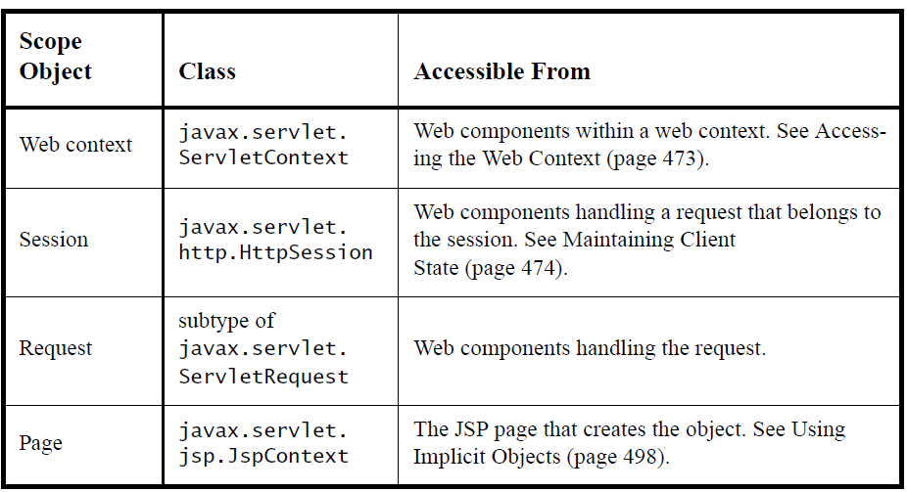

How to create a Listener Class
public class FirstServlet implements ServletContextListener{

@Override
public void contextDestroyed(ServletContextEvent arg0) {

}

@Override
public void contextInitialized(ServletContextEvent arg0) {

}

}

How to Configure
<listener>
<listener-class>com.first.FirstServlet</listener-class>
</listener>

Filter Demo
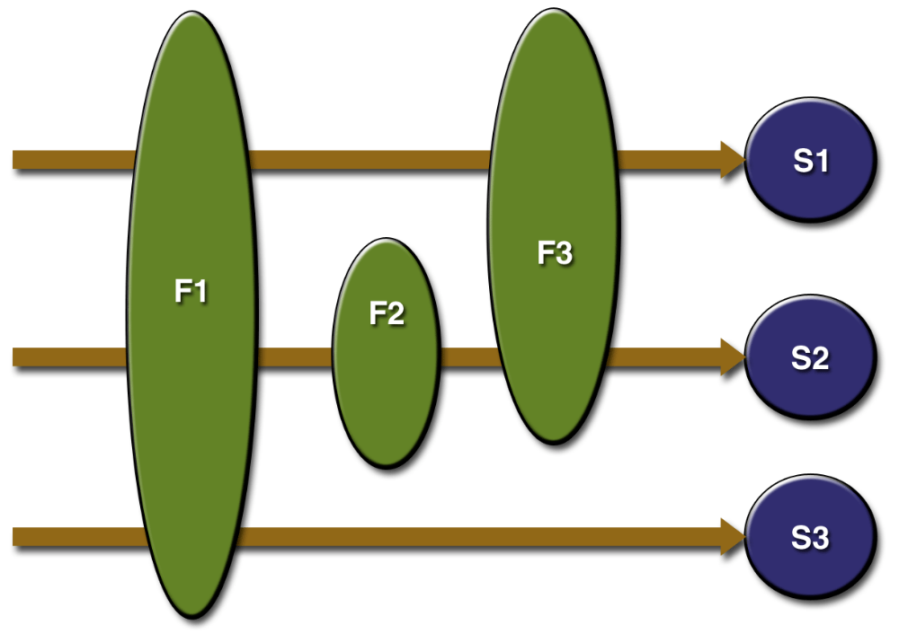
How to create Filter Class
public class FirstServlet implements Filter{

@Override
public void destroy() {

}

@Override
public void doFilter(ServletRequest arg0, ServletResponse arg1,
FilterChain arg2) throws IOException, ServletException {

}

@Override
public void init(FilterConfig arg0) throws ServletException {

}

}
How to Configure Filter Class
<filter>
<filter-name>f1</filter-name>
<filter-class>com.first.FirstServlet</filter-class>
</filter>
<filter-mapping>
<filter-name>f1</filter-name>
<url-pattern>/*.do</url-pattern>
<servlet-name>s1</servlet-name>
<dispatcher>ERROR</dispatcher>
<dispatcher>FORWARD</dispatcher>
<dispatcher>INCLUDE</dispatcher>
<dispatcher>REQUEST</dispatcher>
</filter-mapping>

Servlet API

javax.servlet

Interface Filter

public interface Filter
A filter is an object that performs filtering tasks on either the request to a resource (a servlet or static content), or on the response from a resource, or both.
Filters perform filtering in the doFilter method. Every Filter has access to a FilterConfig object from which it can obtain its initialization parameters, a reference to the ServletContext which it can use, for example, to load resources needed for filtering tasks.
Filters are configured in the deployment descriptor of a web application
Examples that have been identified for this design are
1) Authentication Filters
2) Logging and Auditing Filters
3) Image conversion Filters
4) Data compression Filters
5) Encryption Filters
6) Tokenizing Filters
7) Filters that trigger resource access events
8) XSL/T filters
9) Mime-type chain Filter
Since:
Servlet 2.3

Method Summary
void | destroy()  Called by the web container to indicate to a filter that it is being taken out of service.
void | doFilter(ServletRequest request, ServletResponse response, FilterChain chain)  The doFilter method of the Filter is called by the container each time a request/response pair is passed through the chain due to a client request for a resource at the end of the chain.
void | init(FilterConfig filterConfig)  Called by the web container to indicate to a filter that it is being placed into service.

javax.servlet
Interface FilterChain

public interface FilterChain
A FilterChain is an object provided by the servlet container to the developer giving a view into the invocation chain of a filtered request for a resource. Filters use the FilterChain to invoke the next filter in the chain, or if the calling filter is the last filter in the chain, to invoke the resource at the end of the chain.
Since:
Servlet 2.3
See Also:
Filter

Method Summary
void | doFilter(ServletRequest request, ServletResponse response)  Causes the next filter in the chain to be invoked, or if the calling filter is the last filter in the chain, causes the resource at the end of the chain to be invoked.

javax.servlet
Interface FilterConfig

public interface FilterConfig
A filter configuration object used by a servlet container to pass information to a filter during initialization.
Since:
Servlet 2.3
See Also:
Filter

Method Summary
java.lang.String | getFilterName()  Returns the filter-name of this filter as defined in the deployment descriptor.
java.lang.String | getInitParameter(java.lang.String name)  Returns a String containing the value of the named initialization parameter, or null if the parameter does not exist.
java.util.Enumeration | getInitParameterNames()  Returns the names of the filter's initialization parameters as an Enumeration of String objects, or an empty Enumeration if the filter has no initialization parameters.
ServletContext | getServletContext()  Returns a reference to the ServletContext in which the caller is executing.

javax.servlet
Interface RequestDispatcher

public interface RequestDispatcher
Defines an object that receives requests from the client and sends them to any resource (such as a servlet, HTML file, or JSP file) on the server. The servlet container creates the RequestDispatcher object, which is used as a wrapper around a server resource located at a particular path or given by a particular name.
This interface is intended to wrap servlets, but a servlet container can create RequestDispatcher objects to wrap any type of resource.
Version:
$Version$
Author:
Various
See Also:
ServletContext.getRequestDispatcher(java.lang.String), ServletContext.getNamedDispatcher(java.lang.String), ServletRequest.getRequestDispatcher(java.lang.String)

Method Summary
void | forward(ServletRequest request, ServletResponse response)  Forwards a request from a servlet to another resource (servlet, JSP file, or HTML file) on the server.
void | include(ServletRequest request, ServletResponse response)  Includes the content of a resource (servlet, JSP page, HTML file) in the response.

javax.servlet
Interface Servlet
All Known Implementing Classes:
GenericServlet, HttpServlet

public interface Servlet
Defines methods that all servlets must implement.
A servlet is a small Java program that runs within a Web server. Servlets receive and respond to requests from Web clients, usually across HTTP, the HyperText Transfer Protocol.
To implement this interface, you can write a generic servlet that extends javax.servlet.GenericServlet or an HTTP servlet that extends javax.servlet.http.HttpServlet.
This interface defines methods to initialize a servlet, to service requests, and to remove a servlet from the server. These are known as life-cycle methods and are called in the following sequence:
- The servlet is constructed, then initialized with the init method.
- Any calls from clients to the service method are handled.
- The servlet is taken out of service, then destroyed with the destroy method, then garbage collected and finalized.
In addition to the life-cycle methods, this interface provides the getServletConfig method, which the servlet can use to get any startup information, and the getServletInfo method, which allows the servlet to return basic information about itself, such as author, version, and copyright.
Version:
$Version$
Author:
Various
See Also:
GenericServlet, HttpServlet

Method Summary
void | destroy()  Called by the servlet container to indicate to a servlet that the servlet is being taken out of service.
ServletConfig | getServletConfig()  Returns a ServletConfig object, which contains initialization and startup parameters for this servlet.
java.lang.String | getServletInfo()  Returns information about the servlet, such as author, version, and copyright.
void | init(ServletConfig config)  Called by the servlet container to indicate to a servlet that the servlet is being placed into service.
void | service(ServletRequest req, ServletResponse res)  Called by the servlet container to allow the servlet to respond to a request.

javax.servlet
Interface ServletConfig
All Known Implementing Classes:
GenericServlet, HttpServlet

public interface ServletConfig
A servlet configuration object used by a servlet container to pass information to a servlet during initialization.

Method Summary
java.lang.String | getInitParameter(java.lang.String name)  Returns a String containing the value of the named initialization parameter, or null if the parameter does not exist.
java.util.Enumeration | getInitParameterNames()  Returns the names of the servlet's initialization parameters as an Enumeration of String objects, or an empty Enumeration if the servlet has no initialization parameters.
ServletContext | getServletContext()  Returns a reference to the ServletContext in which the caller is executing.
java.lang.String | getServletName()  Returns the name of this servlet instance.

javax.servlet
Interface ServletContext

public interface ServletContext
Defines a set of methods that a servlet uses to communicate with its servlet container, for example, to get the MIME type of a file, dispatch requests, or write to a log file.
There is one context per "web application" per Java Virtual Machine. (A "web application" is a collection of servlets and content installed under a specific subset of the server's URL namespace such as /catalog and possibly installed via a .war file.)
In the case of a web application marked "distributed" in its deployment descriptor, there will be one context instance for each virtual machine. In this situation, the context cannot be used as a location to share global information (because the information won't be truly global). Use an external resource like a database instead.
The ServletContext object is contained within the ServletConfig object, which the Web server provides the servlet when the servlet is initialized.
Version:
$Version$
Author:
Various
See Also:
Servlet.getServletConfig(), ServletConfig.getServletContext()

Method Summary
java.lang.Object | getAttribute(java.lang.String name)  Returns the servlet container attribute with the given name, or null if there is no attribute by that name.
java.util.Enumeration | getAttributeNames()  Returns an Enumeration containing the attribute names available within this servlet context.
ServletContext | getContext(java.lang.String uripath)  Returns a ServletContext object that corresponds to a specified URL on the server.
java.lang.String | getContextPath()  Returns the context path of the web application.
java.lang.String | getInitParameter(java.lang.String name)  Returns a String containing the value of the named context-wide initialization parameter, or null if the parameter does not exist.
java.util.Enumeration | getInitParameterNames()  Returns the names of the context's initialization parameters as an Enumeration of String objects, or an empty Enumeration if the context has no initialization parameters.
int | getMajorVersion()  Returns the major version of the Java Servlet API that this servlet container supports.
java.lang.String | getMimeType(java.lang.String file)  Returns the MIME type of the specified file, or null if the MIME type is not known.
int | getMinorVersion()  Returns the minor version of the Servlet API that this servlet container supports.
RequestDispatcher | getNamedDispatcher(java.lang.String name)  Returns a RequestDispatcher object that acts as a wrapper for the named servlet.
java.lang.String | getRealPath(java.lang.String path)  Returns a String containing the real path for a given virtual path.
RequestDispatcher | getRequestDispatcher(java.lang.String path)  Returns a RequestDispatcher object that acts as a wrapper for the resource located at the given path.
java.net.URL | getResource(java.lang.String path)  Returns a URL to the resource that is mapped to a specified path.
java.io.InputStream | getResourceAsStream(java.lang.String path)  Returns the resource located at the named path as an InputStream object.
java.util.Set | getResourcePaths(java.lang.String path)  Returns a directory-like listing of all the paths to resources within the web application whose longest sub-path matches the supplied path argument.
java.lang.String | getServerInfo()  Returns the name and version of the servlet container on which the servlet is running.
Servlet | getServlet(java.lang.String name)  Deprecated. As of Java Servlet API 2.1, with no direct replacement.  This method was originally defined to retrieve a servlet from a ServletContext. In this version, this method always returns null and remains only to preserve binary compatibility. This method will be permanently removed in a future version of the Java Servlet API.  In lieu of this method, servlets can share information using the ServletContext class and can perform shared business logic by invoking methods on common non-servlet classes.
java.lang.String | getServletContextName()  Returns the name of this web application corresponding to this ServletContext as specified in the deployment descriptor for this web application by the display-name element.
java.util.Enumeration | getServletNames()  Deprecated. As of Java Servlet API 2.1, with no replacement.  This method was originally defined to return an Enumeration of all the servlet names known to this context. In this version, this method always returns an empty Enumeration and remains only to preserve binary compatibility. This method will be permanently removed in a future version of the Java Servlet API.
java.util.Enumeration | getServlets()  Deprecated. As of Java Servlet API 2.0, with no replacement.  This method was originally defined to return an Enumeration of all the servlets known to this servlet context. In this version, this method always returns an empty enumeration and remains only to preserve binary compatibility. This method will be permanently removed in a future version of the Java Servlet API.
void | log(java.lang.Exception exception, java.lang.String msg)  Deprecated. As of Java Servlet API 2.1, use log(String message, Throwable throwable) instead.  This method was originally defined to write an exception's stack trace and an explanatory error message to the servlet log file.
void | log(java.lang.String msg)  Writes the specified message to a servlet log file, usually an event log.
void | log(java.lang.String message, java.lang.Throwable throwable)  Writes an explanatory message and a stack trace for a given Throwable exception to the servlet log file.
void | removeAttribute(java.lang.String name)  Removes the attribute with the given name from the servlet context.
void | setAttribute(java.lang.String name, java.lang.Object object)  Binds an object to a given attribute name in this servlet context.

javax.servlet
Class GenericServlet
java.lang.Object
javax.servlet.GenericServlet
All Implemented Interfaces:
java.io.Serializable, Servlet, ServletConfig
Direct Known Subclasses:
HttpServlet

public abstract class GenericServlet
extends java.lang.Object
implements Servlet, ServletConfig, java.io.Serializable
Defines a generic, protocol-independent servlet. To write an HTTP servlet for use on the Web, extend HttpServlet instead.
GenericServlet implements the Servlet and ServletConfig interfaces. GenericServlet may be directly extended by a servlet, although it's more common to extend a protocol-specific subclass such as HttpServlet.
GenericServlet makes writing servlets easier. It provides simple versions of the lifecycle methods init and destroy and of the methods in the ServletConfig interface. GenericServlet also implements the log method, declared in the ServletContext interface.
To write a generic servlet, you need only override the abstract service method.
Version:
$Version$
Author:
Various
See Also:
Serialized Form

Constructor Summary
GenericServlet()
Does nothing.

Method Summary
void | destroy()  Called by the servlet container to indicate to a servlet that the servlet is being taken out of service.
java.lang.String | getInitParameter(java.lang.String name)  Returns a String containing the value of the named initialization parameter, or null if the parameter does not exist.
java.util.Enumeration | getInitParameterNames()  Returns the names of the servlet's initialization parameters as an Enumeration of String objects, or an empty Enumeration if the servlet has no initialization parameters.
ServletConfig | getServletConfig()  Returns this servlet's ServletConfig object.
ServletContext | getServletContext()  Returns a reference to the ServletContext in which this servlet is running.
java.lang.String | getServletInfo()  Returns information about the servlet, such as author, version, and copyright.
java.lang.String | getServletName()  Returns the name of this servlet instance.
void | init()  A convenience method which can be overridden so that there's no need to call super.init(config).
void | init(ServletConfig config)  Called by the servlet container to indicate to a servlet that the servlet is being placed into service.
void | log(java.lang.String msg)  Writes the specified message to a servlet log file, prepended by the servlet's name.
void | log(java.lang.String message, java.lang.Throwable t)  Writes an explanatory message and a stack trace for a given Throwable exception to the servlet log file, prepended by the servlet's name.
abstract void | service(ServletRequest req, ServletResponse res)  Called by the servlet container to allow the servlet to respond to a request.

javax.servlet
Interface ServletRequest
All Known Subinterfaces:
HttpServletRequest
All Known Implementing Classes:
HttpServletRequestWrapper, ServletRequestWrapper

public interface ServletRequest
Defines an object to provide client request information to a servlet. The servlet container creates a ServletRequest object and passes it as an argument to the servlet's service method.
A ServletRequest object provides data including parameter name and values, attributes, and an input stream. Interfaces that extend ServletRequest can provide additional protocol-specific data (for example, HTTP data is provided by HttpServletRequest.
Version:
$Version$
Author:
Various
See Also:
HttpServletRequest

Method Summary
java.lang.Object | getAttribute(java.lang.String name)  Returns the value of the named attribute as an Object, or null if no attribute of the given name exists.
java.util.Enumeration | getAttributeNames()  Returns an Enumeration containing the names of the attributes available to this request.
java.lang.String | getCharacterEncoding()  Returns the name of the character encoding used in the body of this request.
int | getContentLength()  Returns the length, in bytes, of the request body and made available by the input stream, or -1 if the length is not known.
java.lang.String | getContentType()  Returns the MIME type of the body of the request, or null if the type is not known.
ServletInputStream | getInputStream()  Retrieves the body of the request as binary data using a ServletInputStream.
java.lang.String | getLocalAddr()  Returns the Internet Protocol (IP) address of the interface on which the request was received.
java.util.Locale | getLocale()  Returns the preferred Locale that the client will accept content in, based on the Accept-Language header.
java.util.Enumeration | getLocales()  Returns an Enumeration of Locale objects indicating, in decreasing order starting with the preferred locale, the locales that are acceptable to the client based on the Accept-Language header.
java.lang.String | getLocalName()  Returns the host name of the Internet Protocol (IP) interface on which the request was received.
int | getLocalPort()  Returns the Internet Protocol (IP) port number of the interface on which the request was received.
java.lang.String | getParameter(java.lang.String name)  Returns the value of a request parameter as a String, or null if the parameter does not exist.
java.util.Map | getParameterMap()  Returns a java.util.Map of the parameters of this request.
java.util.Enumeration | getParameterNames()  Returns an Enumeration of String objects containing the names of the parameters contained in this request.
java.lang.String[] | getParameterValues(java.lang.String name)  Returns an array of String objects containing all of the values the given request parameter has, or null if the parameter does not exist.
java.lang.String | getProtocol()  Returns the name and version of the protocol the request uses in the form protocol/majorVersion.minorVersion, for example, HTTP/1.1.
java.io.BufferedReader | getReader()  Retrieves the body of the request as character data using a BufferedReader.
java.lang.String | getRealPath(java.lang.String path)  Deprecated. As of Version 2.1 of the Java Servlet API, use ServletContext.getRealPath(java.lang.String) instead.
java.lang.String | getRemoteAddr()  Returns the Internet Protocol (IP) address of the client or last proxy that sent the request.
java.lang.String | getRemoteHost()  Returns the fully qualified name of the client or the last proxy that sent the request.
int | getRemotePort()  Returns the Internet Protocol (IP) source port of the client or last proxy that sent the request.
RequestDispatcher | getRequestDispatcher(java.lang.String path)  Returns a RequestDispatcher object that acts as a wrapper for the resource located at the given path.
java.lang.String | getScheme()  Returns the name of the scheme used to make this request, for example, http, https, or ftp.
java.lang.String | getServerName()  Returns the host name of the server to which the request was sent.
int | getServerPort()  Returns the port number to which the request was sent.
boolean | isSecure()  Returns a boolean indicating whether this request was made using a secure channel, such as HTTPS.
void | removeAttribute(java.lang.String name)  Removes an attribute from this request.
void | setAttribute(java.lang.String name, java.lang.Object o)  Stores an attribute in this request.
void | setCharacterEncoding(java.lang.String env)  Overrides the name of the character encoding used in the body of this request.

javax.servlet
Interface ServletResponse
All Known Subinterfaces:
HttpServletResponse
All Known Implementing Classes:
HttpServletResponseWrapper, ServletResponseWrapper

public interface ServletResponse
Defines an object to assist a servlet in sending a response to the client. The servlet container creates a ServletResponse object and passes it as an argument to the servlet's service method.
To send binary data in a MIME body response, use the ServletOutputStream returned by getOutputStream(). To send character data, use the PrintWriter object returned by getWriter(). To mix binary and text data, for example, to create a multipart response, use a ServletOutputStream and manage the character sections manually.
The charset for the MIME body response can be specified explicitly using the setCharacterEncoding(java.lang.String) and setContentType(java.lang.String) methods, or implicitly using the setLocale(java.util.Locale) method. Explicit specifications take precedence over implicit specifications. If no charset is specified, ISO-8859-1 will be used. The setCharacterEncoding, setContentType, or setLocale method must be called before getWriter and before committing the response for the character encoding to be used.
See the Internet RFCs such as RFC 2045 for more information on MIME. Protocols such as SMTP and HTTP define profiles of MIME, and those standards are still evolving.
Version:
$Version$
Author:
Various
See Also:
ServletOutputStream

Method Summary
void | flushBuffer()  Forces any content in the buffer to be written to the client.
int | getBufferSize()  Returns the actual buffer size used for the response.
java.lang.String | getCharacterEncoding()  Returns the name of the character encoding (MIME charset) used for the body sent in this response.
java.lang.String | getContentType()  Returns the content type used for the MIME body sent in this response.
java.util.Locale | getLocale()  Returns the locale specified for this response using the setLocale(java.util.Locale) method.
ServletOutputStream | getOutputStream()  Returns a ServletOutputStream suitable for writing binary data in the response.
java.io.PrintWriter | getWriter()  Returns a PrintWriter object that can send character text to the client.
boolean | isCommitted()  Returns a boolean indicating if the response has been committed.
void | reset()  Clears any data that exists in the buffer as well as the status code and headers.
void | resetBuffer()  Clears the content of the underlying buffer in the response without clearing headers or status code.
void | setBufferSize(int size)  Sets the preferred buffer size for the body of the response.
void | setCharacterEncoding(java.lang.String charset)  Sets the character encoding (MIME charset) of the response being sent to the client, for example, to UTF-8.
void | setContentLength(int len)  Sets the length of the content body in the response In HTTP servlets, this method sets the HTTP Content-Length header.
void | setContentType(java.lang.String type)  Sets the content type of the response being sent to the client, if the response has not been committed yet.
void | setLocale(java.util.Locale loc)  Sets the locale of the response, if the response has not been committed yet.

javax.servlet.http
Interface HttpServletRequest
All Superinterfaces:
ServletRequest
All Known Implementing Classes:
HttpServletRequestWrapper

public interface HttpServletRequest
extends ServletRequest
Extends the ServletRequest interface to provide request information for HTTP servlets.
The servlet container creates an HttpServletRequest object and passes it as an argument to the servlet's service methods (doGet, doPost, etc).
Version:
$Version$
Author:
Various

Field Summary
static java.lang.String | BASIC_AUTH  String identifier for Basic authentication.
static java.lang.String | CLIENT_CERT_AUTH  String identifier for Client Certificate authentication.
static java.lang.String | DIGEST_AUTH  String identifier for Digest authentication.
static java.lang.String | FORM_AUTH  String identifier for Form authentication.

Method Summary
java.lang.String | getAuthType()  Returns the name of the authentication scheme used to protect the servlet.
java.lang.String | getContextPath()  Returns the portion of the request URI that indicates the context of the request.
Cookie[] | getCookies()  Returns an array containing all of the Cookie objects the client sent with this request.
long | getDateHeader(java.lang.String name)  Returns the value of the specified request header as a long value that represents a Date object.
java.lang.String | getHeader(java.lang.String name)  Returns the value of the specified request header as a String.
java.util.Enumeration | getHeaderNames()  Returns an enumeration of all the header names this request contains.
java.util.Enumeration | getHeaders(java.lang.String name)  Returns all the values of the specified request header as an Enumeration of String objects.
int | getIntHeader(java.lang.String name)  Returns the value of the specified request header as an int.
java.lang.String | getMethod()  Returns the name of the HTTP method with which this request was made, for example, GET, POST, or PUT.
java.lang.String | getPathInfo()  Returns any extra path information associated with the URL the client sent when it made this request.
java.lang.String | getPathTranslated()  Returns any extra path information after the servlet name but before the query string, and translates it to a real path.
java.lang.String | getQueryString()  Returns the query string that is contained in the request URL after the path.
java.lang.String | getRemoteUser()  Returns the login of the user making this request, if the user has been authenticated, or null if the user has not been authenticated.
java.lang.String | getRequestedSessionId()  Returns the session ID specified by the client.
java.lang.String | getRequestURI()  Returns the part of this request's URL from the protocol name up to the query string in the first line of the HTTP request.
java.lang.StringBuffer | getRequestURL()  Reconstructs the URL the client used to make the request.
java.lang.String | getServletPath()  Returns the part of this request's URL that calls the servlet.
HttpSession | getSession()  Returns the current session associated with this request, or if the request does not have a session, creates one.
HttpSession | getSession(boolean create)  Returns the current HttpSession associated with this request or, if there is no current session and create is true, returns a new session.
java.security.Principal | getUserPrincipal()  Returns a java.security.Principal object containing the name of the current authenticated user.
boolean | isRequestedSessionIdFromCookie()  Checks whether the requested session ID came in as a cookie.
boolean | isRequestedSessionIdFromUrl()  Deprecated. As of Version 2.1 of the Java Servlet API, use isRequestedSessionIdFromURL() instead.
boolean | isRequestedSessionIdFromURL()  Checks whether the requested session ID came in as part of the request URL.
boolean | isRequestedSessionIdValid()  Checks whether the requested session ID is still valid.
boolean | isUserInRole(java.lang.String role)  Returns a boolean indicating whether the authenticated user is included in the specified logical "role".

javax.servlet.http
Interface HttpServletResponse
All Superinterfaces:
ServletResponse
All Known Implementing Classes:
HttpServletResponseWrapper

public interface HttpServletResponse
extends ServletResponse
Extends the ServletResponse interface to provide HTTP-specific functionality in sending a response. For example, it has methods to access HTTP headers and cookies.
The servlet container creates an HttpServletResponse object and passes it as an argument to the servlet's service methods (doGet, doPost, etc).
Version:
$Version$
Author:
Various
See Also:
ServletResponse

Field Summary
static int | SC_ACCEPTED  Status code (202) indicating that a request was accepted for processing, but was not completed.
static int | SC_BAD_GATEWAY  Status code (502) indicating that the HTTP server received an invalid response from a server it consulted when acting as a proxy or gateway.
static int | SC_BAD_REQUEST  Status code (400) indicating the request sent by the client was syntactically incorrect.
static int | SC_CONFLICT  Status code (409) indicating that the request could not be completed due to a conflict with the current state of the resource.
static int | SC_CONTINUE  Status code (100) indicating the client can continue.
static int | SC_CREATED  Status code (201) indicating the request succeeded and created a new resource on the server.
static int | SC_EXPECTATION_FAILED  Status code (417) indicating that the server could not meet the expectation given in the Expect request header.
static int | SC_FORBIDDEN  Status code (403) indicating the server understood the request but refused to fulfill it.
static int | SC_FOUND  Status code (302) indicating that the resource reside temporarily under a different URI.
static int | SC_GATEWAY_TIMEOUT  Status code (504) indicating that the server did not receive a timely response from the upstream server while acting as a gateway or proxy.
static int | SC_GONE  Status code (410) indicating that the resource is no longer available at the server and no forwarding address is known.
static int | SC_HTTP_VERSION_NOT_SUPPORTED  Status code (505) indicating that the server does not support or refuses to support the HTTP protocol version that was used in the request message.
static int | SC_INTERNAL_SERVER_ERROR  Status code (500) indicating an error inside the HTTP server which prevented it from fulfilling the request.
static int | SC_LENGTH_REQUIRED  Status code (411) indicating that the request cannot be handled without a defined Content-Length.
static int | SC_METHOD_NOT_ALLOWED  Status code (405) indicating that the method specified in the Request-Line is not allowed for the resource identified by the Request-URI.
static int | SC_MOVED_PERMANENTLY  Status code (301) indicating that the resource has permanently moved to a new location, and that future references should use a new URI with their requests.
static int | SC_MOVED_TEMPORARILY  Status code (302) indicating that the resource has temporarily moved to another location, but that future references should still use the original URI to access the resource.
static int | SC_MULTIPLE_CHOICES  Status code (300) indicating that the requested resource corresponds to any one of a set of representations, each with its own specific location.
static int | SC_NO_CONTENT  Status code (204) indicating that the request succeeded but that there was no new information to return.
static int | SC_NON_AUTHORITATIVE_INFORMATION  Status code (203) indicating that the meta information presented by the client did not originate from the server.
static int | SC_NOT_ACCEPTABLE  Status code (406) indicating that the resource identified by the request is only capable of generating response entities which have content characteristics not acceptable according to the accept headers sent in the request.
static int | SC_NOT_FOUND  Status code (404) indicating that the requested resource is not available.
static int | SC_NOT_IMPLEMENTED  Status code (501) indicating the HTTP server does not support the functionality needed to fulfill the request.
static int | SC_NOT_MODIFIED  Status code (304) indicating that a conditional GET operation found that the resource was available and not modified.
static int | SC_OK  Status code (200) indicating the request succeeded normally.
static int | SC_PARTIAL_CONTENT  Status code (206) indicating that the server has fulfilled the partial GET request for the resource.
static int | SC_PAYMENT_REQUIRED  Status code (402) reserved for future use.
static int | SC_PRECONDITION_FAILED  Status code (412) indicating that the precondition given in one or more of the request-header fields evaluated to false when it was tested on the server.
static int | SC_PROXY_AUTHENTICATION_REQUIRED  Status code (407) indicating that the client MUST first authenticate itself with the proxy.
static int | SC_REQUEST_ENTITY_TOO_LARGE  Status code (413) indicating that the server is refusing to process the request because the request entity is larger than the server is willing or able to process.
static int | SC_REQUEST_TIMEOUT  Status code (408) indicating that the client did not produce a request within the time that the server was prepared to wait.
static int | SC_REQUEST_URI_TOO_LONG  Status code (414) indicating that the server is refusing to service the request because the Request-URI is longer than the server is willing to interpret.
static int | SC_REQUESTED_RANGE_NOT_SATISFIABLE  Status code (416) indicating that the server cannot serve the requested byte range.
static int | SC_RESET_CONTENT  Status code (205) indicating that the agent SHOULD reset the document view which caused the request to be sent.
static int | SC_SEE_OTHER  Status code (303) indicating that the response to the request can be found under a different URI.
static int | SC_SERVICE_UNAVAILABLE  Status code (503) indicating that the HTTP server is temporarily overloaded, and unable to handle the request.
static int | SC_SWITCHING_PROTOCOLS  Status code (101) indicating the server is switching protocols according to Upgrade header.
static int | SC_TEMPORARY_REDIRECT  Status code (307) indicating that the requested resource resides temporarily under a different URI.
static int | SC_UNAUTHORIZED  Status code (401) indicating that the request requires HTTP authentication.
static int | SC_UNSUPPORTED_MEDIA_TYPE  Status code (415) indicating that the server is refusing to service the request because the entity of the request is in a format not supported by the requested resource for the requested method.
static int | SC_USE_PROXY  Status code (305) indicating that the requested resource MUST be accessed through the proxy given by the Location field.

Method Summary
void | addCookie(Cookie cookie)  Adds the specified cookie to the response.
void | addDateHeader(java.lang.String name, long date)  Adds a response header with the given name and date-value.
void | addHeader(java.lang.String name, java.lang.String value)  Adds a response header with the given name and value.
void | addIntHeader(java.lang.String name, int value)  Adds a response header with the given name and integer value.
boolean | containsHeader(java.lang.String name)  Returns a boolean indicating whether the named response header has already been set.
java.lang.String | encodeRedirectUrl(java.lang.String url)  Deprecated. As of version 2.1, use encodeRedirectURL(String url) instead
java.lang.String | encodeRedirectURL(java.lang.String url)  Encodes the specified URL for use in the sendRedirect method or, if encoding is not needed, returns the URL unchanged.
java.lang.String | encodeUrl(java.lang.String url)  Deprecated. As of version 2.1, use encodeURL(String url) instead
java.lang.String | encodeURL(java.lang.String url)  Encodes the specified URL by including the session ID in it, or, if encoding is not needed, returns the URL unchanged.
void | sendError(int sc)  Sends an error response to the client using the specified status code and clearing the buffer.
void | sendError(int sc, java.lang.String msg)  Sends an error response to the client using the specified status.
void | sendRedirect(java.lang.String location)  Sends a temporary redirect response to the client using the specified redirect location URL.
void | setDateHeader(java.lang.String name, long date)  Sets a response header with the given name and date-value.
void | setHeader(java.lang.String name, java.lang.String value)  Sets a response header with the given name and value.
void | setIntHeader(java.lang.String name, int value)  Sets a response header with the given name and integer value.
void | setStatus(int sc)  Sets the status code for this response.
void | setStatus(int sc, java.lang.String sm)  Deprecated. As of version 2.1, due to ambiguous meaning of the message parameter. To set a status code use setStatus(int), to send an error with a description use sendError(int, String). Sets the status code and message for this response.

javax.servlet.http
Class Cookie
java.lang.Object
javax.servlet.http.Cookie
All Implemented Interfaces:
java.lang.Cloneable

public class Cookie
extends java.lang.Object
implements java.lang.Cloneable
Creates a cookie, a small amount of information sent by a servlet to a Web browser, saved by the browser, and later sent back to the server. A cookie's value can uniquely identify a client, so cookies are commonly used for session management.
A cookie has a name, a single value, and optional attributes such as a comment, path and domain qualifiers, a maximum age, and a version number. Some Web browsers have bugs in how they handle the optional attributes, so use them sparingly to improve the interoperability of your servlets.
The servlet sends cookies to the browser by using the HttpServletResponse.addCookie(javax.servlet.http.Cookie) method, which adds fields to HTTP response headers to send cookies to the browser, one at a time. The browser is expected to support 20 cookies for each Web server, 300 cookies total, and may limit cookie size to 4 KB each.
The browser returns cookies to the servlet by adding fields to HTTP request headers. Cookies can be retrieved from a request by using the HttpServletRequest.getCookies() method. Several cookies might have the same name but different path attributes.
Cookies affect the caching of the Web pages that use them. HTTP 1.0 does not cache pages that use cookies created with this class. This class does not support the cache control defined with HTTP 1.1.
This class supports both the Version 0 (by Netscape) and Version 1 (by RFC 2109) cookie specifications. By default, cookies are created using Version 0 to ensure the best interoperability.
Version:
$Version$
Author:
Various

Constructor Summary
Cookie(java.lang.String name, java.lang.String value)
Constructs a cookie with a specified name and value.

Method Summary
java.lang.Object | clone()  Overrides the standard java.lang.Object.clone method to return a copy of this cookie.
java.lang.String | getComment()  Returns the comment describing the purpose of this cookie, or null if the cookie has no comment.
java.lang.String | getDomain()  Returns the domain name set for this cookie.
int | getMaxAge()  Returns the maximum age of the cookie, specified in seconds, By default, -1 indicating the cookie will persist until browser shutdown.
java.lang.String | getName()  Returns the name of the cookie.
java.lang.String | getPath()  Returns the path on the server to which the browser returns this cookie.
boolean | getSecure()  Returns true if the browser is sending cookies only over a secure protocol, or false if the browser can send cookies using any protocol.
java.lang.String | getValue()  Returns the value of the cookie.
int | getVersion()  Returns the version of the protocol this cookie complies with.
void | setComment(java.lang.String purpose)  Specifies a comment that describes a cookie's purpose.
void | setDomain(java.lang.String pattern)  Specifies the domain within which this cookie should be presented.
void | setMaxAge(int expiry)  Sets the maximum age of the cookie in seconds.
void | setPath(java.lang.String uri)  Specifies a path for the cookie to which the client should return the cookie.
void | setSecure(boolean flag)  Indicates to the browser whether the cookie should only be sent using a secure protocol, such as HTTPS or SSL.
void | setValue(java.lang.String newValue)  Assigns a new value to a cookie after the cookie is created.
void | setVersion(int v)  Sets the version of the cookie protocol this cookie complies with.

javax.servlet.http
Class HttpServlet
java.lang.Object
javax.servlet.GenericServlet
javax.servlet.http.HttpServlet
All Implemented Interfaces:
java.io.Serializable, Servlet, ServletConfig

public abstract class HttpServlet
extends GenericServlet
implements java.io.Serializable
Provides an abstract class to be subclassed to create an HTTP servlet suitable for a Web site. A subclass of HttpServlet must override at least one method, usually one of these:
- doGet, if the servlet supports HTTP GET requests
- doPost, for HTTP POST requests
- doPut, for HTTP PUT requests
- doDelete, for HTTP DELETE requests
- init and destroy, to manage resources that are held for the life of the servlet
- getServletInfo, which the servlet uses to provide information about itself
There's almost no reason to override the service method. service handles standard HTTP requests by dispatching them to the handler methods for each HTTP request type (the doXXX methods listed above).
Likewise, there's almost no reason to override the doOptions and doTrace methods.
Servlets typically run on multithreaded servers, so be aware that a servlet must handle concurrent requests and be careful to synchronize access to shared resources. Shared resources include in-memory data such as instance or class variables and external objects such as files, database connections, and network connections. See the Java Tutorial on Multithreaded Programming for more information on handling multiple threads in a Java program.
Version:
$Version$
Author:
Various
See Also:
Serialized Form

Constructor Summary
HttpServlet()
Does nothing, because this is an abstract class.

Method Summary
protected void | doDelete(HttpServletRequest req, HttpServletResponse resp)  Called by the server (via the service method) to allow a servlet to handle a DELETE request.
protected void | doGet(HttpServletRequest req, HttpServletResponse resp)  Called by the server (via the service method) to allow a servlet to handle a GET request.
protected void | doHead(HttpServletRequest req, HttpServletResponse resp)  Receives an HTTP HEAD request from the protected service method and handles the request.
protected void | doOptions(HttpServletRequest req, HttpServletResponse resp)  Called by the server (via the service method) to allow a servlet to handle a OPTIONS request.
protected void | doPost(HttpServletRequest req, HttpServletResponse resp)  Called by the server (via the service method) to allow a servlet to handle a POST request.
protected void | doPut(HttpServletRequest req, HttpServletResponse resp)  Called by the server (via the service method) to allow a servlet to handle a PUT request.
protected void | doTrace(HttpServletRequest req, HttpServletResponse resp)  Called by the server (via the service method) to allow a servlet to handle a TRACE request.
protected long | getLastModified(HttpServletRequest req)  Returns the time the HttpServletRequest object was last modified, in milliseconds since midnight January 1, 1970 GMT.
protected void | service(HttpServletRequest req, HttpServletResponse resp)  Receives standard HTTP requests from the public service method and dispatches them to the doXXX methods defined in this class.
void | service(ServletRequest req, ServletResponse res)  Dispatches client requests to the protected service method.

