**EARTHQUAKE PREDICTION MODEL USING PYTHON**

**PHASE 3**

**NAME**: VISHNUPRASATH S  
**REGISTER NUMBER**: 61772131T311

**DATA VISUALIZATION:**

Data visualization using machine learning in an earthquake prediction model refers to the integration of machine learning techniques with visualization tools to analyze and represent diverse data types, including seismic data, geospatial information, and geological characteristics. The outcomes of these analyses are then visually presented through graphs, maps, interactive dashboards, or other visual aids, enabling researchers and stakeholders to interpret and comprehend the data effectively. This fusion of machine learning and visualization enhances the understanding of earthquake-related data, aiding in informed decision-making and proactive earthquake prediction and mitigation efforts.

There are several common techniques used for data visualization: charts (bar, line, pie), plots (scatter, bubble, box), maps (heatmaps, dot distribution maps, cartograms), diagram and matrices.

**DATA VISUALIZATION IN EARTHQUAKE PREDICTION:**

The necessary libraries required for data analysis to data visualization of the earthquake.

**STEP 1:**

Import the pandas, numpy, matplotlib, seaborn and warnings. Unwanted warnings can be ignored and to display the data to index.

Read the data from csv and also columns which necessary for the model and the column which needs to be predicted. For the data can be cleaning and analysis the data.

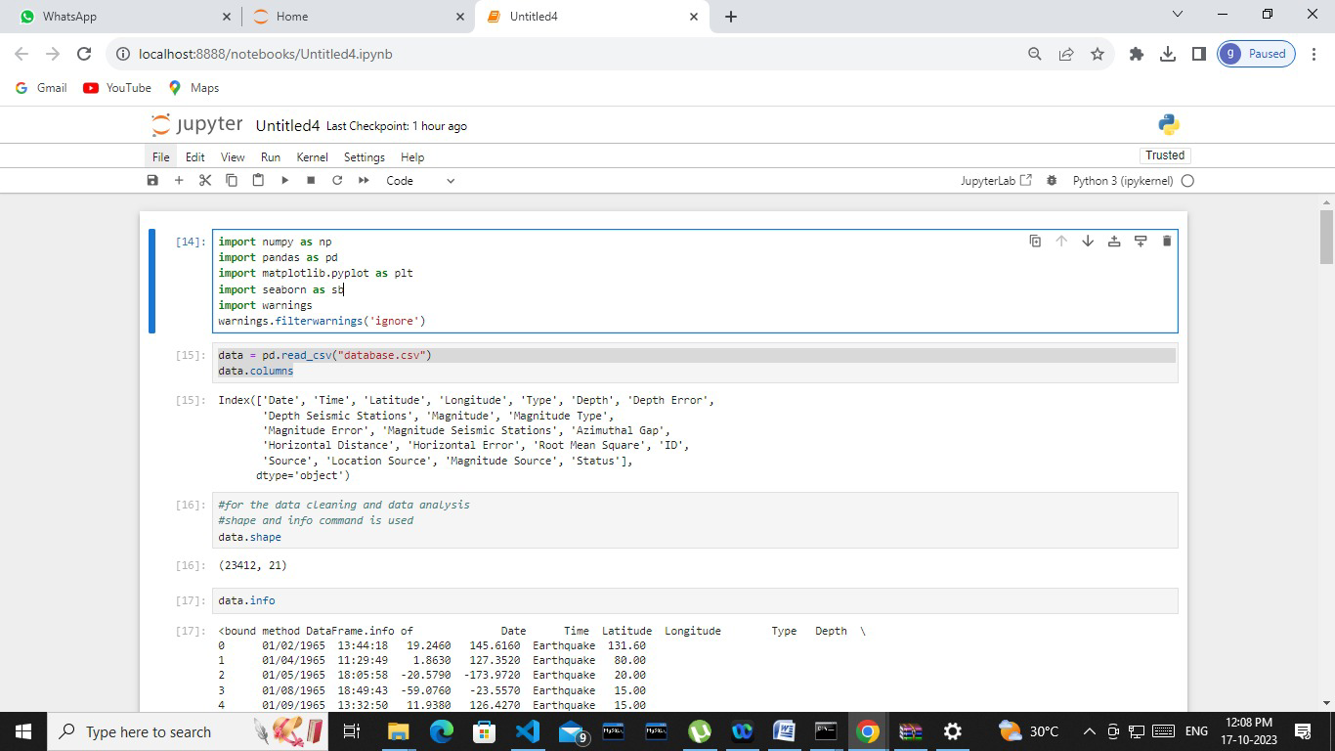

**STEP 2:**

Shape and info command can be used in the given program.

Shape- shape can be represent qualitative data. Each category is represented by a specific shape.

Info- To explore relationships between data, to confirm ideas we hold about data or to explain data in easy to digest manner. Display the information of earthquake prediction.

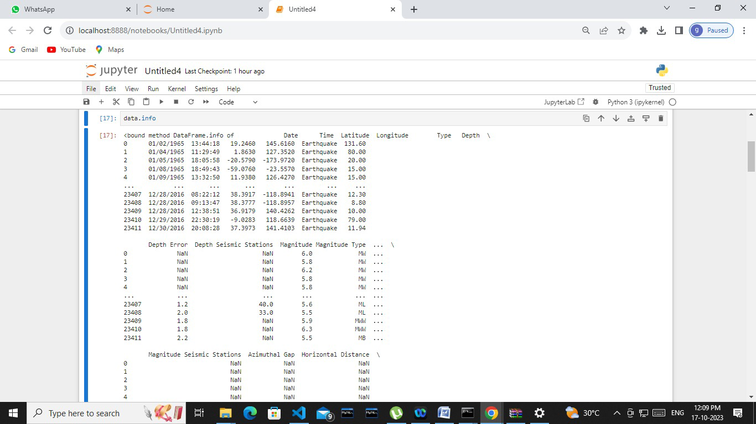

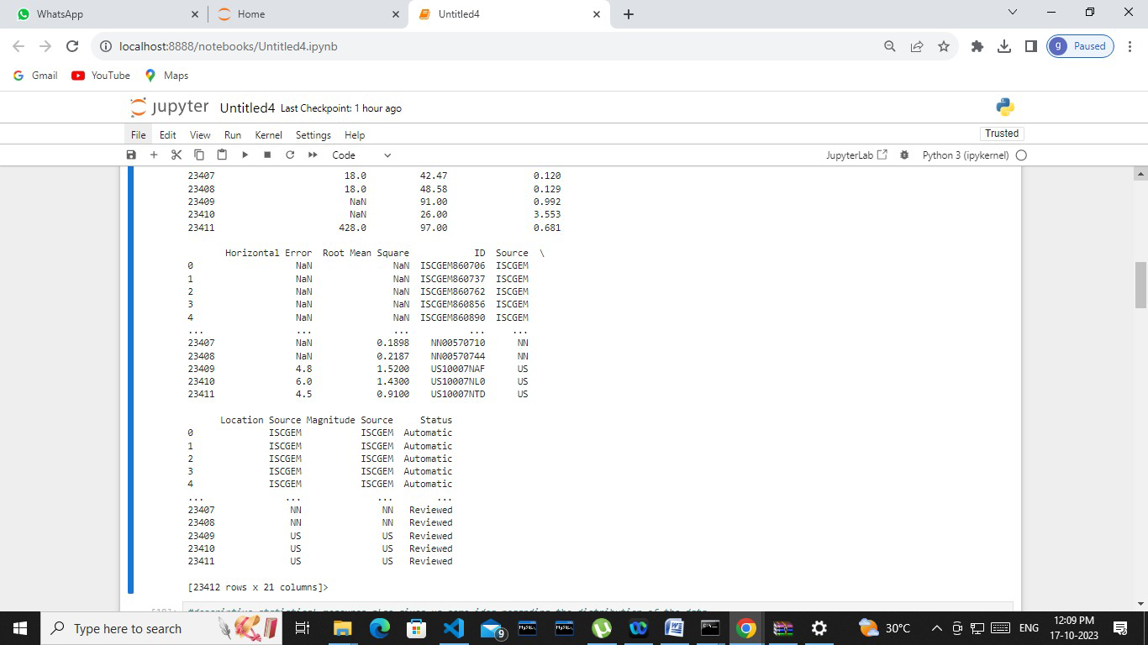

**STEP 3:**

Read the describe data. The Descriptive statistical measures also gives us some idea regarding the distribution of the data.

The data are Longitude, Latitude, Depth, Depth Error, Depth Seismic Stations, Magnitude, Magnitude Seismic Stations, Azimuthal Gap, Horizontal Distance, Horizontal Error, Root Mear Square are describe the data can be read. The data can be described by the data visualization.

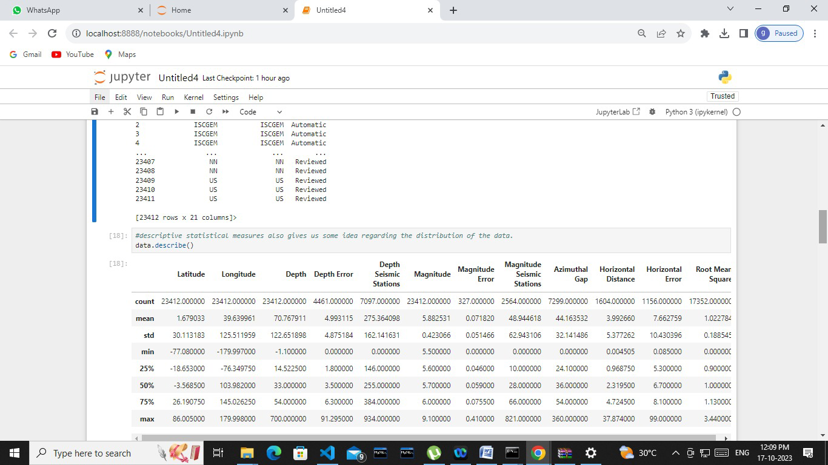

**STEP 4:**

The date visualization for the given dataset. Import the Base map and declare the Longitude, Latitude.

Declare the figure size to be plotted. That can be plot the affected area in the given world ma and to draw coastlines, map boundary, countries. To fill the continents. After the plotted graph can be show in the given output. A visualization that shows data in map form using different shapes and colors to show the relationship between pieces of data and specific locations. A combination of visuals and words that represent data.

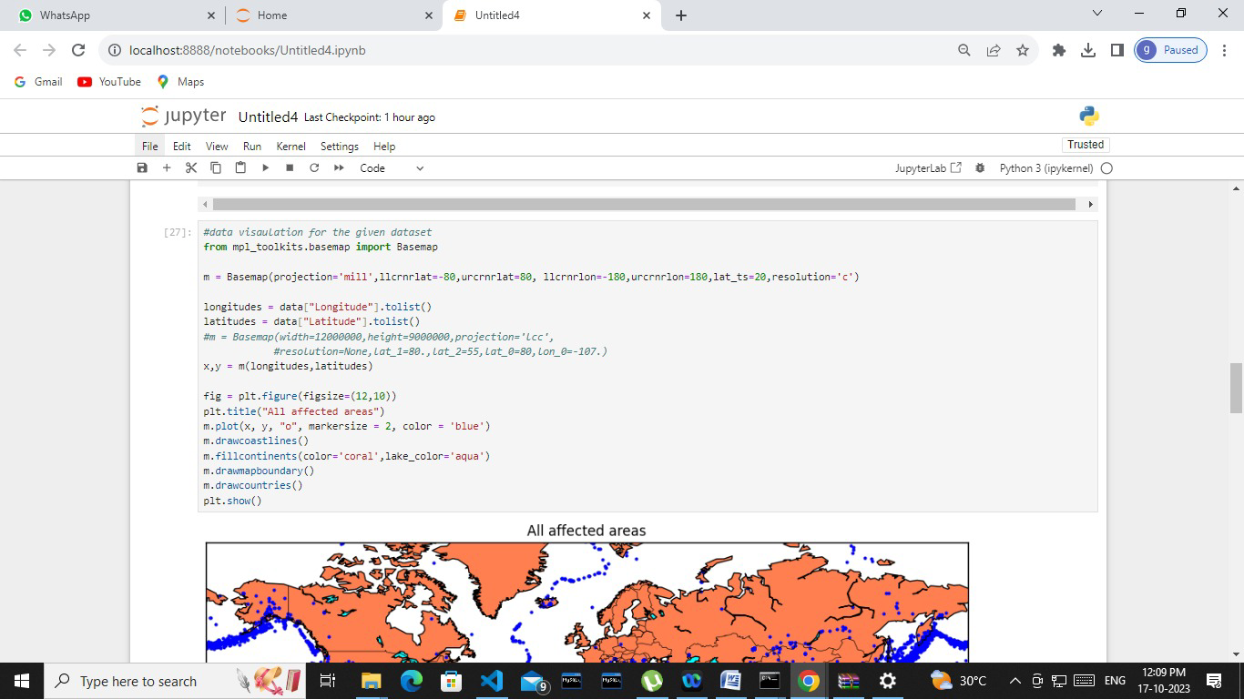

All affected area is shown in the output of the given world map.

Map visualization also known as cartographic visualization. The geospatial data are usually visualized in the form of static or interactive maps.

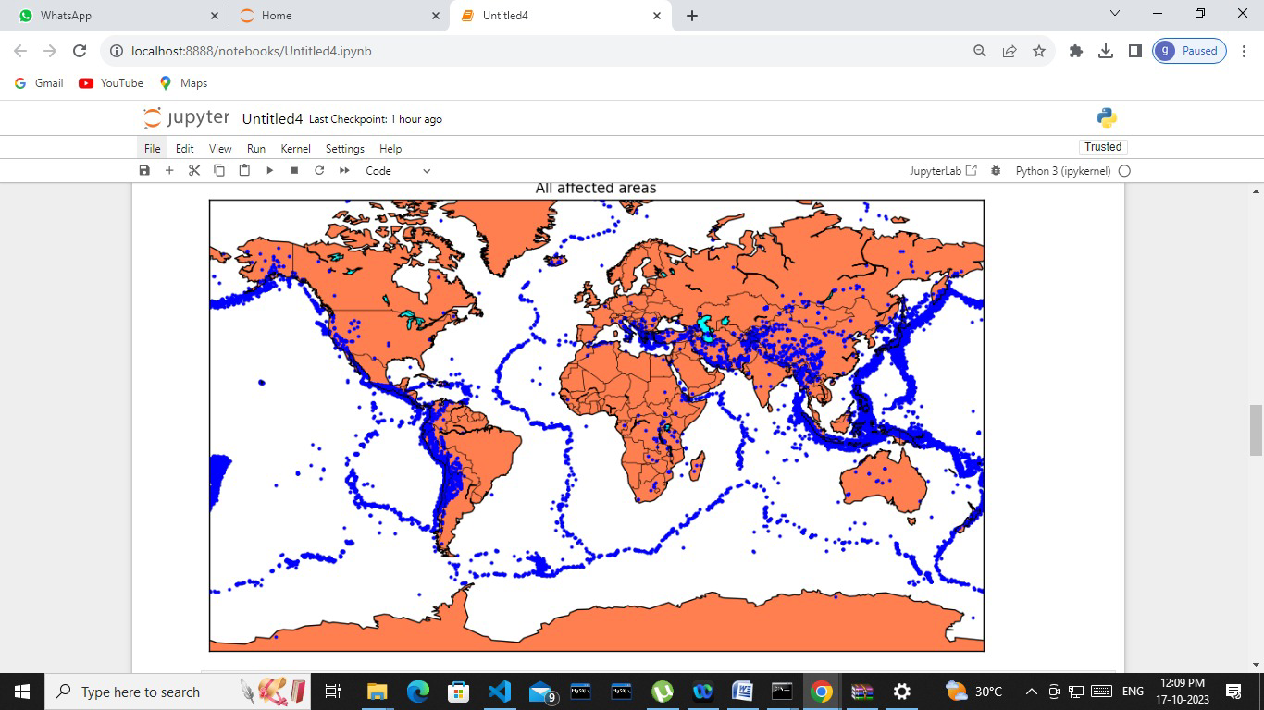

**STEP 5:** Use the matplotlib, seaborn library in the magnitude analysis and visualization of the data.

The length of a bar in a bar chart can represent the magnitude of a specific data point.

The plots are subplots, displots, boxplots are shown in the output of given barchat. The bar chat are plot between density and magnitude and another chart are plot to the magnitude of the points to the data visualization of the dataset.

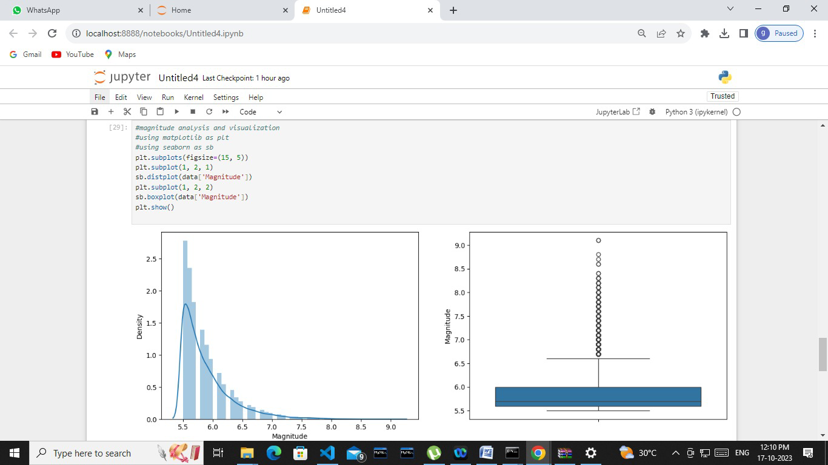

Thus, Data Visualization is completed for Earthquake failure detection by using Python.