**Name: Vishnuprasath S  
Date: 29.09.2023**

**Project Name:** Earthquake Detection model using Python.

**Phase 1: Problem Definition and Design Thinking**

**Problem Definition:**

The problem is to develop an earthquake prediction model using a Kaggle database which analysis the data from (2016 to 2020). The objective is to explore the key features of the earthquake and predict the earthquake magnitude. We need the train the AI so that only we can get the accurate solution by using python

**Key Components:**

Data Collection, Data Processing, Feature Selection, Model Selection, Training and Validation.

**Design Thinking:**

Data Source: Choose a suitable Kaggle dataset containing earthquake da with features like data, time, latitude, longitude, depth and magnitude.

Feature Exploration: Analyse and understand the distribution, correlation and characteristics of the key features.

Visualization: Create a world map visualization to display earthquake frequency distribution.

Data Splitting: Split the dataset into a training set and a test set for model validation

Model Development: Build a neural network model for earthquake magnitude prediction.

Training and Validation: Train the model on the training set the evaluates its performance on the test set.

**Short review of the model:**

1. First let’s start with the data collection.
   1. Data Collection is from Kaggle document.

|  | latitude | longitude | depth | magnitude | Timestamp |
| --- | --- | --- | --- | --- | --- |
| 1 | 19.249 | 145.643 | 131.1 | 6.9 | -1.57631e+08 |
| 2 | 1.864 | 127.323 | 81.0 | 5.2 | -1.57466e+08 |

2.Data Visualization- Let create a world map according to the data collected where the earthquake occurs frequently.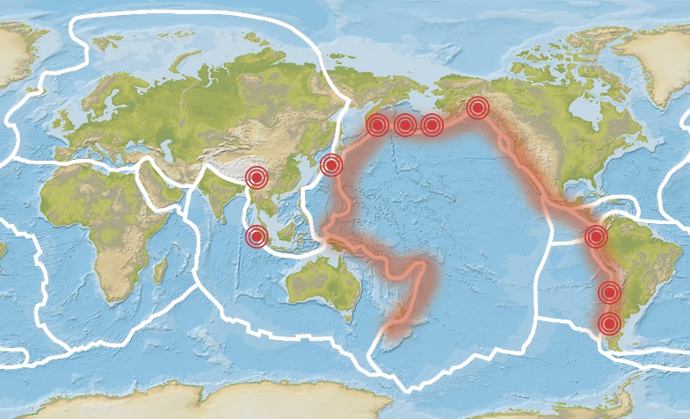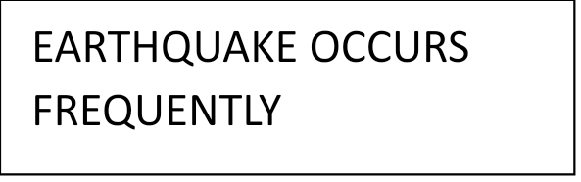

3. Splitting the dataset- According to the algorithm we using let’s split up the data and analysis.

Example: input be (timestamp, latitude, longitude) and the output be (magnitude and depth). Now according to this data, we search the place of earthquake occurrence.

4. Neural Network- After the analysis of the above given data we need to connect to the neural network. Further the neural network analysis the loss and gain of the earthquake.

Final we can decide whether the earthquake occur or not. If occur what is the rate of loss will be trained to the AI by, we trained by the Kaggle dataset.

**FLOW CHART:**

