**EXPERIMENT:23**: **Date:19.03.24**

**Aim:** To Demonstrate Infrastructure as a Service (IaaS) by establishing the remote connection, launch the created VM image and run in your desktop.

**Implementation:**

STEP:1: AFTER,THE COMPLETION OF THE VIRTUAL MACHINE DEPLOYMENT.

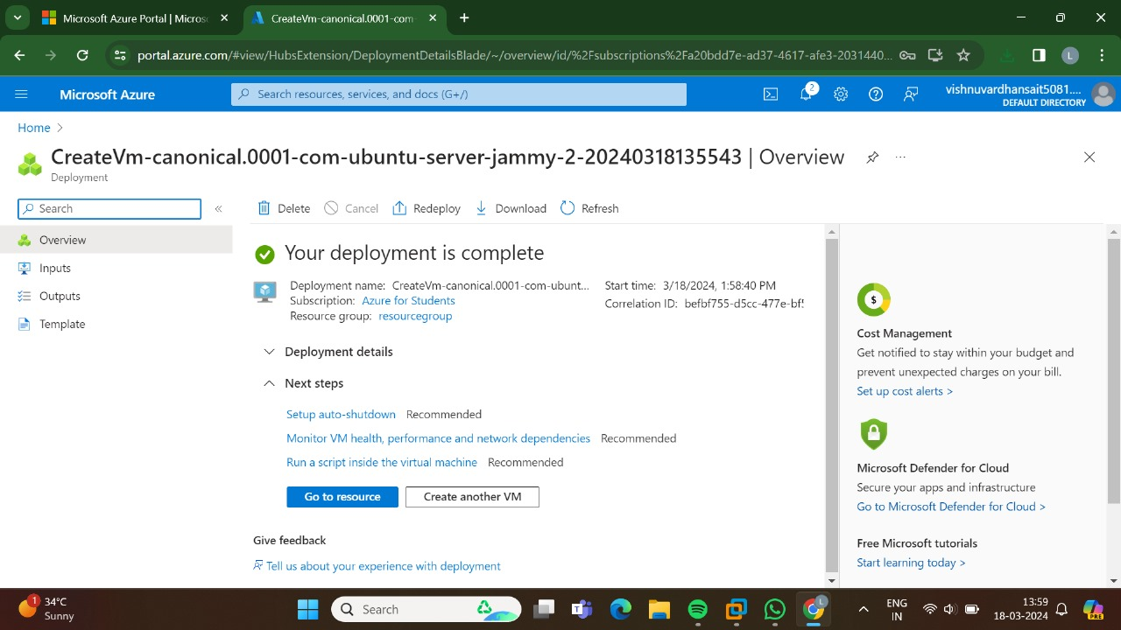

STEP:2:: GO TO THE CONNECT.

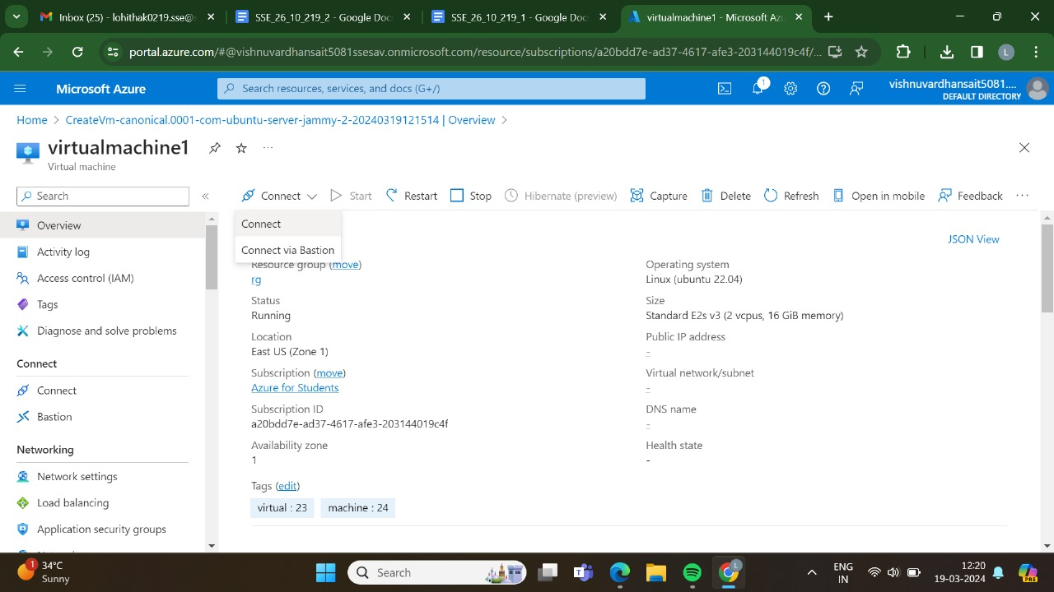

STEP:3:AND ,SWITCH ON TO THAT IP ADDRESS.

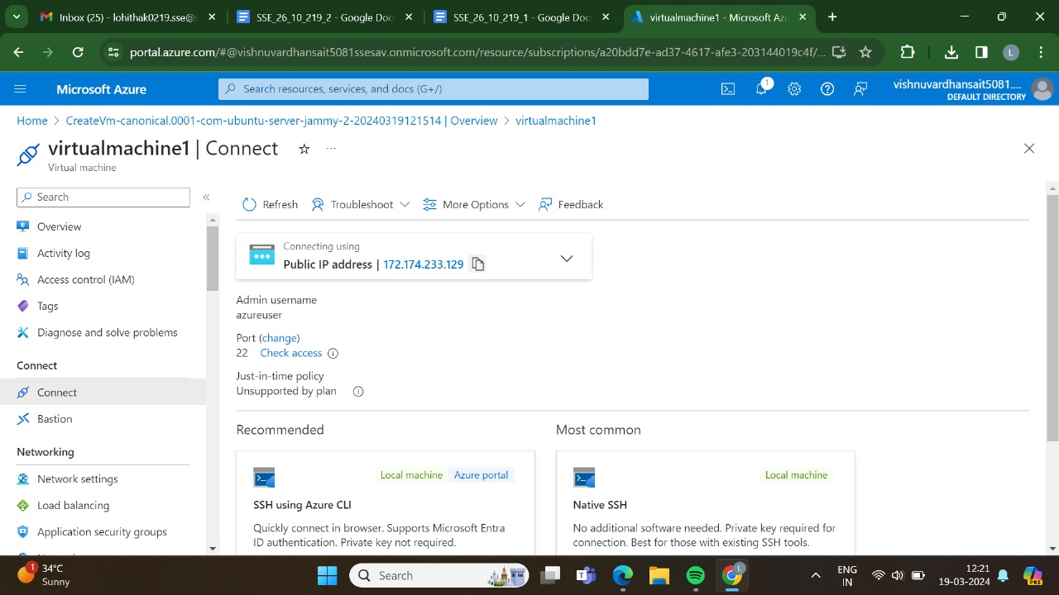

STEP:4:GO,TO THE RECOMMENDED SSH USING AZURE CLI.

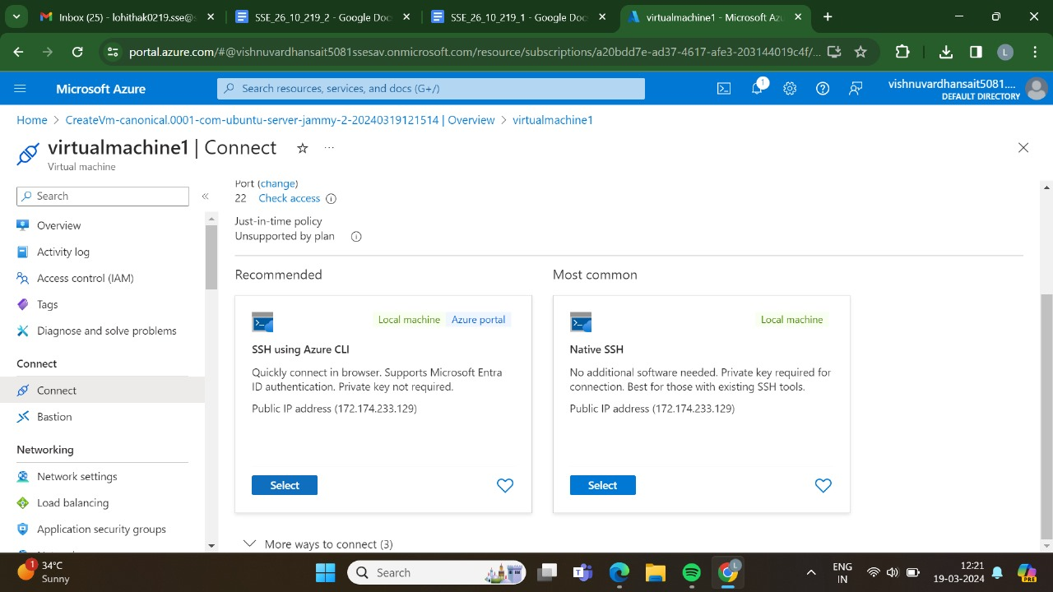

STEP:5:AFTER THET TICK THAT BOX AND GO TO CONGIGURE+CONNECT.

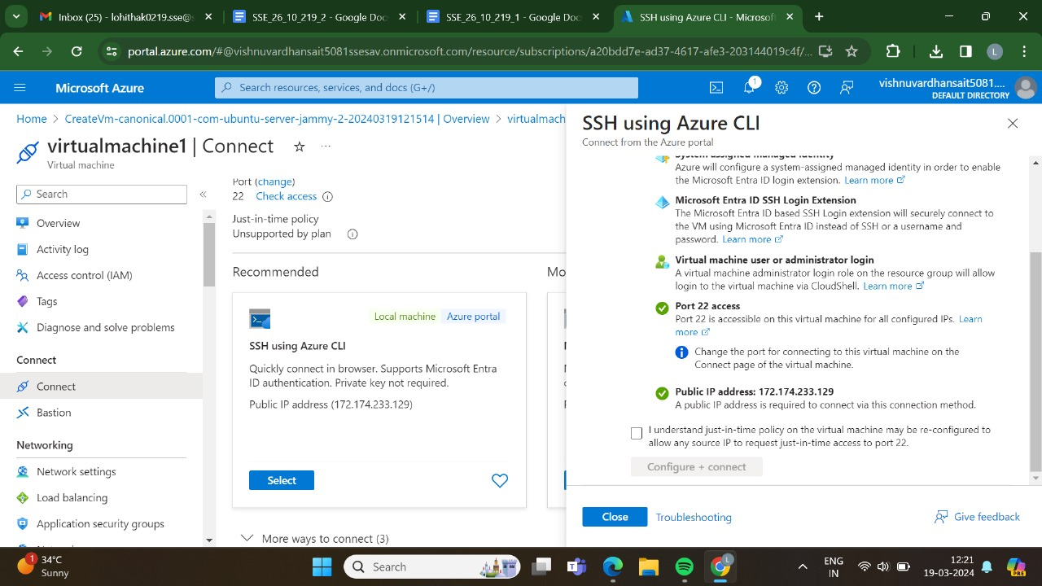

STEP:6:AND ,AT LAST WE THE OUTPUT IS VISIBLE.

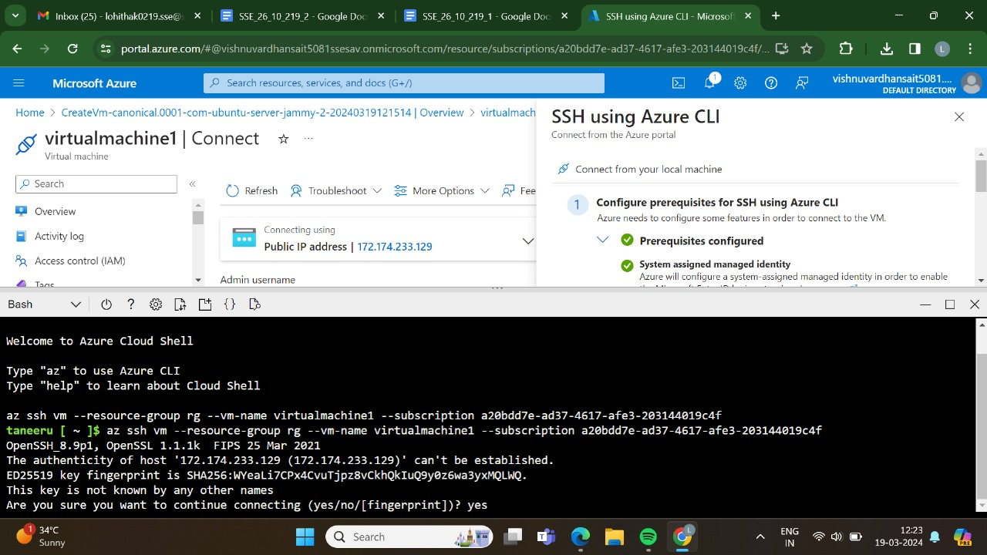

STEP:7:AND,THEN ENTER ALL THE COMMANDS.

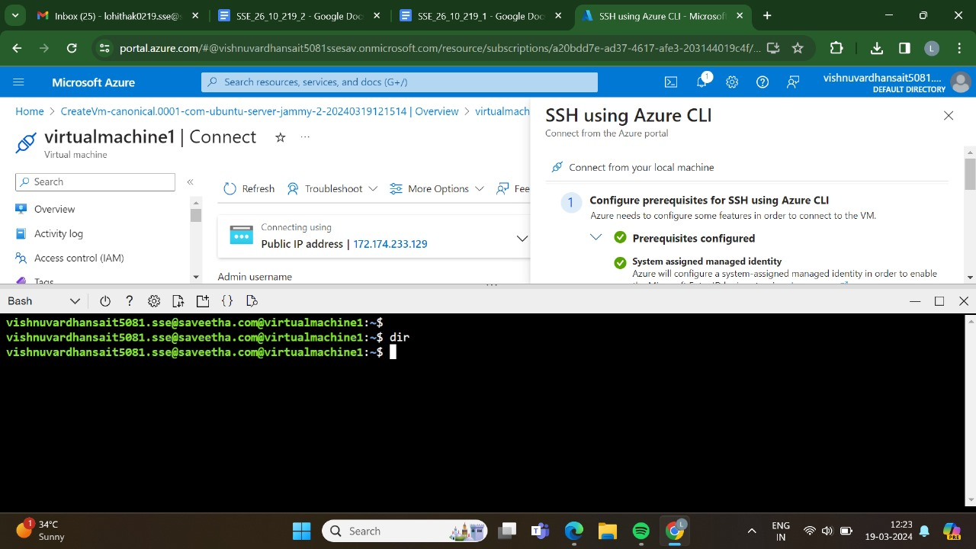

RESULT: THUS,THE PROGRAM FOR THE REMOTE CONNECTION HAS BEEN EXCEUTED SUCCESSFULLY.