1. Container With Most Water You are given an integer array height of length n. There are n vertical lines drawn such that the two endpoints of the ith line are (i, 0) and (i, height[i]). Find two lines that together with the x-axis form a container, such that the container contains the most water. Return the maximum amount of water a container can store. Notice that you may not slant the container.

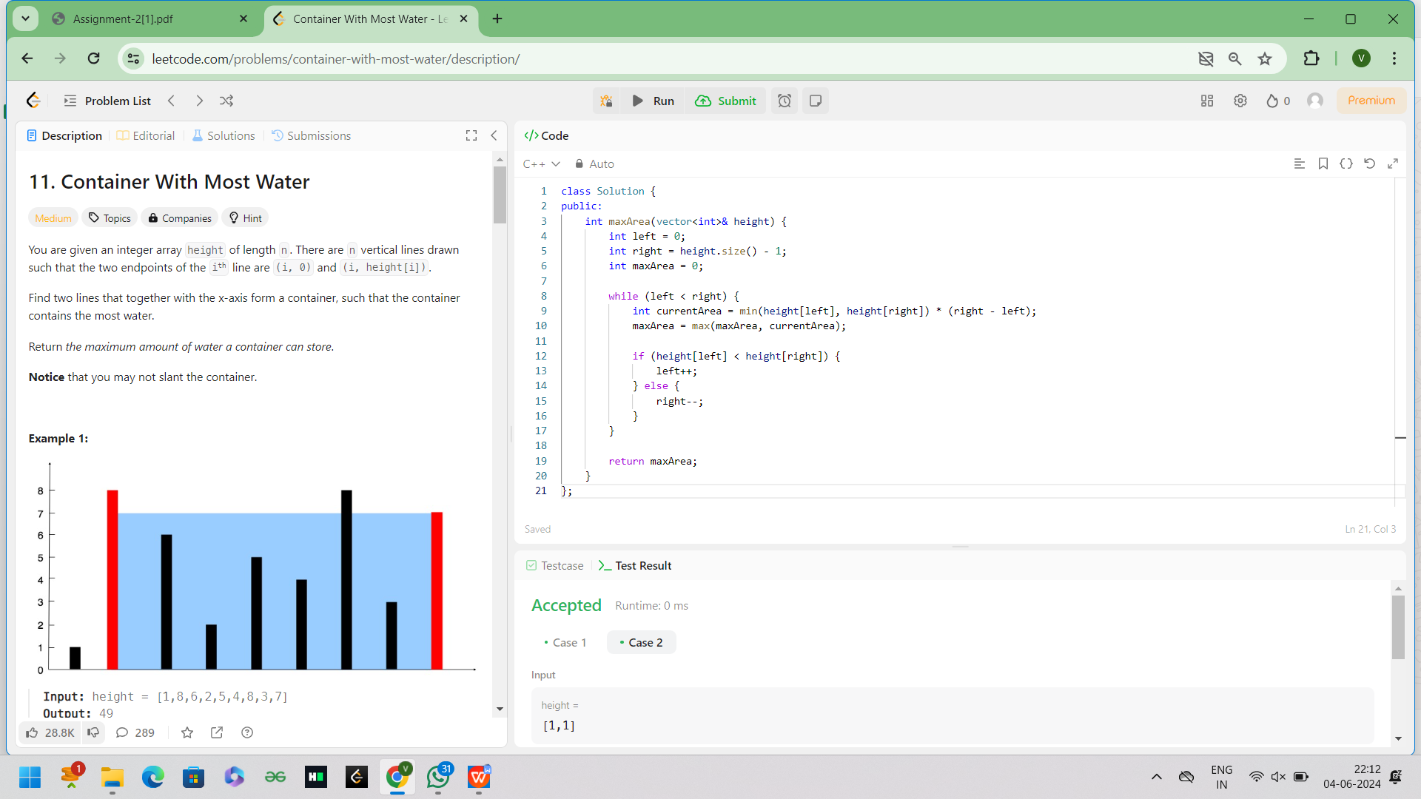

2.Integer to Roman Roman numerals are represented by seven different symbols: I, V, X, L, C, D and M

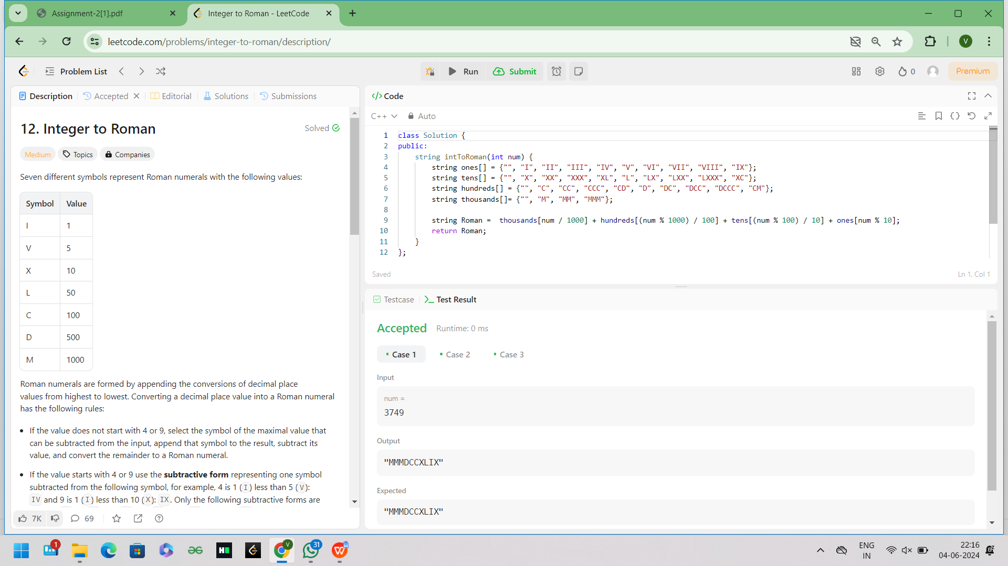

1. Roman to Integer Roman numerals are represented by seven different symbols: I, V, X, L, C, D and M

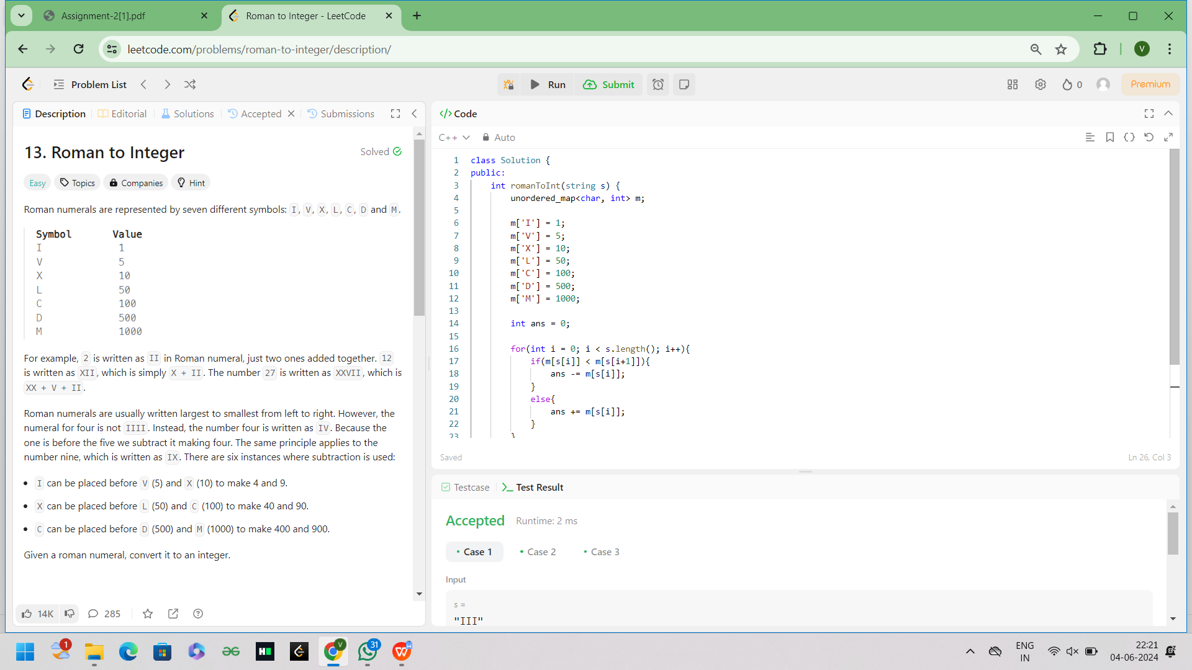

1. Longest Common Prefix Write a function to find the longest common prefix string amongst an array of strings. If there is no common prefix, return an empty string "".

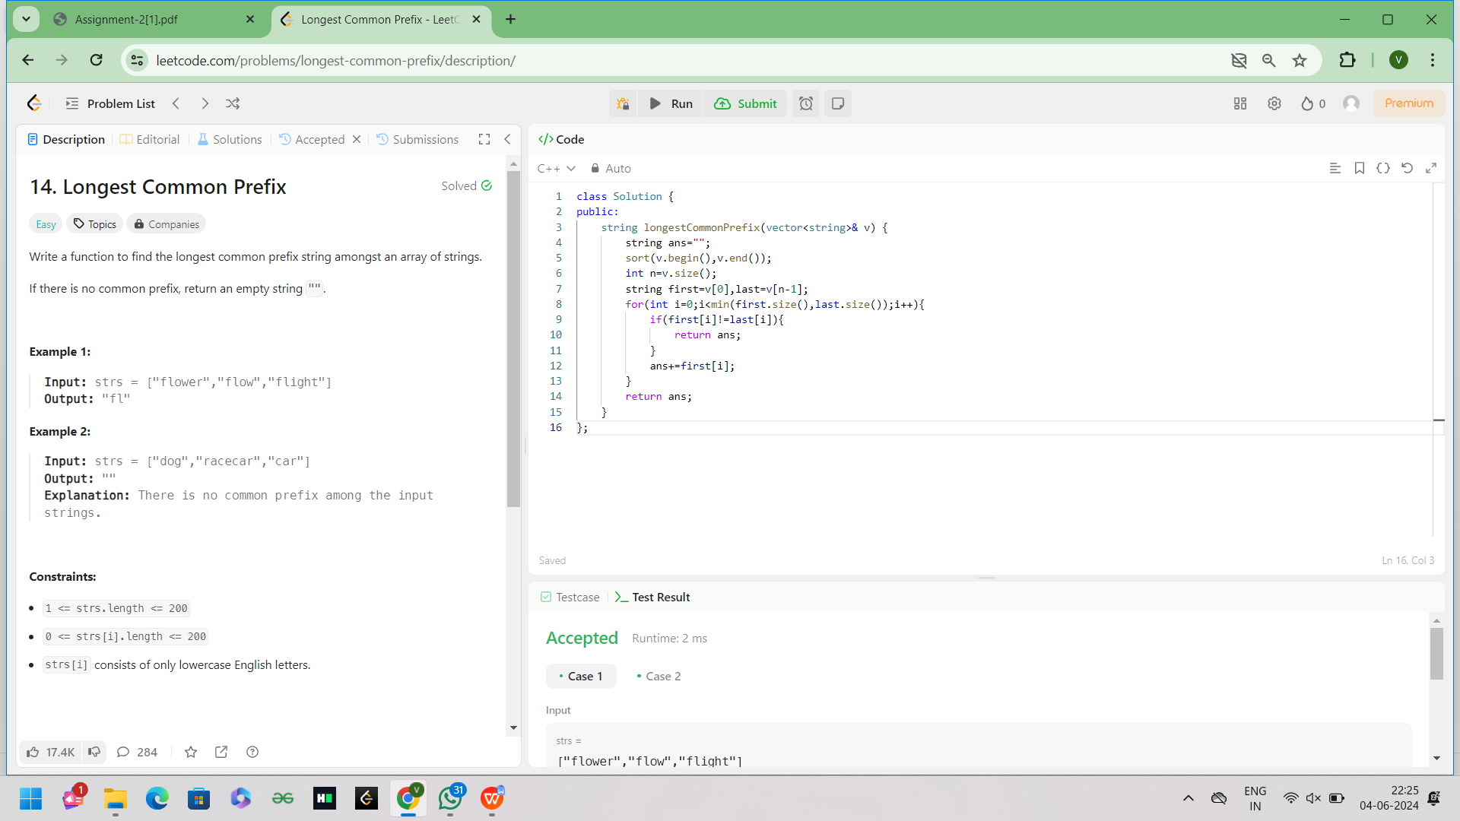

5.3Sum Given an integer array nums, return all the triplets [nums[i], nums[j], nums[k]] such that i != j, i != k, and j != k, and nums[i] + nums[j] + nums[k] == 0. Notice that the solution set must not contain duplicate triplets.

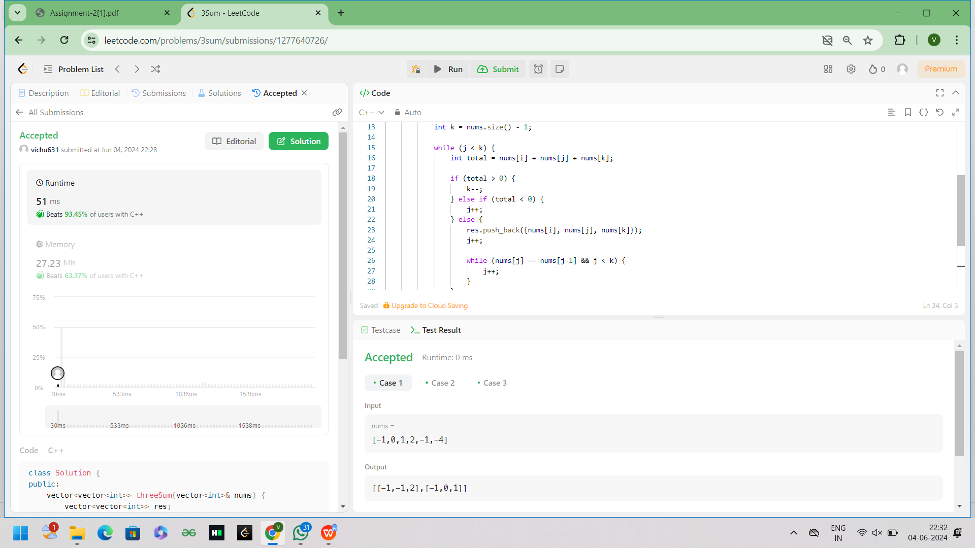

6.3Sum Closest Given an integer array nums of length n and an integer target, find three integers in nums such that the sum is closest to target. Return the sum of the three integers. You may assume that each input would have exactly one solution.

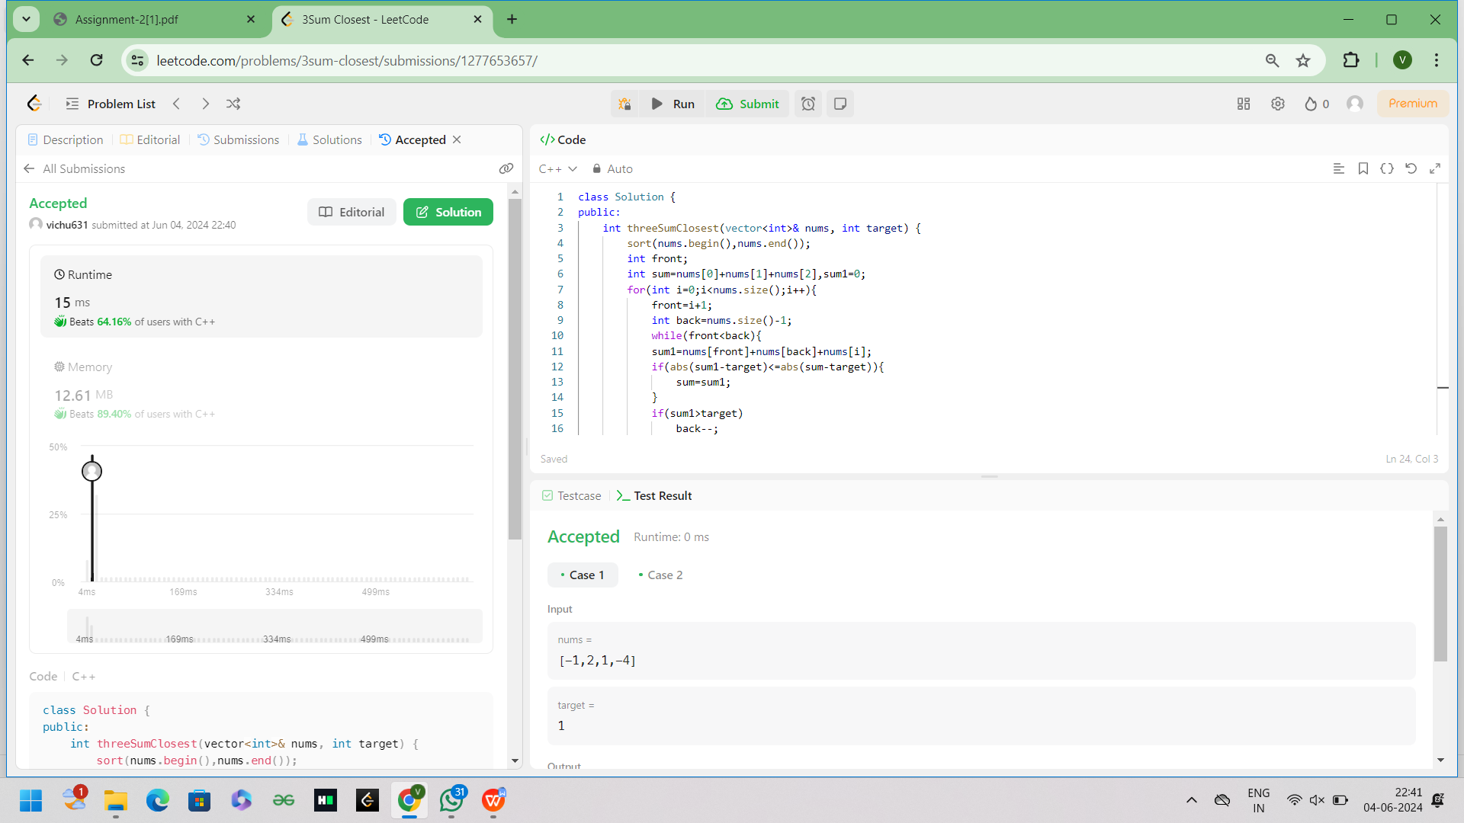

1. Letter Combinations of a Phone Number Given a string containing digits from 2-9 inclusive, return all possible letter combinations that the number could represent. Return the answer in any order. A mapping of digits to letters (just like on the telephone buttons) is given below. Note that 1 does not map to any letters.

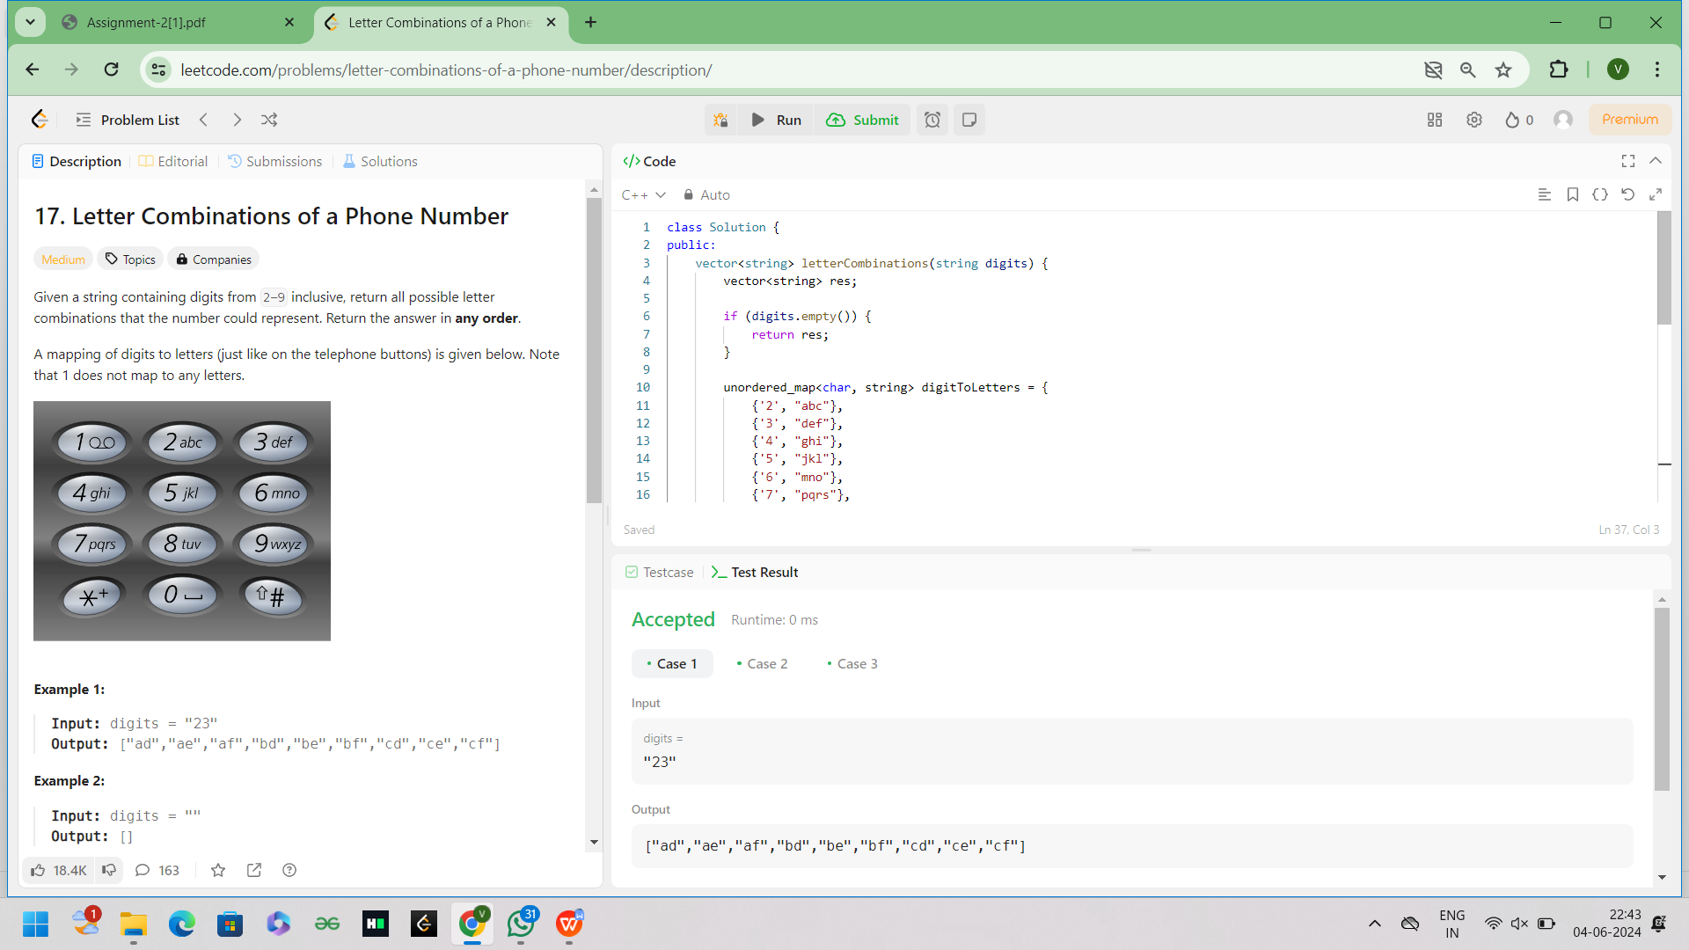

1. 4Sum Given an array nums of n integers, return an array of all the unique quadruplets [nums[a], nums[b], nums[c], nums[d]] such that: ● 0 <= a, b, c, d < n ● a, b, c, and d are distinct. ● nums[a] + nums[b] + nums[c] + nums[d] == target You may return the answer in any order.

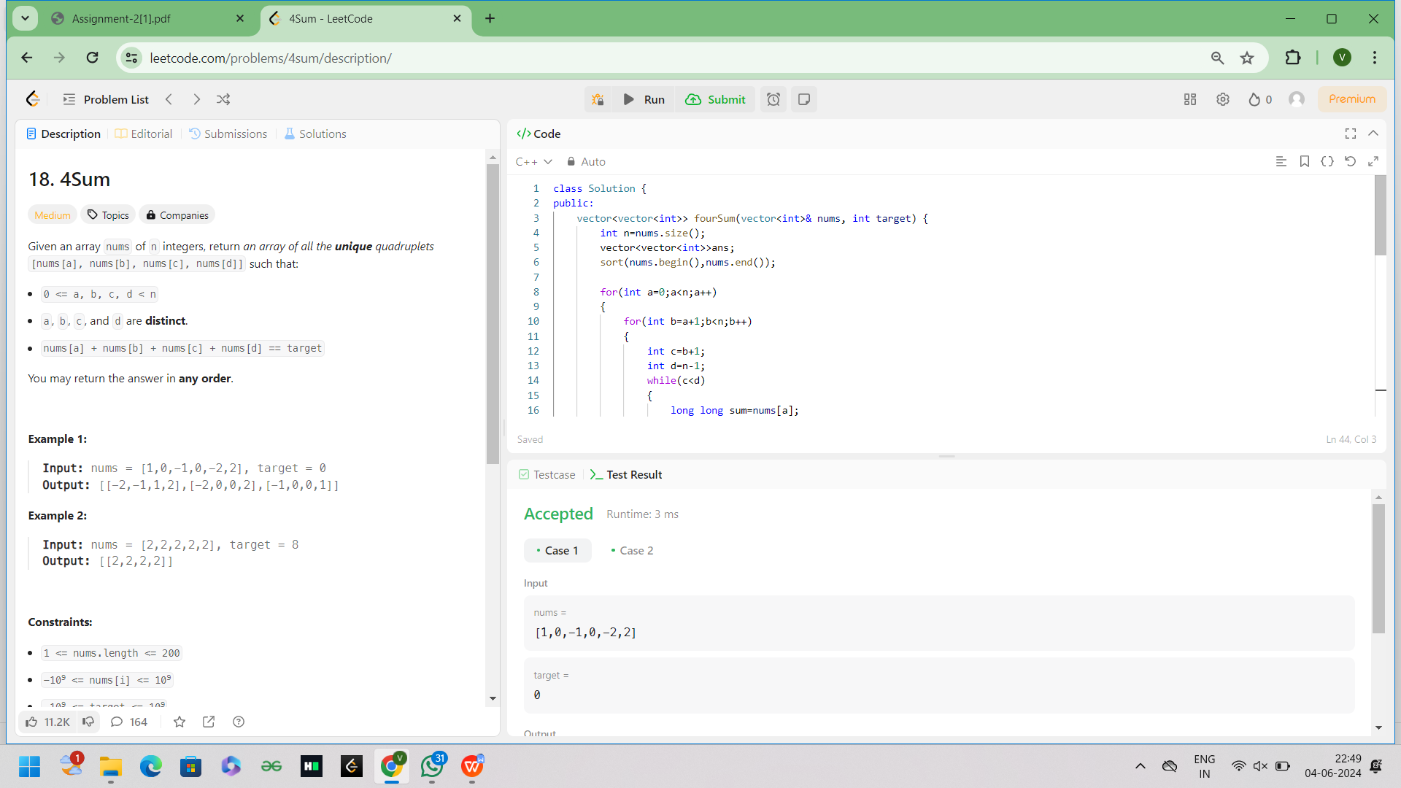

9.Remove Nth Node From End of List Given the head of a linked list, remove the nth node from the end of the list and return its head

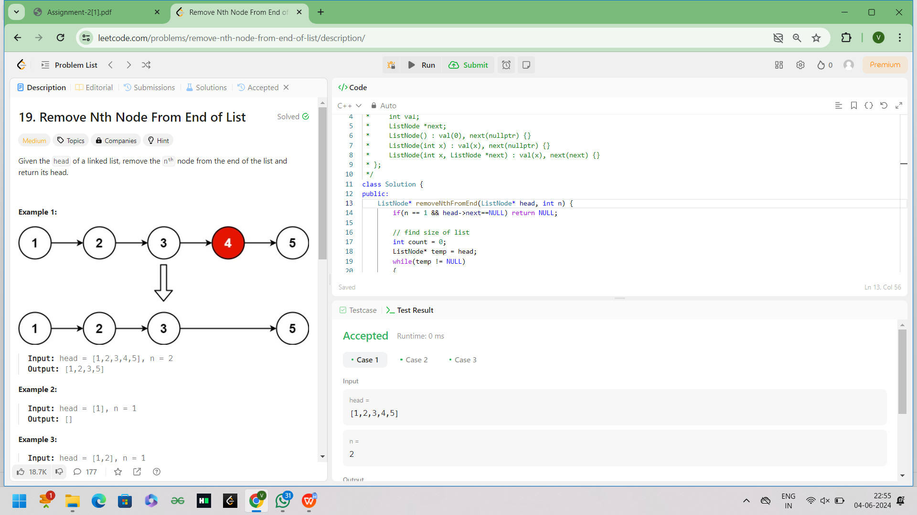

1. Valid Parentheses Given a string s containing just the characters '(', ')', '{', '}', '[' and ']', determine if the input string is valid. An input string is valid if: 1. Open brackets must be closed by the same type of brackets. 2. Open brackets must be closed in the correct order. 3. Every close bracket has a corresponding open bracket of the same type.

