**21) In Figma, design a mobile app interface that prioritizes user connectivity and convenience. Highlight key elements.**

**Aim:**

To design a mobile app interface that prioritizes user connectivity and convenience. Highlight key elements.

**Procedure:**

1. Create a file
2. Add The First Frame
3. Add Shapes
4. Add Text
5. Create The Second Frame
6. Add Prototyping

**Step By Step Procedure :**

**Interface Of Experiment**



**Menu Page:**

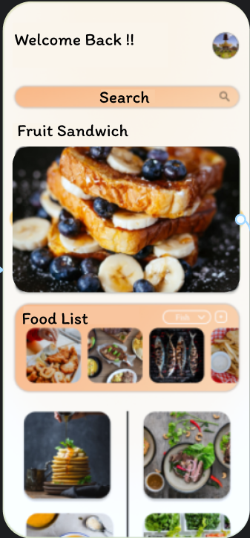

**Final Step:**

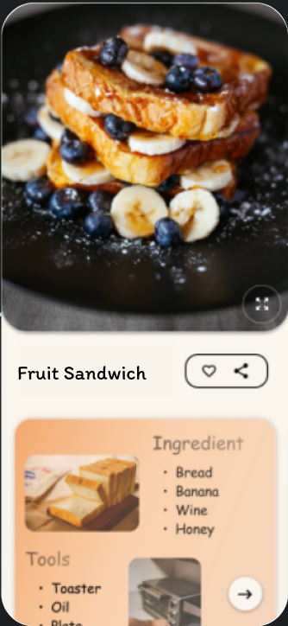

**Prototype:**

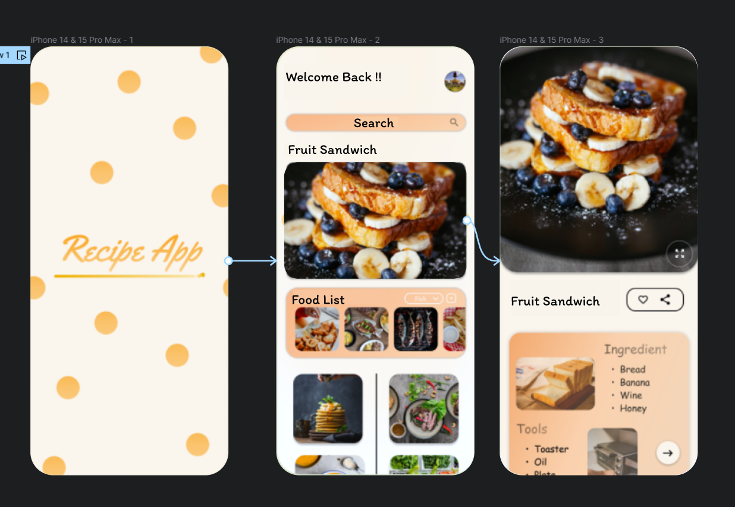

**Result:**

Hence the mobile app interface that prioritizes user connectivity created and executed successfully.