**PKF Machinery Finance**

**PKF** is one of the oldest and leading group of North India serving the Finance needs of its Customers since 1958."Funds taken from PKF are lucky for US", these are the words spoken by our customers. We offer Customized Term Loans to help SME's acquire machines & equipments for starting / expanding a business or industrial unit. Our dedicated relationship managers have a keen insight into your business so that they can identify your unique business requirements and thus offer you term loan product that suits your needs exactly. We offer SME/Machinery loans to improve your cash flows, conserve your cash reserves and maintain your Financial Fexibility.

**We provide loans for the following purposes :-**

* Purchase of New/Refurbished Machinery Finance.
* Re-finance on existing / used Machinery.

**Advantages**

* Lowest Interest Rate on Machinery Finance.
* Maximum Finance - Simple Documentation.
* No Hidden Cost.
* Personalized and Prompt Service
* Payment in 24 Hours - Quick Processing.
* Tailor Made Schemes.
* . Flexible loan structure, tenor, Ticket Size
* Loan ranging from 5 Lacs to 5 Crores
* Interest on Advance Installments.

Apply:

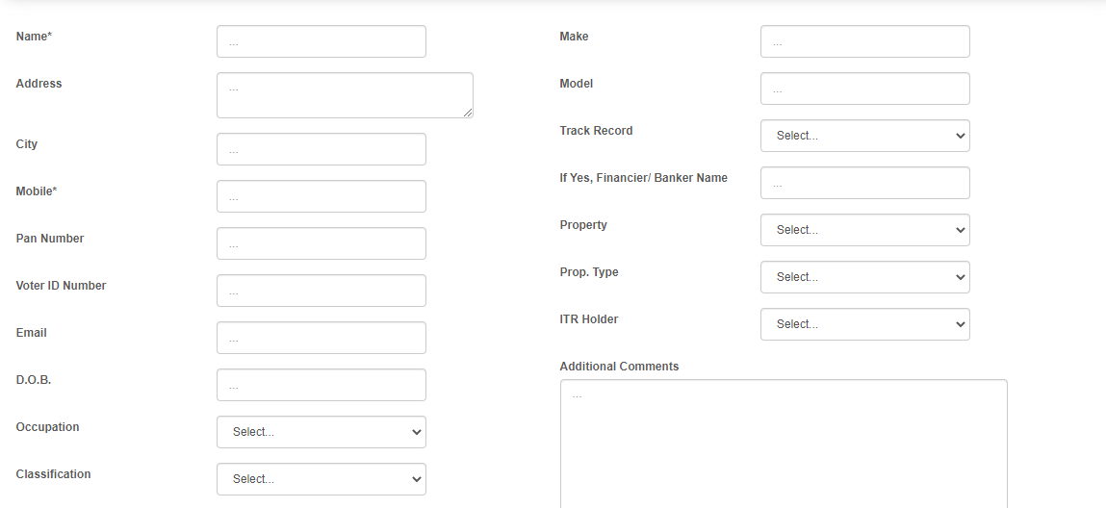

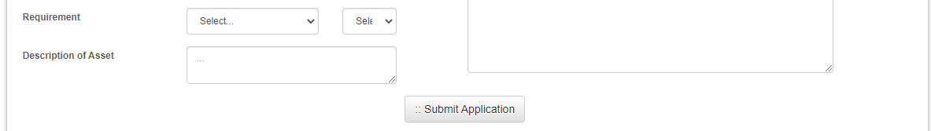

**Modules:**

1. **Application ID generation**

* This module will apply for the Machinery loan as displayed in above screenshot.
* After this one application is generated
* User can track loan with help of application number and date of birth.
* Upload the documents for process.
* Etc,

1. **Document collection and verify Module**
   1. He receives the application submitted by the Loan Representative Officer.
   2. Check the CIBIL status of application, according to the CIBIL report he decides to change status of CIBIL_STATUS as GOOD or LOW.
   3. Documents are get verified, those who’s CIBIL status is GOOD.
   4. Resend the documents if any document is not get verified or fails in verification.

If all documents are get verified and OK then mark the status of the application as APPROVED_BY_DV

1. **Sanctioning and billing module**
   1. Fetch only those applications whose status is APPROVED_BY_DV.
   2. Generate a sanction letter of the applications
   3. Re-verify the documents needed for the loan sanctioning.
   4. If any correction are there, then sends this application to the Loan Representative to add some required information.
   5. Change the status of application to the APPROVED_BY_LS or PENDING_WITH_LS, NOT_APPROVED.

Those applications are not sanction or not gets passed those as mark status as NOT_APPROVED with reason.

f. Fetch only those records who’s status Is APPROVED_BY_LS

g. Check and verify the Bank detail and other important details for disbursing the loan.

1. Calculate and maintain the GST as well.
2. Check the amount we want disburse and the amount company gets sanctioned for the month.
3. If all OK then amount will directly disburse to customers account number.
4. Sends the sanctioning letter to customer.
5. **Administration Module**
   1. Fetch all the applications [loan sanctioned applications as well as loan not sanctioned pending applications as well ]
   2. Maintaining the Monthly, quarterly and Yearly sanctioning amount
   3. Maintaining the Monthly, quarterly and Yearly Application records.

Etc.