AI Usage DISCLOSURE FORM

1. Team Details
Team Name: Team Doomed
Project / Product Name: Lodestone - Semantic Code Retrieval for Evolving Codebases
Organization / Institution (if any): SRM Institute of Science and Technology, Kattankulathur
Submission Date: 30 September 2026

2. AI Usage Declaration
Did your team use any Artificial Intelligence (AI) in developing this project? Yes / No
Yes.

3. Purpose of AI Usage ( Brief Details)
Idea generation / brainstorming Yes - shortlisting embedding models and retrieval approaches before measuring them.
Code generation or assistance Yes - most source files were drafted by Claude Code from our specifications, then reviewed.
UI / UX design Yes - the frontend layout was drafted from our list of required controls.
Content creation Yes - README, reports and slides drafted, then edited by us.
Data analysis No - every metric comes from running the evaluation code in the repo.
Testing / debugging Yes - test drafting. Expected values were checked against real output.
Other -

4. Feature Origin Classification ( Please add/delete based on the number of the feature)
1. Feature Name ONNX encoder
Self-Generated/AI-Generated/Both Both
Description Claude Code. Prompt: a CPU-only encoder for gte-modernbert-base, fp32 ONNX, CLS pooling, with a parity test against PyTorch. Output: embedding/onnx_encoder.py. Modification: we found it loading fp16 weights on CPU, which made the parity test report cosine above 1.0, and forced float32.

2. Feature Name Chunking
Self-Generated/AI-Generated/Both Both
Description Claude Code. Prompt: line-aligned windows under 1,024 tokens, 128-token overlap, and a header carrying the file path and enclosing class or function. Output: chunking/. Modification: the header and the line-alignment rule were our design. AST chunking measured as a tie, so it is opt-in.

3. Feature Name Index storage and incremental re-indexing
Self-Generated/AI-Generated/Both Both
Description Claude Code. Prompt: per-file content hashes, atomic saves, and an encoder fingerprint the index checks on load. Output: index/. Modification: we traced a checksum failure to Git's core.autocrlf rewriting line endings and added .gitattributes.

4. Feature Name Retrieval and ranking
Self-Generated/AI-Generated/Both Both
Description Claude Code. Output: retrieval/. Modification: down-weighting docs and tests was our diagnosis after inspecting failures on a question set we wrote first. Top-1 went from 5/10 to 8/10.

5. Feature Name Versioned indexing
Self-Generated/AI-Generated/Both Both
Description Claude Code. Prompt: revisions keyed by path and content hash so an unchanged file is embedded once, results grouped by file, commits read through a detached git worktree. Output: index/versions.py, retrieval/versions.py.

6. Feature Name Web interface
Self-Generated/AI-Generated/Both Both
Description Claude Code. Prompt: our list of controls - index and version selectors, query box, top-k, code-only filter, latency, stale indicator, re-index button. Output: web/.

7. Feature Name Evaluation harness and reports
Self-Generated/AI-Generated/Both Both
Description Claude Code. Output: eval/ and reports/. Modification: we found MTEB encodes documents as (title + ' ' + text).strip(), which differed on 3,687 of 8,765 documents, and that duplicates need its tie-break on document id. Every score in the repo comes from running this code.

5. Ethical & Compliance Confirmation
AI usage complies with guidelines and policies. Yes
No proprietary or copyrighted data misused. I Agree

6. Declaration & Sign-Off
Name of Team Representative: Vishrut Goel
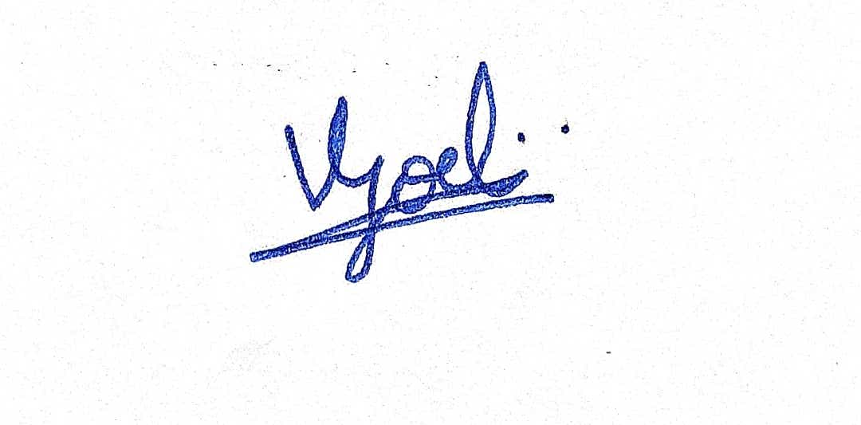
Role: Team Lead
Signature:
Date: 30 September 2026

