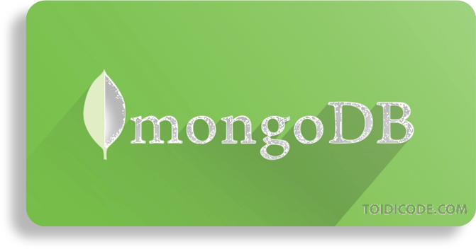

[This Photo](https://toidicode.com/xoa-du-lieu-trong-mongodb-292.html) by Unknown Author is licensed under [CC BY-NC-ND](https://creativecommons.org/licenses/by-nc-nd/3.0/)

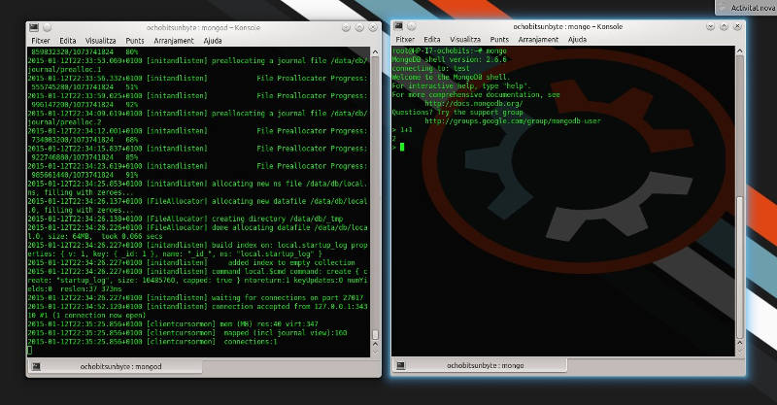

[This Photo](https://www.ochobitshacenunbyte.com/2015/01/12/mongodb-en-gnu-linux/) by Unknown Author is licensed under [CC BY-SA](https://creativecommons.org/licenses/by-sa/3.0/)

**INTRODUCTION**

* MongoDB **stores data in flexible, JSON-like documents**, meaning fields can vary from document to document and data structure can be changed over time
* The document model **maps to the objects in your application code**, making data easy to work with
* **Ad hoc queries, indexing, and real time aggregation** provide powerful ways to access and analyze your data
* MongoDB is a **distributed database at its core**, so high availability, horizontal scaling, and geographic distribution are built in and easy to use

MongoDB is **free to use**. Versions released prior to October 16, 2018 are published under the AGPL. All versions released after October 16, 2018, including patch fixes for prior versions, are published under the [Server Side Public License (SSPL) v1](https://www.mongodb.com/licensing/server-side-public-license)

**What is MongoDB – Working and Features**

MongoDB is an open-source document-oriented database that is designed to store a large scale of data and also allows you to work with that data very efficiently. It is categorized under the NoSQL (Not only SQL) database because the storage and retrieval of data in the MongoDB are not in the form of tables.

The MongoDB database is developed and managed by MongoDB.Inc under SSPL(Server Side Public License) and initially released in February 2009. It also provides official driver support for all the popular languages like C, C++, C#, and .Net, Go, Java, Node.js, Perl, PHP, Python, Motor, Ruby, Scala, Swift, Mongoid. So, that you can create an application using any of these languages. Nowadays there are so many companies that used MongoDB like Facebook, Nokia, eBay, Adobe, Google, etc. to store their large amount of data.

* **How mongoDB is different from RDBMS ?**   
  Some major differences in between MongoDB and the RDBMS are as follows:

|  |  |
| --- | --- |
| **MongoDB** | **RDBMS** |
| **It is a non-relational and document-oriented database.** | **It is a relational database.** |
| **It is suitable for hierarchical data storage.** | **It is not suitable for hierarchical data storage.** |
| **It has a dynamic schema.** | **It has a predefined schema.** |
| **It centers around the CAP theorem (Consistency, Availability, and Partition tolerance).** | **It centers around ACID properties (Atomicity, Consistency, Isolation, and Durability).** |
| **In terms of performance, it is much faster than RDBMS.** | **In terms of performance, it is slower than MongoDB.** |
|  |  |

**Advantages of MongoDB :** 

* It is a schema-less NoSQL database. You need not to design the schema of the database when you are working with MongoDB.
* It does not support join operation.
* It provides great flexibility to the fields in the documents.
* It contains heterogeneous data.
* It provides high performance, availability, scalability.
* It supports Geospatial efficiently.
* It is a document oriented database and the data is stored in BSON documents.
* It also supports multiple document ACID transition(string from MongoDB 4.0).
* It does not require any SQL injection.
* It is easily integrated with Big Data Hadoop

**Disadvantages of MongoDB :** 

* It uses high memory for data storage.
* You are not allowed to store more than 16MB data in the documents.
* The nesting of data in BSON is also limited you are not allowed to nest data more than 100 levels.

## Install MongoDB Community Edition

### Procedure

Follow these steps to install MongoDB Community Edition using the MongoDB Installer wizard. The installation process installs both the MongoDB binaries as well as the default [configuration file](https://www.mongodb.com/docs/manual/reference/configuration-options/" \l "std-label-configuration-options) <install directory>\bin\mongod.cfg.

**1**

#### Download the installer.

Download the MongoDB Community .msi installer from the following link:

➤ [MongoDB Download Center](https://www.mongodb.com/try/download/community?tck=docs_server)

1. In the **Version** dropdown, select the version of MongoDB to download.
2. In the **Platform** dropdown, select **Windows**.
3. In the **Package** dropdown, select **msi**.
4. Click **Download**.

**2**

#### Run the MongoDB installer.

For example, from the Windows Explorer/File Explorer:

1. Go to the directory where you downloaded the MongoDB installer (.msi file). By default, this is your Downloads directory.
2. Double-click the .msi file.

**3**

#### Follow the MongoDB Community Edition installation wizard.

The wizard steps you through the installation of MongoDB and MongoDB Compass.

1. **Choose Setup Type**

You can choose either the **Complete** (recommended for most users) or **Custom** setup type. The **Complete** setup option installs MongoDB and the MongoDB tools to the default location. The **Custom** setup option allows you to specify which executables are installed and where.

1. **Service Configuration**

Starting in MongoDB 4.0, you can set up MongoDB as a Windows service during the install or just install the binaries.

MongoDB Service

MongoDB

The following installs and configures MongoDB as a Windows service.

Starting in MongoDB 4.0, you can configure and start MongoDB as a Windows service during the install, and the MongoDB service is started upon successful installation.

* + Select **Install MongoD as a Service** MongoDB as a service.
  + Select either:
    - **Run the service as Network Service user** (Default)

This is a Windows user account that is built-in to Windows

**or**

* + - **Run the service as a local or domain user**
      * For an existing local user account, specify a period (i.e. .) for the **Account Domain** and specify the **Account Name** and the **Account Password** for the user.
      * For an existing domain user, specify the **Account Domain**, the **Account Name** and the **Account Password** for that user.
  + **Service Name**. Specify the service name. Default name is MongoDB. If you already have a service with the specified name, you must choose another name.
  + **Data Directory**. Specify the data directory, which corresponds to the [--dbpath](https://www.mongodb.com/docs/manual/reference/program/mongod/" \l "std-option-mongod.--dbpath). If the directory does not exist, the installer will create the directory and sets the directory access to the service user.
  + **Log Directory**. Specify the Log directory, which corresponds to the [--logpath](https://www.mongodb.com/docs/manual/reference/program/mongod/" \l "std-option-mongod.--logpath). If the directory does not exist, the installer will create the directory and sets the directory access to the service user.

1. **Install MongoDB Compass**

Optional. To have the wizard install [MongoDB Compass](https://www.mongodb.com/products/compass), select **Install MongoDB Compass** (Default).

1. When ready, click **Install**.

### Install mongosh

The .msi installer does not include [mongosh](https://www.mongodb.com/docs/mongodb-shell/). Follow the [mongosh installation instructions](https://www.mongodb.com/docs/mongodb-shell/install/) to download and install the shell separately.

### If You Installed MongoDB as a Windows Service

The MongoDB service starts upon successful installation.

If you would like to customize the service, you must [stop the service](https://www.mongodb.com/docs/manual/tutorial/install-mongodb-on-windows/#std-label-stop-mongodb-community-edition-windows-service). Customize the MongoDB instance by editing the configuration file at <install directory>\bin\mongod.cfg.

For information about the available configuration options, refer to [Configuration File Options.](https://www.mongodb.com/docs/manual/reference/configuration-options/" \l "std-label-configuration-options)

After making changes, [start the service again.](https://www.mongodb.com/docs/manual/tutorial/install-mongodb-on-windows/#std-label-start-mongodb-community-edition-windows-service)

### If You Did Not Install MongoDB as a Windows Service

If you only installed the executables and did not install MongoDB as a Windows service, you must manually start the MongoDB instance.

See [Run MongoDB Community Edition from the Command Interpreter](https://www.mongodb.com/docs/manual/tutorial/install-mongodb-on-windows/#std-label-run-mongodb-from-cmd) for instructions to start a MongoDB instance.

## Run MongoDB Community Edition as a Windows Service

Starting in version 4.0, you can install and configure MongoDB as a **Windows Service** during installation. The MongoDB service starts upon successful installation. Configure the MongoDB instance with the configuration file <install directory>\bin\mongod.cfg.

If you have not already done so, follow the [mongosh installation instructions](https://www.mongodb.com/docs/mongodb-shell/install/) to download and install the MongoDB Shell ([mongosh](https://www.mongodb.com/docs/mongodb-shell/)).

Be sure to add the path to your mongosh.exe binary to your PATH environment variable during installation.

Open a new **Command Interpreter** and enter mongosh.exe to connect to MongoDB.

For more information on connecting to a [mongod](https://www.mongodb.com/docs/manual/reference/program/mongod/" \l "mongodb-binary-bin.mongod) using [mongosh.exe](https://www.mongodb.com/docs/mongodb-shell/), such as connecting to a MongoDB instance running on a different host and/or port, see [Connect to a Deployment.](https://www.mongodb.com/docs/mongodb-shell/connect/)

For information on CRUD (Create, Read, Update, Delete) operations, see:

Add, Update and Delete Data:

First step is we want to switch our database to the given collection by using command. “use db” Now the database is switched to db. To find whether the data present in the given collection, here the collection name is about the information of students. we can use the command “Show collections” In the above example the collection name is stud or stu.

To find the total number of collection of the database use the command. “db.stud.find().count()” It shows the total collections of students in the database.

To find the collection of the database use the command. “db.stud.find()” Collections: A collection is a group of documents. If a document is the MongoDB analog of a row in a relational database, then a collection can be thought of as the analog to a table.

Database: MongoDB groups collections into databases. A single instance of MongoDB can host several databases, each grouping together zero or more collections. WHERE AND OR & CRUD:

• WHERE: Given a collection you want to filter a subset based on a condition. That is the place WHERE is used. To find all students with GPA greater than 3.5, we use command- “db.stud.find({gpa:{$gt:3.5}});” Here $gt represent the greater than and it gives the information that are belongs to greater than 3.5 gpa.

• AND: Given a collection you want to filter a subset based on multiple conditions. To find all students who live in “City 5” AND have a based group of “A+” Here we use the command: Db.stud.find({ $and: [ {home_city : “City 5”}, {blood_group: “A+”} ] });

Above example is filtered based on some conditions like: ‘home_city: City5’ and ‘blood_group : A+’. OR: In the given collection that is student we want to filter a subset based on multiple conditions but any one is sufficient. In the above example , the stud database is filtered based on either ‘blood_group : A+’ or ‘gpa greater than 3.5’. ($gt: greater than).

• CURD: C-Create/Insert R-Remove U-Update D-Delete This is applicable for a collection or a document.

• Insert: To insert the data into collection we use the following command

: Const studentData={ “name”: “Jam”, “age”:12,, “courses”:[“CS”, “MATHS”, “KANNADA”], “gpa”:3.2, “home_city”: “City 4”, “blood_group”: “AB+”, “is_hotel_resident”:true } I.

n the above example we are inserting the student details name ‘Jam’ and other information to The collection of database called studentData.

• Update: Here we can update any data that are present in the collections. To update we use ‘$set’ command.

• Delete: The delete operation is used to delete the data present in the given collection.

• Projection: This is used when we don’t need all columns or attributes. In the above example it shows only the name and gpa, because the command is given as ‘name:1’ and ‘gpa:1’.

