**Task:1**

1. **Task Description**

Convert between currencies using real-time exchange rates.

1. **Task Output Screenshot**

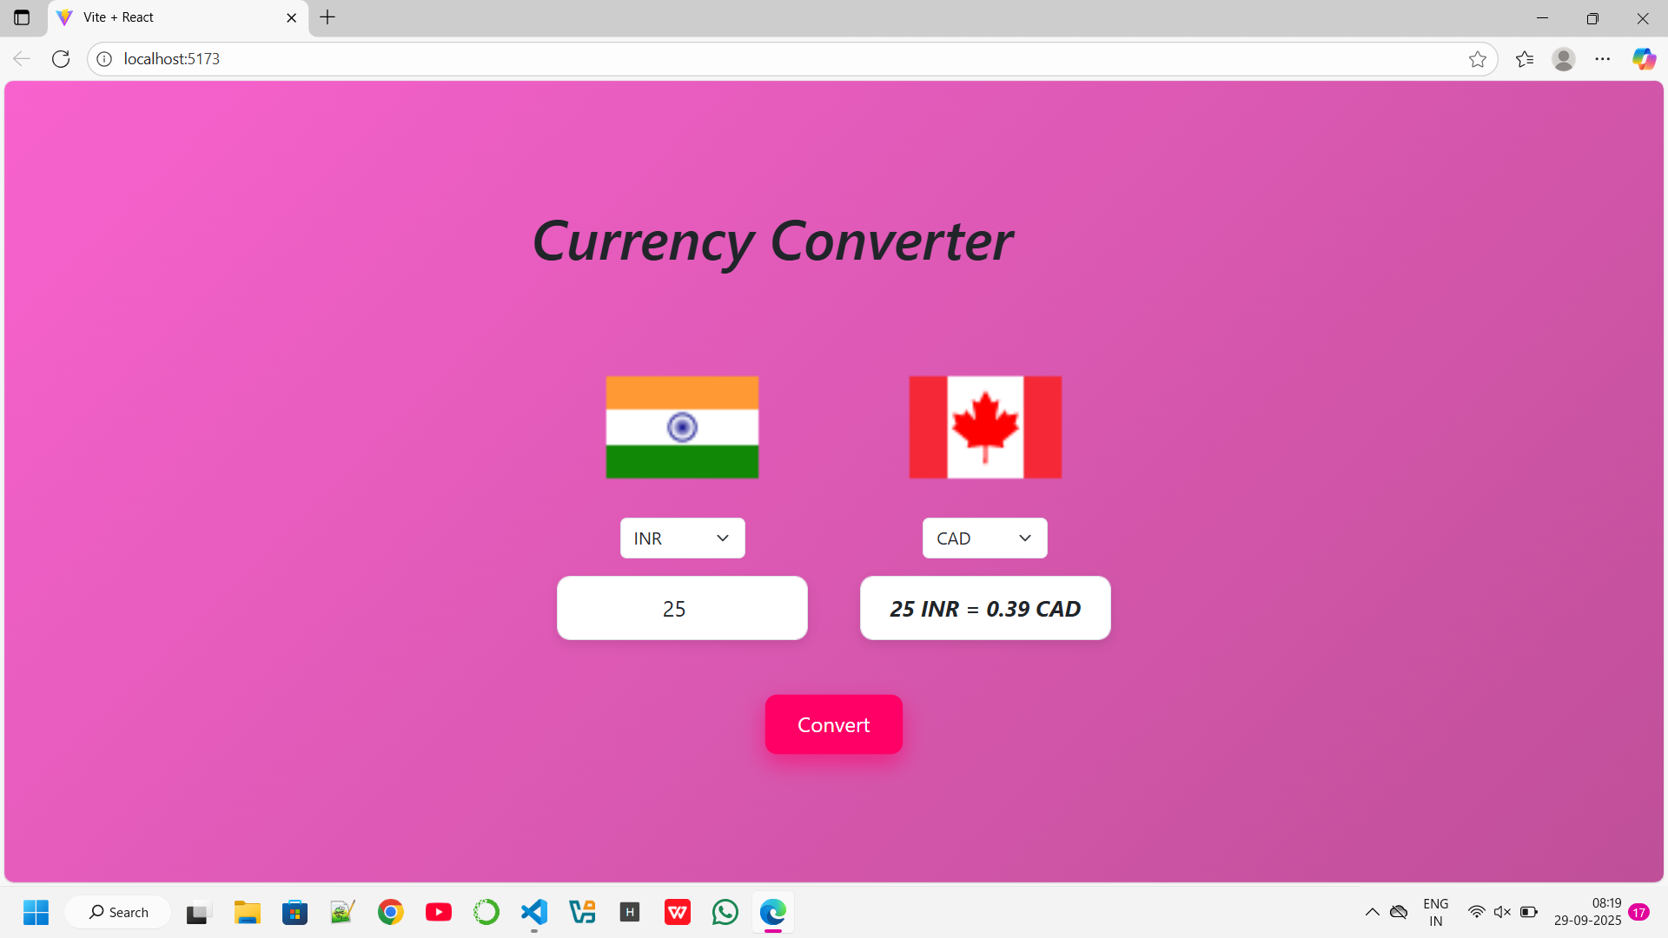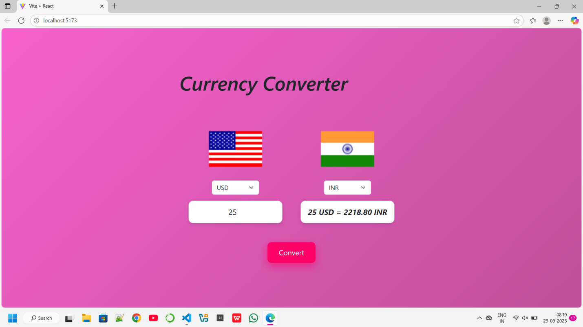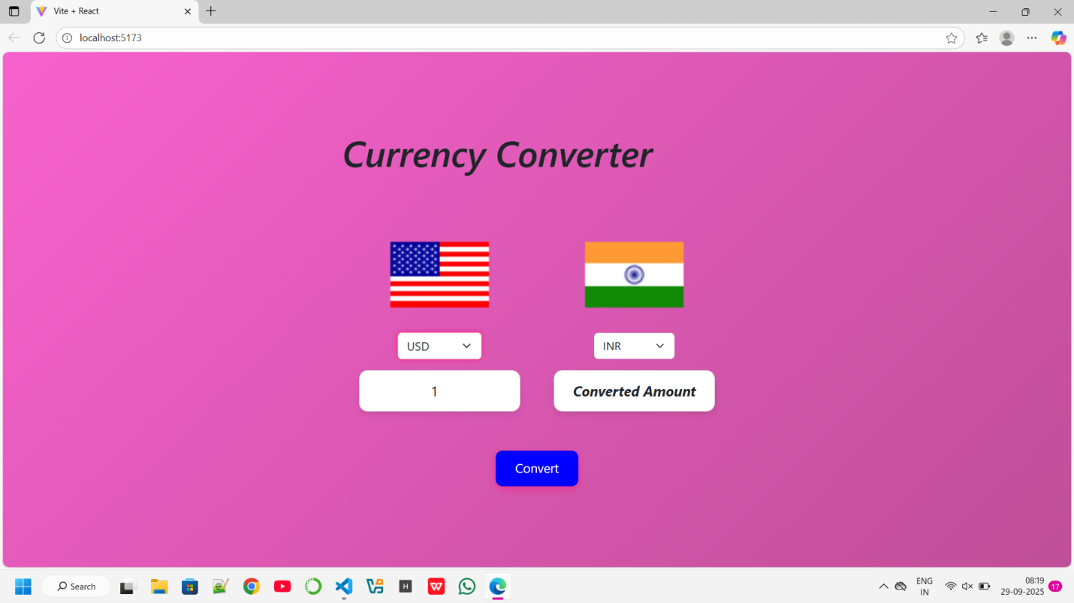

1. **Widget/Algorithm Used In Task**

**Algorithm:** Convert via a common base currency (rates fetched from the API). Conversion formula: amount * (rate_to / rate_from).

**Widget:** Simple controlled inputs: number input + two selects.