**Task:2**

1. **Task Description**

Get a random quote from an API, then store that quote as a new post in your backend.

1. **Task Output Screenshot**

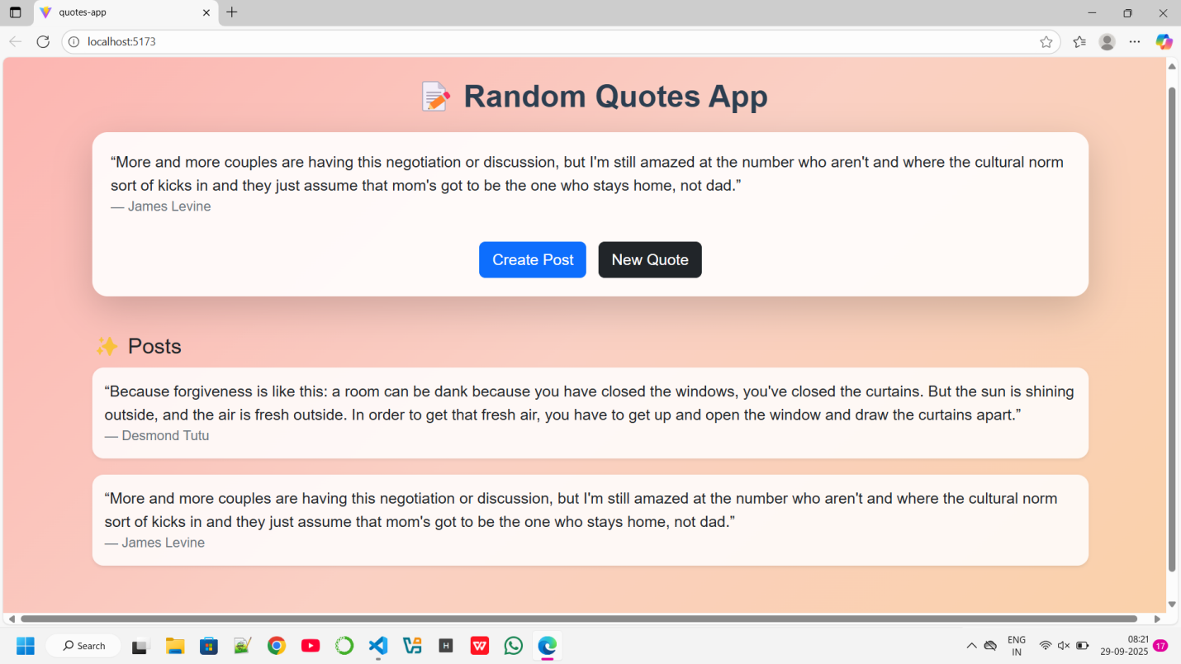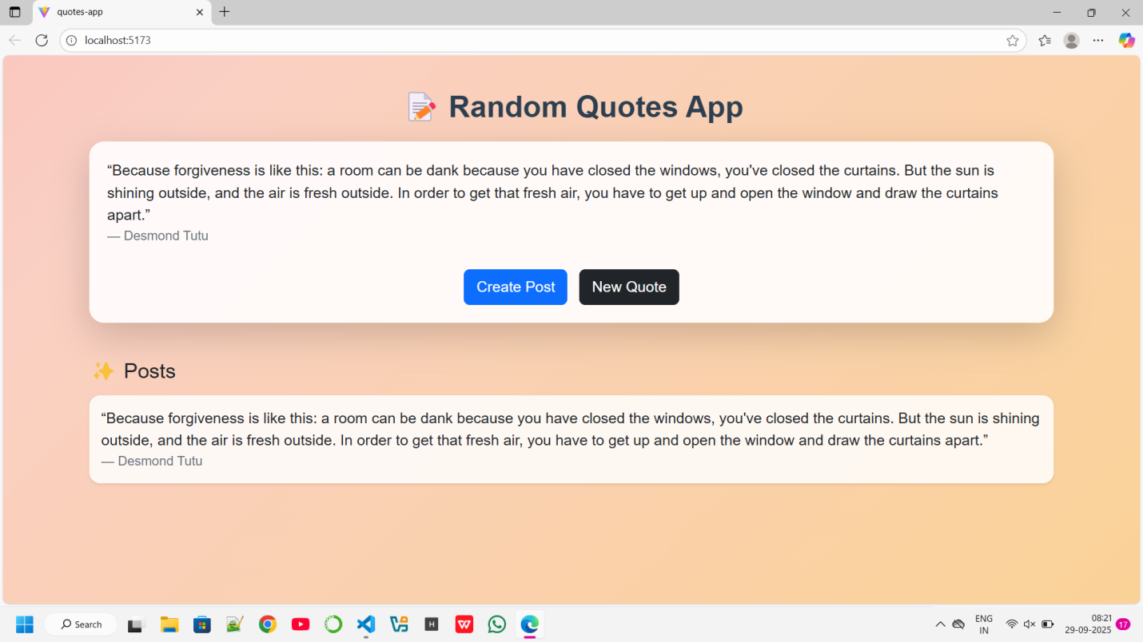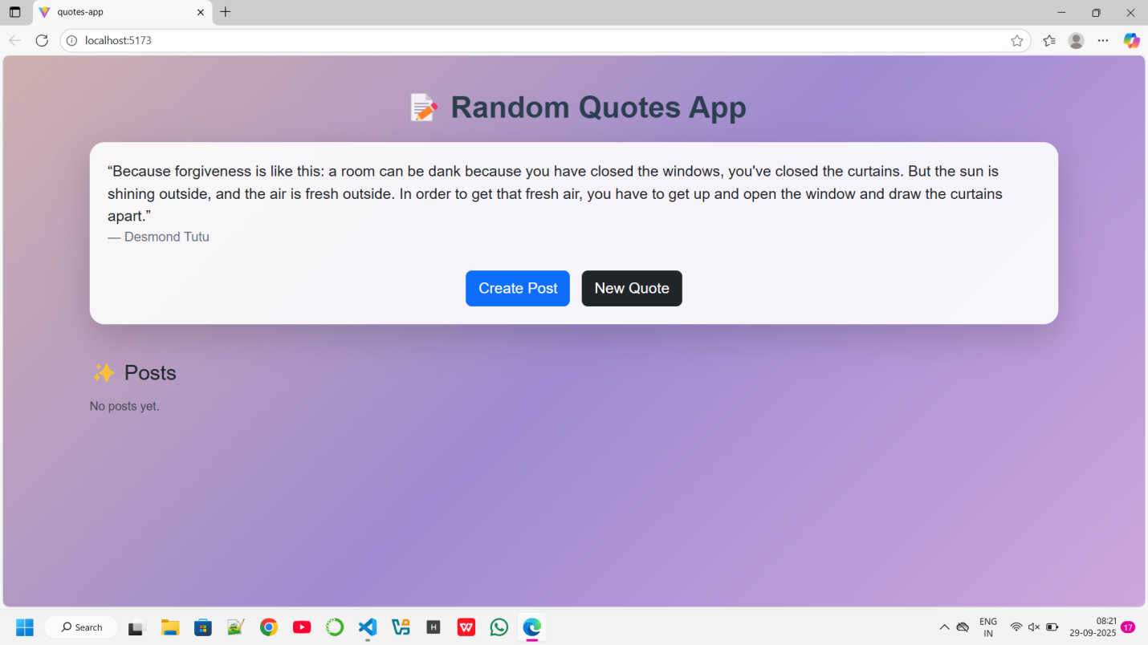

1. **Widget/Algorithm Used In Task**

· **Widget:** Fetch button, display blockquote, and a "Create Post" button.

· **Algorithm:** Fetch JSON from https://api.quotable.io/random, map fields into post schema, POST to server.