**Task:3**

1. **Task Description**

Todo list with add, remove, mark complete using Redux.

1. **Task Output Screenshot**

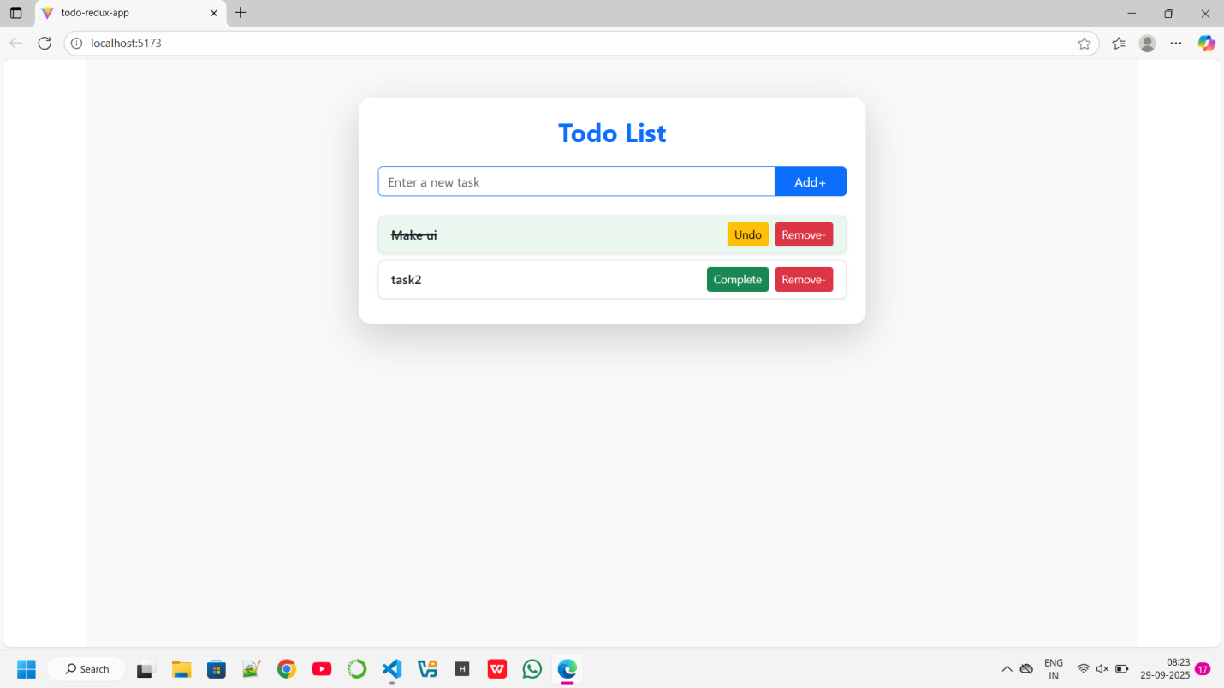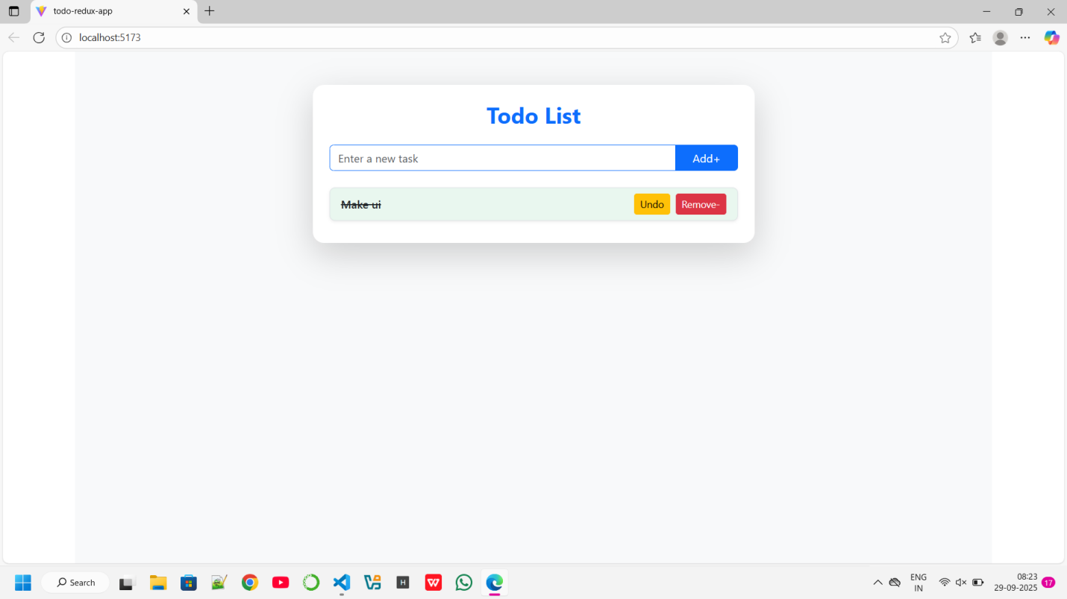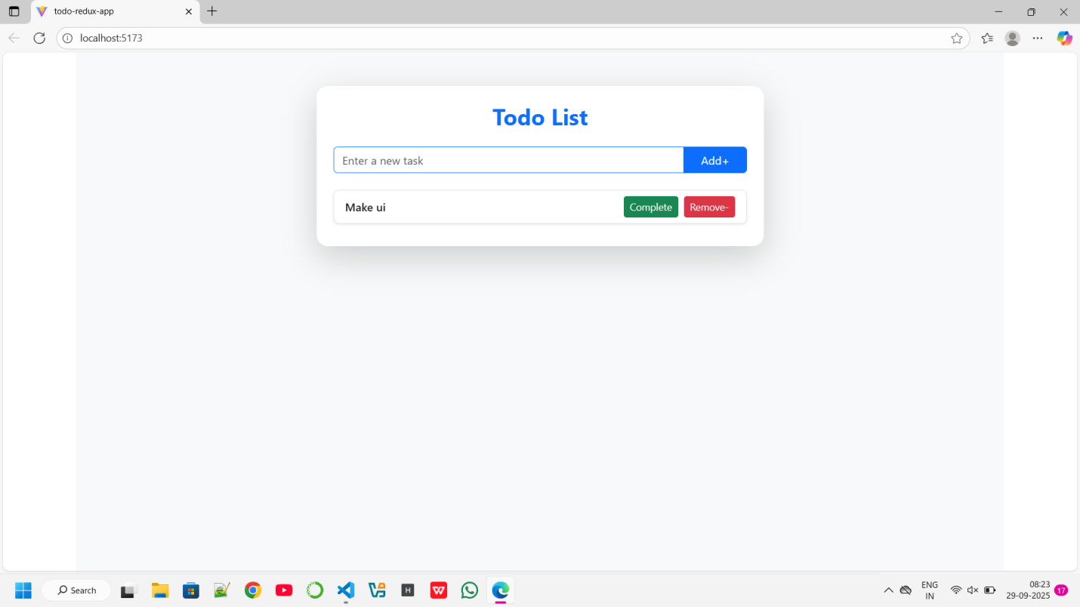

1. **Widget/Algorithm Used In Task**

· **Widget:** Form input + list with checkbox and delete button.

· **Algorithm:** Immutable state changes handled by Redux Toolkit reducers. nanoid() generates unique IDs.