**Task:5**

1. **Task Description**

Create a reusable input component using react-hook-form with validations.

1. **Task Output Screenshot**

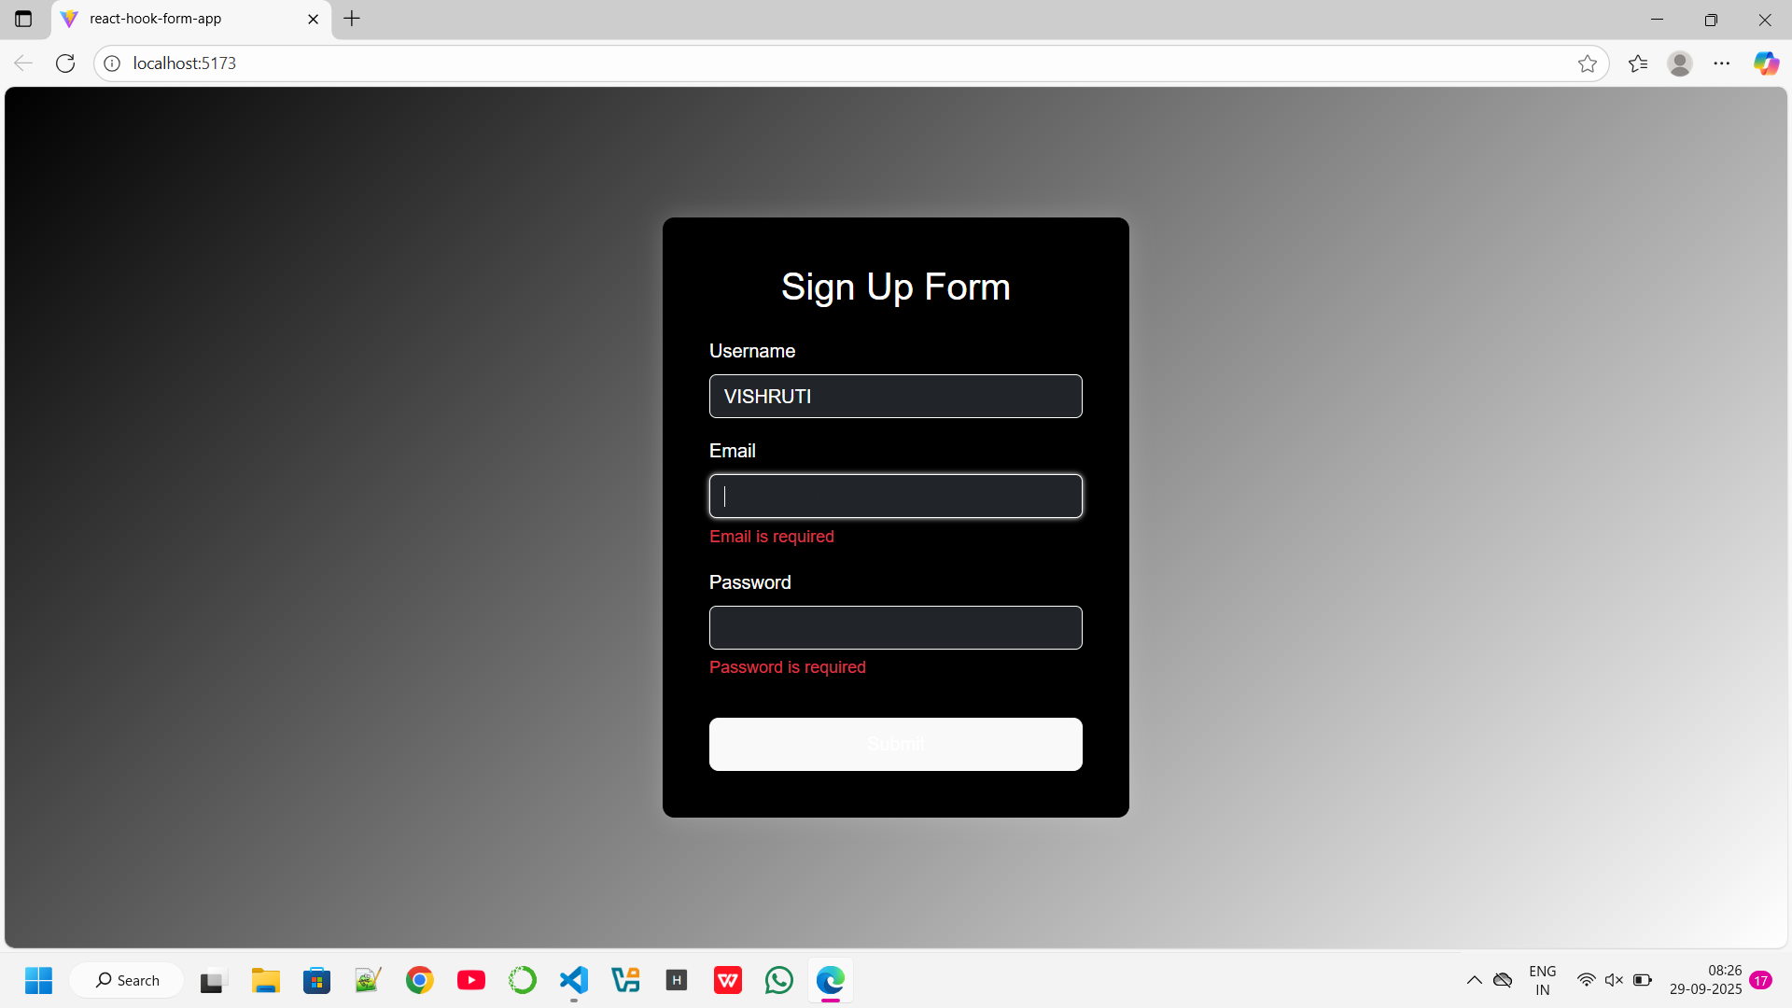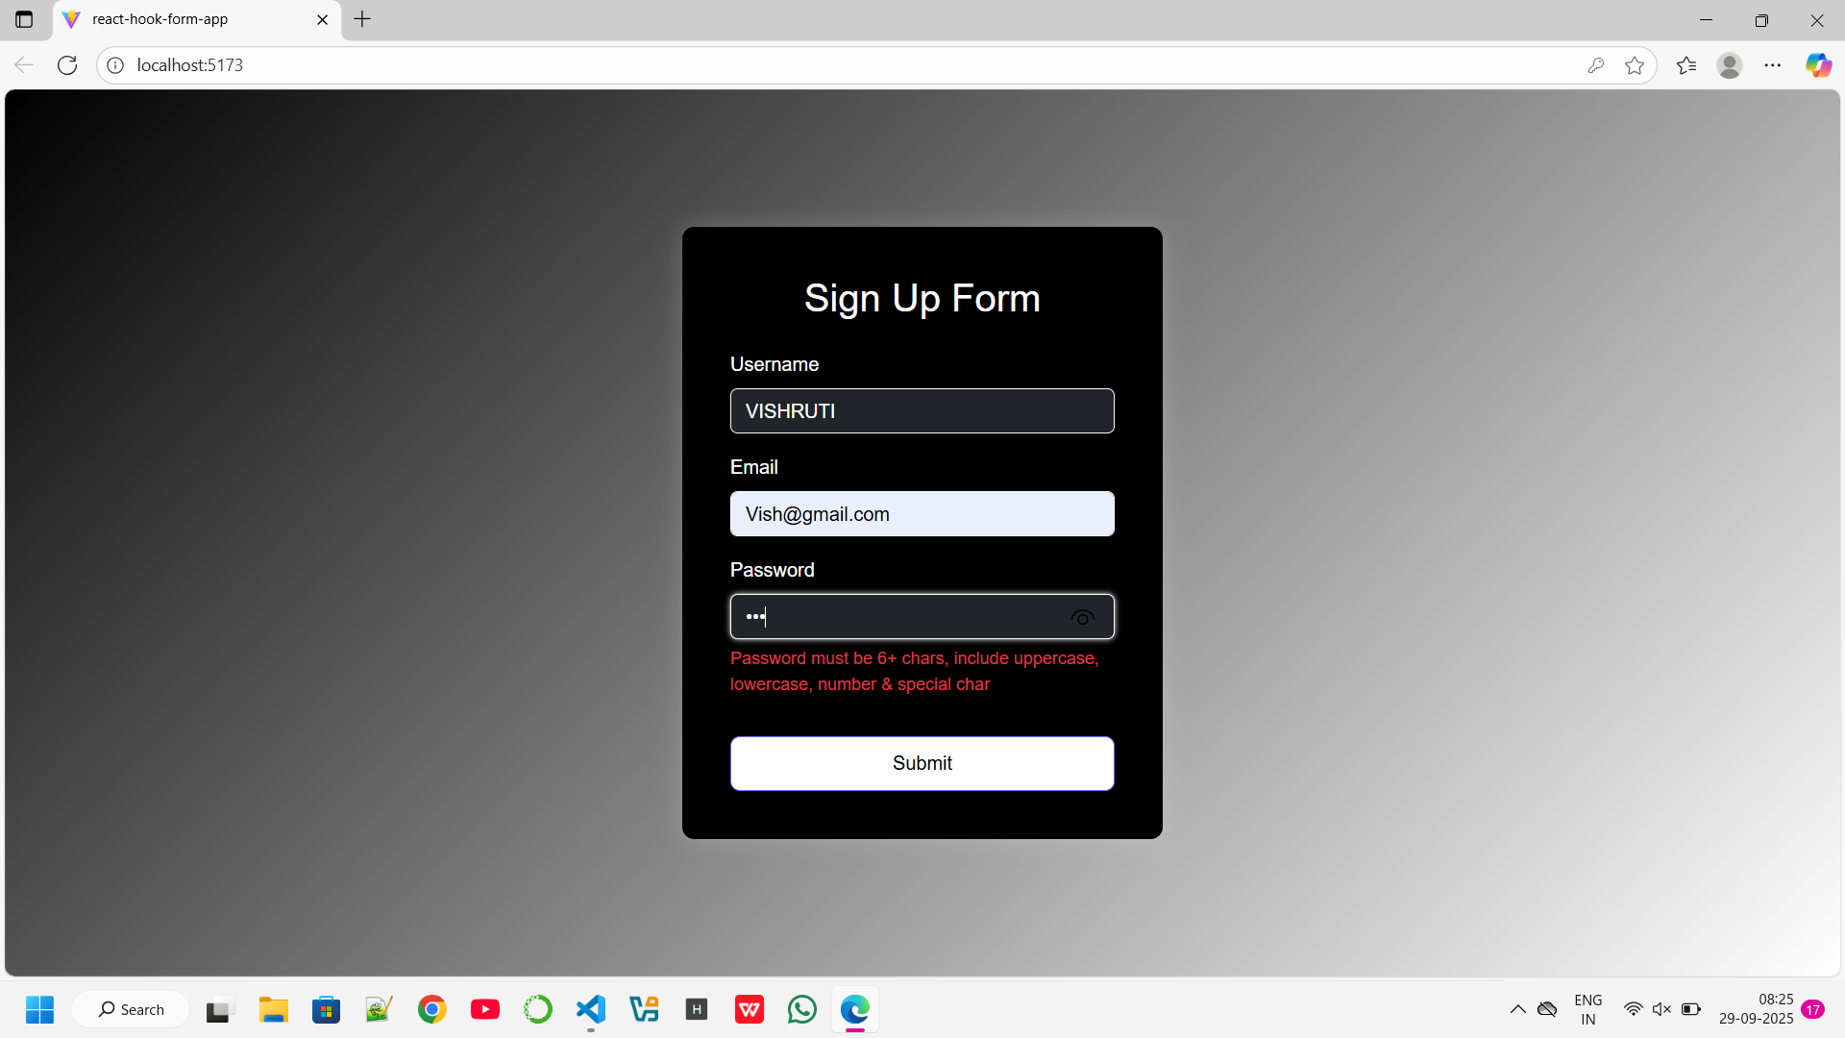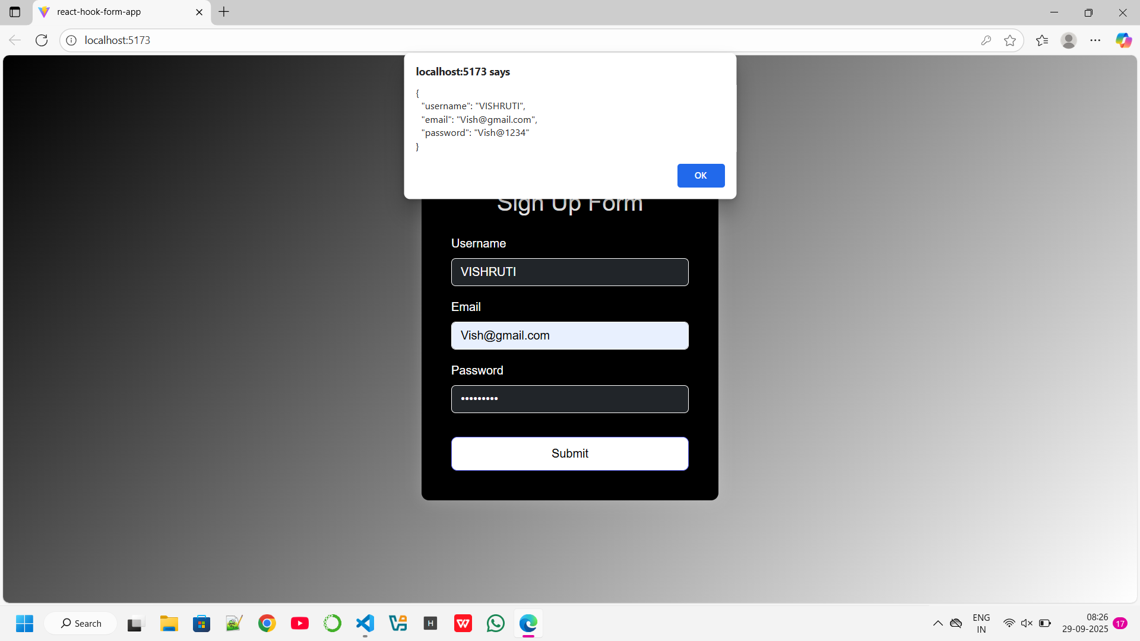

1. **Widget/Algorithm Used In Task**

· **Widget:** FormInput is a controlled adapter that uses Controller from react-hook-form to connect any input to the form.

· **Algorithm:** Validation rules provided via rules prop (required, minLength, pattern, custom validators).