Technical Design Document

Project name: **LEO Bank(E-Wallet)**

By: Vishruti Malviya (46023283)

**Introduction:**

LEO Bank is created to meet the needs of online banking system, with 1 actor Customer. The architecture implemented is Spring Boot and Angular.

**Functional Requirements:**

The functional requirements of the project are:

**For the Customer:**

* Create an Account
* Deposit Money
* Withdraw Money
* Transfer Money
* Show Profile and Balance
* Check Transaction History

**Overall Architecture Diagram:**

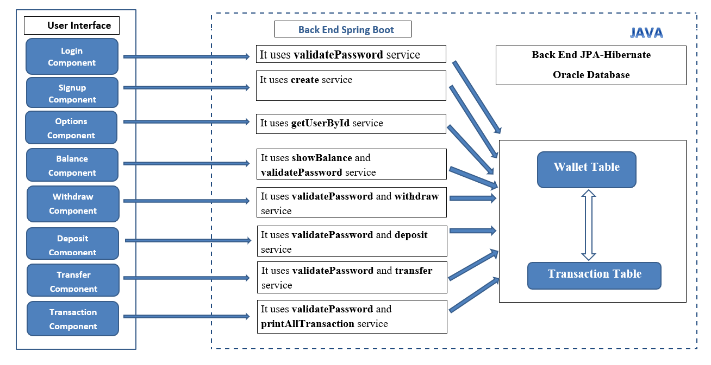

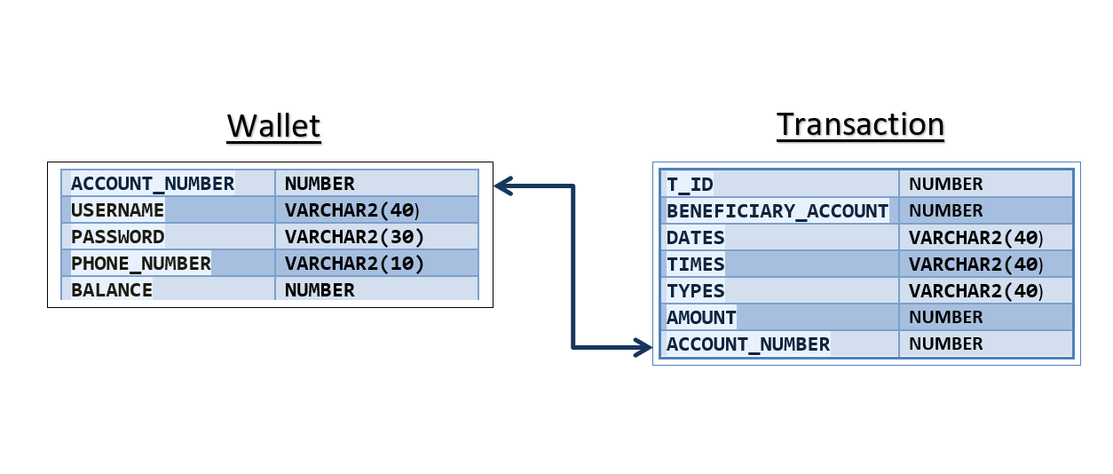**Entity Relationship Diagram:**

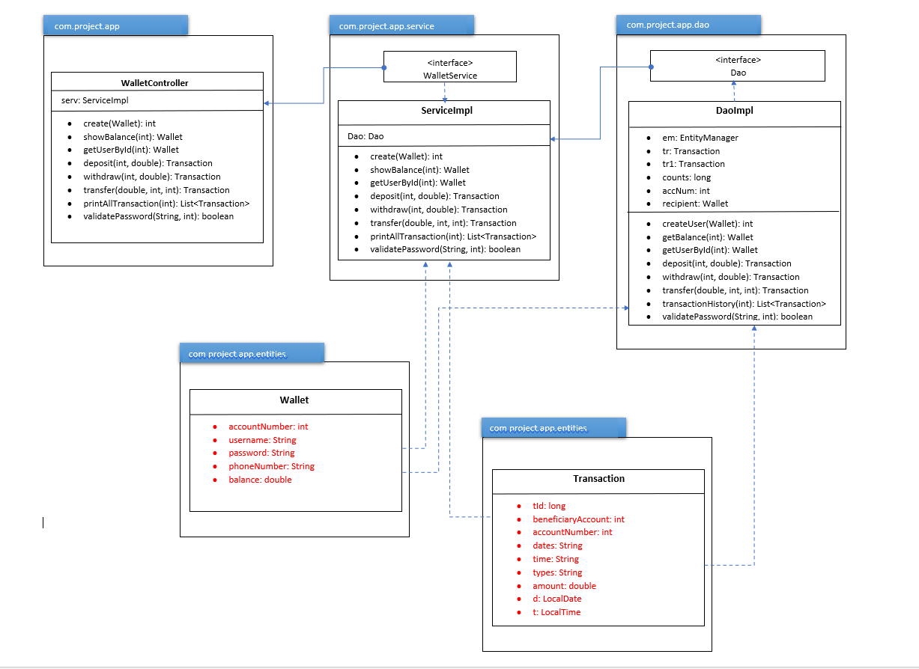**Class Diagram:**