**Exercise 1: Implementing the Singleton Pattern**

**Code :**

public class Logger {

    private static Logger instance;

    private Logger() {

        System.out.println("Logger instance created.");

    }

    public static Logger getInstance() {

        if (instance == null) {

            instance = new Logger();

        }

        return instance;

    }

    public void log(String message) {

        System.out.println("Log: " + message);

    }

}

public class SingletonPatternExample {

    public static void main(String[] args) {

        Logger logger1 = Logger.getInstance();

        Logger logger2 = Logger.getInstance();

        logger1.log("This is the first log message.");

        logger2.log("This is the second log message.");

        if (logger1 == logger2) {

            System.out.println("Both logger instances are the same (Singleton works).");

        } else {

            System.out.println("Different logger instances exist (Singleton failed).");

        }

    }

}

**Output** **:**

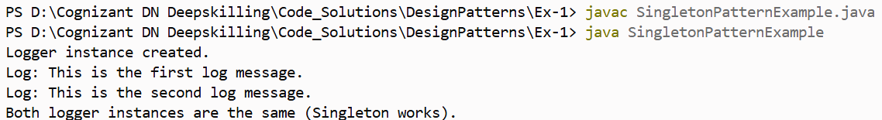

**Exercise 2: Implementing the Factory Method Pattern**

**Code :**

public interface Document {

void open();

}

public class WordDocument implements Document {

@Override

public void open() {

System.out.println("Opening a Word document.");

}

}

public class PdfDocument implements Document {

@Override

public void open() {

System.out.println("Opening a PDF document.");

}

}

public class ExcelDocument implements Document {

@Override

public void open() {

System.out.println("Opening an Excel document.");

}

}

public abstract class DocumentFactory {

public abstract Document createDocument();

}

public class WordDocumentFactory extends DocumentFactory {

@Override

public Document createDocument() {

return new WordDocument();

}

}

public class PdfDocumentFactory extends DocumentFactory {

@Override

public Document createDocument() {

return new PdfDocument();

}

}

public class ExcelDocumentFactory extends DocumentFactory {

@Override

public Document createDocument() {

return new ExcelDocument();

}

}

public class FactoryMethodPatternExample {

    public static void main(String[] args) {

        DocumentFactory wordFactory = new WordDocumentFactory();

        Document wordDoc = wordFactory.createDocument();

        wordDoc.open();

        DocumentFactory pdfFactory = new PdfDocumentFactory();

        Document pdfDoc = pdfFactory.createDocument();

        pdfDoc.open();

        DocumentFactory excelFactory = new ExcelDocumentFactory();

        Document excelDoc = excelFactory.createDocument();

        excelDoc.open();

    }

}

**Output :**

