**Hands-On 1**

**Code**

**//File : App.js**

import React from 'react';

function App() {

  return (

    <div>

      <h1>Hello, welcome to my first React app!</h1>

    </div>

  );

}

export default App;

**Output**

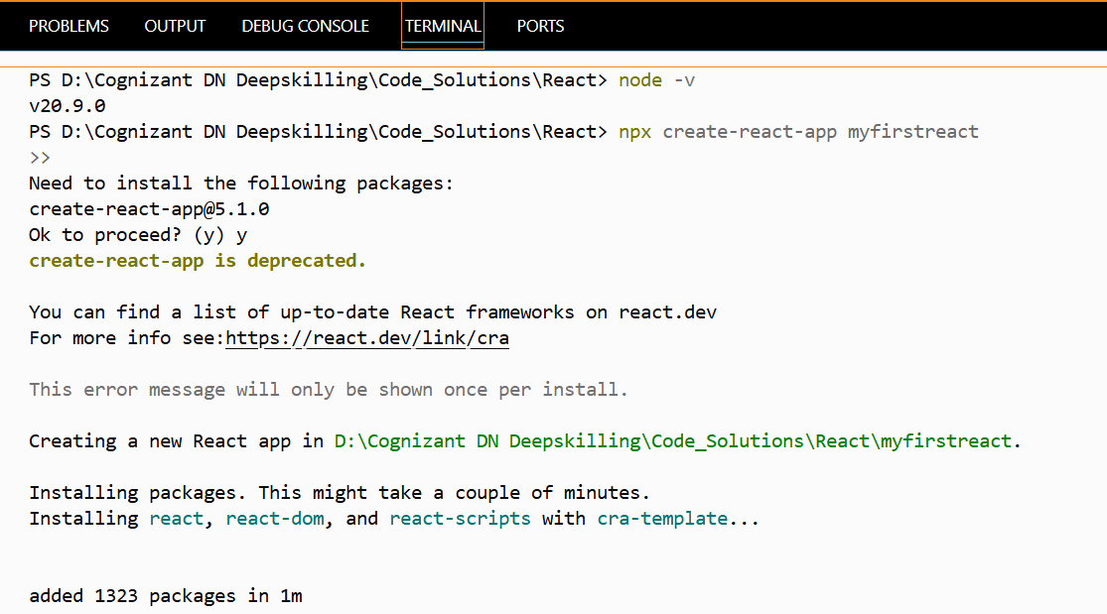

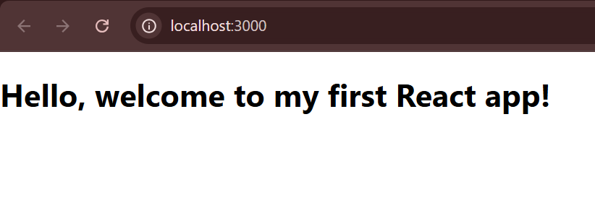

**Hands-On 2**

**Code**

**//File : Components/Home.js**

import React, { Component } from 'react';

class Home extends Component {

render() {

return (

<div>

<h3>Welcome to the Home page of Student Management Portal</h3>

</div>

);

}

}

export default Home;

**//File : Components/About.js**

import React, { Component } from 'react';

class About extends Component {

render() {

return (

<div>

<h3>Welcome to the About page of the Student Management Portal</h3>

</div>

);

}

}

export default About;

**//File : Components/Contact.js**

import React, { Component } from 'react';

class Contact extends Component {

render() {

return (

<div>

<h3>Welcome to the Contact page of the Student Management Portal</h3>

</div>

);

}

}

export default Contact;

**//File : App.js**

import logo from './logo.svg';

import './App.css';

import Home from './Components/Home';

import About from './Components/About';

import Contact from './Components/Contact';

function App() {

return (

<div className="container">

<Home />

<About />

<Contact />

</div>

);

}

export default App;

**Output**

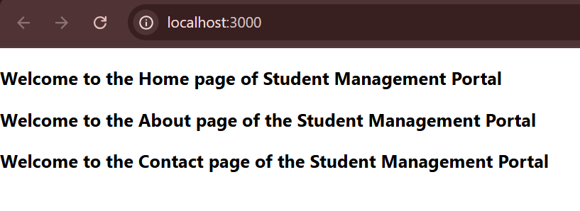

**Hands-On 3**

**Code**

**//File : Components/CalculateScore.js**

import React from 'react';

import '../Stylesheets/mystyle.css';

const percentToDecimal = (decimal) => {

return (decimal * 100).toFixed(2) + '%';

}

const calcScore = (total, goal) => {

return percentToDecimal(total / goal);

}

// Note: props names should start lowercase

export const CalculateScore = ({ Name, School, total, goal }) => (

<div className="formatstyle">

<h1><font color="Brown">Student Details:</font></h1>

<div className="Name">

<b><span>Name: </span></b>

<span>{Name}</span>

</div>

<div className="School">

<b><span>School: </span></b>

<span>{School}</span>

</div>

<div className="Total">

<b><span>Total: </span></b>

<span>{total}</span>

<span> Marks</span>

</div>

<div className="Score">

<b>Score: </b>

<span>{calcScore(total, goal)}</span>

</div>

</div>

);

**//File : Stylesheets/mystyle.css**

.Name {

font-weight: 300;

color: blue;

}

.School {

color: crimson;

}

.Total {

color: darkmagenta;

}

.Score {

color: forestgreen;

}

.formatstyle {

text-align: center;

font-size: large;

}

**//File : App.js**

import './App.css';

import { CalculateScore } from './Components/CalculateScore';

function App() {

return (

<div>

<CalculateScore

Name="Steeve"

School="DNV Public School"

total={284}

goal={300}

/>

</div>

);

}

export default App;

**Output**

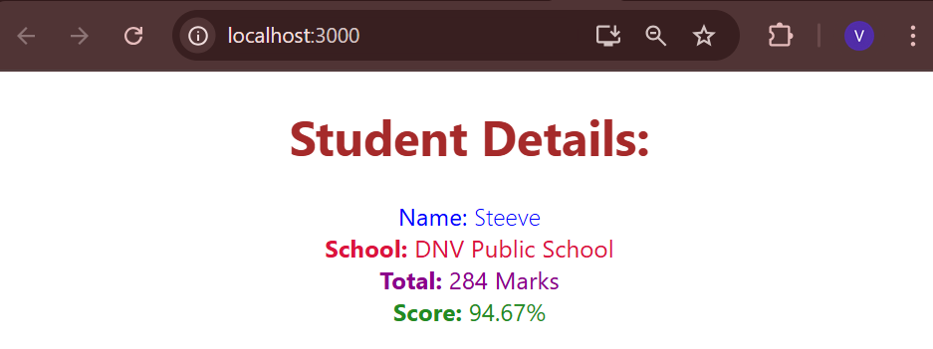

**Hands-On 4**

**Code**

**//File : Post.js**

class Post {

constructor(id, title, body) {

this.id = id;

this.title = title;

this.body = body;

}

}

export default Post;

**//File : Posts.js**

import React from 'react';

import Post from './Post';

class Posts extends React.Component {

constructor(props) {

super(props);

this.state = {

posts: [] // Initialize state

};

}

// Method to load posts

loadPosts() {

fetch('https://jsonplaceholder.typicode.com/posts')

.then(response => response.json())

.then(data => {

// Map fetched data to array of Post objects

const postsList = data.map(item => new Post(item.id, item.title, item.body));

this.setState({ posts: postsList });

})

.catch(error => {

console.error('Error fetching posts:', error);

alert('Failed to load posts');

});

}

// Call loadPosts when component mounts

componentDidMount() {

this.loadPosts();

}

// Render posts

render() {

return (

<div>

<h2>Posts</h2>

{this.state.posts.map(post => (

<div key={post.id}>

<h3>{post.title}</h3>

<p>{post.body}</p>

<hr />

</div>

))}

</div>

);

}

// Catch and show errors as alert

componentDidCatch(error, info) {

console.error('Error caught in component:', error, info);

alert('An error occurred: ' + error.toString());

}

}

export default Posts;

**//File : App.js**

import React from 'react';

import './App.css';

import Posts from './Posts';

function App() {

return (

<div className="App">

<h1>Blog App</h1>

<Posts />

</div>

);

}

export default App;

**Output**

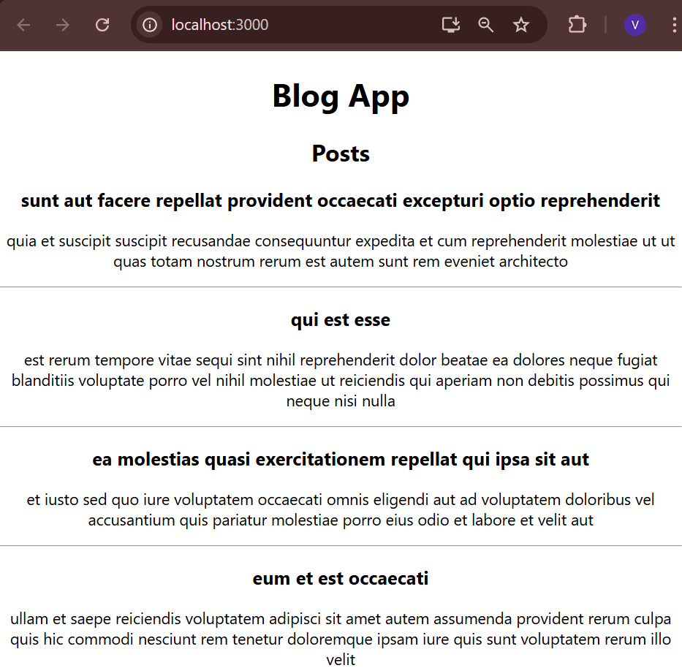

**Hands-On 5**

**Code**

**//File : CohortDetails.js**

import React from 'react';

import styles from './CohortDetails.module.css';

const CohortDetails = () => {

// example cohort data

const cohorts = [

{

id: 'INTADMDF10 -.NET FSD',

startedOn: '22-Feb-2022',

status: 'Scheduled',

coach: 'Aathma',

trainer: 'Jojo Jose'

},

{

id: 'ADM21JF014 - Java FSD',

startedOn: '10-Sep-2021',

status: 'Ongoing',

coach: 'Apoorrv',

trainer: 'Elisa Smith'

},

{

id: 'CDBJF21025 - Java FSD',

startedOn: '24-Dec-2021',

status: 'Ongoing',

coach: 'Aathma',

trainer: 'John Doe'

}

];

return (

<div>

<h2>Cohorts Details</h2>

{cohorts.map((cohort, index) => (

<div key={index} className={styles.box}>

<h3 style={{ color: cohort.status === 'Ongoing' ? 'green' : 'blue' }}>

{cohort.id}

</h3>

<dl>

<dt>Started On</dt>

<dd>{cohort.startedOn}</dd>

<dt>Current Status</dt>

<dd>{cohort.status}</dd>

<dt>Coach</dt>

<dd>{cohort.coach}</dd>

<dt>Trainer</dt>

<dd>{cohort.trainer}</dd>

</dl>

</div>

))}

</div>

);

};

export default CohortDetails;

**//File : CohortDetails.module.css**

.box {

width: 300px;

display: inline-block;

margin: 10px;

padding: 10px 20px;

border: 1px solid black;

border-radius: 10px;

}

dt {

font-weight: 500;

}

**//File : App.js**

import React from 'react';

import './App.css';

import CohortDetails from './CohortDetails';

function App() {

return (

<div className="App">

<CohortDetails />

</div>

);

}

export default App;

**Output**

